|  |
| --- |
|  |
| Capstone Project Document |

**WingS**

|  |  |  |
| --- | --- | --- |
| **WingS** | | |
| **Group Members** | Đào Trọng Nghĩa | SE03220 |
| Lê Hồng Nhiên | SE03377 |
| Tạ Ngọc Duy | SE03267 |
| Đỗ Văn Tuấn | SE03297 |
| Hoàng Anh Tuấn | SE03108 |
| **Supervisor** | Mr. Nguyễn Văn Sang | |
| **Project code** | WS | |

**- Hanoi, 12/2016 -**

TABLE CONTENTS

1 INTRODUCTION 5

1.1 Purpose 5

1.2 Acronyms and Definitions 5

1.3 Abstract 5

1.4 Literature Review 5

1.4.1 Kickstarter 6

1.4.2 Comicola 7

1.5 Proposal 7

1.5.1 The idea 7

1.5.2 The objective 7

1.5.3 Brief description about system 8

1.5.4 System features 9

1.6 Benefits from Project 10

1.6.1 For our group 10

1.6.2 For Community 10

1.7 Critical Assumption and Constraints 10

1.8 Potential Risks 11

2 PROJECT MANAGEMENT 12

2.1 Introduction 12

2.1.1 Purpose 12

2.1.2 Definitions and Acronyms 12

2.2 Project Overview 12

2.2.1 Project Description 12

2.2.2 Scope and Purpose 13

2.2.3 Assumptions and Constraints 15

2.2.4 Project Objectives 16

2.2.5 Critical Dependencies 17

2.2.6 Project Risk 18

2.3 Project Development Approach 19

2.3.1 Project Process 19

2.3.2 Requirement Change Management 21

2.3.3 Quality Management 21

2.4 Estimation 24

2.4.1 Size 24

2.4.2 Effort 24

2.4.3 Schedule 25

2.4.4 Resource 33

2.4.5 Infrastructure 33

2.4.6 Training Plan 34

2.4.7 Finance 34

2.5 Project Organization 35

2.5.1 Organization Structure 35

2.5.2 Project Team 35

2.6 Communication & Reporting 38

3 SOFTWARE REQUIREMENT 40

3.1 Introduction 40

3.1.1 Purpose 40

3.1.2 Definitions and Acronyms 40

3.2 User Requirement Specification 41

3.2.1 Business Process Overview 41

3.2.2 Product Features 52

3.2.3 User characteristic 54

3.2.4 Functional Requirements 54

3.2.5 Non-functional Requirement 55

3.3 Software Requirements Specification 56

3.3.1 Overall Description 56

3.3.2 Functional Specification 59

3.3.3 Non-Functional Specification 138

4 SOFTWARE DESIGN 140

4.1 Introduction 140

4.1.1 Purpose 140

4.1.2 Definitions, Acronyms, Abbreviations 140

4.2 Architecture design 140

4.2.1 Choice of Architecture Design 140

4.2.2 Architecture Representation 146

4.2.3 Architectural Goals and Constraints 147

4.2.4 Logical View 148

4.2.5 Process view 152

4.2.6 Deployment View 154

4.3 Detail Design 155

4.3.1 Package 155

4.3.2 Function 185

4.4 Data design 216

4.4.1 Entity Relationship Diagram 216

4.4.2 Table Diagram 218

4.5 Screen Design 226

4.5.1 User Client 226

4.5.2 Admin 258

5 SOFTWARE TESTING 274

5.1 Introduction 274

5.1.1 Purpose 274

5.1.2 Definitions and Acronyms 274

5.1.3 Scope of testing 275

5.1.4 Constraints 276

5.2 Test plan 277

5.2.1 Test type 277

5.2.2 Test stages 279

5.2.3 Test model 279

5.2.4 Acceptance test criteria. 281

5.2.5 Futures to be tested 281

5.2.6 Feature not to be tested 281

5.2.7 Resources 281

5.2.8 Test milestones 282

5.2.9 Deliverables 283

5.3 Test case 283

5.4 Test Report 284

5.4.1 System test report 284

5.4.2 Integration test report 284

5.4.3 Test report 284

5.4.4 Defect report 285

6 USER MANUAL 286

6.1 Introduction 286

6.1.1 Purpose 286

6.1.2 Environment 286

6.2 Installation Guideline 286

6.2.1 Connecting an ASP.NET MVC Web App with SQL Azure 286

6.2.2 Create & Deploying the Azure Website 291

6.2.3 Connecting SQL Management Studio to SQL Azure 293

6.3 User Guideline 297

6.3.1 User Client 297

6.3.2 Admin 319

7 PROJECT RESULT REPORT 326

7.1 Product Judging 326

7.1.1 Advantage of Dandelion system 326

7.1.2 Current Limitations 326

7.1.3 Expectation in Future 326

7.2 Project Summary 326

7.3 Lesson Learnt 327

8 REFERENCES 329

# INTRODUCTION

## Purpose

This document is created as the introduction for event WingS – our Capstone Event at FPT University. In this document, we will descript the overview of some existing systems, the initial idea for our event, a brief description about our expected system and some potential risks, critical assumptions, constrains. Moreover, this document also shows opportunities what it offers for users.

## Acronyms and Definitions

|  |  |
| --- | --- |
| **Acronym & Abbreviation** | **Definition** |
| WS | WingS |
| FU | FPT University |
| Q&A | Question and Answer |

**Table 1-1:** Definitions and Acronyms

## Abstract

WS makes connections that enable people to help themselves and each other. Website allows users (who created organization) create charity topics or event as long as it follows our rules to help other people. Donors can also take part in a event by donating money through a single donation or supporting event as a regular donor publicly or privately, not to profit financially. Instead, charity topic creators offer rewards to thank backers for their support. We hope our event can help as much people as we can in our country.

## Literature review

There are many charity organizations in Vietnam, but few of them can make connections between the organizations and people who need help. Some kind of charity organization website: childrenofvietnam.org, lovingkindnessvietnam.org.

* **Childrenofvietnam**

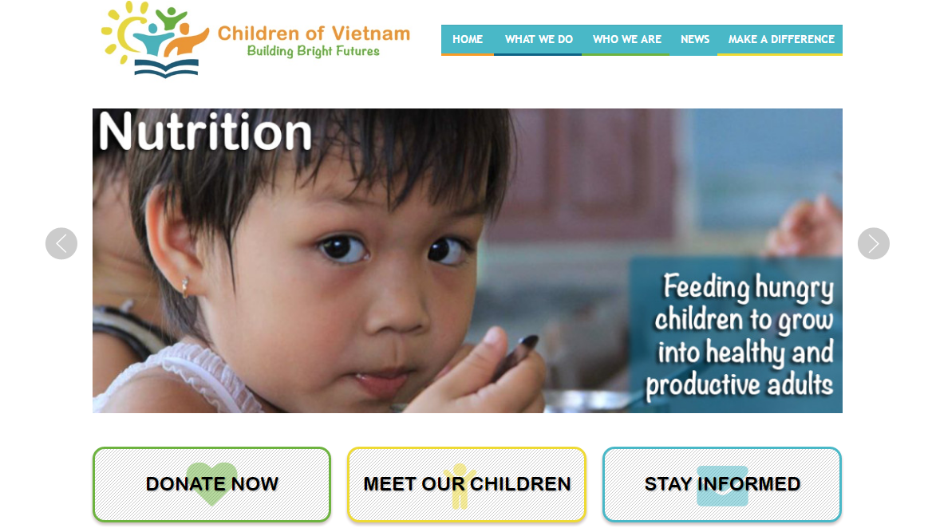

**Figure 1-1:** Website Childrenofvietnam

Childrenofvietnam is a website works solely as a volunteer, and does not receive a salary or compensation. They spend nothing on marketing, advertising, or solicitations.

* **Advantages:**
* Has friendly user interface
* **Disadvantages:**
* Only support PayPal. The language is English.
* No marketing or advertising so it is not popular in Vietnam.
* Only about children.
* **Lovingkindnessvietnam**

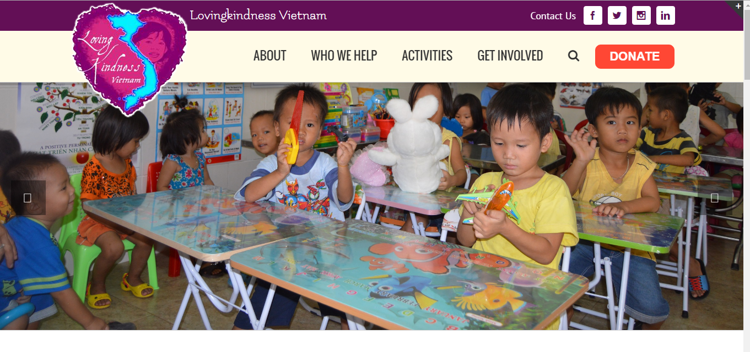

**Figure 1-2:** Website lovingkindnessvietnam

The mission of Lovingkindness Vietnam is to directly aid those in need throughout the area surround Nha Trang, Vietnam. Seeking out and visit the wonderful orphanages, charity schools, and communities, identify how best to improve the health and wellbeing of the children, and put into place programs to bring about lasting change. As they are a small charity dedicated to one area, they can oversee customized from donors overseas.

* **Advantages:**
  + Has friendly user interface
* **Disadvantages:**
  + Only support PayPal. The language is English.
  + No marketing or advertising so it is not popular in Vietnam.

## Proposal

### The idea

Nowadays in our country, there are many people have difficult circumstances. Besides that, many organizations and personals have financial condition and possibilities for helping. But the problem is they can’t meet the other. Thanks for Internet, WS can solve this problem by making connections that enable people to help themselves and each other.

### Objectives

This event is the Capstone Event in FPT University studying program.

First, this event is responsibility for all team members. So we must complete all requirements from teacher and FU. During the time doing event, we can learn how to develop a event, how to manage event, how to working in group, how to control time, how to perform teamwork effectively. Moreover, we also have experience in .NET technology, website designing, software testing. Therefore, we think this event is very necessary for us to improve skills, knowledge which we studied in FU. This event also makes our CV more beautiful after graduating from FU. This is also an opportunity for us to prove capacity with recruiters.

Second, we hope that out event can help the other people and we hope to make our country better.

### Brief description about system

This software has friendly and attractive interface, users can easily find out the event to donate or create a new event when they have enough capacity and capability. User also can send opinion to admin if they need help.

WS uses familiar technologies as: Bootstraps, .NET MVC5, AngularJS…, and we are planning to develop a mobile version for easily connecting.

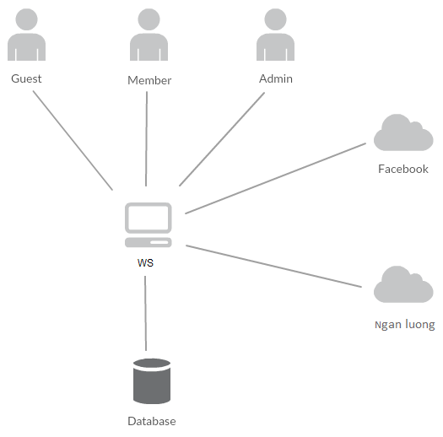

**Figure 1-3:** Brief descriptions diagram of WS system

### System features

About the features of WS, we focus to provide for users main features as searching, create new event, create thread, donate, message etc. Admin can manage members, manage organization, manage database, manage contribute database and manage Q&A.

In here, we focus on features which can help users can understand the best way what user want to have with features of WS. There are the detailed features of WS:

#### Client features

* Register: User can register an account and login to use all features of WS.
* Login/Logout: Users login/logout an account to use or exit system WS.
* Event
  + Create new event: Organization can create new program with basic info, contact, timeline and content.
  + Update program Information: User can change and update information of program which has been created.
  + Chat room: An event has a room chat where all user whom connected in can chat with the others.
  + Comment/Remind: Users can comment/remind an program to follow and discuss with another users.
  + Report: User can report a event which violate regulation to administrator.
* Thread:
  + Create new thread: Users can create new thread for discuss with other or get ideal about creating an event
  + Comment/Remind: Users can comment/remind a thread to follow and discuss with another users.
  + Report: User can report a thread which violate regulation to administrator
* Donate: User can donate money to help event and get point rewards.
* Organization:
  + Create new organization: Users can request create new organization.
  + Create a new event to raise donate.
  + Update profile: Organization can change or update information.
  + Manage created event.
* Profile:
  + Change password: User can change password to keep security.
  + Update profile: User can change or update information.
  + Manage created event, donated event, created thread. View statistical event had created, backed.
  + Sent/Receive message: Users can send to or receive from other users to discuss about event.
* Search:
  + Users can search any what they want follow: account, thread, event, organization.
* Message:
  + Users can message with others: members or admin.
* Report:
  + Users can report others users, events, threads, organizations.

#### Admin features

* Manage user:
  + Search user: Admin can search with name of user and system will display simple information about that user(name, email, phone number)
  + Inactive/active user: admin can set user’s account to inactive or active.
* Manage event:
  + Search event:
    - Search with event name: Admin can search with name of event and system will display simple information about that event.
  + Edit status: Admin can set status of an event: Inactive/active depend on report.
* Manage thread:
  + Search thread :
    - Search with thread name: Admin can search with name of thread and system will display simple information about that thread.
  + Edit status: Admin can set status of an thread: Inactive/active depend on report.
* Manage organization:
  + Admin manages creating organization requests from users. It means admin can accept or not a request.
  + Edit status: Admin can set status of an organization: Inactive/active depend on report.
* Manage report:
  + Admin recives reports of users. It means admin can accept or not a request.
* Message: Admin can view received messages/sent messages.
  + Compose new message: Admin can compose new message to send to user.

## Benefits from project

### For our team

After developing and implementing this event, our team will get some benefits:

* Have more experiences and knowledge about software event management how to manage plan, time, member and risk.
* Have more knowledge and skill about .NET MVC5 and AngularJS programming
* Know how to communicate with team members and how to teamwork more effective.

### For Community

Just need to have a device that connect to the internet and any web browser, user can:

* Easy join to a charity event to help other people who need.
* Easy to create a new charity event

## Critical Assumption and Constrains

* Critical assumption:
  + Training: All developers can train .NET and AngularJS in 7-10 days. Before starting this project, only 2 members in our team have knowledge about .NET MVC5 and one member have knowledge about AngularJS, but with programming techniques which we studied at FU, we have to try the best to not missing any deadline in project plan.
  + Human resources: Assume that all members in team have a good healthy to do their tasks.
* Constraints:
  + Time and deadline: We must complete task on time. We work on 14 weeks, each member works 5 hours/day and 5 days/week. We do not have more time for us to complete developing and deliver application to teachers. Besides, we have to submit report documents before deadline to teacher can review.
  + Quality: The products must be run well when users perform main functions in Google Chrome 53
  + Process: We have to follow the software processing of FPT Software
  + Human resources: There are 5 members in our team, each member have to study 2 subjects (Japanese and JIT) at school.

## Potential Risks

After studying about this event, we find out some problem that we may be encountered:

* Under-estimate scope and time or miss deadline because lack of experience in group working, managing and controlling work.
* Loss data, source code before uploading data to server because of careless.
* Equipment got broken because of careless or accident.
* Human resources: Team member cannot complete their works because of health reasons, key member leave team or un-cooperating on team.
* Change requirements: Requirement changed when some functions cannot be completed or some technologies is not suitable.

# PROJECT MANAGEMENT

## Introduction

### Purpose

This part is the project management plan of WingS (WS) Project – our Capstone Project  
in FPT University. It is included the project overview, project organization, tools and  
infrastructures, schedule of this project.

### Definitions and Acronyms

|  |  |  |
| --- | --- | --- |
| Acronym | Definition | Note |
| BA | Business Analyst |  |
| BU | Business Unit |  |
| CC | Infrastructure Configuration Controller |  |
| CM | Configuration Management |  |
| WS | WingS |  |
| ORG | Organization |  |
| DEV | Developer |  |
| PIC | Person in charge |  |
| PM | Project Manager |  |
| PTL | Project Technical Leader |  |
| QA | Quality Assurance Officer |  |
| SRS | Software Requirement Specification |  |
| TC | Test Case |  |
| PCB | Process Capability Baseline |  |

1. Definitions and acronyms

## Project overview

### Project Description

|  |  |  |  |
| --- | --- | --- | --- |
| Project Code | WS | Contract Type | None |
| Customer | FPT University | 2nd Customer | None |
| Project Level | Group | Project Rank | None |
| Application Type | Website | Project Manager | Đào Trọng Nghĩa |
| Project Category | Development | Business Domain | E-commerce |

1. Project Description

### Scope and Purpose

#### Purpose of Project

WS makes connections that enable people to help themselves and each other. Website allows users (person or organizations) create charity topics or raise fund project as long as it follows our rules to help other people. Backers can also take part in a project by donating money through a single donation or supporting project as a regular donor publicly or privately, not to profit financially. Instead, project creators offer rewards to thank backers for their support. We hope our project can help as much people as we can in our country.

#### Scope of Project

The scope of this project contains: Requirement Analysis, Design, Coding and Testing (Unit Test, Integration Test, and System Test).

##### The functions of Project

These are the functions of WS’s project:

##### Client User Module.

* **Register**: User can register an account and login to use all features of WS.
* **Login/Logout**: Users login/logout an account to use or exit system WS.
* **Search**: User and guest can search with: name of users, title of threads, event , name of organization, and system will display all of post relate to keywords.
* **Raise Request:** User can request to create an Organization. Admin can accept or refuse.
* **Thread:**
  + **Create New Thread:** User (ORG) can create new post with basic info, timeline, clip and some pictures.
  + **Update Post Information**: User can change and update information of post which created.
  + **Comment /Like/Share**: Users can comment/remind/like/share a post to follow and discuss with another users.
  + **Report:** User can report a post or Organization which violate regulation to administrator.
* **Event:**
  + **Create New Event:** ORG can create new event with basic info, timeline, clip and some pictures.
  + **Update Event Information**: ORG can change and update information of post which created.
  + **Comment /Like/Share**: Users can comment/remind/like/share a post to follow and discuss with another users.
  + **Report:** User can report a post or Organization which violate regulation to administrator.
* **Donate**: User can donate money, clothes or others for Organization to charity.
* **Profile:**
  + **Change password:** User can change password to keep security.
  + **Update profile:** User can change or update information.
  + **Manage created posts, reminded posts:** User (ORG) can follow process of post, post reminded. View statistical post had created, reminded.
  + **Sent/Receive message:** Users can send or receive from organizations or admin to discuss about post or problem.

##### Admin Module

* **Login/Logout**: Admin login/logout an account to use or exit system WS
* **Manage user:**
  + Search user:Admin can search with name of user and system will display simple information about that user (name, email,...)
  + Ban/Unban user: admin can set user’s account to block or unblock.
* **Manage Thread:** 
  + Search post :
    - Search with thread title:Admin can search with title of post and system will display all of post relate to keywords.
  + Edit thread status: Admin can set status of a thread: Inactive/active depend on report.
* **Manage Event :**.
  + Search event :
    - Search with event title:Admin can search with title of event and system will display all of event relate to keywords.
  + Edit event status: Admin can set status of a event: Inactive/active depend on report.
* **Manage Organization :**.
  + Search Organization :
    - Search with organization title:Admin can search with name of organization and system will display all of event relate to keywords.
  + Edit organization status: Admin can set status of a organization: Inactive/active depend on report.
* **Manage Donate:** Admin can view users who donated . Also, Admin can view amount of money, numbers of clothes.. to rank for users.
* **Manage Requests Of Users:** 
  + View/Accept/Decline: Admin can View/Accept/Decline requests : raise a ORG, report a post of users.
* **Message:** Admin can view received messages/sent messages.
  + Compose new message: Admin can compose new message to send to user.
  + Delete message: Admin can delete received messages/sent messages.

### Assumptions and Constraints

|  |  |  |
| --- | --- | --- |
| No | Description | Note |
| Assumptions | | |
| 1 | Customer reviewers will get seven days to approve a milestone document. If no comments are received within this time period, it will be considered as approved. | External Interfaces |
| Constraints | | |
| 1 | This project must be completed and delivered before 16/12/2016 | Schedule |
| 2 | In doing project processing, PM must submit report (include 6 reports) on certain date. | Schedule |
| 3 | Software Requirement Specification Document and Project Plan must be completedwithin10dayssince7/09/2016  **Deadline**: 16/09/2016 | Schedule |
| 4 | Design Document (include Architecture Design, Screen Design, Database Design) must be completed within 17 days since 22/09/2016  **Deadline**:20/10/2016 | Schedule |
| 5 | Completed coding activity and have unit test result within 18 days since 20/10/2016  **Deadline**: 18/11/2016 | Schedule |
| 6 | Integration TestPlan (include test plan and test case…) must be completed within20dayssince1/11/2016  **Deadline**: 28/11/2016 | Schedule |
| 8 | Deliver report about User manual, software package and installation guide on 2 days since 6/12/2016  **Deadline**: 10/12/2016 | Schedule |
| 9 | Complete all of document and application before finishingtheprojecton12/12/2016 | Schedule |
| 10 | Project contains 6 members | Resource |

1. Project Description

### Project Objectives

#### Standard Objectives

|  |  |  |  |  |
| --- | --- | --- | --- | --- |
| Metrics | Unit | Committed | Re-committed | Note |
| Start Date |  | 05-09-2016 |  |  |
| End Date |  | 16-12-2016 |  |  |
| Duration | Day | 75 |  |  |
| Team Size | Person | 5 |  |  |
| Billable Effort | Person-day | 375 |  |  |
| Calendar effort | Person-day | 375 |  |  |
| Effort Usage | % | 100 |  |  |

1. Standard Objectives 1

|  |  |  |
| --- | --- | --- |
| Metrics | Unit | Basic for setting Goals |
| Average |
| Customer Satisfaction | Point | 9.5 |
| Leakage | Wdef/mm | 5 |
| Effort Efficiency | % | 95 |
| Timeliness | % | 100 |

1. Standard Objectives 2

#### Specific Objectives

|  |  |  |  |
| --- | --- | --- | --- |
| Metrics | Unit | Basic for setting Goals | |
| Plan | Actual |
| Training technology: MVC, Bootstrap, jQuery, AngularJS, Ajax | Person-day | 15 | 15 |
| Execute group review | Person-day | 8 | 5 |
| Training requirements, process before coding | Person-day | 8 | 5 |

1. Specific Objectives

### Critical Dependencies

|  |  |  |  |  |
| --- | --- | --- | --- | --- |
| No | Dependency | Expected delivery date | | Note |
| 1 | This project must be completed and delivered to FPT University. | 16/12/2016 |  | |
| 2 | Project Plan and SRS must be completed and delivered to Supervisor. | 20/09/2016 |  | |
| 3 | User manual, Software Package and Installation Guide must be completed and delivered to Supervisor and FPT University. | 14/12/2016 |  | |
| 4 | Beside Capstone Project, Team members have to joining in Japanese class and Japanese Fundamental Exam class. | 05/09/2016 |  | |

1. Critical Dependencies

### Project Risk

PM identifies risks in the Risk Management Plan. The document is updated to trigger each milestone, each event also. The document is updated weekly by the PM, Risk Management Plan will be notified to all of the stakeholders affected. Status of risk is reported to supervisor at Project Milestones Report.

Reference to WS_Risk Management Plan_v1.0_EN.xlsx

## Project Development Approach

### Project Process

Process of this project is performed follow to Software Development Process of FPT Software.

#### FPT Software Process Model



Figure 1‑1: FPT Software process model

The software lifecycle is broken into *cycles*, each cycle working on a new generation of the product. The FPT Software process divides one development cycle in six consecutive *phases*:

1. Initiation phase
2. Definition phase
3. Solution phase
4. Construction phase
5. Transition
6. Termination

#### Project Life Cycle

Basing on FPT Software process and real-world project, we decided to divide the project into 4 phases: Initiation, Solution, Construction, and Termination:

* **Initiation Phase:** This is the explanatory phase of the project. Project objective and description is described at this stage. The purpose of this phase is to collect and understand business requirements, detail the project plan and agree upon a high level statement of work. Our primary objectives are complete project identification and project plan. After these are completed, the project is checked against the following criteria:
  + Identify business functions of the system
  + Determining the scope, conditions and limitations of the project
  + List the main functions of the system
  + List one or more suitable architecture for the system
  + Identify project risks
  + Complete Report #1, and Report #2
* **Solution Phase**: In this phase, the architecture of the system is designed. The goal is to translate requirements and specification into a technical solution to produce Technical Design.
  + Our *primary objectives* are completeRequirement Specification, Architecture Design and Database Design.
  + Finally, the plan must be provided (including estimates of cost and time) for the construction phase. The plan must ensure proper and accurate based on experience.
  + Complete Report #3 and Report #4
* **Construction Phase**: This is the longest phase of a project life cycle.
  + In this phase, all functions of the system will be installed. The installation will be divided into small stages, each stage of the installation a few functions. The results of each phase will be the release of the module function can be executed.
  + Construction and improvement of products until the final product is ready to deliver to the user. During this phase, all the components and other features of the application is developed and integrated into the product.
  + This phase emphasizes the resource management and control operations to optimize cost, time and quality.
  + Complete software packages and Report #5
* **Termination Phase**: This is the final phase in the life cycle of a project.
  + Their products will be deployed to the client. The feedback received during the transfer process will be recorded and put on the new functional requirements or functionality enhancements in the next version of the product.
  + Phase transfer switch also includes the training system and the new system for the user.
  + Complete software packages and Report #6

### Requirement Change Management

|  |  |
| --- | --- |
| Who logs the change request? | Any team members |
| Who reviews the change request? | PM or who is PM assign |
| Who approves the change request? | PM by default. PTL if:   * Changes to project scope * Changes in delivery plan of project deliverables * Changes to assignment for key roles (PM, PTL) |

1. Requirement Change Management

### Quality Management

#### Defect Prevention Strategy

|  |  |  |
| --- | --- | --- |
| Item (Process/Product) | Strategy | Expected Benefits |
| Requirement missing | List up all of requirement into SRS document. | 10–20% reduction in defect injection rate and about 2% improvement in productivity |
| Careless mistake in Design Document Format/Template wrong | After designing, QA will review Document Format base on checklist review design | Improvement in quality as overall defect removal efficiency will improve; some benefits in productivity as defects will be detected early |
| Use wrong template | Have a meeting to disseminate all template that is used in this project for all member | All member will use right template when do document |
| Coding application does not match with User Requirement. | Develop Team must study about Requirement/Design within 1 weeks since project is assigned.  PM and PTL has responsibility to review task results and explain User Requirement for Develop Team | Coding Application match with User Requirement. |

1. Defect Prevention Strategy

#### Review Strategy

|  |  |  |  |  |
| --- | --- | --- | --- | --- |
| Review Item | Reviewer | Review Type | Review Method | Completion Criteria |
| Project Plan  Project Schedule  CM Plan | PM,QA, Supervisor | Group review  Group review  One-person review | Use checklist and Self-review |  |
| Business analysis and requirements specification document, Use Case catalog | PM,QA, Supervisor | Group review and One-person review | Use checklist |  |
| Design document, object model | Self-review, PM,QA Supervisor | One-person Review | Use checklist |  |
| Stage plans | PM,QA, Supervisor | One-person review | Use checklist |  |
| Complex/first time generated program specs incl. test cases, interactive diagrams |  | Group review |  |  |
| Source code | Self-review, Peer review, PM, Supervisor | One-person review and Group review | Self-review and use checklist |  |

1. Review Strategy

#### Unit Testing Strategy

|  |  |  |  |  |
| --- | --- | --- | --- | --- |
| Item to be Unit Tested | Unit Test Type | Unit Test Technique | Tool Used | Unit Test Completion Criteria |
| Source Code | White-Box Test | Using unit test case and test script | None | - Number of UTC/KLOC: 20 UTC/KLOC  - Number defects/KLOC: 3-4 defects/KLOC  - Statement coverage: 97%  - Branch coverage: 100%  - Path coverage: 100% |

1. Unit Testing Strategy

#### Integration Testing Strategy

|  |  |  |  |  |
| --- | --- | --- | --- | --- |
| Item to be Integration Tested | Integration Test Type | Integration Test Technique | Tool Used | Completion Criteria |
| Do test by flow of functions and items which have concern each other | Black-Box Test |  | Checklist, Boundary | - Number of UTC/KLOC: 20  - Number of defects/KLOC: 2-3 |

1. Integration Testing Strategy

#### System Testing Strategy

|  |  |  |  |  |
| --- | --- | --- | --- | --- |
| Item to be System Tested | System Test Type | System Test Technique | Tool Used | Completion Criteria |
| Test whole system | Black-Box Test |  | None | -Number of UTC/KLOC: 60  -Number of defects/KLOC: 4-6 |

1. System Testing Strategy

#### Estimates of Defects to be detected

|  |  |  |  |
| --- | --- | --- | --- |
| Review/Testing Stage | Targeted No. of Defects to be detected | % of Defects to be detected | Basic for Estimation |
| Requirements review | 10 | 7.5% | Referenced to similar project estimations |
| Design review | 15 | 11.5% | Referenced to similar project estimations |
| Code review | 30 | 23% | Referenced to similar project estimations |
| Unit Test | 45 | 35.5% | Referenced to similar project estimations |
| Integration Test | 15 | 11.5% | Referenced to similar project estimations |
| System Test | 10 | 7.5% | Referenced to similar project estimations |
| User Acceptance Test | 5 | 3.5% | Referenced to similar project estimations |
| Total | 130 | 100% |  |

1. Estimates of Defects

#### Measurements Program

|  |  |  |  |
| --- | --- | --- | --- |
| Data to be collected | Purpose | PIC | When |
| Size: No. of KLOC | Achieve target | PM | At the end of stages |
| Effort: No. person-day | Monitor and controlling team member to keep plan. | Team members | Daily |
| Quality: No. defects detected | Managing product’s quality. | Reviewer  Tester | Right after the review/test |
| Schedule | Monitor and controlling software developing processing keep plan. | PM | Weekly and at the end of stages |

1. Measurements Program

## Estimation

### Size

This project is performed and must complete all requirements from teacher and FPT University. So size of our project is in Capstone Project limit.

### Effort

The Effort estimation is documented in the table below.

|  |  |  |  |  |  |
| --- | --- | --- | --- | --- | --- |
|  | Initiation | Solution | Construction | Termination | Total |
| Effort(person/day) | 82 | 163 | 200 | 65 | **510** |
| Total % budgeted Effort Usage (%) | 100 | 100 | 100 | 100 |  |

1. Effort Estimation

### Schedule

#### Project Milestone & Deliverables

|  |  |  |  |  |
| --- | --- | --- | --- | --- |
| No | Stage | Committed Delivery date | Description of Deliverable | Delivery media |
| Initiation | |  | Requirements agreed, Report 1 reviewed | |
| 1 | Develop project idea | 06-09-2016 | Project goals and scope defined, milestone description defined, resource committed | Commit TortoiseGit |
| 2 | Q&A Management Sheet | 12-09-2016 | Criteria: Documentation reviewed | Commit TortoiseGit |
| 3 | Complete User Requirement Specification | 16-09-2016 | Complete User Requirement Specification | Commit TortoiseGit |
| 4 | Submit report no.1 final | 16-09-2016 | Completed report no.1 | Commit TortoiseGit |
| 5 | Project Plan | 15-09-2016 | Criteria: Documentation reviewed | Commit TortoiseGit |
| Solution | |  |  | |
| 1 | Screen Prototype | 02-10-2016 | Criteria: Documentation reviewed | Commit TortoiseGit |
| 2 | Architecture Design | 04-10-2016 | Criteria: Documentation reviewed | Commit TortoiseGit |
| 3 | Screen Design | 06-10-2016 | Criteria: Documentation reviewed | Commit TortoiseGit |
| 4 | Class Design | 04-10-2016 | Criteria: Documentation reviewed | Commit TortoiseGit |
| 5 | Detail Data Design | 07-10-2016 | Criteria: Documentation reviewed | Commit TortoiseGit |
| 6 | Submit progress report 2 | 5-10-2016 | Completed report no.2 | Commit TortoiseGit |
| 7 | Create Test Plan Final | 13-10-2016 | Criteria: Documentation reviewed | Commit TortoiseGit |
| 8 | Submit Report no.3 Final | 14-10-2016 | Completed report no.3 | Commit TortoiseGit |
| Construction | |  | Product developed & tested and released to supervisor, documentation reviewed. | |
| 1 | Complete Coding and Unit Test | 14-11-2016 | Source code  Acceptance criteria: Product unit tested | Commit TortoiseGit |
| 4 | Complete Testing | 28-11-2016 | Completed Test | Commit TortoiseGit |
| 5 | Submit report no.5 Final | 02-12-2016 | Completed report no.5 | Commit TortoiseGit |
| 6 | Submit the last document and CD source code | 10-12-2016 | Final Documents and Source Code | Commit TortoiseGit |
| Termination | |  | Project post-mortem is conducted, Project assets archived and released to supervisor | |
| 1 | Lesson learned | 05-12-2015 | Criteria: Completed | Commit TortoiseGit |
| 2 | Complete Presentation Slide | 07-12-2016 | Criteria: Completed | Commit TortoiseGit |
| 3 | Present capstone project | 16-12-2016 | Criteria: Completed | Commit TortoiseGit |
| 4 | Project Complete | 16-12-2016 | Criteria: Completed | Commit TortoiseGit |

1. Project Milestone and Deliverables

#### Activity Schedule

The detail project schedule is available in file WS_ProjectSchedule_v1.0_EN.mpp. The Project Schedule is weekly updated by the Project Manager.

|  |  |  |  |  |
| --- | --- | --- | --- | --- |
| No | Activity | Start date | End date | Responsible |
| Defect Prevention | | | | |
| 1 | Training coding convention C#, Javascript, CSS | 12-09-2016 | 16-09-2016 | Lê Hồng Nhiên |
| 2 | Training for Q&A and tester to use checklist | 06-10-2016 | 10-10-2016 | Tạ Ngọc Duy |
| **Quality Control** | | | | |
| 1 | Group review requirement | 14-10-2016 | 16-10-2016 | Đào Trọng Nghĩa |
| 2 | Group review design | 07-10-2016 | 09-10-2016 | Tạ Ngọc Duy |
| 3 | Group review coding | 16-11-2016 | 24-11-2016 | Lê Hồng Nhiên |
| Project Tracking | | | | |
| 1 | Solution: Milestone review meeting | 15-10-2016 | 16-10-2016 | Đào Trọng Nghĩa |
| 2 | Construction: Milestone review meeting | 3-12-2016 | 04-12-2016 | Đào Trọng Nghĩa |
| 3 | Transition: Milestone review meeting | 10-12-2016 | 11-12-2016 | Đào Trọng Nghĩa |
| Configuration Management | | | | |
| 1 | Baseline code | 17-10-2016 | 20-10-2016 | Đào Trọng Nghĩa |
| 2 | Base line test report, test case and test plan | 22-10-2016 | 29-10-2016 | Đỗ Văn Tuấn |
| Q&A | | | | |
| 1 | Final Inspection: Report 1 | 05-09-2016 | 16-09-2016 | Đào Trọng Nghĩa |
| 2 | Final Inspection: Report 2 | 19-09-2016 | 05-10-2016 | Đào Trọng Nghĩa |
| 3 | Final Inspection: Report 3 | 06-10-2016 | 14-10-2016 | Đào Trọng Nghĩa |
| 4 | Final Inspection: Report 4 | 17-10-2016 | 15-11-2016 | Đào Trọng Nghĩa |
| 5 | Final Inspection: Report 5 | 1-11-2016 | 02-12-2016 | Đào Trọng Nghĩa |
| 6 | Final Inspection: Report 6 | 05-12-2016 | 10-12-2016 | Đào Trọng Nghĩa |

1. Activity Schedule

### Resource

Specified as in the section 4.2. Project Team

### Infrastructure

|  |  |  |  |
| --- | --- | --- | --- |
| Item | Description | Expected Availability by | Note |
| Development Environment | | | |
| Operating System | Window 8.1, 10 (32 bit, 64 bit) |  |  |
| Browser | Chrome (40 or above), Firefox (30 or above), Cốc Cốc |  |  |
| Development language | .NET C# |  |  |
| Technology | | | |
| Development language | .NET C#, MVC Model, AngularJS |  |  |
| Database | SQL Server 2008 |  |  |
| Hardware Requirement | | | |
| Hardware Configuration | 2GB workspaces on server |  |  |
| Equipment & Tools | | | |
| Source Version Control | TortoiseGit | Definition stage |  |
| Task Tracking | MS Project Professional 2013 | Initiation stage |  |
| SRS | Microsoft Office Word 2013, Microsoft Office Excel 2013, Microsoft Office Visio 2013 | Initiation stage |  |

1. Infrastructure

### Training Plan

|  |  |  |  |
| --- | --- | --- | --- |
| Training Area | Participants | Duration | Waiver Criteria |
| **Technical** | | | |
| .NET MVC5 | Team | 1 week | Mandatory |
| AngularJS, jQuery | Team | 1 week | Mandatory |
| Bootstrap | Team | 1 week |  |
| **Process** | | | |
| Quality system |  | 3 hours | If already trained |
| Configuration management |  | 2 hours | If already trained for CC. For others, on-the-job training |
| Group review |  | 2 hours | If already trained |
| Defect prevention |  | 2 hours | Mandatory |

1. Training Plan

### Finance

Because this project is non-business, it is a Capstone Project at FPT University. So we do not estimate about finance.

## Project Organization

### Organization Structure

Figure 1-2: Organization Structure

### Project Team

|  |  |  |  |  |  |
| --- | --- | --- | --- | --- | --- |
| Role | Responsibility | Full name | Effort (%) | Start date | End date |
| PM | Have overall responsibility of the project:  - Project planning and scheduling  - Task assignment and tracking processing  - Review documents  - Reporting to supervisor | Đào Trọng Nghĩa | 50 | 05-09-2016 | 15-12-2016 |
| PTL | PTL is responsible for the technical project execution | Lê Hồng Nhiên | 50 | 05-09-2016 | 15-12-2016 |
| Programmer #1 | - Study technique (C#, MVC, AngularJS, etc.)  - Coding functions and modules of system.  - Peer-review source code of others members | Đỗ Văn Tuấn,  Hoàng Anh Tuấn,  Tạ Ngọc Duy,  Lê Hồng Nhiên,  Đào Trọng Nghĩa | 100 | 05-09-2016 | 15-12-2016 |
| Programmer #2 | - Support coding functions and modules of system. | Lê Hồng Nhiên | 50 | 05-09-2016 | 15-12-2016 |
| Programmer #3 | - Support coding functions and modules of system. | Hoàng Anh Tuấn | 100 | 05-09-2016 | 15-12-2016 |
| Test Leader | - Create test plan, test case, test report, quality report  - Execute test. | Đỗ Văn Tuấn | 100 | 1-11-2016 | 15-12-2016 |
| Tester | - Support creating test plan, test case, test report, quality report  Execute test. | Tạ Ngọc Duy | 100 | 1-11-2016 | 15-12-2016 |
| Design  Lead | - Create screen design, prototype  - Review design of others member | Tạ Ngọc Duy | 100 | 05-09-2016 | 15-12-2016 |
| Designer #1 | - Support creating screen design | Đào Trọng Nghĩa | 50 | 05-09-2016 | 15-12-2016 |

1. Project Team description

The detail of Human resource budget allocation over the whole project life is in the below table:

|  |  |  |  |  |  |  |  |  |  |  |  |  |  |  |  |  |
| --- | --- | --- | --- | --- | --- | --- | --- | --- | --- | --- | --- | --- | --- | --- | --- | --- |
| Role | Name | W2-  Sep | W3-  Sep | W4-  Sep | W1-  Oct | W2-  Oct | W3-  Oct | W4-  Oct | W1-  Nov | W2-  Nov | W3-  Nov | W4-  Nov | W1-  Dec | W2-  Dec | W3-  Dec | Total (pd) |
| PM/Designer | Đào Trọng Nghĩa | 100% | 100% | 100% | 100% | 100% | 100% | 100% | 100% | 100% | 100% | 100% | 100% | 100% | 100% | 80 |
| PTL/Dev | Lê Hồng Nhiên | 100% | 100% | 100% | 100% | 100% | 100% | 100% | 100% | 100% | 100% | 100% | 100% | 100% | 100% | 80 |
| Dev/Tester | Hoàng Anh Tuấn | 100% | 100% | 100% | 100% | 100% | 100% | 100% | 100% | 100% | 100% | 100% | 100% | 100% | 100% | 80 |
| Test Leader/Dev | Đỗ Văn Tuấn | 100% | 100% | 100% | 100% | 100% | 100% | 100% | 100% | 100% | 100% | 100% | 100% | 100% | 100% | 80 |
| Tester/Designer/Dev | Tạ Ngọc Duy | 100% | 100% | 100% | 100% | 100% | 100% | 100% | 100% | 100% | 100% | 100% | 100% | 100% | 100% | 80 |
| **Total** |  |  |  |  |  |  |  |  |  |  |  |  |  |  |  | **400** |

1. Human Resource Budget Allocation

### External Interfaces

#### FPT University’s Interfaces

|  |  |  |  |
| --- | --- | --- | --- |
| Department | Contact Person  (name-position) | Contact address  (email, telephone) | Responsibility |
| Teacher | Nguyen Van Sang | [SangNV@fpt.edu.vn](mailto:SangNV@fpt.edu.vn) | - Review and accept documents during project  - Review and accept products of the project.  - Resolve escalated issues and receive project reports. |
| Training Department |  | [acad.hn@fpt.edu.vn](mailto:acad.hn@fpt.edu.vn) | Management course of student |

1. FPT University’s Interfaces

## Communication and Reporting

|  |  |  |  |  |
| --- | --- | --- | --- | --- |
| Communication Type | Method/Tool | When | Information | Participants/ Responsible |
| Project Task Tracking | | | | |
| Task scheduling | MS Project Professional 2013 | At the beginning of every stage, and weekly  Refinement and rescheduling as necessary |  | PM |
| Task assignment | MS Project Professional 2013 | Weekly |  | PTL |
| Task status reporting | Daily Report | Daily |  | Project Team members |

|  |
| --- |
| Project Meeting |

|  |  |  |  |  |
| --- | --- | --- | --- | --- |
| Kick-off Meeting | Face to face | Initiation stage | Project introduction; Project plan review; Risk identification; stakeholders identify. | PM, Project Team Members |
| Project Progress Review Meetings | Face to face | Weekly and on event | Communicate project status  Communicate and resolve any open issue, risks, and changes  Discuss any suggested improvement | PM, Project Team Members |
| Milestone Meetings | Face to face | 5 days after the completion of stages: Definition, Solution & Construction | Project objective review, evaluate project performance (quality, schedule, effort), Causal analysis, update project plan for next stage | PM, Project Team Members, QA, Supervisor |
| Transfer/Sharing of project documentation/information | TortoiseGit | When available | All project documentation and information | PM, Project Team Members, QA |

|  |
| --- |
| Supervisor Communication and Reporting: |

|  |  |  |  |  |
| --- | --- | --- | --- | --- |
| Project Report | Agreed FPT Software and FU standard format | Daily | Project status report, Issue requiring clarifications, escalation, if any | PM |
| Project Meetings with supervisor | Face to face | 13h45 Wednesday, Weekly | As above | PM |
| Requirement gathering/clarification | Face to face meeting | During requirement analysis phase | As in Q&A list | PM |

|  |
| --- |
| Communication with Supervisor |

|  |  |  |  |  |
| --- | --- | --- | --- | --- |
| Review Project Plan & Project schedule | By attend project meeting | Significant changes to WO, PP and Project schedule (scope, objectives Organization, HR, major milestone, deliverables ) |  | PM |
| Project Progress Review | By email and/or via Operation meeting at Group/Division level | Weekly | Project status report, Issue requiring clarifications, escalation, if any | PM |
| Project Milestone Review | By email and via project milestone review meeting | End of every stage | Project objective review, evaluate project performance (quality, schedule, effort), Causal analysis, update project plan for next stage | PM |

1. Communication and Reporting Plan

# SOFTWARE REQUIREMENT

## Introduction

### Purpose

This document will provide the describing of general requirement and non-functional requirements of our WS system. It also describes the requirement scope of each phase in the project.

### Definition and Acronyms

|  |  |
| --- | --- |
| Terms | Description |
| WS | WingS |
|  |  |

Table 1‑1: Definition and Acronyms

## User Requirement Specification

### Business Process Overview

WS is a website. Therefore, that system will implement the following processes:

#### Accept/Decline Request workflow

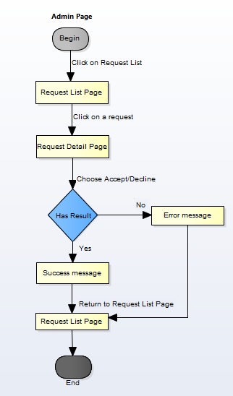

Figure 1‑1: Accept/Decline Request workflow

Brief description: Admin can use this function. Steps:

* Step 1: Admin Click on Request List.
* Step 2: System return Request list page.
* Step 3: Admin click on a Request.
* Step 4: System return Request detail page.
* Step 5: Admin click on button Accept/Decline.
* Step 6: System return success message or error message.
* Step 7: System return Request list page.

#### Ban/Unban User workflow

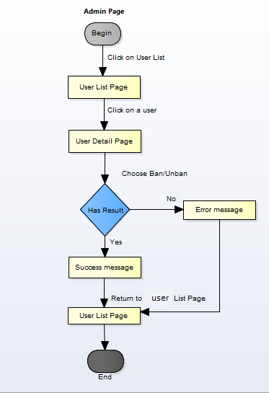

Figure 1‑2: Ban/Unban User workflow

Brief description: Admin can use this function. Steps:

* Step 1: Admin click on users list.
* Step 2: System return users list page.
* Step 3: Admin click on a user
* Step 4: System return user profile page.
* Step 5: Admin click on button Ban/Unban
* Step 6: System return success message or error message.
* Step 7: System return users list page.

#### Report a Post workflow

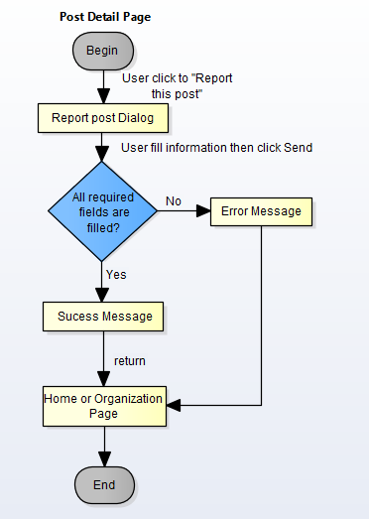

Figure 1‑3: Report a Post workflow

Brief description: Member can use this function. Steps:

* Step 1: User click to “report this post”.
* Step 2: System return “Report this post” dialog.
* Step 3: User fill information and click “Send”
* Step 4: System return success message or error message.
* Step 5: System return Home page or organization page.

#### Add slider workflow

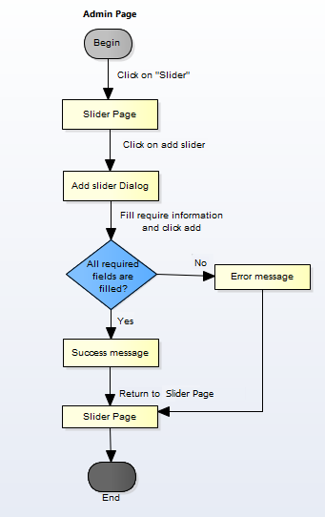

Figure 1‑4: Add slider workflow

Brief description: Admin can use this function. Steps:

* Step 1: Admin click on Slider.
* Step 2: System return slider page.
* Step 3: Admin click on button add slider.
* Step 4: System return dialog “Add Slider”.
* Step 5: Admin fill information and click “Add”
* Step 6: System return success message or error message.
* Step 7: System return slider page.

#### Send message workflow

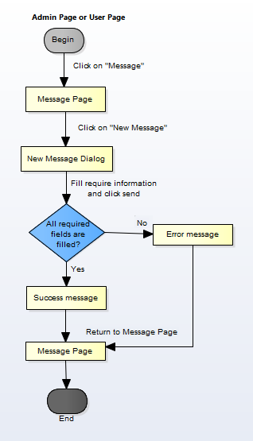

Figure 1‑5: Send message workflow

Brief description: Admin or user can use this function. Steps:

* Step 1: User click on Message.
* Step 2: System return message page.
* Step 3: User click on “new message”.
* Step 4: System return dialog “New Message”.
* Step 5: User fill information and click “Send”
* Step 6: System return success message or error message.
* Step 7: System return message page.

#### Register workflow

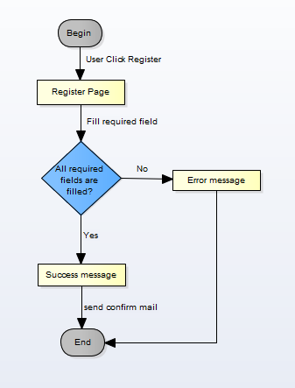

Figure 1‑6: Register workflow

Brief description: Guest can use this function. Steps:

* Step 1: User click register.
* Step 2: System return register page.
* Step 3: User fill all required fields and click Register or press Enter.
* Step 4: System return complete message.
* Step 5: System send confirm mail to user’s entered email.

#### Search workflow

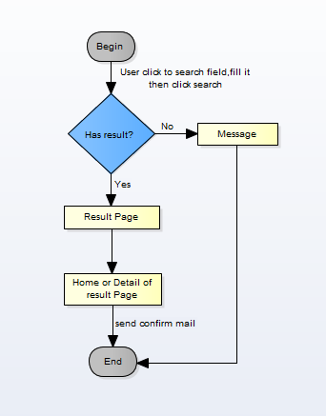

Figure 1‑7: Search workflow

Brief description: Guest and Member can use this function. Steps:

* Step 1: User input keyword into search text box and click Search or press Enter
* Step 2: System return search results or message if found nothing.
* Step 3: User can click return to Home page or click to result to Detail Page of the result.

#### Comment workflow

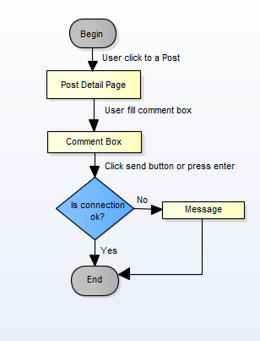

Figure 1‑8: Comment workflow

Brief description: Member can use this function. Steps:

* Step 1: User click on a post.
* Step 2: System return Post detail page.
* Step 3: User fill comment box.
* Step 4: User click send.

#### Login workflow

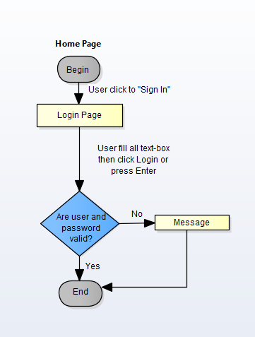

Figure 1‑9: Login workflow

Brief description: Guest can use this function. Steps:

* Step 1: At Home page click to “Sign in”.
* Step 2: System display Login Page.
* Step 3: User fill user name and password textbox then click login button.
* Step 4: System show message if login failed. System return Home page if login success

#### Create a Post workflow

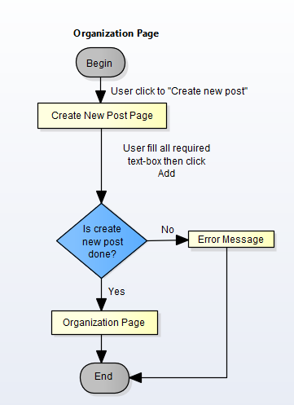

Figure 1‑10: Create a post workflow

Brief description: Member can use this function. Steps:

* Step 1: At organization user click to “Create new post”.
* Step 2: System return Create New Post page.
* Step 3: User fill all required textbox then click to “Add” button
* Step 4: System return message.
* Step 5: System return to Organization Page if success.

#### Join an organization workflow

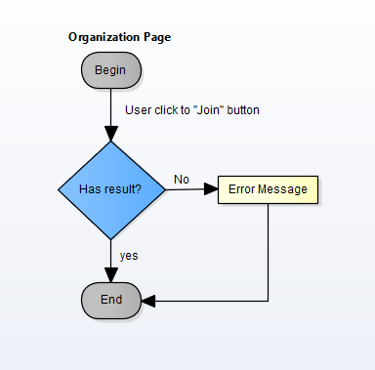

Figure 1‑11: Join an organization workflow

Brief description: Member can use this function. Steps:

* Step 1: At Organization Page click on “Join” button.
* Step 2: System return success message or error message.
* Step 3: System return Organization Page.

#### Donate workflow

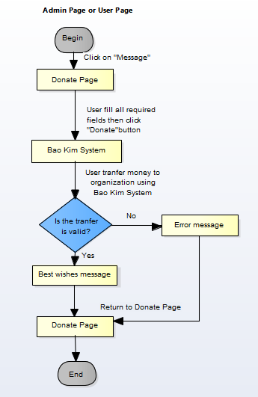

Figure 1‑12: Donate workflow

Brief description: Member can use this function. Steps:

* Step 1: At Home Page click on “Donate” button.
* Step 2: System display Donate Page.
* Step 3: User fill all required fields then click to Donate button.
* Step 4: System will automatically linked with Bao Kim
* Step 5: User transfer money to organization by using Bao Kim System.
* Step 6: System display message.
* Step 7: Return to Home Page.

### Product Features

WS is a website, user only connect to internet to use website. System provides these main functions:

#### Client features

* **Register:** User can register an account and login to use all features of WS.
* **Login/Logout**: Users login/logout an account to use or exit system WS.
* **Search**: User and guest can search with title of posts, name of organization, and system will display all of post relate to keywords.
* **Search Advanced**: Search (Event, Discussion, Organization, User) follow location.
* **Raise Request:** User can request to create an Organization. Admin can accept or refuse.
* **Post:**
  + **Create New Post:** User (ORG) can create new post with basic info, timeline, clip and some pictures.
  + **Update Post Information**: User can change and update information of post which created.
  + **Comment/Remind/Like/Share**: Users can comment/remind/like/share a post to follow and discuss with another users.
  + **Report:** User can report a post or Organization which violate regulation to administrator.
* **Donate**: User can donate money, clothes or others for Organization to charity
* **Profile:**
  + Change password: User can change password to keep security.
  + Update profile: User can change or update information.
  + Manage created posts, reminded posts: User (ORG) can follow process of post, post reminded. View statistical post had created, reminded.
  + Sent/Receive message: Users can send to or receive from other users to discuss about events or activity.

#### Admin features

* **Login/Logout**: Admin login/logout an account to use or exit system WS
* **Manage user:**
  + Search user:Admin can search with name of user and system will display simple information about that user (name, email,...)
  + Ban/Unban user: admin can set user’s account to block or unblock.
* **Manage Post:** 
  + Search post :
    - Search with post title:Admin can search with title of post and system will display all of post relate to keywords.
    - Search with name of ORG: Admin can search with name of ORG and system will display all of post relate to keywords.
  + Edit Post status: Admin can set status of a Post: Inactive/active depend on report.
* **Manage Donate:** Admin can view users who donated . Also, Admin can view amount of money, numbers of clothes.. to rank for users.
* **Manage Requests Of Users:** 
  + View/Accept/Decline: Admin can View/Accept/Decline requests : raise a ORG, report a post of users.
* **Manage Slider:** Slider list includes images what running at homepage.
  + Add new image: Admin can add new image to slider
  + Inactive/active: Admin can set image’s status to inactive or active on slider.
  + Delete image: Admin can delete image.
* **Message:** Admin can view received messages/sent messages.
  + Compose new message: Admin can compose new message to send to user.
  + Delete message: Admin can delete received messages/sent messages.

### User characteristic

WS makes connections that enable people to help themselves and each other. Website allows users (person or organizations) create charity topics or raise fund project as long as it follows our rules to help other people. Backers can also take part in a project by donating money through a single donation or supporting project as a regular donor publicly or privately, not to profit financially. Instead, project creators offer rewards to thank backers for their support. We hope our project can help as much people as we can in our country. If users want to use all function, they must be login.

There are 2 main actors that system support:

* **Member:** Have account on system, they can use all functions of website. For example: Searching, create post, donate etc…
* **Administrator:** They can use all functions of normal member and have an Administrator control panel to manage all configuration of system.

### Functional Requirements

#### Common Function

**Access right: Guest and member**

This function is used to by guest and member. Guest or Member can search for their needs, results may be organization, post, discussion or members’ name.

#### View

**Access right: Guest and member**

This function is used to view an overview of the post, event. They can read information then decided join that event, donate items… or not.

#### Create Thread

**Access right: Member**

This function is used to create new post. In this screen, users input thread title, add media, information about thread… and click on button create.

#### Create Event

**Access right: Member**

This function is used to create new event. In this screen, users input event name, add media, information about event… and click on button create.

#### Send/Receive messages

**Access right: Member and Administrator.**

This function is used to send and receive messages between users and users, users and admin. The system will display a Message Screen for users and admin to view message. In this screen, users can compose new message, search, filter and delete received messages/sent messages.

#### Management profile

**Access right: Member**

This function is used to manage profile. The system will display a Profile Screen. In this screen, users can update, modify their information such as: name, password, age, phone number and choose which information would be public; users also can view many information such as recent joined event, donated money, user class,…

#### Donate

**Access right: Member and Administrator.**

This function is used to donate money for organization. The system will display a Donate Screen that contain amount of money, information of donor, donate to which organization,…  
then click Donate button. The system will display another page that linked with Bao Kim to help user transfer money to organization through WS system.

#### Management Member’s account

**Access right: Administrator**

This function is used to manage member’s account. The system will display a Management Member Screen. In this screen, admin can view information about member, status of member (active or Inactive). When a member violates some rules of website, admin can block these member’ account temporarily, then these account cannot continue to use some functions of website. Locked account will be unlocked when lock is expired or they can send message to admin to request unban. If these’ account violate rules one more time, Admin can lock account permanently.

Warn: If member violate the rules (reported by others), admin can send message to warn this people from stopping violation and delete/modify violated post. If member still violate the rules, admin will ban them.

#### Management Post

**Access right: Member(Organization), Administrator**

This function is used to manage post. User (ORG) can follow process of post, post reminded. View statistical post had created, reminded. Admin can delete a post that violate the rules.

#### Management Overview

**Access right: Administrator**

This function is used to manage report. The system will display a Dashboard Screen to have overview all of system. In this screen, admin can view information about user and post such as the number of accessing, new users, active users, inactive users, number of post, amount of donate…

#### Management Request

**Access right: Administrator**

This function is used to manage user request. The system will display a Request screen that contains all users’ request. Admin will check that request then decide accept or decline request.

### Non-functional Requirement

The system has to satisfy these principles:

* **Learnable**: The user interface must be easy to learn, even at the first time looking at the screen, user may immediately understand the function of each button or icon.
* **Efficiency**: The user interface must minimize the number of steps that the system takes to complete its task.
* **Memorable**: System contains some complex screens. Therefore, interface should be easier to use each time the user interacts with it.
* **Visibility**: Important information (example: text in nodes) should be clearly visible.
* **Consistency**: Like items should always be displayed and act the same way through the entire application.
* **Easy to maintain and upgrade**
* **Ensure data security capabilities, high performance**
* **Scalability system**

## Software Requirement Specification

### OVERALL DESCRIPTION

#### **System overview**

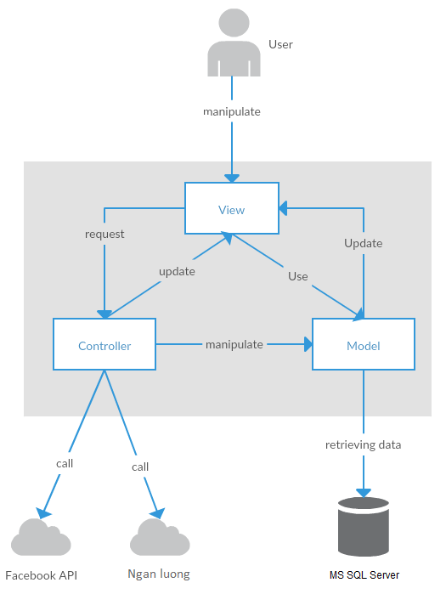

Figure 2-1: System Overview

#### **System Use Case**

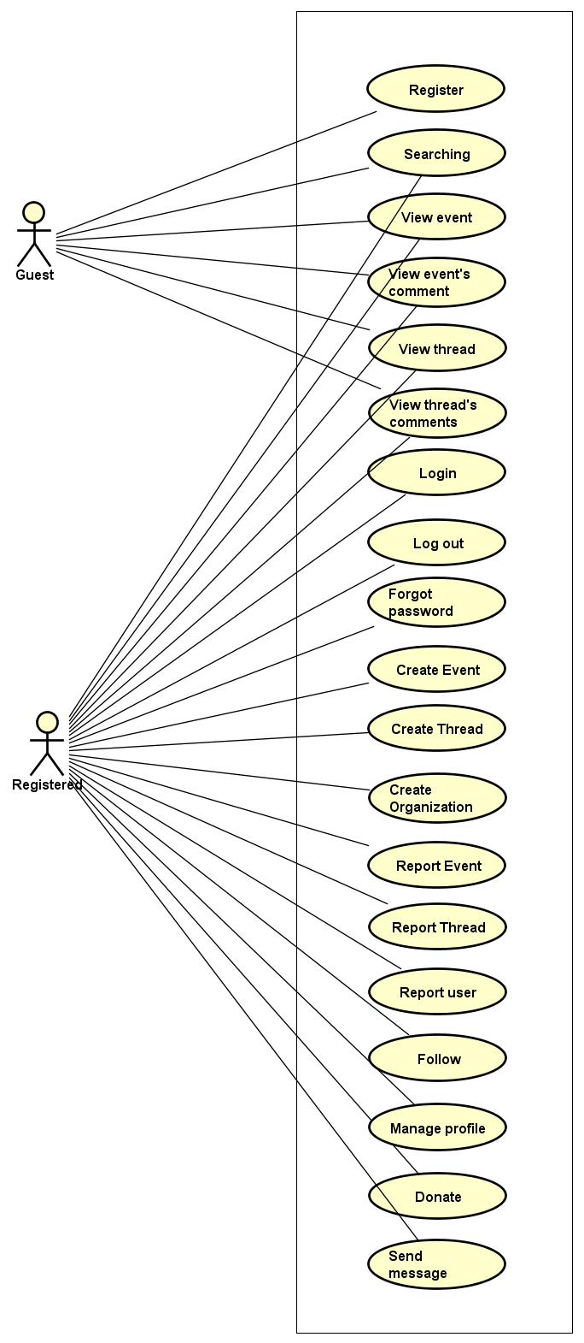

Figure 2-2: User use case diagram of WS system

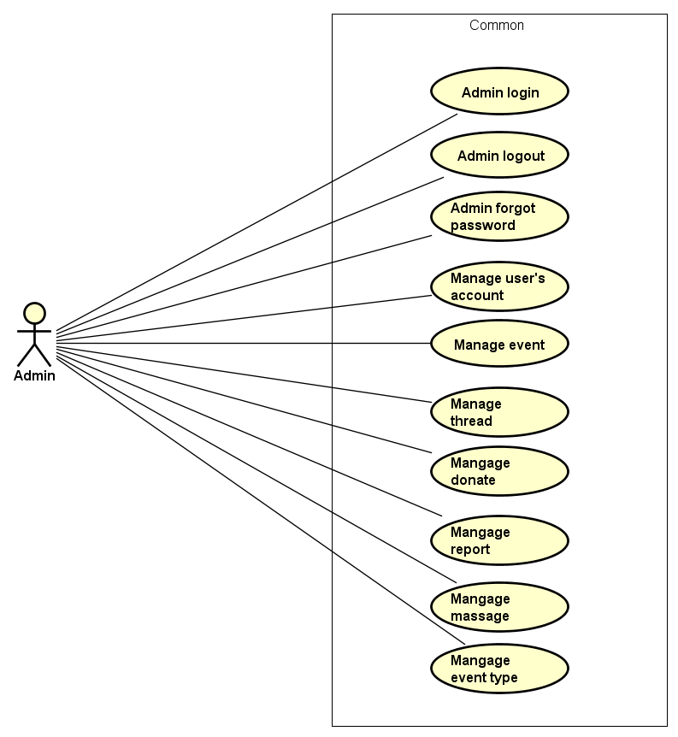

Figure 2-3: Admin use case diagram of WS system

#### **Product Features**

|  |  |  |  |
| --- | --- | --- | --- |
| UC No. | Group Of Functions | Function | Glossary |
| Guest/Registered | | | |
|  | Common | Searching (User, Event, thread or organization) |  |
|  | View event | View event |  |
|  | View event’s comments |  |
|  | View thread |  |
|  | View thread’s comments |  |
| Guest | | | |
|  | Common | Register |  |
| Registered | | | |
|  | Common | Login |  |
|  | Logout |  |
|  | Forgot password |  |
|  | Create event |  |
|  | Create thread |  |
|  | Create Organization |  |
|  | Report Event |  |
|  | Report Thread |  |
|  | Report User |  |
|  | Follow Event |  |
|  |  | Donate |  |
|  | View Personal page | View other profile |  |
|  | View profile |  |
|  | View number created thread |  |
|  | View participated event |  |
|  | View point |  |
|  | Edit profile |  |
|  | Message | Send message |  |
|  | Group message |  |
|  | Receive message |  |
|  | Comment | View list comment |  |
|  | Post comment |  |
|  | Reply comment |  |
|  | Delete comment |  |
|  | Chat room | Go to room chat |  |
|  | View all other’s message |  |
|  | Receive message |  |
|  | Send message |  |
| Administrator | | | |
|  | Common | Admin login |  |
|  | Admin logout |  |
|  | Admin forgot password |  |
|  | Manage user's account | View list user |  |
|  | View user profile |  |
|  | Activate user's account |  |
|  | Deactivate user's account |  |
|  | View user’s dashboard |  |
|  | Manage event | View event’s dashboard |  |
|  | Active event |  |
|  | De-active event |  |
|  | View event detail |  |
|  | Search event |  |
|  | Manage donate | View list backing |  |
|  | Search backing |  |
|  | View backing's information |  |
|  | Export list backings |  |
|  | Manage Thread | View list thread |  |
|  | Activate thread |  |
|  | Deactivate thread |  |
|  | Search thread |  |
|  | View thread detail |  |
|  | Manage Messages | View list messages |  |
|  | Receive message |  |
|  | Send message |  |
|  | Delete message |  |
|  | Delete message |  |
|  | Manage Organization | View list Organization |  |
|  | Activate thread |  |
|  | Deactivate thread |  |
|  | Manage Reports | View list reports |  |
|  | View report detail |  |
|  | Change report's status |  |

Table 2-2: List of use case diagram

##### User Characteristics

WS website towards to anyone wants to create an event on WingS as long as it follows our rules. Event creators set a donation goal and timeline. If have interested in event, they can donate this event by money or efforts. Donors are supporting event and help it to success and help as much people as they can, not to profit financially. Instead, WS system offer rewards to thank donors for their support by activities point. WS has three main objective users:

* **Guest:** Users did not register, they can use some function like Register, view event or thread, Search, etc...
* **Registered**: Users have account on WS, they can use almost functions of WS for user like Login, Logout, Create, Edit event, Comment, Report, etc…
* **Administrator:** They can use all functions of normal member and have an Administrator control panel to manage all information, event, user and configuration of WS.

##### User Documentation

|  |  |
| --- | --- |
| Name | Description |
| User Guide | Provide detailed explanation about the system, screens and guide users how to use all features of WS. |

Table 2-3: User Documentation

##### Assumption

* Receive the guidance and good support of teacher.
* No one of member got sick in the software development process.
* In the development process, no device got fail.
* Every report, task meets the deadline.
* Team member do not conflict in the work process.

#### **Entity Relation Model**

##### Entity-Relationship Diagram

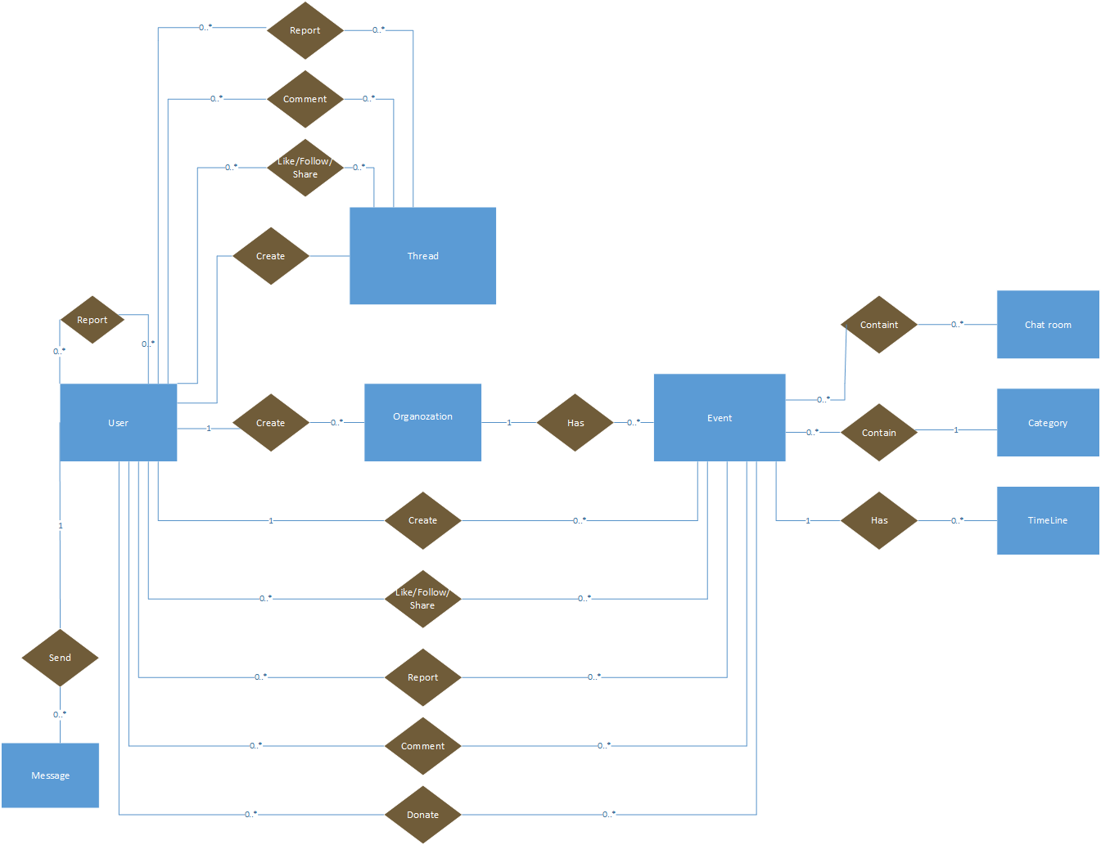

**Figure 2-3:** Entity Relationship Diagram

##### Entity Detail

###### WS_User

|  |  |  |  |  |
| --- | --- | --- | --- | --- |
| No | Attribute | Type | Mandatory | Description |
|  | UserID | Int | Y | User’s ID |
|  | UserName | String | Y | User’s name |
|  | Password | String | Y | User’s password |
|  | AccountType | String | Y | User’s type (admin or normal user) |
|  | IsActive | Bit | Y | User’s active status (inactive, active) |
|  | IsVerify | Bit | Y | User’ email verify status |
|  | CreatedDate | Date | Y | User’s created date |
|  | LastLogin | Date | Y | User’s last login |
|  | Email | String |  | User’s email |
|  | VerifyCode | String |  | User’s verify code |

Table 2-4: WS-User

###### Organization

|  |  |  |  |  |
| --- | --- | --- | --- | --- |
| No | Attribute | Type | Mandatory | Description |
|  | OrganizationID | Int | Y | Organization’s |
|  | OrganizationName | String | Y | Organization’s Name |
|  | EOrganizationName | String |  | EOrganization’s Name |
|  | Introduction | String |  | Organization’s introduction |
|  | LogoUrl | String |  | Organization’s image link |
|  | Phone | String |  | Organization’s phone |
|  | Email | String |  | Organization’s email |
|  | Address | String |  | Organization’s address |
|  | Status | Bit | Y | Is Organization expired |
|  | Point | Int | Y |  |

Table 2-5: Organization

###### Thread

|  |  |  |  |  |
| --- | --- | --- | --- | --- |
| No | Attribute | Type | Mandatory | Description |
| 1 | ThreadIdID | Int | Y | Thread’s ID |
| 2 | UserId | Int | Y | UserID who created thread |
| 3 | Title | String | Y | Thread’s title |
| 4 | Etitle | String | Y | Thread’s ETitle |
| 5 | [Content] | String | Y | Thread’s content |
| 6 | VideoUrl | String | Y | Thread’s video link |
| 7 | CreatedDate | Date | Y | Thread’s created date |
| 8 | UpdatedDate | Date | Y | Thread’s updated date |
| 9 | Status | Bit | Y | Thread’s status: active or banned |

Table 2-5: Thread

###### Event

|  |  |  |  |  |
| --- | --- | --- | --- | --- |
| No | Attribute | Type | Mandatory | Description |
| 1 | EventID | Int | Y | Event’s ID |
| 2 | CreatorID | Int | Y | UserID who created event |
| 3 | EventType | String | Y | Event’s type |
| 4 | EventName | String | Y | Event’s name |
| 5 | EEventName | String | Y | EEvent’s name |
| 6 | Created_Date | Date | Y | Event’s created date |
| 7 | Start_Date | Date | Y | Event’s start date |
| 8 | Finish_Date | Date | Y | Event’s finish date |
| 9 | UpdatedDate | Date | Y | Event’s updated date |
| 10 | Contact | String | Y | Contact of event’s creator |
| 11 | ShortDescription | String | Y | Event’s short description |
| 12 | Description | String | Y | Event’s description |
| 13 | Location | String | Y | Event’s location |
| 14 | VideoUrl | String | Y | Event’s video link |
| 15 | ExpectedMoney | Float | Y | Amount Money which event expected |
| 16 | TotalPoint | Int | Y | Total point of event |
| 17 | Status | Bit | Y | Event’s status |

Table 2-5: Event

###### Event Type

|  |  |  |  |  |
| --- | --- | --- | --- | --- |
| No | Attribute | Type | Mandatory | Description |
| 1. 1 | EventTypeID | Int | Y | Event type’s ID |
| 1. 2 | EventName | String | Y | Event type’s name |
|  | [Content] | String | Y | Event type’s description |

Table 2-6: Event type

###### Event Timeline

|  |  |  |  |  |
| --- | --- | --- | --- | --- |
| No | Attribute | Type | Mandatory | Description |
| 1. 1 | TimelineID | Int | Y | Timeline’s ID |
| 1. 2 | EventId | Int | Y | Event’s id |
| 1. 3 | [Content] | String | Y | Timeline’s contents |
|  | FromDate | Date | Y | Timeline’s start date |
|  | ToDate | Date | Y | Timeline’s end date |
|  | Status | Bit | Y | Timeline’s status |

Table 2-8: Event Timeline

###### Event chat room

|  |  |  |  |  |
| --- | --- | --- | --- | --- |
| No | Attribute | Type | Mandatory | Description |
|  | PublicRoomId | Int | Y | Conversation’s ID |
|  | ConnectionId | Int | Y | Conversation’s creator id |
|  | EventId | Int | Y | Conversation’s receiver |

Table 2-13: Event chat room

###### Message table

|  |  |  |  |  |
| --- | --- | --- | --- | --- |
| No | Attribute | Type | Mandatory | Description |
| 1. 1 | MessageID | Int | Y | Message’s ID |
| 1. 2 | ConversationID | Int | Y | Message’s conversation id |
| 1. 3 | UserID | Int | Y | Message’s user id |
|  | CreatedDate | Date | Y | Message’s sent time |
|  | Content | String | Y | Message’s content |
|  | Status | Bit | Y | Message’s status |

Table 2-11: Message table

### FUNCTIONAL SPECIFICATION

#### Business Rules

|  |  |
| --- | --- |
| **No** | **Description** |
|  | Search textbox cannot be empty |
|  | Content is unlimited characters |
|  | Chat box cannot be empty |
|  | Subject is limited to 1000 characters |
|  | Name cannot be empty |
|  | If user accesses to nonexistent page, WS displays error message “Error” |
|  | Email must content characters ‘@’ and ‘.’ |
|  | Date of birth must be chosen |
|  | Displayed date is mm/dd/yyyy format |
|  | Date time input format is datetime |
|  | Number is rounded to 2 decimal number |
|  | Unit of money is VND |
|  | Displayed money is rounded to 2 decimal number |
|  | Allowed file extension: .jpg, .png, .bmp |
|  | File size is limited to 100 MB |
|  | Message displayed like a Gmail format |
|  | Rank is calculated depending on point which gain from donating event or creating thread |

Table 2-13: Business rules

#### Use Cases

##### Guest/ Registered Group Function

###### Common Module

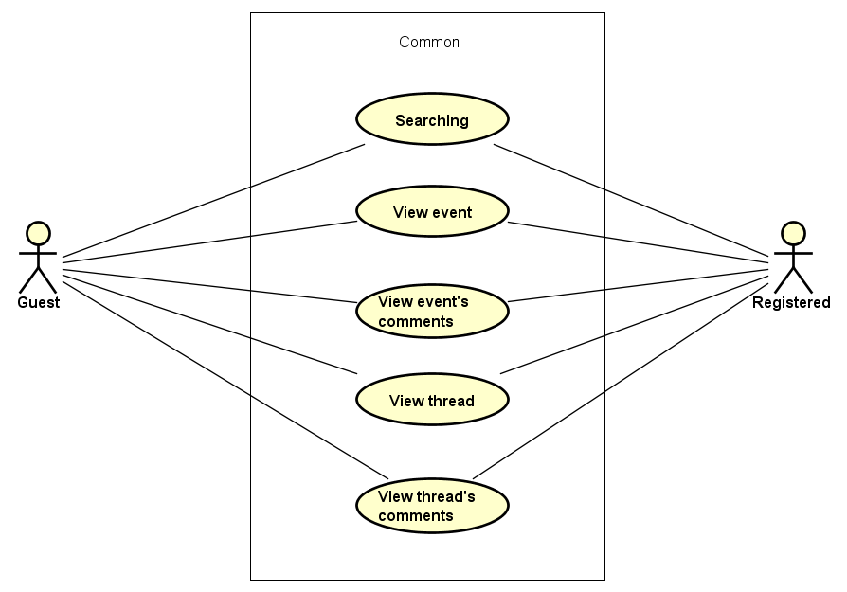

Figure 3-1: Common module use case

UC001-Searching

|  |  |  |  |  |
| --- | --- | --- | --- | --- |
| **Use Case ID** | | UC001 | **Version** | 1.0 |
| **Use Case Name** | | Search event | | |
| **Created by:** | | DuyTN | **Date Created:** | 05/11/2016 |
| **Primary Actor** | | Registered user  Guest | **Secondary Actor** |  |
| **Priority** | | High | | |
| **Frequency of Use:** | | High | | |
| **Description:** | | This function allows user to search existing information about Search existing information about User, Account, Event, Thread or  Organization | | |
| **Preconditions:** | | 1. WS website is available 2. User browsed WS website | | |
| **Trigger:** | | User enters search phrase, choose the search type (User, Account, Event, Thread or  Organization) and click Search or press Enter | | |
| **Post conditions:** | | List all results that matched with the keyword user enters will be displayed bellow Search screen | | |
| **Normal Flow** | | | | |
| **Step** | **Actor** | **Action** | | |
| 1 | User | Enter search phrase to text box | | |
| 2 | User | Choose one of bellow search type (User, Account, Event, Thread or  Organization) | | |
| 3 | User | Click Search icon or press Enter | | |
| 4 | WS | List all results that matched with the keyword user entered in. | | |
| **Alternative Flows:** | | | | |
| **Exceptions: N/A** | | | | |
| **Business Rules:** | | B1 | | |
| **Other Information:** | | N/A | | |

Table 2- 15: Searching Use case

UC002-View event

|  |  |  |  |  |
| --- | --- | --- | --- | --- |
| **Use Case ID** | | UC002 | **Version** | 1.0 |
| **Use Case Name** | | View event | | |
| **Created by:** | | DuyTN | **Date Created:** | 05/11/2016 |
| **Primary Actor** | | Registered user  Guest | **Secondary Actor** |  |
| **Priority** | | High | | |
| **Frequency of Use:** | | High | | |
| **Description:** | | This function allows user to show all existing events and event detail stored on WS | | |
| **Preconditions:** | | 1. WS website is available 2. User browsed WS website | | |
| **Trigger:** | | User click “Event” | | |
| **Post conditions:** | | Event information will be displayed in the Event detail screen | | |
| **Normal Flow** | | | | |
| **Step** | **Actor** | **Action** | | |
| 1 | User | Click Event | | |
| 2 | WS | List all existing event | | |
| 3 | User | Click on one event | | |
| 4 | WS | Redirect to event detail page | | |
| **Alternative Flows:** | | | | |
| **AT1** | At step 3 in the main flows, if user click other hyperlinks or buttons | | | |
| **Step** | **Actor** | **Action** | | |
| 1.0 | WS | Redirects user to chosen hyperlink or button | | |
|  | | | | |
| **Exceptions: N/A** | | | | |
| **Business Rules:** | | N/A | | |
| **Other Information:** | | N/A | | |

Table 2- 14: View event Use case

UC003-View event’s comment

|  |  |  |  |  |
| --- | --- | --- | --- | --- |
| **Use Case ID** | | UC003 | **Version** | 1.0 |
| **Use Case Name** | | View event’s comment | | |
| **Created by:** | | DuyTN | **Date Created:** | 05/11/2016 |
| **Primary Actor** | | Registered user  Guest | **Secondary Actor** |  |
| **Priority** | | High | | |
| **Frequency of Use:** | | High | | |
| **Description:** | | This function allows user to show all comment stored in a event | | |
| **Preconditions:** | | 1. WS website is available 2. User browsed WS website | | |
| **Trigger:** | | User click “Event” | | |
| **Post conditions:** | | List all Event’s comment will be displayed in the Event detail screen | | |
| **Normal Flow** | | | | |
| **Step** | **Actor** | **Action** | | |
| 1 | User | Click Event | | |
| 2 | WS | List all existing event | | |
| 3 | User | Click on 1 event and scroll down | | |
| 4 | WS | Display all comment in event | | |
| **Alternative Flows:** | | | | |
| **AT1** | At step 1 in the main flows, if user click other hyperlinks or buttons | | | |
| **Step** | **Actor** | **Action** | | |
| 1.0 | WS | Redirects user to chosen hyperlink or button | | |
|  | | | | |
| **Exceptions: N/A** | | | | |
| **Business Rules:** | | N/A | | |
| **Other Information:** | | N/A | | |

Table 2- 14: View comment in Event Use case

UC004-View thread

|  |  |  |  |  |
| --- | --- | --- | --- | --- |
| **Use Case ID** | | UC004 | **Version** | 1.0 |
| **Use Case Name** | | View thread | | |
| **Created by:** | | DuyTN | **Date Created:** | 05/11/2016 |
| **Primary Actor** | | Registered user  Guest | **Secondary Actor** |  |
| **Priority** | | High | | |
| **Frequency of Use:** | | High | | |
| **Description:** | | This function allows user to show all existing event stored on WS | | |
| **Preconditions:** | | 1. WS website is available 2. User browser WS is available | | |
| **Trigger:** | | User click “Thread” | | |
| **Post conditions:** | | Thread information will be displayed in the Thread detail screen | | |
| **Normal Flow** | | | | |
| **Step** | **Actor** | **Action** | | |
| 1 | User | Click Thread | | |
| 2 | WS | List all existing Thread | | |
| 3 | User | Click on one thread in the list | | |
| 4 | WS | Redirect and Display information of thread in thread detail page | | |
| **Alternative Flows:** | | | | |
| **AT1** | At step 1 in the main flows, if user click other hyperlinks or buttons | | | |
| **Step** | **Actor** | **Action** | | |
| 1.0 | WS | Redirects user to chosen hyperlink or button | | |
| **Exceptions: N/A** | | | | |
| **Business Rules:** | | N/A | | |
| **Other Information:** | | N/A | | |

Table 2- 14: View thread Use case

UC005-View thread’s comment

|  |  |  |  |  |
| --- | --- | --- | --- | --- |
| **Use Case ID** | | UC005 | **Version** | 1.0 |
| **Use Case Name** | | View event’s comment | | |
| **Created by:** | | DuyTN | **Date Created:** | 05/11/2016 |
| **Primary Actor** | | Registered user  Guest | **Secondary Actor** |  |
| **Priority** | | High | | |
| **Frequency of Use:** | | High | | |
| **Description:** | | This function allows user to show all comment stored in event | | |
| **Preconditions:** | | 1. WS website is available 2. User browsed WS website | | |
| **Trigger:** | | User click “Thread” | | |
| **Post conditions:** | | List all Thread’s comment will be displayed in the Thread detail screen | | |
| **Normal Flow** | | | | |
| **Step** | **Actor** | **Action** | | |
| 1 | User | Click Thread | | |
| 2 | WS | List all existing thread | | |
| 3 | User | Click on 1 thread and scroll down | | |
| 4 | WS | Display all comment in thread | | |
| **Alternative Flows:** | | | | |
| **AT1** | At step 1 in the main flows, if user click other hyperlinks or buttons | | | |
| **Step** | **Actor** | **Action** | | |
| 1.0 | WS | Redirects user to chosen hyperlink or button | | |
|  | | | | |
| **Exceptions: N/A** | | | | |
| **Business Rules:** | | N/A | | |
| **Other Information:** | | N/A | | |

Table 2- 14: View comment in thread Use case

##### Guest Group Function

###### Common Module

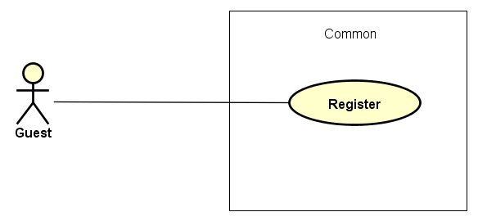

Figure 3-2: Guest common use case

UC006-Register

|  |  |  |  |  |  |
| --- | --- | --- | --- | --- | --- |
| **Use Case ID** | | | UC006 | **Version** | 1.0 |
| **Use Case Name** | | | Register | | |
| **Created by:** | | | DuyTN | **Date Created:** | 05/11/2016 |
| **Primary Actor** | | | Guest | **Secondary Actor** |  |
| **Priority** | | | High | | |
| **Frequency of Use:** | | | High | | |
| **Description:** | | | Visitor can create new account to use more function as a register user | | |
| **Preconditions:** | | | 1. WS must be connected to the Internet 2. User browsed WS website | | |
| **Trigger:** | | | Click on register link on the website | | |
| **Post conditions:** | | | 1. Add account information to database 2. Send confirm email 3. Save user information into system 4. Redirect user to confirm validate code page 5. Display login screen | | |
| **Normal Flow** | | | | | |
| **Step** | **Actor** | | **Action** | | |
|  | User | | Click Register in header | | |
|  | WS | | Display Register page includes:   * Header * User name text box * Password text box * Confirm password text box * Email text box * Register button * Cancel button | | |
|  | User | | Enters data in fields | | |
|  | User | | Click Register | | |
|  | WS | | Send confirm validate code email | | |
|  | WS | | Logs user into system | | |
|  | WS | | Display validate code page | | |
|  | WS | | Display login page | | |
| **Alternative Flows** | | | | | |
| **AT1** | At step 4, user click Cancel | | | | |
| **Step** | **Actor** | | **Action** | | |
| 4.1 | WS | | Redirects user to previous page | | |
|  | | | | | |
| **AT2** | At step 4 in the main flows, if user click other hyperlinks or buttons | | | | |
| **Step** | **Actor** | **Action** | | | |
| 4.1 | WS | Redirects user to chosen hyperlink or button | | | |
|  | | | | | |
| **Exceptions:** | | | | | |
| **EC1** | At step 4, required fields are not entered | | | | |
| **Step** | **Actor** | | **Action** | | |
| 4.1 | WS | | Display Register page with message: with ID MSG5 | | |
| 4.2 | WS | | Mark error fields | | |
|  | | | | | |
| **EC2** | At step 4, fields are entered with wrong type of data | | | | |
| **Step** | **Actor** | | **Action** | | |
| 4.1 | WS | | Display Register page with message: with ID MSG6 | | |
| 4.2 | WS | | Mark error fields | | |
| **Business Rules:** | | |  | | |
| **Other Information:** | | | N/A | | |

Table 2- 30: Register Use case

##### Registered Group Function

###### Common module

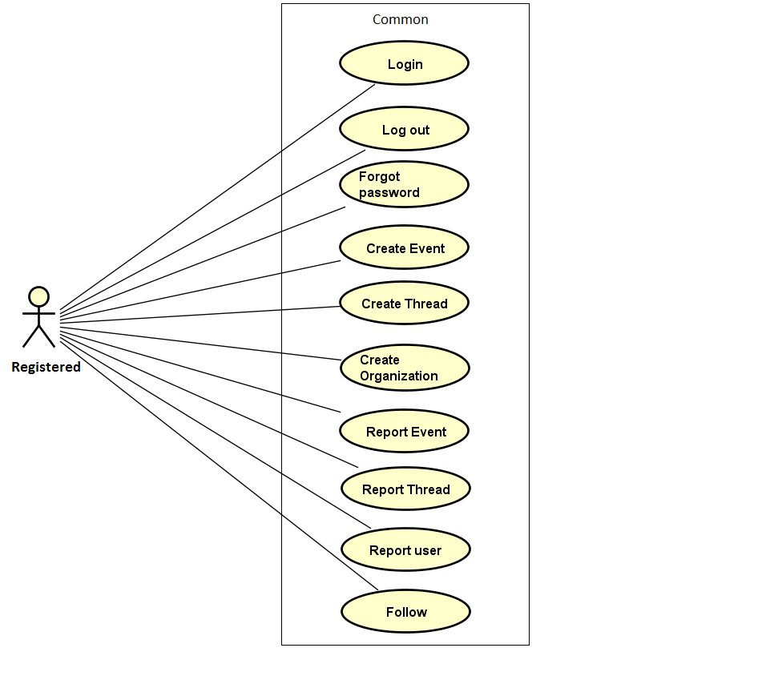

Figure 3-3: Registered common use case

UC007- Login

|  |  |  |  |  |
| --- | --- | --- | --- | --- |
| **Use Case ID** | | UC007 | **Version** | 1.0 |
| **Use Case Name** | | Login by social network’s account  Login by registered account | | |
| **Created by:** | | DuyTN | **Date Created:** | 05/11/2016 |
| **Primary Actor** | | Registered User | **Secondary Actor** |  |
| **Priority** | | High | | |
| **Frequency of Use:** | | High | | |
| **Description:** | | When User want to login by Facebook/Register account to use more functions in website | | |
| **Preconditions:** | | 1. WS must be connected to the Internet 2. User browsed WS website 3. Account Facebook/Register must be exist and correctly 4. User is viewing Login page | | |
| **Trigger:** | | User enter wings.com | | |
| **Post conditions:** | | 1. Log user into system 2. Redirect user to previous page and display as Member | | |
| **Normal Flow** | | | | |
| **Step** | **Actor** | **Action** | | |
|  | User | Click Login in Homepage | | |
|  | WS | Redirect to Login page includes:   * User name text box * Password text box * Login button * Cancel button * Facebook button * Forgot password hyperlink * Remember me check box | | |
|  | User | Enters User name and Password | | |
|  | User | Click Login | | |
|  | WS | Logs user into system | | |
|  | WS | Redirect to Homepage | | |
|  | WS | Display previous page as Member | | |
| **Alternative Flows** | | | | |
| **AT1** | At step 3 in the main flows, if user click Facebook button | | | |
| **Step** | **Actor** | **Action** | | |
| 3.1 | WS | Redirects user to confirm site | | |
| 3.2 | WS | Logs user into system with Facebook account | | |
|  | | | | |
| **AT2** | At step 4, user choose Cancel: | | | |
| **Step** | **Actor** | **Action** | | |
| 4.1 | WS | Closes popup. | | |
|  | | | | |
| **AT3** | At step 8 in the main flows, if user click other hyperlinks or buttons | | | |
| **Step** | **Actor** | **Action** | | |
| 8.1 | WS | Redirects user to chosen hyperlink or button | | |
|  | | | | |
| **Exceptions:** | | | | |
| **EC1** | At step 4 in main flow, if user entered wrong User name or Password | | | |
| **Step** | **Actor** | **Action** | | |
| 3.1 | WS | Display Login popup message with ID MSG14 | | |
| 3.2 | WS | Mark error fields | | |
| **Business Rules:** | | N/A | | |
| **Other Information:** | | N/A | | |

Table 2- 31: Login Use case

UC008- Logout

|  |  |  |  |  |
| --- | --- | --- | --- | --- |
| **Use Case ID** | | UC008 | **Version** | 1.0 |
| **Use Case Name** | | Logout | | |
| **Created by:** | | DuyTN | **Date Created:** | 05/11/2016 |
| **Primary Actor** | | User | **Secondary Actor** |  |
| **Priority** | | High | | |
| **Frequency of Use:** | | High | | |
| **Description:** | | When User want to logout their account | | |
| **Preconditions:** | | 1. WS must be connected to the Internet 2. User browsed WS website 3. User logged in to system | | |
| **Trigger:** | | User click Logout in user menu | | |
| **Post conditions:** | | 1. Log user out from system. 2. Redirect user to guest homepage view | | |
| **Normal Flow** | | | | |
| **Step** | **Actor** | **Action** | | |
| 1 | User | Click Logout | | |
| 2 | WS | Display page as Guest | | |
| **Alternative Flows: N/A** | | | | |
| **Exceptions: N/A** | | | | |
| **Business Rules:** | | N/A | | |
| **Other Information:** | | N/A | | |

Table 2- 32: Logout Use case

UC009- Forgot password

|  |  |  |  |  |
| --- | --- | --- | --- | --- |
| **Use Case ID** | | UC009 | **Version** | 1.0 |
| **Use Case Name** | | Forgot password | | |
| **Created by:** | | DuyTN | **Date Created:** | 05/11/2016 |
| **Primary Actor** | | User | **Secondary Actor** |  |
| **Priority** | | Normal | | |
| **Frequency of Use:** | | Normal | | |
| **Description:** | | When Member forgot their password to login the system, this function will receiving their password to email | | |
| **Preconditions:** | | 1. WS must be connected to the Internet 2. User browsed WS website 3. User logged in to system | | |
| **Trigger:** | | Click Forgot password in Login popup | | |
| **Post conditions:** | | 1. Send confirm email | | |
| **Normal Flow** | | | | |
| **Step** | **Actor** | **Action** | | |
|  | User | Click Forgot password in Login page | | |
|  | WS | Display Email text box | | |
|  | User | Enter registered email | | |
|  | User | Click Get password | | |
|  | WS | Sends confirm email | | |
|  | WS | Display message: | | |
| **Alternative Flows** | | | | |
| **AT2** | At step 3 in the main flow, user clicks on Cancel button | | | |
| **Step** | **Actor** | **Action** | | |
| 3.1 | WS | Return to previous screen | | |
|  | | | | |
| **AT2** | At step 4 in the main flows, if user click other hyperlinks or buttons | | | |
| **Step** | **Actor** | **Action** | | |
| 4.1 | WS | Redirects user to chosen hyperlink or button | | |
|  | | | | |
| **Exceptions:** | | | | |
| **EC1** | At step 4, entered email is invalid | | | |
| **Step** | **Actor** | **Action** | | |
| 4.1 | WS | Displays Login popup with message: with ID MSG15 | | |
| 4.2 | WS | Marks email text box | | |
| **Business Rules:** | | N/A | | |
| **Other Information:** | | N/A | | |

Table 2- 33: Forgot password Use case

UC010-Create Event

|  |  |  |  |  |
| --- | --- | --- | --- | --- |
| **Use Case ID** | | UC010 | **Version** | 1.0 |
| **Use Case Name** | | Create event | | |
| **Created by:** | | DuyTN | **Date Created:** | 05/11/2016 |
| **Primary Actor** | | Registered user | **Secondary Actor** |  |
| **Priority** | | High | | |
| **Frequency of Use:** | | High | | |
| **Description:** | | This function allows user to create an event | | |
| **Preconditions:** | | 1. WS website is available  2. User browsed WS website  3. User logged in to system  4. User has their own organization  5. User is on homepage or event page | | |
| **Trigger:** | | User click on button “Create Even” | | |
| **Post conditions:** | | Create an event page is displayed | | |
| **Normal Flow** | | | | |
| **Step** | **Actor** | **Action** | | |
| 1 | User | Click create event | | |
| 2 | WS | Show create event page | | |
| 3 | User | Fill all information about event | | |
| 4 | WS | Create button enable | | |
| 5 | User | Click on Create Event | | |
| 6 | WS | Event created and waiting for administrator accept. | | |
| **Alternative Flows: N/A** | | | | |
| **Exceptions:** | | | | |
| **EC1** | At step 3 in the main flows, if user don’t fill all information of event | | | |
| **Step** | **Actor** | **Action** | | |
| 3.1 | WS | Warning label display to remind user | | |
| **Business Rules:** | | N/A | | |
| **Other Information:** | | N/A | | |

Table 2- 34: Create event Use case

UC011- Create Thread

|  |  |  |  |  |
| --- | --- | --- | --- | --- |
| **Use Case ID** | | UC011 | **Version** | 1.0 |
| **Use Case Name** | | Share event | | |
| **Created by:** | | DuyTN | **Date Created:** | 05/11/2016 |
| **Primary Actor** | | Registered user | **Secondary Actor** |  |
| **Priority** | | High | | |
| **Frequency of Use:** | | High | | |
| **Description:** | | This function allows user to create a thread to discussion | | |
| **Preconditions:** | | 1.WS website is available  2.User browsed WS website  3.User logged in to system  4.User is on homepage or thread page | | |
| **Trigger:** | | User click on create thread button | | |
| **Post conditions:** | | Create an thread page is displayed | | |
| **Normal Flow** | | | | |
| **Step** | **Actor** | **Action** | | |
| 1 | User | Click create thread | | |
| 2 | WS | Show create thread page | | |
| 3 | User | Fill all information about thread | | |
| 4 | WS | Create button enable | | |
| 5 | User | Click on Create Thread | | |
| 6 | WS | Thread created has been created | | |
| **Alternative Flows: N/A** | | | | |
| **EC1** | At step 3 in the main flows, if user don’t fill all information of thread | | | |
| **Step** | **Actor** | **Action** | | |
| 3.1 | WS | Warning label display to remind user | | |
| **Exceptions: N/A** | | | | |
| **Business Rules:** | |  | | |
| **Other Information:** | | N/A | | |

Table 2- 35: Create Thread Use case

UC012- Create Organization

|  |  |  |  |  |
| --- | --- | --- | --- | --- |
| **Use Case ID** | | UC012 | **Version** | 1.0 |
| **Use Case Name** | | Star event | | |
| **Created by:** | | DuyTN | **Date Created:** | 05/11/2016 |
| **Primary Actor** | | Registered user | **Secondary Actor** |  |
| **Priority** | | High | | |
| **Frequency of Use:** | | High | | |
| **Description:** | | This function allows user to create an organization | | |
| **Preconditions:** | | 1.WS website is available  2.User browsed WS website  3.User logged in to system  4.User is on organization page | | |
| **Trigger:** | | User click on Create Organization button | | |
| **Post conditions:** | | Organization page is displayed | | |
| **Normal Flow** | | | | |
| **Step** | **Actor** | **Action** | | |
| 1 | User | Click create organization | | |
| 2 | WS | Show create thread page | | |
| 3 | User | Fill all information about thread | | |
| 4 | WS | Create button enable | | |
| 5 | User | Click on Create Thread | | |
| 6 | WS | Thread created has been created | | |
| **Alternative Flows: N/A** | | | | |
| **EC1** | At step 3 in the main flows, if user don’t fill all information of organization | | | |
| **Step** | **Actor** | **Action** | | |
| 3.1 | WS | Warning label display to remind user | | |
|  | | | | |
| **Exceptions: N/A** | | | | |
| **Business Rules:** | | N/A | | |
| **Other Information:** | | N/A | | |

Table 2- 36: Create Organization Use case

UC013- Report event

|  |  |  |  |  |
| --- | --- | --- | --- | --- |
| **Use Case ID** | | UC013 | **Version** | 1.0 |
| **Use Case Name** | | Report event | | |
| **Created by:** | | DuyTN | **Date Created:** | 05/11/2016 |
| **Primary Actor** | | Registered user | **Secondary Actor** |  |
| **Priority** | | Normal | | |
| **Frequency of Use:** | | High | | |
| **Description:** | | This function allows user to report an event | | |
| **Preconditions:** | | 1.WS website is available  2.User browsed WS website  3.User logged in to system  4.User is on event detail page | | |
| **Trigger:** | | User click on button report | | |
| **Post conditions:** | | Event detail page is displayed | | |
| **Normal Flow** | | | | |
| **Step** | **Actor** | **Action** | | |
| 1 | WS | Display all information of event | | |
| 2 | User | Click Report Button | | |
| 3 | WS | Show confirm dialog with question ask about reason | | |
| 4 | User | Fill reason then click send report | | |
| 5 | WS | Send report | | |
| **Alternative Flows: N/A** | | | | |
| **Exceptions: N/A** | | | | |
| **Business Rules:** | |  | | |
| **Other Information:** | | N/A | | |

Table 2- 37: Report Event Use case

UC014- Report thread

|  |  |  |  |  |
| --- | --- | --- | --- | --- |
| **Use Case ID** | | UC014 | **Version** | 1.0 |
| **Use Case Name** | | Report thread | | |
| **Created by:** | | DuyTN | **Date Created:** | 05/11/2016 |
| **Primary Actor** | | Registered user | **Secondary Actor** |  |
| **Priority** | | High | | |
| **Frequency of Use:** | | High | | |
| **Description:** | | This function allows user to report a thread | | |
| **Preconditions:** | | 1.WS website is available  2.User browsed WS website  3.User logged in to system  4.User is on thread detail page | | |
| **Trigger:** | | User click on button report | | |
| **Post conditions:** | | Thread detail page is displayed | | |
| **Normal Flow** | | | | |
| **Step** | **Actor** | **Action** | | |
| 1 | WS | Display all information of event | | |
| 2 | User | Click Report | | |
| 3 | WS | Show confirm dialog with question ask about reason | | |
| 4 | User | Fill reason then confirm | | |
| 5 | WS | Send report | | |
| **Alternative Flows: N/A** | | | | |
| **Exceptions: N/A** | | | | |
| **Business Rules:** | | N/A | | |
| **Other Information:** | | N/A | | |

Table 2- 37: Report thread Use case

UC015- Report user

|  |  |  |  |  |
| --- | --- | --- | --- | --- |
| **Use Case ID** | | UC015 | **Version** | 1.0 |
| **Use Case Name** | | Report user | | |
| **Created by:** | | DuyTN | **Date Created:** | 05/11/2016 |
| **Primary Actor** | | Registered user | **Secondary Actor** |  |
| **Priority** | | Normal | | |
| **Frequency of Use:** | | High | | |
| **Description:** | | This function allows user to report an user | | |
| **Preconditions:** | | 1.WS website is available  2.User browsed WS website  3.User logged in to system  4.User is on User profife page | | |
| **Trigger:** | | User click on button report | | |
| **Post conditions:** | | User profile page is displayed | | |
| **Normal Flow** | | | | |
| **Step** | **Actor** | **Action** | | |
| 1 | WS | Display all information of user | | |
| 2 | User | Click Report | | |
| 3 | WS | Show confirm dialog with question ask about reason | | |
| 4 | User | Fill reason then confirm | | |
| 5 | WS | Send report | | |
| **Alternative Flows: N/A** | | | | |
| **Exceptions: N/A** | | | | |
| **Business Rules:** | |  | | |
| **Other Information:** | | N/A | | |

Table 2- 37: Report user Use case

###### Manage Personal Information page

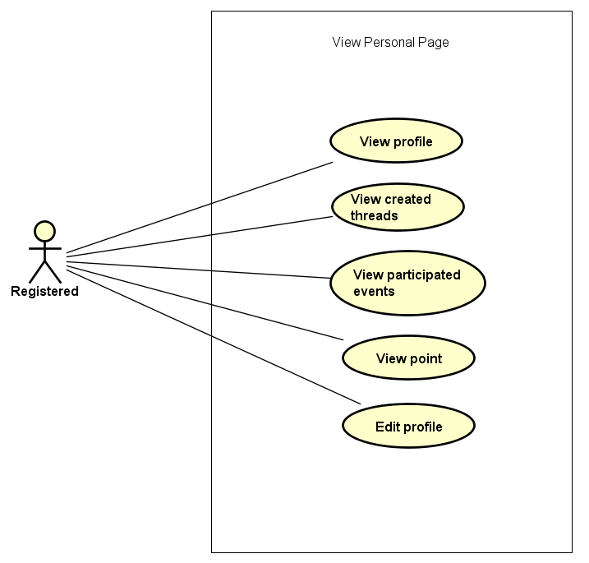

Figure 3-4: Manage Personal Information use case

UC016- View profile

|  |  |  |  |  |
| --- | --- | --- | --- | --- |
| **Use Case ID** | | UC016 | **Version** | 1.0 |
| **Use Case Name** | | Display user profile | | |
| **Created by:** | | DuyTN | **Date Created:** | 05/11/2016 |
| **Primary Actor** | | Registered user | **Secondary Actor** |  |
| **Priority** | | High | | |
| **Frequency of Use:** | | High | | |
| **Description:** | | WS display the information of user on user profile page | | |
| **Preconditions:** | | 1. WS website is available  2.User browsed WS website  3. User logged in to system | | |
| **Trigger:** | | User move on Avatar image icon | | |
| **Post conditions:** | | The user profile is displayed | | |
| **Normal Flow** | | | | |
| **Step** | **Actor** | **Action** | | |
| 1 | User | Click Avatar image button in header | | |
| 2 | WS | Display a menu includes:   * Message * Notification * Profile * Organization * Logout | | |
| 3 | User | Click View Profile | | |
| 4 | WS | Redirect user to Profile page includes:   * Header * User information tab * Donation tab * Thread tab * Change password tab | | |
| **Alternative Flows: N/A** | | | | |
| **Exceptions: N/A** | | | | |
| **Business Rules:** | | N/A | | |
| **Other Information:** | | N/A | | |

Table 2- 24: View profile Use case

UC017- View created thread

|  |  |  |  |  |
| --- | --- | --- | --- | --- |
| **Use Case ID** | | UC017 | **Version** | 1.0 |
| **Use Case Name** | | Display created event | | |
| **Created by:** | | DuyTN | **Date Created:** | 05/11/2016 |
| **Primary Actor** | | Registered user | **Secondary Actor** |  |
| **Priority** | | High | | |
| **Frequency of Use:** | | High | | |
| **Description:** | | WS records all thread which user created | | |
| **Preconditions:** | | 1. WS website is available  2.User browsed WS website  3. User logged in to system | | |
| **Trigger:** | | User move on Avatar image icon | | |
| **Post conditions:** | | All created thread is displayed | | |
| **Normal Flow** | | | | |
| **Step** | **Actor** | **Action** | | |
| 1 | User | Click Avatar image button in header | | |
| 2 | WS | Display a menu includes:   * Message * Notification * Profile * Organization * Logout | | |
| 3 | User | Click Profile | | |
| 4 | WS | Redirect user to Profile page includes:   * Header * User information tab * Donation tab * Thread tab * Change password tab | | |
| 5 | User | Click Created Thread tab | | |
| 6 | WS | Display all thread created | | |
| **Alternative Flows: N/A** | | | | |
| **Exceptions: N/A** | | | | |
| **Business Rules:** | | N/A | | |
| **Other Information:** | | N/A | | |

Table 2- 25: View Created thread Use case

UC018- View donated event

|  |  |  |  |  |
| --- | --- | --- | --- | --- |
| **Use Case ID** | | UC018 | **Version** | 1.0 |
| **Use Case Name** | | Display donated event | | |
| **Created by:** | | DuyTN | **Date Created:** | 05/11/2016 |
| **Primary Actor** | | Registered user | **Secondary Actor** |  |
| **Priority** | | High | | |
| **Frequency of Use:** | | High | | |
| **Description:** | | WS records all event which user donated | | |
| **Preconditions:** | | 1. WS website is available  2.User browsed WS website  3. User logged in to system | | |
| **Trigger:** | | User move on Avatar image icon | | |
| **Post conditions:** | | All donated event are displayed | | |
| **Normal Flow** | | | | |
| **Step** | **Actor** | **Action** | | |
| 1 | User | Click Avatar image button in header | | |
| 2 | WS | Display a menu includes:   * Message * Notification * Profile * Organization * Logout | | |
| 3 | User | Click Profile | | |
| 4 | WS | Redirect user to Profile page includes:   * Header * User information tab * Donation tab * Thread tab * Change password tab | | |
| 5 | User | Click on donated event tab | | |
| 6 | WS | Display all donated event | | |
| **Alternative Flows: N/A** | | | | |
| **Exceptions: N/A** | | | | |
| **Business Rules:** | | N/A | | |
| **Other Information:** | | N/A | | |

Table 2- 26: View craeted event Use case

UC019- View point

|  |  |  |  |  |
| --- | --- | --- | --- | --- |
| **Use Case ID** | | UC019 | **Version** | 1.0 |
| **Use Case Name** | | Display user activity point | | |
| **Created by:** | | DuyTN | **Date Created:** | 05/11/2016 |
| **Primary Actor** | | Registered user | **Secondary Actor** |  |
| **Priority** | | Normal | | |
| **Frequency of Use:** | | High | | |
| **Description:** | | WS record every user activity and base on it to point or rank each user | | |
| **Preconditions:** | | 1. WS website is available  2.User browsed WS website  3. User logged in to system | | |
| **Trigger:** | | User move on Avatar image icon | | |
| **Post conditions:** | | Display activity point of user | | |
| **Normal Flow** | | | | |
| **Step** | **Actor** | **Action** | | |
| 1 | User | Click Avatar image button in header | | |
| 2 | WS | Display a menu includes:   * Message * Notification * Profile * Organization * Logout | | |
| 3 | User | Click Profile | | |
| 4 | WS | Redirect user to Profile page includes:   * Header * User information | | |
| **Alternative Flows: N/A** | | | | |
| **Exceptions: N/A** | | | | |
| **Business Rules:** | | N/A | | |
| **Other Information:** | | N/A | | |

Table 2- 27: View activity point Use case

UC020- Edit profile

|  |  |  |  |  |
| --- | --- | --- | --- | --- |
| **Use Case ID** | | UC020 | **Version** | 1.0 |
| **Use Case Name** | | Edit Profile | | |
| **Created by:** | | DuyTN | **Date Created:** | 05/11/2016 |
| **Primary Actor** | | Registered user | **Secondary Actor** |  |
| **Priority** | | High | | |
| **Frequency of Use:** | | High | | |
| **Description:** | | This function allows user to edit profile | | |
| **Preconditions:** | | 1. WS website is available  2.User browsed WS website  3. User logged in to system | | |
| **Trigger:** | | User click Edit button | | |
| **Post conditions:** | | Edit profile screen is displayed | | |
| **Normal Flow** | | | | |
| **Step** | **Actor** | **Action** | | |
| 1 | User | Click Avatar image button in header | | |
| 2 | WS | Display a menu includes:   * Message * Notification * Profile * Organization * Logout | | |
| 3 | User | Click Profile | | |
| 4 | WS | Redirect user to Profile page includes:   * Header * User information | | |
| 5 | User | Click Edit profile button | | |
| 6 | WS | Some text box are enable to edit | | |
| 7 | User | Edit information and click Save button | | |
| 8 | WS | Display message successful  All information has been saved and display. All text box are disable to edit. | | |
| **Alternative Flows: N/A** | | | | |
| **Exceptions:** | | | | |
| **EC1** | At step 7 in main flow, if user do not click Save and go to other page | | | |
| **Step** | **Actor** | **Action** | | |
| 8.1 | WS | All the information which has been changed do not save | | |
| **Business Rules:** | | N/A | | |
| **Other Information:** | | N/A | | |

Table 2- 28: Edit Profile Use case

UC021- Change password

|  |  |  |  |  |
| --- | --- | --- | --- | --- |
| **Use Case ID** | | UC021 | **Version** | 1.1 |
| **Use Case Name** | | Change password | | |
| **Created by:** | | AnhDD | **Date Created:** | 24/09/2015 |
| **Primary Actor** | | Registered user | **Secondary Actor** |  |
| **Priority** | | Normal | | |
| **Frequency of Use:** | | Normal | | |
| **Description:** | | This function allows user to change password | | |
| **Preconditions:** | | 1. WS website is available  2.User browsed WS website  3. User logged in to system | | |
| **Trigger:** | | User click Change password tab | | |
| **Post conditions:** | | Password has been changed | | |
| **Normal Flow** | | | | |
| **Step** | **Actor** | **Action** | | |
| 1 | User | Click Avatar image button in header | | |
| 2 | WS | Display a menu includes:   * Message * Notification * Profile * Organization * Logout | | |
| 3 | User | Click Profile | | |
| 4 | WS | Redirect user to Profile page includes:   * Header * User information tab * Donation tab * Thread tab * Change password tab | | |
| 5 | User | Click change password tab | | |
| 6 | WS | Display change password tab | | |
| **Alternative Flows: N/A** | | | | |
| **Exceptions: N/A** | | | | |
| **Business Rules:** | | N/A | | |
| **Other Information:** | | N/A | | |

Table 2- 29: Change password

###### Message

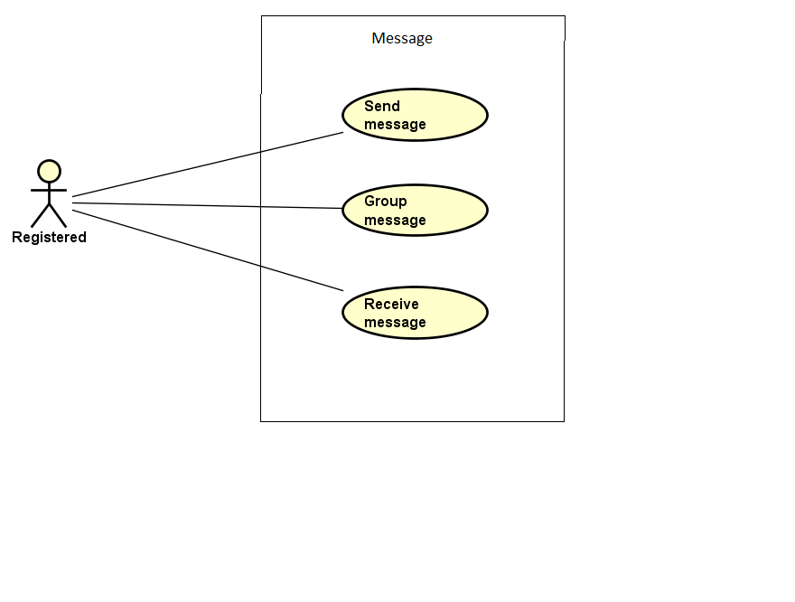

Figure 3-5: Message Modal use case

UC022- Group message

|  |  |  |  |  |
| --- | --- | --- | --- | --- |
| **Use Case ID** | | UC022 | **Version** | 1.0 |
| **Use Case Name** | | Group message | | |
| **Created by:** | | DuyTN | **Date Created:** | 05/11/2016 |
| **Primary Actor** | | Registered user | **Secondary Actor** |  |
| **Priority** | | Normal | | |
| **Frequency of Use:** | | High | | |
| **Description:** | | WS records all message of user | | |
| **Preconditions:** | | 1. WS website is available  2.User browsed WS website  3. User logged in to system | | |
| **Trigger:** | | User click Message then choose message type in drop box | | |
| **Post conditions:** | | List all results that matched with the message type and on screen | | |
| **Normal Flow** | | | | |
| **Step** | **Actor** | **Action** | | |
| 1 | User | Click Avatar image button in header | | |
| 2 | WS | Display a menu includes:   * Message * Notification * Profile * Organization * Logout | | |
| 3 | User | Click Message | | |
| 4 | WS | Display message page | | |
| 5 | User | Choose message type in drop box | | |
| 6 | WS | List all results that matched with the message type and on screen | | |
| **Alternative Flows: N/A** | | | | |
| **Exceptions:** | | | | |
| **EC1** | At step 5 in the main flows, if there is no result matched the message type | | | |
| **Step** | **Actor** | **Action** | | |
| 3.1 | WS | Display Nothing | | |
|  | | | | |
| **Priority** | | Normal | | |
| **Frequency of Use:** | | Normal | | |
| **Business Rules:** | | N/A | | |
| **Other Information:** | | N/A | | |

Table 2- 22: Group message Use case

UC023-Send Message

|  |  |  |  |  |
| --- | --- | --- | --- | --- |
| **Use Case ID** | | UC023 | **Version** | 1.0 |
| **Use Case Name** | | Send message | | |
| **Created by:** | | DuyTN | **Date Created:** | 05/11/2016 |
| **Primary Actor** | | Registered user | **Secondary Actor** |  |
| **Priority** | | High | | |
| **Frequency of Use:** | | High | | |
| **Description:** | | This function allows user to send a message | | |
| **Preconditions:** | | 1. WS website is available 2. User browsed WS website 3. User logged in to system 4. User are on message page | | |
| **Trigger:** | | User enters message and click Send | | |
| **Post conditions:** | | Message sent | | |
| **Normal Flow** | | | | |
| **Step** | **Actor** | **Action** | | |
| 1 | User | Click Avatar image button in header | | |
| 2 | WS | Display a menu includes:   * Message * Notification * Profile * Organization * Logout | | |
| 3 | User | Click Message | | |
| 4 | WS | Display message page | | |
| 5 | User | Choose 1 message of other user | | |
| 6 | WS | Display conversation of 2 user | | |
| 7 | User | Enter message and click Send or Press Enter | | |
| 8 | WS | Message send to user | | |
| **Alternative Flows:** | | | | |
| **AT1** | At step 5 in the main flows, if user enter user URL linl | | | |
| **Step** | **Actor** | **Action** | | |
| 1 | WS | Redirects user to other user profile | | |
| 2 | User | Click on Send Message button | | |
| 3 | WS | Display message pop-up | | |
| 4 | User | Write message and click Send | | |
| 5 | WS | Send message and display notification | | |
|  | | | | |
| **AT2** | At step 2 in the main flows, if user click other hyperlinks or buttons | | | |
| **Step** | **Actor** | **Action** | | |
| 2.1 | WS | Redirects user to chosen hyperlink or button | | |
|  | | | | |
| **Exceptions:** | | | | |
| **EC1** | Message can not sent | | | |
| **Step** | **Actor** | **Action** | | |
| 1 | WS | Show a dialog error | | |
|  | | | | |
| **Priority** | | High | | |
| **Frequency of Use:** | | High | | |
| **Business Rules:** | |  | | |
| **Other Information:** | | N/A | | |

UC024-Receive Message

|  |  |  |  |  |
| --- | --- | --- | --- | --- |
| **Use Case ID** | | UC024 | **Version** | 1.0 |
| **Use Case Name** | | Receive message | | |
| **Created by:** | | DuyTN | **Date Created:** | 05/11/2016 |
| **Primary Actor** | | Registered user | **Secondary Actor** |  |
| **Priority** | | High | | |
| **Frequency of Use:** | | High | | |
| **Description:** | | This function allows user to receive message from other user | | |
| **Preconditions:** | | 1.WS website is available  2.User browsed WS website  3.User logged in to system | | |
| **Trigger:** | | User choose a message button | | |
| **Post conditions:** | | All message is displayed | | |
| **Normal Flow** | | | | |
| **Step** | **Actor** | **Action** | | |
| 1 | User | Click Avatar image button in header | | |
| 2 | WS | Display a menu includes:   * Message * Notification * Profile * Organization * Logout | | |
| 3 | User | Click Message | | |
| 4 | WS | Display message page | | |
| 5 | User | Choose 1 of message type | | |
| 6 | WS | Display all message which has been sent from other | | |
| **Alternative Flows:** | | | | |
| **AT1** | At step 2 in the main flows, if user click other hyperlinks or buttons | | | |
| **Step** | **Actor** | **Action** | | |
| 2.1 | WS | Redirects user to chosen hyperlink or button | | |
|  | | | | |
| **Exceptions: N/A** | | | | |
| **Priority** | | High | | |
| **Frequency of Use:** | | High | | |
| **Business Rules:** | |  | | |
| **Other Information:** | | N/A | | |

Table 2- 23: Receive message Use case

###### Chat room

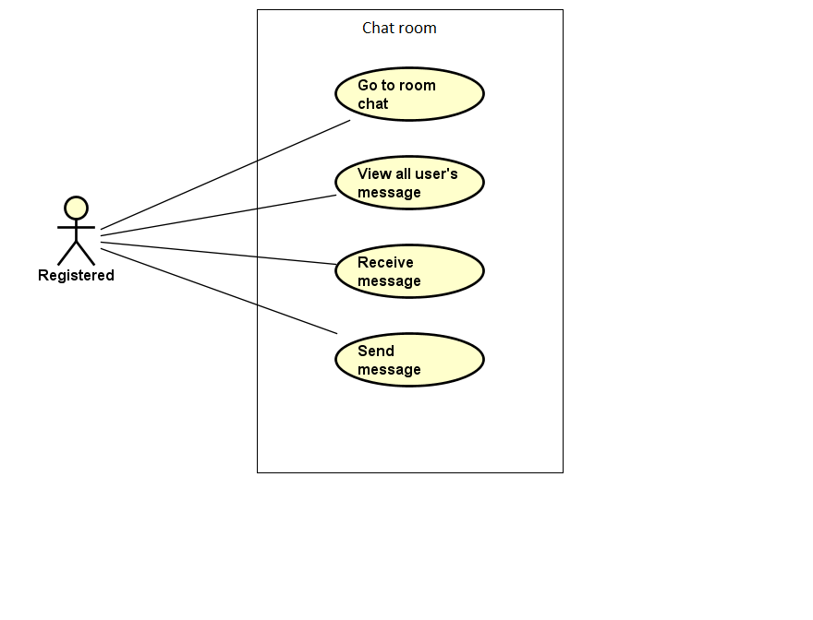

Figure 3-6: Message Modal use case

UC025- Go to Room chat

|  |  |  |  |  |
| --- | --- | --- | --- | --- |
| **Use Case ID** | | UC025 | **Version** | 1.0 |
| **Use Case Name** | | Enter event chat room | | |
| **Created by:** | | DuyTN | **Date Created:** | 05/11/2016 |
| **Primary Actor** | | Registered user | **Secondary Actor** |  |
| **Priority** | | High | | |
| **Frequency of Use:** | | High | | |
| **Description:** | | User enter to event chat room | | |
| **Preconditions:** | | 1. WS website is available  2.User browsed WS website  3. User logged in to system | | |
| **Trigger:** | | User click Enter chat room | | |
| **Post conditions:** | | User enter chat room | | |
| **Normal Flow** | | | | |
| **Step** | **Actor** | **Action** | | |
| 1 | User | Click on an event on homepage | | |
| 2 | WS | Redirect to event detail | | |
| 3 | User | Click on pop-up Chat and click Enter Room chat | | |
| 4 | WS | Move to event room chat and display all chat message of all user | | |
| **Alternative Flows: N/A** | | | | |
| **Exceptions:** | | | | |
| **EC1** | At step 3 in the main flows, if user cannot enter room chat | | | |
| **Step** | **Actor** | **Action** | | |
| 3.1 | WS | Display Error | | |
|  | | | | |
| **Priority** | | Normal | | |
| **Frequency of Use:** | | High | | |
| **Business Rules:** | | N/A | | |
| **Other Information:** | | N/A | | |

Table 2- 22: Enter room chat Use case

UC026- View all user message

|  |  |  |  |  |
| --- | --- | --- | --- | --- |
| **Use Case ID** | | UC026 | **Version** | 1.0 |
| **Use Case Name** | | View all user message before | | |
| **Created by:** | | DuyTN | **Date Created:** | 05/11/2016 |
| **Primary Actor** | | Registered user | **Secondary Actor** |  |
| **Priority** | | Normal | | |
| **Frequency of Use:** | | High | | |
| **Description:** | | User enter to event chat room | | |
| **Preconditions:** | | 1. WS website is available  2.User browsed WS website  3. User logged in to system | | |
| **Trigger:** | | User click Enter chat room | | |
| **Post conditions:** | | Display all message of users before | | |
| **Normal Flow** | | | | |
| **Step** | **Actor** | **Action** | | |
| 1 | User | Click on an event on homepage | | |
| 2 | WS | Redirect to event detail | | |
| 3 | User | Click on pop-up Chat and click Enter Room chat | | |
| 4 | WS | Move to event room chat and display all chat message of all user | | |
| **Alternative Flows** | | | | |
| **Exceptions:** | | | | |
| **EC1** | At step 3 in the main flows, if user cannot enter room chat | | | |
| **Step** | **Actor** | **Action** | | |
| 3.1 | WS | Display Error | | |
|  | | | | |
| **Priority** | | Normal | | |
| **Frequency of Use:** | | High | | |
| **Business Rules:** | | N/A | | |
| **Other Information:** | | N/A | | |

Table 2- 22: View all user message Use case

UC027- Receive Message

|  |  |  |  |  |
| --- | --- | --- | --- | --- |
| **Use Case ID** | | UC027 | **Version** | 1.0 |
| **Use Case Name** | | Enter event chat room | | |
| **Created by:** | | DuyTN | **Date Created:** | 05/11/2016 |
| **Primary Actor** | | Registered user | **Secondary Actor** |  |
| **Priority** | | High | | |
| **Frequency of Use:** | | High | | |
| **Description:** | | User enter to event chat room | | |
| **Preconditions:** | | 1. WS website is available  2.User browsed WS website  3. User logged in to system | | |
| **Trigger:** | | User click Enter chat room | | |
| **Post conditions:** | | User receive message when other send | | |
| **Normal Flow** | | | | |
| **Step** | **Actor** | **Action** | | |
| 1 | User | Click on an event on homepage | | |
| 2 | WS | Redirect to event detail | | |
| 3 | User | Click on pop-up Chat and click Enter Room chat | | |
| 4 | WS | Display message when other send | | |
| **Alternative Flows** | | | | |
| **Exceptions:** | | | | |
| **EC1** | At step 3 in the main flows, if user cannot enter room chat | | | |
| **Step** | **Actor** | **Action** | | |
| 3.1 | WS | Display Error | | |
|  | | | | |
| **Priority** | | Normal | | |
| **Frequency of Use:** | | High | | |
| **Business Rules:** | | N/A | | |
| **Other Information:** | | N/A | | |

Table 2- 22: Receive message Use case

UC028- Send Message

|  |  |  |  |  |
| --- | --- | --- | --- | --- |
| **Use Case ID** | | UC028 | **Version** | 1.0 |
| **Use Case Name** | | Enter event chat room | | |
| **Created by:** | | DuyTN | **Date Created:** | 05/11/2016 |
| **Primary Actor** | | Registered user | **Secondary Actor** |  |
| **Priority** | | High | | |
| **Frequency of Use:** | | High | | |
| **Description:** | | User enter to event chat room | | |
| **Preconditions:** | | 1. WS website is available  2.User browsed WS website  3. User logged in to system | | |
| **Trigger:** | | User click Enter chat room | | |
| **Post conditions:** | | Message has been sent and display on room chat | | |
| **Normal Flow** | | | | |
| **Step** | **Actor** | **Action** | | |
| 1 | User | Click on an event on homepage | | |
| 2 | WS | Redirect to event detail | | |
| 3 | User | Click on pop-up Chat and click Enter Room chat | | |
| 4 | WS | Move to event room chat and display all chat message of all user | | |
| 5 | User | Write message and click Send (Or press Enter) | | |
| 6 | WS | Send message and display on room chat pop-up | | |
| **Alternative Flows** | | | | |
| **Exceptions:** | | | | |
| **EC1** | At step 3 in the main flows, if user cannot enter room chat | | | |
| **Step** | **Actor** | **Action** | | |
| 3.1 | WS | Display Error | | |
|  | | | | |
| **Priority** | | High | | |
| **Frequency of Use:** | | High | | |
| **Business Rules:** | | N/A | | |
| **Other Information:** | | N/A | | |

Table 2- 22: Send message Use case

###### Like

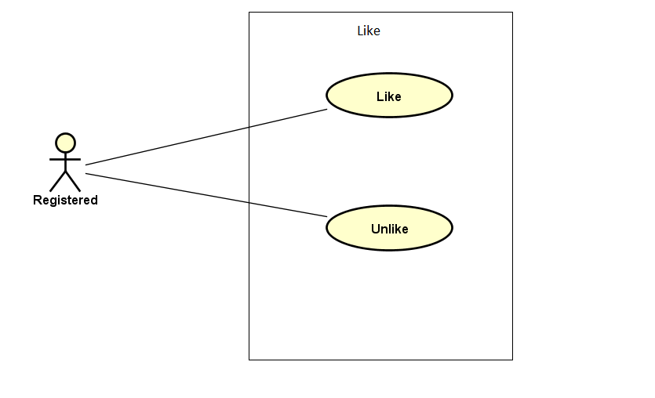

Figure 3-7: Like use case

UC029- Like

|  |  |  |  |  |
| --- | --- | --- | --- | --- |
| **Use Case ID** | | UC029 | **Version** | 1.0 |
| **Use Case Name** | | Like comment or thread | | |
| **Created by:** | | DuyTN | **Date Created:** | 05/11/2016 |
| **Primary Actor** | | Registered user | **Secondary Actor** |  |
| **Priority** | | Normal | | |
| **Frequency of Use:** | | High | | |
| **Description:** | | User like an comment or thread which they interested | | |
| **Preconditions:** | | 1. WS website is available  2. User browsed WS website  3. User logged in to system | | |
| **Trigger:** | | User click like | | |
| **Post conditions:** | | Event or thread has been liked | | |
| **Normal Flow** | | | | |
| **Step** | **Actor** | **Action** | | |
| 1 | User | Click on an event or thread | | |
| 2 | WS | Go to event or thread information detail page | | |
| 3 | User | Like | | |
| 4 | WS | Show like number | | |
| **Alternative Flows: N/A** | | | | |
| **Exceptions: N/A** | | | | |
| **Priority** | | Normal | | |
| **Frequency of Use:** | | High | | |
| **Business Rules:** | | N/A | | |
| **Other Information:** | | N/A | | |

Table 2- 38: Like Use case

UC030- Unlike

|  |  |  |  |  |
| --- | --- | --- | --- | --- |
| **Use Case ID** | | UC030 | **Version** | 1.0 |
| **Use Case Name** | | Unlike comment or thread | | |
| **Created by:** | | DuyTN | **Date Created:** | 05/11/2016 |
| **Primary Actor** | | Registered user | **Secondary Actor** |  |
| **Priority** | | Normal | | |
| **Frequency of Use:** | | High | | |
| **Description:** | | User like an comment or thread which they interested | | |
| **Preconditions:** | | 1. WS website is available  2. User browsed WS website  3. User logged in to system | | |
| **Trigger:** | | User click like (already liked this before) | | |
| **Post conditions:** | | Event or thread has been unliked | | |
| **Normal Flow** | | | | |
| **Step** | **Actor** | **Action** | | |
| 1 | User | Click on an event or thread | | |
| 2 | WS | Go to event or thread information detail page | | |
| 3 | User | Click on like button (already like it before) | | |
| 4 | WS | Unlike this event or thread | | |
| **Alternative Flows: N/A** | | | | |
| **Exceptions: N/A** | | | | |
| **Priority** | | Normal | | |
| **Frequency of Use:** | | High | | |
| **Business Rules:** | | N/A | | |
| **Other Information:** | | N/A | | |

Table 2- 38: Like Use case

###### Comment

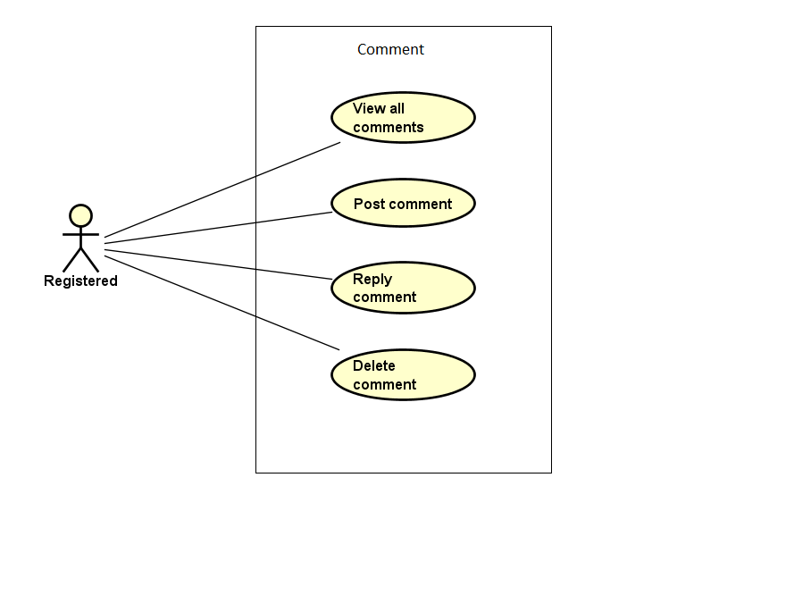

Figure 3-8: Comment use case

UC031- View all comment

|  |  |  |  |  |
| --- | --- | --- | --- | --- |
| **Use Case ID** | | UC031 | **Version** | 1.0 |
| **Use Case Name** | | View list comment | | |
| **Created by:** | | DuyTN | **Date Created:** | 05/11/2016 |
| **Primary Actor** | | Registered user | **Secondary Actor** |  |
| **Priority** | | High | | |
| **Frequency of Use:** | | High | | |
| **Description:** | | WS show all comment of an event or thread | | |
| **Preconditions:** | | 1. WS website is available  2. User browsed WS website  3. User logged in to system | | |
| **Trigger:** | | User click on event or thread detail | | |
| **Post conditions:** | | Comment is displayed | | |
| **Normal Flow** | | | | |
| **Step** | **Actor** | **Action** | | |
| 1 | User | Click on an event or thread | | |
| 2 | WS | Go to event or thread detail page | | |
| 3 | User | Scroll down to comment area | | |
| 4 | WS | Display list comment | | |
| **Alternative Flows: N/A** | | | | |
| **Exceptions: N/A** | | | | |
| **Priority** | | High | | |
| **Frequency of Use:** | | High | | |
| **Business Rules:** | | N/A | | |
| **Other Information:** | | N/A | | |

Table 2- 38: View all comment Use case

UC032- Post comment

|  |  |  |  |  |
| --- | --- | --- | --- | --- |
| **Use Case ID** | | UC032 | **Version** | 1.0 |
| **Use Case Name** | | Post comment | | |
| **Created by:** | | DuyTN | **Date Created:** | 05/11/2016 |
| **Primary Actor** | | Registered user | **Secondary Actor** |  |
| **Priority** | | High | | |
| **Frequency of Use:** | | High | | |
| **Description:** | | User post a comment | | |
| **Preconditions:** | | 1. WS website is available  2. User browsed WS website  3. User logged in to system | | |
| **Trigger:** | | User click on event or thread | | |
| **Post conditions:** | | Comment area is displayed | | |
| **Normal Flow** | | | | |
| **Step** | **Actor** | **Action** | | |
| 1 | User | Click on an event or thread | | |
| 2 | WS | Go to event or thread detail page | | |
| 3 | User | Scroll down to comment area | | |
| 4 | WS | Display list comment | | |
| 5 | User | Fill the comment text box then click post | | |
| 6 | WS | Post the user comment | | |
| **Alternative Flows: N/A** | | | | |
| **Exceptions: N/A** | | | | |
| **Priority** | | High | | |
| **Frequency of Use:** | | High | | |
| **Business Rules:** | | N/A | | |
| **Other Information:** | | N/A | | |

Table 2- 39: Post comment Use case

UC033- Reply comment

|  |  |  |  |  |
| --- | --- | --- | --- | --- |
| **Use Case ID** | | UC033 | **Version** | 1.0 |
| **Use Case Name** | | Edit comment | | |
| **Created by:** | | DuyTN | **Date Created:** | 05/11/2016 |
| **Primary Actor** | | Registered user | **Secondary Actor** |  |
| **Priority** | | Normal | | |
| **Frequency of Use:** | | High | | |
| **Description:** | | User edit comment | | |
| **Preconditions:** | | 1. WS website is available  2. User browsed WS website  3. User logged in to system  4. User clicked on a event | | |
| **Trigger:** | | User click on comment tab in event information page | | |
| **Post conditions:** | | Comment tab is displayed | | |
| **Normal Flow** | | | | |
| **Step** | **Actor** | **Action** | | |
| 1 | User | Click on an event or thread | | |
| 2 | WS | Go to event or thread detail page | | |
| 3 | User | Scroll down to comment area | | |
| 4 | WS | Display list comment | | |
| 5 | User | Choose a comment which want to reply and click Reply | | |
| 6 | WS | Show comment text box | | |
| 7 | User | Write the reply in text box and press Enter | | |
| 8 | WS | Display the comment as reply comment | | |
| **Alternative Flows: N/A** | | | | |
| **Exceptions: N/A** | | | | |
| **Priority** | | High | | |
| **Frequency of Use:** | | High | | |
| **Business Rules:** | | N/A | | |
| **Other Information:** | | N/A | | |

Table 2- 40: Registered user Use case

UC034- Delete comment

|  |  |  |  |  |
| --- | --- | --- | --- | --- |
| **Use Case ID** | | UC034 | **Version** | 1.0 |
| **Use Case Name** | | Delete comment | | |
| **Created by:** | | DuyTN | **Date Created:** | 05/11/2016 |
| **Primary Actor** | | Registered user | **Secondary Actor** |  |
| **Priority** | | Normal | | |
| **Frequency of Use:** | | Normal | | |
| **Description:** | | User edit comment | | |
| **Preconditions:** | | 1. WS website is available  2. User browsed WS website  3. User logged in to system | | |
| **Trigger:** | | User click on thread or event detail page | | |
| **Post conditions:** | | Comment area is displayed | | |
| **Normal Flow** | | | | |
| **Step** | **Actor** | **Action** | | |
| 1 | User | Click on an event or thread | | |
| 2 | WS | Go to event or thread detail page | | |
| 3 | User | Scroll down to comment area | | |
| 4 | WS | Display list comment | | |
| 5 | User | Click on own comment and click delete | | |
| 6 | WS | Delete the comment | | |
| **Alternative Flows: N/A** | | | | |
| **Exceptions: N/A** | | | | |
| **Priority** | | High | | |
| **Frequency of Use:** | | High | | |
| **Business Rules:** | | N/A | | |
| **Other Information:** | | N/A | | |

Table 2- 41: Delete comment Use case

###### Manage Event

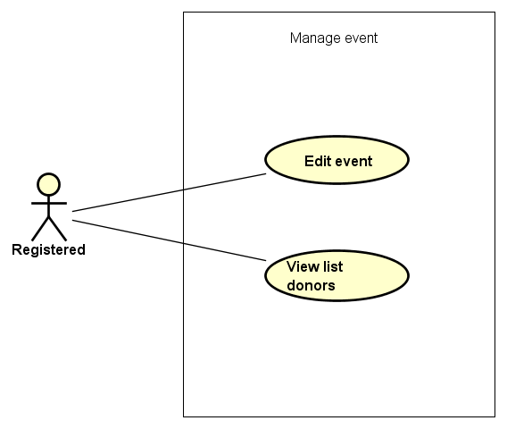

Figure 3-9: Manage event use case

UC035- Edit Event

|  |  |  |  |  |
| --- | --- | --- | --- | --- |
| **Use Case ID** | | UC035 | **Version** | 1.0 |
| **Use Case Name** | | Edit Event | | |
| **Created by:** | | DuyTN | **Date Created:** | 05/11/2016 |
| **Primary Actor** | | Registered user | **Secondary Actor** |  |
| **Priority** | | High | | |
| **Frequency of Use:** | | High | | |
| **Description:** | | This function allows user to edit Event | | |
| **Preconditions:** | | 1. WS website is available  2.User browsed WS website  3. User logged in to system | | |
| **Trigger:** | | User click Edit | | |
| **Post conditions:** | | Edit event Page is displayed | | |
| **Normal Flow** | | | | |
| **Step** | **Actor** | **Action** | | |
| 1 | User | Choose a event what user’s own | | |
| 2 | User | Click edit | | |
| 3 | User | Edit information | | |
| 4 | User | Click save | | |
| 5 | WS | Save change | | |
| **Alternative Flows: N/A** | | | | |
| **Exceptions:** | | | | |
| **EC1** | At step 3 in the main flows, if user miss fill 1 or more information | | | |
| **Step** | **Actor** | **Action** | | |
| 3.1 | WS | Display Dialog to remind user | | |
|  | | | | |
| **Priority** | | High | | |
| **Frequency of Use:** | | High | | |
| **Business Rules:** | | N/A | | |
| **Other Information:** | | N/A | | |

Table 2- 42: Edit Event Use case

UC036-View list donor

|  |  |  |  |  |
| --- | --- | --- | --- | --- |
| **Use Case ID** | | UC036 | **Version** | 1.0 |
| **Use Case Name** | | View list donor | | |
| **Created by:** | | DuyTN | **Date Created:** | 05/11/2016 |
| **Primary Actor** | | Registered user | **Secondary Actor** |  |
| **Priority** | | High | | |
| **Frequency of Use:** | | High | | |
| **Description:** | | This function allows user to edit Event | | |
| **Preconditions:** | | 1. WS website is available  2.User browsed WS website  3. User logged in to system | | |
| **Trigger:** | | User click list backer tab | | |
| **Post conditions:** | | Event information page is displayed | | |
| **Normal Flow** | | | | |
| **Step** | **Actor** | **Action** | | |
| 1 | User | Choose a event what user’s own | | |
| 2 | User | Click on list donor tab | | |
| 3 | WS | Show list donor table | | |
| **Alternative Flows: N/A** | | | | |
| **Exceptions: N/A** | | | | |
| **Priority** | | High | | |
| **Frequency of Use:** | | High | | |
| **Business Rules:** | | N/A | | |
| **Other Information:** | | N/A | | |

Table 2- 43: View list donors Use case

###### Manage Thread

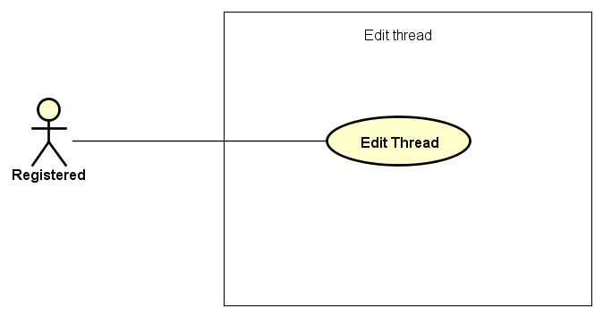

Figure 3-9: Manage thread use case

UC037- Edit Thread

|  |  |  |  |  |
| --- | --- | --- | --- | --- |
| **Use Case ID** | | UC037 | **Version** | 1.0 |
| **Use Case Name** | | Edit Thread | | |
| **Created by:** | | DuyTN | **Date Created:** | 05/11/2016 |
| **Primary Actor** | | Registered user | **Secondary Actor** |  |
| **Priority** | | High | | |
| **Frequency of Use:** | | High | | |
| **Description:** | | This function allows user to edit Thread | | |
| **Preconditions:** | | 1. WS website is available  2.User browsed WS website  3. User logged in to system | | |
| **Trigger:** | | User click Edit | | |
| **Post conditions:** | | Edit thread Page is displayed | | |
| **Normal Flow** | | | | |
| **Step** | **Actor** | **Action** | | |
| 1 | User | Choose a thread what user’s own | | |
| 2 | User | Click edit | | |
| 3 | User | Edit information | | |
| 4 | User | Click save | | |
| 5 | WS | Save change | | |
| **Alternative Flows: N/A** | | | | |
| **Exceptions:** | | | | |
| **EC1** | At step 3 in the main flows, if user miss fill 1 or more information | | | |
| **Step** | **Actor** | **Action** | | |
| 3.1 | WS | Display Dialog to remind user | | |
|  | | | | |
| **Priority** | | High | | |
| **Frequency of Use:** | | High | | |
| **Business Rules:** | | N/A | | |
| **Other Information:** | | N/A | | |

Table 2- 42: Edit Thread Use case

##### Administrator Group Function

###### Common module

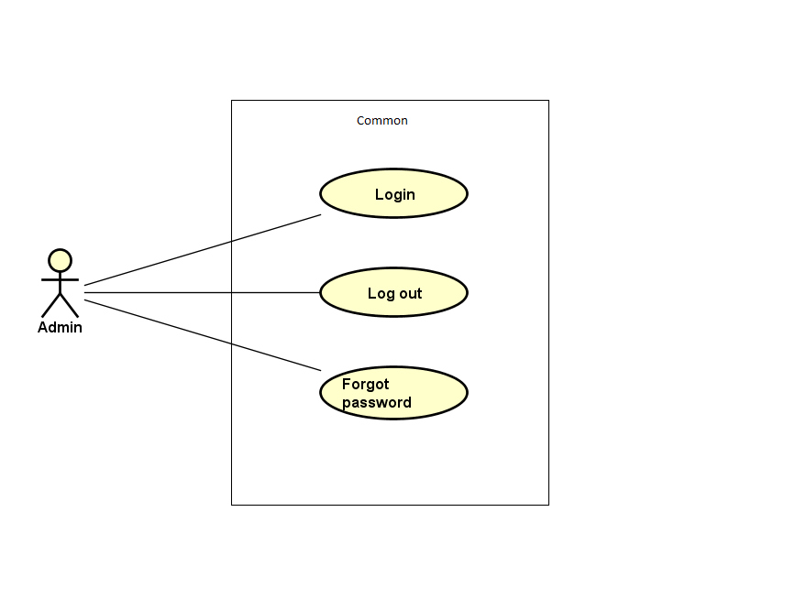

Figure 3-10: Admin common module use case

UC038- Admin login

|  |  |  |  |  |  |
| --- | --- | --- | --- | --- | --- |
| **Use Case ID** | | UC038 | **Version** | 1.0 | |
| **Use Case Name** | | Admin login | | | |
| **Created by:** | | DuyTN | **Date Created:** | 11/11/2016 | |
| **Primary Actor** | | Administrator(Admin) | **Secondary Actor** |  | |
| **Priority** | | High | | | |
| **Frequency of Use:** | | High | | | |
| **Description:** | | This function allows Admin logins into website | | | |
| **Preconditions:** | | 1. WS website is available  2. Admin browsed WS website | | | |
| **Trigger:** | | Admin clicks on Login button | | | |
| **Post conditions:** | | 1. Log Admin into system 2. Redirect Admin to Admin home page | | | |
| **Normal Flow** | | | | | |
| **Step** | **Actor** | **Action** | | | |
| 1 | Admin | Enter URL link: wings.com/Admin | | | |
| 2 | WS | Display Admin Login page. | | | |
| 3 | Admin | Type username and password | | | |
| 4 | WS | Verify:   * 1. Email address   2. Password | | | |
| 5 | WS | * Log Admin into system * Redirect Admin to Admin home page | | | |
| **Alternative Flows: N/A** | | | | | |
| **Exceptions:** | | | | | |
| **EC1** | At step 3 in main flow, if Admin entered wrong UserName or Password | | | |
| **Step** | **Actor** | **Action** | | |
| 2.1 | WS | Display warning error access failed | | |
| **Business Rules:** | | N/A | | | |
| **Other Information:** | | N/A | | | |

Table 2- 45: Admin login Use case

UC039- Admin logout

|  |  |  |  |  |
| --- | --- | --- | --- | --- |
| **Use Case ID** | | UC039 | **Version** | 1.0 |
| **Use Case Name** | | Admin logout | | |
| **Created by:** | | DuyTN | **Date Created:** | 11/11/2016 |
| **Primary Actor** | | Administrator(Admin) | **Secondary Actor** |  |
| **Priority** | | High | | |
| **Frequency of Use:** | | High | | |
| **Description:** | | This function allows Admin logouts of WS website | | |
| **Preconditions:** | | Admin logged in WS website as Administrator | | |
| **Trigger:** | | Admin clicks on Logout | | |
| **Post conditions:** | | Admin is logged out from WS website | | |
| **Normal Flow** | | | | |
| **Step** | **Actor** | **Action** | | |
| 1 | Admin | * Click on dropdown at right side of WS website * Choose Logout option | | |
| 2 | WS | * Logout Admin * Redirect to Admin Login page | | |
| **Alternative Flows:N/A** | | | | |
| **Exceptions: N/A** | | | | |
| **Business Rules:** | | N/A | | |
| **Other Information:** | | N/A | | |

Table 2- 46: Admin logout Use case

UC040- Admin forgot password

|  |  |  |  |  |  |
| --- | --- | --- | --- | --- | --- |
| **Use Case ID** | | UC040 | **Version** | 1.0 | |
| **Use Case Name** | | Admin forgot password | | | |
| **Created by:** | | DuyTN | **Date Created:** | 11/11/2016 | |
| **Primary Actor** | | Administrator(Admin) | **Secondary Actor** |  | |
| **Priority** | | Normal | | | |
| **Frequency of Use:** | | Normal | | | |
| **Description:** | | This function allows Admin receiving her/ his password to email | | | |
| **Preconditions:** | | 1. WS website is available 2. Admin browsed WS website | | | |
| **Trigger:** | | Click Forgot password in Login page | | | |
| **Post conditions:** | | Admin get new password on her/ his email | | | |
| **Normal Flow** | | | | | |
| **Step** | **Actor** | **Action** | | | |
| 1 | Admin | Click Forgot password in Login page | | |
| 2 | WS | Display Email text box | | |
| 3 | Admin | Enter registered email | | |
| 4 | Admin | Click Get Password | | |
| 5 | WS | Sends confirm email | | |
| 6 | WS | Redirect to guest homepage | | |
| **Alternative Flows:** | | | | |
| **AT1** | At step 3 in the main flows, if Admin click other hyperlinks or buttons | | | |
| **Step** | **Actor** | **Action** | | |
| 3.1 | WS | Redirects Admin to chosen hyperlink or button | | |
|  | | | | |
| **Exceptions:** | | | | |
| **EC1** | At step 3, mail input is invalid | | | |
| **Step** | **Actor** | **Action** | | |
| 3.1 | WS | Displays warning message | | |
| **Business Rules:** | | N/A | | |
| **Other Information:** | | N/A | | |

Table 2- 47: Admin forgot password Use case

###### Manage user's account

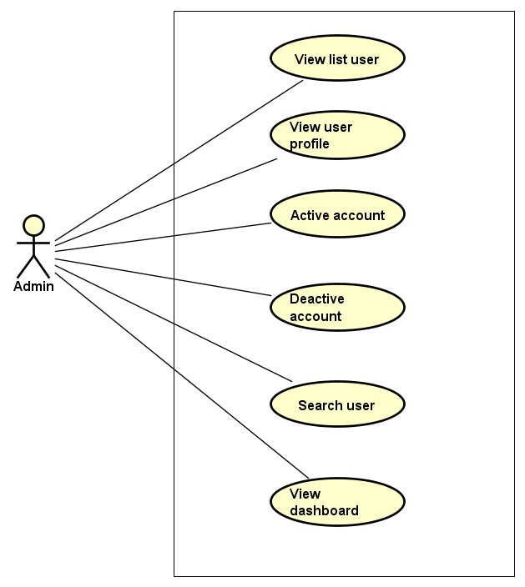

Figure 3-11: Manage user account use case

UC041- View list user

|  |  |  |  |  |
| --- | --- | --- | --- | --- |
| **Use Case ID** | | UC041 | **Version** | 1.0 |
| **Use Case Name** | | View user list | | |
| **Created by:** | | DuyTN | **Date Created:** | 11/11/2016 |
| **Primary Actor** | | Administrator(Admin) | **Secondary Actor** |  |
| **Priority** | | High | | |
| **Frequency of Use:** | | High | | |
| **Description:** | | This function allows Administrator to view User list of who has registered. | | |
| **Preconditions:** | | 1. WS website is available 2. Admin browsed WS website 3. Admin logged in as Administrator | | |
| **Trigger:** | | Admin clicks on Users List | | |
| **Post conditions:** | | Users List is displayed | | |
| **Normal Flow** | | | | |
| **Step** | **Actor** | **Action** | | |
| 1 | Admin | * Click on Users at left side * Click on Users List | | |
| 2 | WS | Display list of users | | |
| **Alternative Flows:** | | | | |
| **AT1** | At step 1 in the main flows, if do not have any user | | | |
| **Step** | **Actor** | **Action** | | |
| 2.1 | WS | Display “Do not have any user” message | | |
| **Exceptions: N/A** | | | | |
| **Business Rules:** | | N/A | | |
| **Other Information:** | | N/A | | |

Table 2- 48: View user list Use case

UC042- View user profile

|  |  |  |  |  |
| --- | --- | --- | --- | --- |
| **Use Case ID** | | UC042 | **Version** | 1.0 |
| **Use Case Name** | | View user profile | | |
| **Created by:** | | DuyTN | **Date Created:** | 11/11/2016 |
| **Primary Actor** | | Administrator(Admin) | **Secondary Actor** |  |
| **Priority** | | High | | |
| **Frequency of Use:** | | High | | |
| **Description:** | | This function allows Administrator to view profile of an user | | |
| **Preconditions:** | | Admin is viewing Users List | | |
| **Trigger:** | | Admin clicks on View button | | |
| **Post conditions:** | | Profile of this user is displayed | | |
| **Normal Flow** | | | | |
| **Step** | **Actor** | **Action** | | |
| 1 | Admin | Click on View detail button at Action column of the user whom want to see profile | | |
| 2 | WS | Display profile of this user | | |
| **Alternative Flows: N/A** | | | | |
| **Exceptions: N/A** | | | | |
| **Business Rules:** | | N/A | | |
| **Other Information:** | | N/A | | |

Table 2- 49: View user profile Use case

UC043- Activate user's account

|  |  |  |  |  |
| --- | --- | --- | --- | --- |
| **Use Case ID** | | UC043 | **Version** | 1.0 |
| **Use Case Name** | | Activate user's account | | |
| **Created by:** | | DuyTN | **Date Created:** | 11/11/2016 |
| **Primary Actor** | | Administrator(Admin) | **Secondary Actor** |  |
| **Priority** | | High | | |
| **Frequency of Use:** | | High | | |
| **Description:** | | This function allows Administrator to activate an user’s account | | |
| **Preconditions:** | | * Admin is viewing Users List * Status of this user is deactivate | | |
| **Trigger:** | | Admin clicks on Deactivate button on status column | | |
| **Post conditions:** | | User’s account is activated | | |
| **Normal Flow** | | | | |
| **Step** | **Actor** | **Action** | | |
| 1 | Admin | Click on Deactivate button at Status column of the user whom want to activate | | |
| 2 | WS | Display pop-up confirm change status | | |
| 3 | Admin | Confirm and click YES | | |
| 4 | WS | * Change displayed status from Deactivate to Activate * Change status of this user’s account to Activate on database * Display message success | | |
| 5 | Admin | Click OK | | |
| 6 | WS | Close pop-up | | |
| **Alternative Flows:** | | | | |
| **AT1** | At step 3 in the main flows, if Admin click NO | | | |
| **Step** | **Actor** | **Action** | | |
| 3.1 | WS | Display “Cancel Action” message and Status doesn’t chage | | |
| 3.2 | Admin | Click OK | | |
| 3.3 | WS | Close pop-up | | |
| **Exceptions: N/A** | | | | |
| **Business Rules:** | | N/A | | |
| **Other Information:** | | N/A | | |

Table 2- 50: Activate user's account Use case

UC044- Deactivate user's account

|  |  |  |  |  |
| --- | --- | --- | --- | --- |
| **Use Case ID** | | UC044 | **Version** | 1.0 |
| **Use Case Name** | | Deactivate user's account | | |
| **Created by:** | | DuyTN | **Date Created:** | 11/11/2016 |
| **Primary Actor** | | Administrator(Admin) | **Secondary Actor** |  |
| **Priority** | | High | | |
| **Frequency of Use:** | | High | | |
| **Description:** | | This function allows Administrator to deactivate an user’s account | | |
| **Preconditions:** | | * Admin is viewing Users List * Status of this user is activate | | |
| **Trigger:** | | Admin clicks on Active button on status column | | |
| **Post conditions:** | | User’s account is deactivated | | |
| **Normal Flow** | | | | |
| **Step** | **Actor** | **Action** | | |
| 1 | Admin | Click on Active button at Status column of the user whom want to activate | | |
| 2 | WS | Display pop-up confirm change status | | |
| 3 | Admin | Confirm and click YES | | |
| 4 | WS | * Change displayed status from Active to Deactive * Change status of this user’s account to Deactive on database * Display message success | | |
| 5 | Admin | * Click OK | | |
| 6 | WS | * Close pop-up | | |
| **Alternative Flows** | | | | |
| **AT1** | At step 3 in the main flows, if Admin click NO | | | |
| **Step** | **Actor** | **Action** | | |
| 3.1 | WS | Display “Cancel Action” message and Status doesn’t chage | | |
| 3.2 | Admin | Click OK | | |
| 3.3 | WS | Close pop-up | | |
|  | | | | |
| **Exceptions: N/A** | | | | |
| **Business Rules:** | | N/A | | |
| **Other Information:** | | N/A | | |

Table 2- 51: Deactivate user's account Use case

UC045- Search user's account

|  |  |  |  |  |
| --- | --- | --- | --- | --- |
| **Use Case ID** | | UC045 | **Version** | 1.0 |
| **Use Case Name** | | Search user's account | | |
| **Created by:** | | DuyTN | **Date Created:** | 11/11/2016 |
| **Primary Actor** | | Administrator(Admin) | **Secondary Actor** |  |
| **Priority** | | High | | |
| **Frequency of Use:** | | High | | |
| **Description:** | | This function allows Administrator to search an user’s account | | |
| **Preconditions:** | | Admin is viewing Users List | | |
| **Trigger:** | | Admin types name of user at Search textbox | | |
| **Post conditions:** | | Display list of searched user | | |
| **Normal Flow** | | | | |
| **Step** | **Actor** | **Action** | | |
| 1 | Admin | * Type keyword of user whom want to search | | |
| 2 | WS | * Display list of users who have the name is typed | | |
| **Alternative Flows:** | | | | |
| **F** | At step 1 in the main flows, if the typed name is not exist | | | |
| **Step** | **Actor** | **Action** | | |
| 2.1 | WS | Display “No matching records found” message | | |
|  | | | | |
| **Exceptions: N/A** | | | | |
| **Business Rules:** | | N/A | | |
| **Other Information:** | | N/A | | |

Table 2- 52: Search user's account Use case

UC046- View user’s dashboard

|  |  |  |  |  |
| --- | --- | --- | --- | --- |
| **Use Case ID** | | UC046 | **Version** | 1.0 |
| **Use Case Name** | | View user’s dashboard | | |
| **Created by:** | | DuyTN | **Date Created:** | 11/11/2016 |
| **Primary Actor** | | Administrator(Admin) | **Secondary Actor** |  |
| **Priority** | | High | | |
| **Frequency of Use:** | | High | | |
| **Description:** | | This function allows Administrator to view dashboard about user of the event | | |
| **Preconditions:** | | 1. WS website is available 2. Admin browsed WS website 3. Admin logged in as Administrator | | |
| **Trigger:** | | Admin clicks on Dashboard | | |
| **Post conditions:** | | Dashboard about user is displayed | | |
| **Normal Flow** | | | | |
| **Step** | **Actor** | **Action** | | |
| 1 | Admin | * Click on Users at left side * Click on Dashboard | | |
| 2 | WS | Display User Dashboard page | | |
| **Alternative Flows: N/A** | | | | |
| **Exceptions: N/A** | | | | |
| **Business Rules:** | | N/A | | |
| **Other Information:** | | N/A | | |

Table 2- 54: View user’s dashboard Use case

###### Manage event

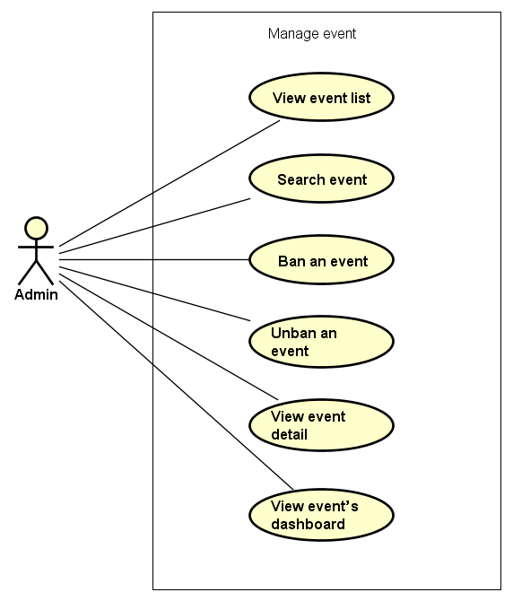

Figure 3-12: Manage event use case

UC047- View event list

|  |  |  |  |  |
| --- | --- | --- | --- | --- |
| **Use Case ID** | | UC047 | **Version** | 1.0 |
| **Use Case Name** | | View event list | | |
| **Created by:** | | DuyTN | **Date Created:** | 11/11/2016 |
| **Primary Actor** | | Administrator(Admin) | **Secondary Actor** |  |
| **Priority** | | High | | |
| **Frequency of Use:** | | High | | |
| **Description:** | | This function allows Administrator to view event list | | |
| **Preconditions:** | | 1. WS website is available 2. Admin browsed WS website 3. Admin logged in as Administrator | | |
| **Trigger:** | | Admin clicks on Events List | | |
| **Post conditions:** | | Event List is displayed | | |
| **Normal Flow** | | | | |
| **Step** | **Actor** | **Action** | | |
| 1 | Admin | * Click on Event at left side * Click on Events List | | |
| 2 | WS | Display list of events | | |
| **Alternative Flows:** | | | | |
| **AT1** | At step 1 in the main flows, if do not have any event | | | |
| **Step** | **Actor** | **Action** | | |
| 2.1 | WS | Display “Do not have any event” message | | |
| **Exceptions: N/A** | | | | |
| **Business Rules:** | | N/A | | |
| **Other Information:** | | N/A | | |

Table 2- 55: View event list Use case

UC048- Search event

|  |  |  |  |  |
| --- | --- | --- | --- | --- |
| **Use Case ID** | | UC048 | **Version** | 1.0 |
| **Use Case Name** | | Search event | | |
| **Created by:** | | DuyTN | **Date Created:** | 11/11/2016 |
| **Primary Actor** | | Administrator(Admin) | **Secondary Actor** |  |
| **Priority** | | High | | |
| **Frequency of Use:** | | High | | |
| **Description:** | | This function allows Administrator to search an event | | |
| **Preconditions:** | | Admin is viewing Event List | | |
| **Trigger:** | | Admin types name of event on Search textbox | | |
| **Post conditions:** | | Display list of searched event | | |
| **Normal Flow** | | | | |
| **Step** | **Actor** | **Action** | | |
| 1 | Admin | * Type name of event which want to search | | |
| 2 | WS | * Display list of event which have the name is typed | | |
| **Alternative Flows:** | | | | |
| **AT1** | At step 1 in the main flows, if the typed name is not exist | | | |
| **Step** | **Actor** | **Action** | | |
| 2.1 | WS | Display “No matching records found” message | | |
| **Exceptions: N/A** | | | | |
| **Business Rules:** | | B1 | | |
| **Other Information:** | | N/A | | |

Table 2- 56: Search event Use case

UC049- Ban Event

|  |  |  |  |  |
| --- | --- | --- | --- | --- |
| **Use Case ID** | | UC049 | **Version** | 1.0 |
| **Use Case Name** | | Ban event | | |
| **Created by:** | | DuyTN | **Date Created:** | 11/11/2016 |
| **Primary Actor** | | Administrator(Admin) | **Secondary Actor** |  |
| **Priority** | | High | | |
| **Frequency of Use:** | | High | | |
| **Description:** | | This function allows Administrator to ban an event | | |
| **Preconditions:** | | Admin is viewing Event List and chosen event is not be banned | | |
| **Trigger:** | | Admin clicks on button Ban | | |
| **Post conditions:** | | Event has been banned | | |
| **Normal Flow** | | | | |
| **Step** | **Actor** | **Action** | | |
| 1 | Admin | Admin clicks on button ban at Action column | | |
| 2 | WS | Ban the chosen event | | |
| **Alternative Flows: N/A** | | | | |
| **Exceptions: N/A** | | | | |
| **Business Rules:** | | N/A | | |
| **Other Information:** | | N/A | | |

Table 2- 57: Ban event Use case

UC050- Unban Event

|  |  |  |  |  |
| --- | --- | --- | --- | --- |
| **Use Case ID** | | UC050 | **Version** | 1.0 |
| **Use Case Name** | | Unban event | | |
| **Created by:** | | DuyTN | **Date Created:** | 11/11/2016 |
| **Primary Actor** | | Administrator(Admin) | **Secondary Actor** |  |
| **Priority** | | High | | |
| **Frequency of Use:** | | High | | |
| **Description:** | | This function allows Administrator to unban an event | | |
| **Preconditions:** | | Admin is viewing Event List and chosen event which is banned | | |
| **Trigger:** | | Admin clicks on button unban | | |
| **Post conditions:** | | Event has been unbanned | | |
| **Normal Flow** | | | | |
| **Step** | **Actor** | **Action** | | |
| 1 | Admin | Admin clicks on button ban at Action column | | |
| 2 | WS | Ban the chosen event | | |
| **Alternative Flows: N/A** | | | | |
| **Exceptions: N/A** | | | | |
| **Business Rules:** | | N/A | | |
| **Other Information:** | | N/A | | |

Table 2- 58: Unban event Use case

UC051- View event detail

|  |  |  |  |  |
| --- | --- | --- | --- | --- |
| **Use Case ID** | | UC051 | **Version** | 1.0 |
| **Use Case Name** | | View event detail | | |
| **Created by:** | | DuyTN | **Date Created:** | 11/11/2016 |
| **Primary Actor** | | Administrator(Admin) | **Secondary Actor** |  |
| **Priority** | | High | | |
| **Frequency of Use:** | | High | | |
| **Description:** | | This function allows Administrator view information of event | | |
| **Preconditions:** | | Admin login | | |
| **Trigger:** | | Admin clicks on a event on thread list | | |
| **Post conditions:** | | Display event detail page | | |
| **Normal Flow** | | | | |
| **Step** | **Actor** | **Action** | | |
| 1 | Admin | Click on an event on event list | | |
| 2 | WS | Display Event detail page | | |
| **Alternative Flows: N/A** | | | | |
| **Exceptions: N/A** | | | | |
| **Business Rules:** | |  | | |
| **Other Information:** | | N/A | | |

Table 2- 59: View event Use case

UC052- View event dashboard

|  |  |  |  |  |
| --- | --- | --- | --- | --- |
| **Use Case ID** | | UC052 | **Version** | 1.0 |
| **Use Case Name** | | View event dashboard | | |
| **Created by:** | | DuyTN | **Date Created:** | 11/11/2016 |
| **Primary Actor** | | Administrator(Admin) | **Secondary Actor** |  |
| **Priority** | | High | | |
| **Frequency of Use:** | | High | | |
| **Description:** | | This function allows Administrator to view dashboard of event | | |
| **Preconditions:** | | 1. WS website is available 2. Admin browsed WS website 3. Admin logged in as Administrator | | |
| **Trigger:** | | Admin clicks on Dashboard | | |
| **Post conditions:** | | Dashboard about event is displayed | | |
| **Normal Flow** | | | | |
| **Step** | **Actor** | **Action** | | |
| 1 | Admin | * Click on Event at left side * Click on Dashboard | | |
| 2 | WS | Display Event Dashboard page | | |
| **Alternative Flows: N/A** | | | | |
| **Exceptions: N/A** | | | | |
| **Business Rules:** | | N/A | | |
| **Other Information:** | | N/A | | |

Table 2- 61: View event’s dashboard Use case

###### Manage thread

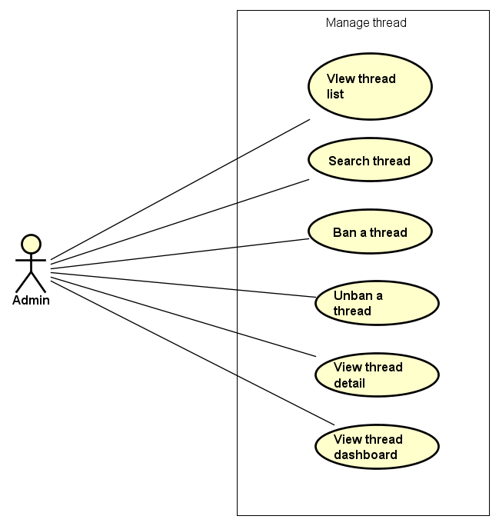

Figure 3-12: Manage thread use case

UC053- View thread list

|  |  |  |  |  |
| --- | --- | --- | --- | --- |
| **Use Case ID** | | UC053 | **Version** | 1.0 |
| **Use Case Name** | | View thread list | | |
| **Created by:** | | DuyTN | **Date Created:** | 11/11/2016 |
| **Primary Actor** | | Administrator(Admin) | **Secondary Actor** |  |
| **Priority** | | High | | |
| **Frequency of Use:** | | High | | |
| **Description:** | | This function allows Administrator to view thread list | | |
| **Preconditions:** | | 1. WS website is available 2. Admin browsed WS website 3. Admin logged in as Administrator | | |
| **Trigger:** | | Admin clicks on Thread List | | |
| **Post conditions:** | | Thread List is displayed | | |
| **Normal Flow** | | | | |
| **Step** | **Actor** | **Action** | | |
| 1 | Admin | * Click on Thread at left side * Click on Thread List | | |
| 2 | WS | Display list of thread | | |
| **Alternative Flows:** | | | | |
| **AT1** | At step 1 in the main flows, if do not have any thread | | | |
| **Step** | **Actor** | **Action** | | |
| 2.1 | WS | Display “Do not have any thread” message | | |
| **Exceptions: N/A** | | | | |
| **Business Rules:** | | N/A | | |
| **Other Information:** | | N/A | | |

Table 2- 55: View thread list Use case

UC054- Search thread

|  |  |  |  |  |
| --- | --- | --- | --- | --- |
| **Use Case ID** | | UC054 | **Version** | 1.0 |
| **Use Case Name** | | Search Thread | | |
| **Created by:** | | DuyTN | **Date Created:** | 11/11/2016 |
| **Primary Actor** | | Administrator(Admin) | **Secondary Actor** |  |
| **Priority** | | High | | |
| **Frequency of Use:** | | High | | |
| **Description:** | | This function allows Administrator to search a Thread | | |
| **Preconditions:** | | Admin is viewing Thread List | | |
| **Trigger:** | | Admin types name of thread on Search textbox | | |
| **Post conditions:** | | Display list of searched thread | | |
| **Normal Flow** | | | | |
| **Step** | **Actor** | **Action** | | |
| 1 | Admin | * Type name of thread which want to search | | |
| 2 | WS | * Display list of threads which have the name is typed | | |
| **Alternative Flows:** | | | | |
| **AT1** | At step 1 in the main flows, if the typed name is not exist | | | |
| **Step** | **Actor** | **Action** | | |
| 2.1 | WS | Display “No matching records found” message | | |
| **Exceptions: N/A** | | | | |
| **Business Rules:** | | B1 | | |
| **Other Information:** | | N/A | | |

Table 2- 56: Search thread Use case

UC055- Ban Thread

|  |  |  |  |  |
| --- | --- | --- | --- | --- |
| **Use Case ID** | | UC055 | **Version** | 1.0 |
| **Use Case Name** | | Ban thread | | |
| **Created by:** | | DuyTN | **Date Created:** | 11/11/2016 |
| **Primary Actor** | | Administrator(Admin) | **Secondary Actor** |  |
| **Priority** | | High | | |
| **Frequency of Use:** | | High | | |
| **Description:** | | This function allows Administrator to ban a thread | | |
| **Preconditions:** | | Admin is viewing Thread List and chosen thread is not be banned | | |
| **Trigger:** | | Admin clicks on button Ban | | |
| **Post conditions:** | | Thread has been banned | | |
| **Normal Flow** | | | | |
| **Step** | **Actor** | **Action** | | |
| 1 | Admin | Admin clicks on button ban at Action column | | |
| 2 | WS | Ban the chosen thread | | |
| **Alternative Flows: N/A** | | | | |
| **Exceptions: N/A** | | | | |
| **Business Rules:** | | N/A | | |
| **Other Information:** | | N/A | | |

Table 2- 57: Ban thread Use case

UC056- Unban Thread

|  |  |  |  |  |
| --- | --- | --- | --- | --- |
| **Use Case ID** | | UC056 | **Version** | 1.0 |
| **Use Case Name** | | Unban thread | | |
| **Created by:** | | DuyTN | **Date Created:** | 11/11/2016 |
| **Primary Actor** | | Administrator(Admin) | **Secondary Actor** |  |
| **Priority** | | High | | |
| **Frequency of Use:** | | High | | |
| **Description:** | | This function allows Administrator to unban a thread | | |
| **Preconditions:** | | Admin is viewing Thread List and chosen thread which is banned | | |
| **Trigger:** | | Admin clicks on button unban | | |
| **Post conditions:** | | Thread has been unbanned | | |
| **Normal Flow** | | | | |
| **Step** | **Actor** | **Action** | | |
| 1 | Admin | Admin clicks on button ban at Action column | | |
| 2 | WS | Ban the chosen thread | | |
| **Alternative Flows: N/A** | | | | |
| **Exceptions: N/A** | | | | |
| **Business Rules:** | | N/A | | |
| **Other Information:** | | N/A | | |

Table 2- 58: Unban thread Use case

UC057- View thread detail

|  |  |  |  |  |
| --- | --- | --- | --- | --- |
| **Use Case ID** | | UC057 | **Version** | 1.0 |
| **Use Case Name** | | View event detail | | |
| **Created by:** | | DuyTN | **Date Created:** | 11/11/2016 |
| **Primary Actor** | | Administrator(Admin) | **Secondary Actor** |  |
| **Priority** | | High | | |
| **Frequency of Use:** | | High | | |
| **Description:** | | This function allows Administrator view information of thread | | |
| **Preconditions:** | | * Admin login | | |
| **Trigger:** | | Admin clicks on a thread on thread list | | |
| **Post conditions:** | | Display thread detail page | | |
| **Normal Flow** | | | | |
| **Step** | **Actor** | **Action** | | |
| 1 | Admin | Click on a thread on thread list | | |
| 2 | WS | Display thread detail page | | |
| **Alternative Flows: N/A** | | | | |
| **Exceptions: N/A** | | | | |
| **Business Rules:** | | N/A | | |
| **Other Information:** | | N/A | | |

Table 2- 59: View thread detail Use case

UC058- View thread dashboard

|  |  |  |  |  |
| --- | --- | --- | --- | --- |
| **Use Case ID** | | UC058 | **Version** | 1.0 |
| **Use Case Name** | | View thread dashboard | | |
| **Created by:** | | DuyTN | **Date Created:** | 11/11/2016 |
| **Primary Actor** | | Administrator(Admin) | **Secondary Actor** |  |
| **Priority** | | High | | |
| **Frequency of Use:** | | High | | |
| **Description:** | | This function allows Administrator to view dashboard of thread | | |
| **Preconditions:** | | 1. WS website is available 2. Admin browsed WS website 3. Admin logged in as Administrator | | |
| **Trigger:** | | Admin clicks on Dashboard | | |
| **Post conditions:** | | Dashboard about thread is displayed | | |
| **Normal Flow** | | | | |
| **Step** | **Actor** | **Action** | | |
| 1 | Admin | * Click on Thread at left side * Click on Dashboard | | |
| 2 | WS | Display Thread Dashboard page | | |
| **Alternative Flows: N/A** | | | | |
| **Exceptions: N/A** | | | | |
| **Business Rules:** | | N/A | | |
| **Other Information:** | | N/A | | |

Table 2- 61: View thread’s dashboard Use case

###### Manage organization

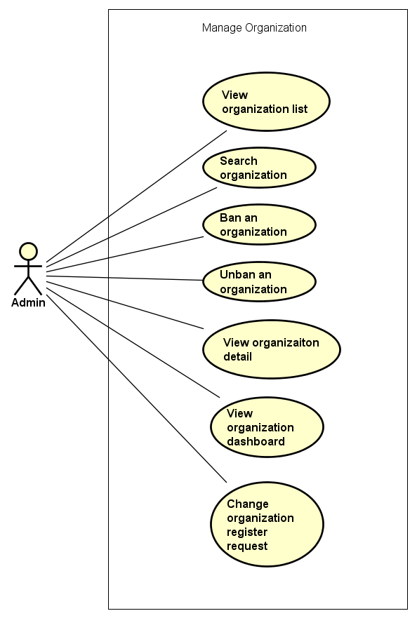

Figure 3-12: Manage organization use case

UC059- View organization list

|  |  |  |  |  |
| --- | --- | --- | --- | --- |
| **Use Case ID** | | UC059 | **Version** | 1.0 |
| **Use Case Name** | | View organization list | | |
| **Created by:** | | DuyTN | **Date Created:** | 11/11/2016 |
| **Primary Actor** | | Administrator(Admin) | **Secondary Actor** |  |
| **Priority** | | High | | |
| **Frequency of Use:** | | High | | |
| **Description:** | | This function allows Administrator to view organization list | | |
| **Preconditions:** | | 1. WS website is available 2. Admin browsed WS website 3. Admin logged in as Administrator | | |
| **Trigger:** | | Admin clicks on Organization List | | |
| **Post conditions:** | | Organization List is displayed | | |
| **Normal Flow** | | | | |
| **Step** | **Actor** | **Action** | | |
| 1 | Admin | * Click on Organization at left side * Click on Organization List | | |
| 2 | WS | Display list of Organization | | |
| **Alternative Flows:** | | | | |
| **AT1** | At step 1 in the main flows, if do not have any thread | | | |
| **Step** | **Actor** | **Action** | | |
| 2.1 | WS | Display “Do not have any thread” message | | |
| **Exceptions: N/A** | | | | |
| **Business Rules:** | | N/A | | |
| **Other Information:** | | N/A | | |

Table 2- 55: View organization list Use case

UC060- Search organization

|  |  |  |  |  |
| --- | --- | --- | --- | --- |
| **Use Case ID** | | UC060 | **Version** | 1.0 |
| **Use Case Name** | | Search Organization | | |
| **Created by:** | | DuyTN | **Date Created:** | 11/11/2016 |
| **Primary Actor** | | Administrator(Admin) | **Secondary Actor** |  |
| **Priority** | | High | | |
| **Frequency of Use:** | | High | | |
| **Description:** | | This function allows Administrator to search an Organization | | |
| **Preconditions:** | | Admin is viewing Organization List | | |
| **Trigger:** | | Admin types name of thread on Search textbox | | |
| **Post conditions:** | | Display list of searched thread | | |
| **Normal Flow** | | | | |
| **Step** | **Actor** | **Action** | | |
| 1 | Admin | * Type name of organization which want to search | | |
| 2 | WS | * Display list of organizations which have the name is typed | | |
| **Alternative Flows:** | | | | |
| **AT1** | At step 1 in the main flows, if the typed name is not exist | | | |
| **Step** | **Actor** | **Action** | | |
| 2.1 | WS | Display “No matching records found” message | | |
| **Exceptions: N/A** | | | | |
| **Business Rules:** | | N/A | | |
| **Other Information:** | | N/A | | |

Table 2- 56: Search organization Use case

UC061- Ban Organization

|  |  |  |  |  |
| --- | --- | --- | --- | --- |
| **Use Case ID** | | UC061 | **Version** | 1.0 |
| **Use Case Name** | | Ban organization | | |
| **Created by:** | | DuyTN | **Date Created:** | 11/11/2016 |
| **Primary Actor** | | Administrator(Admin) | **Secondary Actor** |  |
| **Priority** | | High | | |
| **Frequency of Use:** | | High | | |
| **Description:** | | This function allows Administrator to ban an Organization | | |
| **Preconditions:** | | Admin is viewing Organization List and chosen an organization which is not be banned | | |
| **Trigger:** | | Admin clicks on button Ban | | |
| **Post conditions:** | | Organization has been banned | | |
| **Normal Flow** | | | | |
| **Step** | **Actor** | **Action** | | |
| 1 | Admin | Admin clicks on button ban at Action column | | |
| 2 | WS | Ban the chosen thread | | |
| **Alternative Flows: N/A** | | | | |
| **Exceptions: N/A** | | | | |
| **Business Rules:** | | N/A | | |
| **Other Information:** | | N/A | | |

Table 2- 57: Ban organization Use case

UC062- Unban Organization

|  |  |  |  |  |
| --- | --- | --- | --- | --- |
| **Use Case ID** | | UC062 | **Version** | 1.0 |
| **Use Case Name** | | Unban Organization | | |
| **Created by:** | | DuyTN | **Date Created:** | 11/11/2016 |
| **Primary Actor** | | Administrator(Admin) | **Secondary Actor** |  |
| **Priority** | | High | | |
| **Frequency of Use:** | | High | | |
| **Description:** | | This function allows Administrator to unban an Organization | | |
| **Preconditions:** | | Admin is viewing Organization List and chosen organization which is banned | | |
| **Trigger:** | | Admin clicks on button unban | | |
| **Post conditions:** | | Organization has been unbanned | | |
| **Normal Flow** | | | | |
| **Step** | **Actor** | **Action** | | |
| 1 | Admin | Admin clicks on button ban at Action column | | |
| 2 | WS | Ban the chosen organization | | |
| **Alternative Flows: N/A** | | | | |
| **Exceptions: N/A** | | | | |
| **Business Rules:** | | N/A | | |
| **Other Information:** | | N/A | | |

Table 2- 58: Unban organization Use case

UC063- View organization detail

|  |  |  |  |  |
| --- | --- | --- | --- | --- |
| **Use Case ID** | | UC063 | **Version** | 1.0 |
| **Use Case Name** | | View organization detail | | |
| **Created by:** | | DuyTN | **Date Created:** | 11/11/2016 |
| **Primary Actor** | | Administrator(Admin) | **Secondary Actor** |  |
| **Priority** | | High | | |
| **Frequency of Use:** | | High | | |
| **Description:** | | This function allows Administrator view information of Organization | | |
| **Preconditions:** | | * Admin login | | |
| **Trigger:** | | Admin clicks on an Organization on thread list | | |
| **Post conditions:** | | Display organization detail page | | |
| **Normal Flow** | | | | |
| **Step** | **Actor** | **Action** | | |
| 1 | Admin | Click on an organization on Organization list | | |
| 2 | WS | Display organization detail page | | |
| **Alternative Flows: N/A** | | | | |
| **Exceptions: N/A** | | | | |
| **Business Rules:** | | N/A | | |
| **Other Information:** | | N/A | | |

Table 2- 59: View organization detail Use case

UC064- View organization dashboard

|  |  |  |  |  |
| --- | --- | --- | --- | --- |
| **Use Case ID** | | UC064 | **Version** | 1.0 |
| **Use Case Name** | | View Organization dashboard | | |
| **Created by:** | | DuyTN | **Date Created:** | 11/11/2016 |
| **Primary Actor** | | Administrator(Admin) | **Secondary Actor** |  |
| **Priority** | | High | | |
| **Frequency of Use:** | | High | | |
| **Description:** | | This function allows Administrator to view dashboard of Organization | | |
| **Preconditions:** | | 1. WS website is available 2. Admin browsed WS website 3. Admin logged in as Administrator | | |
| **Trigger:** | | Admin clicks on Dashboard | | |
| **Post conditions:** | | Dashboard about Organization is displayed | | |
| **Normal Flow** | | | | |
| **Step** | **Actor** | **Action** | | |
| 1 | Admin | * Click on Organization at left side * Click on Dashboard | | |
| 2 | WS | Display Organization Dashboard page | | |
| **Alternative Flows: N/A** | | | | |
| **Exceptions: N/A** | | | | |
| **Business Rules:** | | N/A | | |
| **Other Information:** | | N/A | | |

Table 2- 61: View Organization’s dashboard Use case

UC065- Manage organization register request

|  |  |  |  |  |
| --- | --- | --- | --- | --- |
| **Use Case ID** | | UC065 | **Version** | 1.0 |
| **Use Case Name** | | Manage organization register request | | |
| **Created by:** | | DuyTN | **Date Created:** | 11/11/2016 |
| **Primary Actor** | | Administrator(Admin) | **Secondary Actor** |  |
| **Priority** | | High | | |
| **Frequency of Use:** | | High | | |
| **Description:** | | This function allows Administrator to change the request register an organization | | |
| **Preconditions:** | | Admin is viewing Organization Register request List | | |
| **Trigger:** | | Admin clicks accept or not | | |
| **Post conditions:** | | Organization request status is changed | | |
| **Normal Flow** | | | | |
| **Step** | **Actor** | **Action** | | |
| 1 | Admin | Admin clicks on Organization Register request List | | |
| 2 | WS | Dislay request list | | |
| 3 | Admin | Admin choose a request and change stauts | | |
| 4 | WS | Request status is changed and mail to creator | | |
| **Alternative Flows: N/A** | | | | |
| **Exceptions: N/A** | | | | |
| **Business Rules:** | | N/A | | |
| **Other Information:** | | N/A | | |

Table 2- 57: Ban organization Use case

###### Manage donate

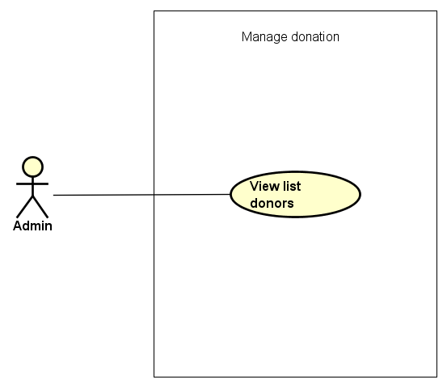

Figure 3-14: Manage donation use case

UC066- View donation list

|  |  |  |  |  |  |
| --- | --- | --- | --- | --- | --- |
| **Use Case ID** | | UC066 | **Version** | 1.0 | |
| **Use Case Name** | | View donation list | | | |
| **Created by:** | | DuyTN | **Date Created:** | 11/11/2016 | |
| **Primary Actor** | | Administrator(Admin) | **Secondary Actor** |  | |
| **Priority** | | High | | | |
| **Frequency of Use:** | | High | | | |
| **Description:** | | This function allows Administrator to view Donation list of the event | | | |
| **Preconditions:** | | 1. WS website is available 2. Admin browsed WS website 3. Admin logged in as Administrator | | | |
| **Trigger:** | | Admin clicks on Donate | | | |
| **Post conditions:** | | Donation List is displayed | | | |
| **Normal Flow** | | | | | |
| **Step** | **Actor** | **Action** | | | |
| 1 | Admin | Click on Donate at left side | | | |
| 2 | WS | Display list of Donate | | | |
| **Alternative Flows:** | | | | | |
| **AT1** | At step 1 in the main flows, if do not have any donation | | | | |
| **Step** | **Actor** | **Action** | | | |
| 2.1 | WS | Display “Do not have any donate” message | | | |
|  | | | | | |
| **Exceptions: N/A** | | | | |
| **Business Rules:** | | N/A | | |
| **Other Information:** | | N/A | | |

Table 2- 62: View donation list Use case

###### Manage event categories

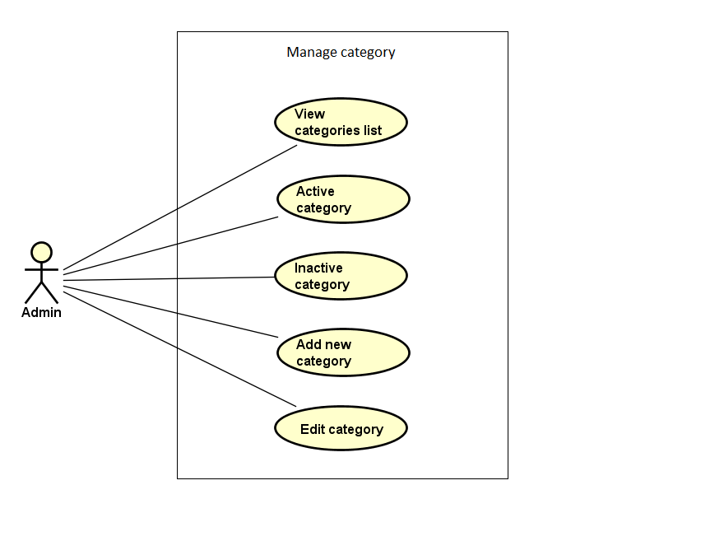

Figure 3-15: Manage event categories use case

UC067- View category list

|  |  |  |  |  |  |
| --- | --- | --- | --- | --- | --- |
| **Use Case ID** | | UC067 | **Version** | 1.0 | |
| **Use Case Name** | | View category list | | | |
| **Created by:** | | DuyTN | **Date Created:** | 11/11/2016 | |
| **Primary Actor** | | Administrator(Admin) | **Secondary Actor** |  | |
| **Priority** | | Normal | | | |
| **Frequency of Use:** | | High | | | |
| **Description:** | | This function allows Administrator to view Category list of the event | | | |
| **Preconditions:** | | 1. WS website is available 2. Admin browsed WS website 3. Admin logged in as Administrator | | | |
| **Trigger:** | | Admin clicks on Category | | | |
| **Post conditions:** | | Category List is displayed | | | |
| **Normal Flow** | | | | | |
| **Step** | **Actor** | **Action** | | | |
| 1 | Admin | Click on Category at left side | | | |
| 2 | WS | Display list of categories | | | |
| **Alternative Flows:** | | | | | |
| **AT1** | At step 1 in the main flows, if do not have any category | | | | |
| **Step** | **Actor** | **Action** | | | |
| 2.1 | WS | Display “Do not have any category” message | | | |
|  | | | | | |
| **Exceptions: N/A** | | | | |
| **Business Rules:** | | B1 | | |
| **Other Information:** | | N/A | | |

Table 2- 67: View category list Use case

UC068- Search category

|  |  |  |  |  |
| --- | --- | --- | --- | --- |
| **Use Case ID** | | UC068 | **Version** | 1.0 |
| **Use Case Name** | | Search category | | |
| **Created by:** | | DuyTN | **Date Created:** | 11/11/2016 |
| **Primary Actor** | | Administrator(Admin) | **Secondary Actor** |  |
| **Priority** | | Normal | | |
| **Frequency of Use:** | | High | | |
| **Description:** | | This function allows Administrator to search a category | | |
| **Preconditions:** | | Admin is viewing Category List | | |
| **Trigger:** | | Admin types name of category at Search textbox | | |
| **Post conditions:** | | Display list of searched category | | |
| **Normal Flow** | | | | |
| **Step** | **Actor** | **Action** | | |
| 1 | Admin | Type name of category which want to search | | |
| 2 | WS | Display list of categories which have the name is typed | | |
| **Alternative Flows:** | | | | |
| **AT1** | At step 1 in the main flows, if the typed name is not exist | | | |
| **Step** | **Actor** | **Action** | | |
| 2.1 | WS | Display “No matching records found” message | | |
| **Exceptions: N/A** | | | | |
| **Business Rules:** | | N/A | | |
| **Other Information:** | | N/A | | |

Table 2- 68: Search category Use case

UC069- Activate category

|  |  |  |  |  |
| --- | --- | --- | --- | --- |
| **Use Case ID** | | UC069 | **Version** | 1.0 |
| **Use Case Name** | | Activate category | | |
| **Created by:** | | DuyTN | **Date Created:** | 11/11/2016 |
| **Primary Actor** | | Administrator(Admin) | **Secondary Actor** |  |
| **Priority** | | High | | |
| **Frequency of Use:** | | High | | |
| **Description:** | | This function allows Administrator to activate a category | | |
| **Preconditions:** | | * Admin is viewing Category List * Status of this category is deactivate | | |
| **Trigger:** | | Admin clicks on Deactivate button | | |
| **Post conditions:** | | Category is activated | | |
| **Normal Flow** | | | | |
| **Step** | **Actor** | **Action** | | |
| 1 | Admin | Click on Deactivate button at Status column of the category which want to activate | | |
| 2 | WS | * Change displayed status from Deactivate to Activate * Change status of this category to Activate on database | | |
| **Alternative Flows: N/A** | | | | |
| **Exceptions: N/A** | | | | |
| **Priority** | | High | | |
| **Frequency of Use:** | | High | | |
| **Business Rules:** | | N/A | | |
| **Other Information:** | | N/A | | |

Table 2- 69: Activate category Use case

UC070- Deactivate category

|  |  |  |  |  |
| --- | --- | --- | --- | --- |
| **Use Case ID** | | UC070 | **Version** | 1.0 |
| **Use Case Name** | | Deactivate category | | |
| **Created by:** | | DuyTN | **Date Created:** | 11/11/2016 |
| **Primary Actor** | | Administrator(Admin) | **Secondary Actor** |  |
| **Priority** | | High | | |
| **Frequency of Use:** | | High | | |
| **Description:** | | This function allows Administrator to deactivate a category | | |
| **Preconditions:** | | * Admin is viewing Category List * Status of this category is activate | | |
| **Trigger:** | | Admin clicks on Activate button | | |
| **Post conditions:** | | Category is deactivated | | |
| **Normal Flow** | | | | |
| **Step** | **Actor** | **Action** | | |
| 1 | Admin | Click on Activate button at Status column of the category which want to deactivate | | |
| 2 | WS | * Change displayed status from Activate to Deactivate * Change status of this category to Deactivate on database | | |
| **Alternative Flows: N/A** | | | | |
| **Exceptions: N/A** | | | | |
| **Business Rules:** | | N/A | | |
| **Other Information:** | | N/A | | |

Table 2- 70: Deactivate category Use case

UC071- Add new category

|  |  |  |  |  |
| --- | --- | --- | --- | --- |
| **Use Case ID** | | UC071 | **Version** | 1.0 |
| **Use Case Name** | | Add new category | | |
| **Created by:** | | DuyTN | **Date Created:** | 11/11/2016 |
| **Primary Actor** | | Administrator(Admin) | **Secondary Actor** |  |
| **Priority** | | High | | |
| **Frequency of Use:** | | High | | |
| **Description:** | | This function allows Administrator to add new a category | | |
| **Preconditions:** | | Admin is viewing Category List | | |
| **Trigger:** | | Admin clicks on Add button | | |
| **Post conditions:** | | New category is added | | |
| **Normal Flow** | | | | |
| **Step** | **Actor** | **Action** | | |
| 1 | Admin | Click on Add Category button at right side of Category list table | | |
| 2 | WS | Display Add new category popup | | |
| 3 | Admin | * Type Category Name * Type Description * Choose picture from Admin’s computer * Click Add button | | |
| **Alternative Flows:** | | | | |

|  |  |  |
| --- | --- | --- |
| **AT1** | At step 3 in the main flows, if Admin click on Close button | |
| **Step** | **Actor** | **Action** |
| 3.1 | WS | Turn off Add new category popup |
|  | | |

|  |
| --- |
| **Exceptions:** |

|  |  |  |
| --- | --- | --- |
| **EC1** | At step 4 in main flow, if Admin does not type Category Name/ Description or does not choose picture | |
| **Step** | **Actor** | **Action** |
| 3.1 | WS | Display Add popup message with error message |
| 3.2 | WS | Mark error fields |

|  |  |
| --- | --- |
| **Business Rules:** | N/A |
| **Other Information:** | N/A |

Table 2- 71: Add new category Use case

UC072- Edit category

|  |  |  |  |  |
| --- | --- | --- | --- | --- |
| **Use Case ID** | | UC072 | **Version** | 1.0 |
| **Use Case Name** | | Edit category | | |
| **Created by:** | | DuyTN | **Date Created:** | 11/11/2016 |
| **Primary Actor** | | Administrator(Admin) | **Secondary Actor** |  |
| **Priority** | | High | | |
| **Frequency of Use:** | | High | | |
| **Description:** | | This function allows Administrator to edit a category | | |
| **Preconditions:** | | Admin is viewing Category List | | |
| **Trigger:** | | Admin clicks on Edit button | | |
| **Post conditions:** | | Category is edited | | |
| **Normal Flow** | | | | |
| **Step** | **Actor** | **Action** | | |
| 1 | Admin | Click on Edit button at Edit column | | |
| 2 | WS | Display Edit category popup | | |
| 3 | Admin | * Type Category Name * Type Description * Choose picture from Admin’s computer * Click Add button | | |
| **Alternative Flows:** | | | | |

|  |  |  |
| --- | --- | --- |
| **AT1** | At step 3 in the main flows, if Admin click on Close button | |
| **Step** | **Actor** | **Action** |
| 3.1 | WS | * Turn off Edit category popup * Keep old information of this category |
|  | | |

|  |  |
| --- | --- |
| **Exceptions: N/A** | |
| **Business Rules:** | N/A |
| **Other Information:** | N/A |

Table 2- 72: Edit category Use case

###### Manage report

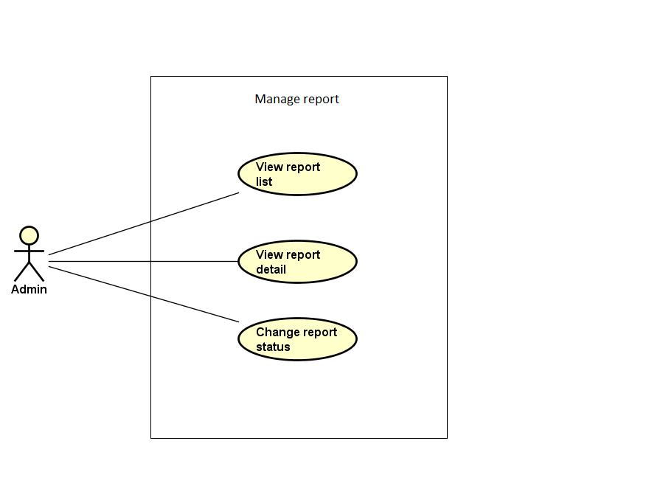

Figure 3-18: Manage report use case

UC083- View report list

|  |  |  |  |  |
| --- | --- | --- | --- | --- |
| **Use Case ID** | | UC083 | **Version** | 1.0 |
| **Use Case Name** | | View report list | | |
| **Created by:** | | DuyTN | **Date Created:** | 11/11/2016 |
| **Primary Actor** | | Administrator(Admin) | **Secondary Actor** |  |
| **Priority** | | High | | |
| **Frequency of Use:** | | High | | |
| **Description:** | | This function allows Administrator to view Report list | | |
| **Preconditions:** | | 1. WS website is available 2. Admin browsed WS website 3. Admin logged in as Administrator | | |
| **Trigger:** | | Admin clicks on User/ Event | | |
| **Post conditions:** | | Report List is displayed | | |
| **Normal Flow** | | | | |
| **Step** | **Actor** | **Action** | | |
| 1 | Admin | * Click on Report at left side * Click on User/ Event | | |
| 2 | WS | Display list of reports | | |
| **Alternative Flows: N/A** | | | | |
| **Exceptions: N/A** | | | | |
| **Business Rules:** | | N/A | | |
| **Other Information:** | | N/A | | |

Table 2- 86: View report list Use case

UC084- View report detail

|  |  |  |  |  |
| --- | --- | --- | --- | --- |
| **Use Case ID** | | UC084 | **Version** | 1.0 |
| **Use Case Name** | | View report detail | | |
| **Created by:** | | DuyTN | **Date Created:** | 11/11/2016 |
| **Primary Actor** | | Administrator(Admin) | **Secondary Actor** |  |
| **Priority** | | High | | |
| **Frequency of Use:** | | High | | |
| **Description:** | | This function allows Administrator to view information of a report | | |
| **Preconditions:** | | Admin is viewing Report List | | |
| **Trigger:** | | Admin clicks on button View at Action column | | |
| **Post conditions:** | | Detail of this report is displayed | | |
| **Normal Flow** | | | | |
| **Step** | **Actor** | **Action** | | |
| 1 | Admin | Admin clicks on button View at Action column of the user/ event which want to view report’s detail information | | |
| 2 | WS | Display View Report Content popup | | |
| **Alternative Flows: N/A** | | | | |
| **Exceptions: N/A** | | | | |
| **Business Rules:** | | N/A | | |
| **Other Information:** | | N/A | | |

Table 2- 87: View report detail Use case

UC085- Change report's status

|  |  |  |  |  |
| --- | --- | --- | --- | --- |
| **Use Case ID** | | UC085 | **Version** | 1.0 |
| **Use Case Name** | | Change report's status | | |
| **Created by:** | | DuyTN | **Date Created:** | 11/11/2016 |
| **Primary Actor** | | Administrator(Admin) | **Secondary Actor** |  |
| **Priority** | | High | | |
| **Frequency of Use:** | | High | | |
| **Description:** | | This function allows Administrator to change status of a report | | |
| **Preconditions:** | | Admin is viewing Report List | | |
| **Trigger:** | | Admin clicks on button at Status column | | |
| **Post conditions:** | | Status of this report is changed | | |
| **Normal Flow** | | | | |
| **Step** | **Actor** | **Action** | | |
| 1 | Admin | Admin clicks on button Waiting/ Cancel/ Confirmed at Status column of the user/ event which want to change report’s status | | |
| 2 | WS | * Display changed status as content of the button * Change status of report in database | | |
| **Alternative Flows: N/A** | | | | |
| **Exceptions: N/A** | | | | |
| **Business Rules:** | | N/A | | |
| **Other Information:** | | N/A | | |

Table 2- 89: Change report's status Use case

### NON-FUNCTIONAL SPECIFICATION

#### Reliability

1. Mean time between failures: The mean time between each failure is expected to be about 360 hours of using.
2. The maximum bugs per function are 2 bugs/a function when user uses software within 2 months. The average number of bugs in the software during system testing is about to be around 1 bugs/KLOC.
3. The database must be backed up daily and can be recovered if necessary

#### Performance Requirements

##### Availability

The application must be available 95% of time. Users can access to it everywhere from their

Web browser with internet connection.

##### Maintainability

* **Coding standards and naming conventions**
  + Output of the event must include coding standards and naming conventions documentations. Implementation code must be easy to maintain.
  + If some components are reused, the documentations of those components must also be included.
* **Design**
  + The design of the system must be loosely coupled that chances on some module will not affect others.
* **Logging**
  + All the errors should be logged, supporting for bug fixing and maintenance.
  + All strange or sensitive situations should also be logged.
* **Mean time to repair:** Immediately when Administrator finds out problem or website is attacked/ hacked by someone. Average 1 day.

##### Usability

Usability Requirements support the following from the perspective of its primary users:

● **Efficiency of use:** user can complete each function in less than 10 actions

● **Intuitiveness:** User can understand approximately 90% help/ error messages

##### Security Requirements

In order to avoid unwanted access by strangers, the security implemented in various ways:

* **User authorize**: Each function must be distributed system access and manipulate the individual parts. To edit information, user must declare their username and password before the operation. Functions will be show after users login dependencies user’s role and permission of each user.
* **Manage Data Layer**: Only Administrator can modify database system.

##### Hardware/Software Requirements

● **Hardware requirement:**

**- Server:** IIS Express

**- Client:** PC/Laptop (window 7, window 8, 8.1)

● **Software requirements:** Web browser (Chrome 53.0, Firefox 50.0) with internet connection

# SOFTWARE DESIGN

## Introduction

### Purpose

This chapter provides a guideline for the development team of what the system’s architect, how to implement functions.

This section of document is the software design of the project in order to develop the software, it includes four main parts:

* Architecture Design.
* Detail Design.
* Database design.
* Screen design.

### Definitions, Acronyms, Abbreviations

|  |  |  |
| --- | --- | --- |
| **Acronym** | **Definition** | **Note** |
| WS | WingS |  |
| DB | Database |  |
| MVC | Model view control |  |
| IDE | Integrated development environment |  |
| Q&A | Question and answer |  |
| GUI | Graphic user interface |  |
| FU | FPT University |  |

1. Definitions and Acronyms

## Architecture design

### CHOICE OF ARCHITECTURE DESIGN

#### MVC Model

The purpose of WS is developing as a charity website, where people can start their ideas and make it real. The system of WS is structured based on MVC combined with layered architecture.

##### MVC Model Overview

The **model-view-controller or MVC** is software architecture commonly used for creating web applications or software. In other words, it's a structure for web applications to follow in order to ensure efficiency and consistency. Many of the most popular frameworks use the MVC architecture, including ASP.NET. At the same time, there are many web developers who don't use a coding framework yet still set up their applications to follow the MVC structure.

The Model-View-Controller (MVC) design pattern assigns objects in an application one of  
three roles: model, view, or controller. The pattern defines not only the roles objects play in  
the application, it defines the way objects communicate with each other. Each of the three  
types of objects is separated from the others by abstract boundaries and communicates with  
objects of the other types across those boundaries. The collection of objects of a certain MVC  
type in an application is sometimes referred to as a layer—for example, model layer.

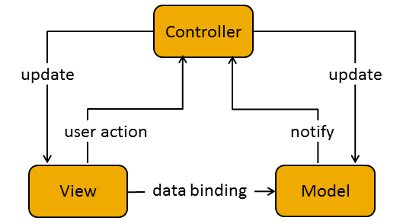

Figure 2‑1: MVC Model

In addition to dividing the application into three kinds of components, the MVC design defines the interactions between them:

* **A controller:** can send commands to its associated view to change the view's presentation of the model (e.g., by scrolling through a document). It can also send commands to the model to update the model's state (e.g., editing a document).
* **A model:** notifies its associated views and controllers when there has been a change in its state. This notification allows the views to produce updated output, and the controllers to change the available set of commands. A passive implementation of MVC omits these notifications, because the application does not require them or the software platform does not support them.
* **A view:** requests from the model the information that it needs to generate an output representation to the user.

##### Advantages and disadvantages of MVC Model

* Advantages:
* The MVC model demonstrates professionalism in programming and design analysis. It is divided into independent components to help develop applications faster, simpler, easier upgrades and maintenance.
* Many MVC vendor framework tool kits are available.
* Multiple views synchronized with same data model.
* Easy to change or plug in new interface views, allowing updating of interface views with new technologies without overhauling the rest of system.
* Develop tools is useful and easy to use.
* Large of documentary sources.
* Disadvantages:
* For small projects that apply MVC model caused cumbersome, time consuming in development process.
* Time consuming to transits data between components.
* Not suitable for agent-oriented applications such as interactive mobile and robotics applications.
* Multiple pairs of controllers and views based on the same data model make data model change expensive.
* The division between the View and the Controller is not clear in some cases.

##### The reasons for choosing MVC Model

* Better support for test-driven development.
* It is good support for application built by project team has many developers and designers but still managed application features.
* Better support for test-driven development.
* Tools is useful and documentary source is large makes MVC is easy to develop.
* WS system is not complete system, now. We built the system that towards extensibility and maintainability in the future.

#### .Net Framework

##### .Net Framework Overview

.NET Framework is a software framework developed by Microsoft that runs primarily on Microsoft Windows. It includes a large class library known as Framework Class Library (FCL) and provides language interoperability (each language can use code written in other languages) across several programming languages.

The .NET Framework is a technology that supports building and running the next generation of applications and XML Web services. The .NET Framework is designed to fulfill the following objectives:

* To provide a consistent object-oriented programming environment whether object code is stored and executed locally, executed locally but Internet-distributed, or executed remotely.
* To provide a code-execution environment that minimizes software deployment and versioning conflicts.
* To provide a code-execution environment that promotes safe execution of code, including code created by an unknown or semi-trusted third party.
* To provide a code-execution environment that eliminates the performance problems of scripted or interpreted environments.
* To make the developer experience consistent across widely varying types of applications, such as Windows-based applications and Web-based applications.
* To build all communication on industry standards to ensure that code based on the .NET Framework can integrate with any other code.

##### Advantages and disadvantages of .Net Framework

* Advantages
* Less time to produce product
* Less Complexity.
* Easily to access complex O.S functions
* Easily to build Data Oriented Project, support huge DB functions.
* Managed
* Support Both Windows and Web Application.
* Easy to create Dynamic sites.
* Disadvantages
* Not suitable for High End Application
* Low performance compare to C, C++.
* Unavailability of build in methods.
* .NET framework is free to download but Code Editor is costly.
* Only few O.S supports .NET.

##### The reasons for choosing .Net Framework

* Consistent with WS system.
* There are many plugins and resources which support creating a website using MVC model.
* Many members can use and have experiences using C# (a language of .Net Framework)

#### AngularJS

##### AngularJS Overview

AngularJS is a structural framework for dynamic web apps. It lets you use HTML as your template language and lets you extend HTML's syntax to express your application's components clearly and succinctly. Angular's data binding and dependency injection eliminate much of the code you would otherwise have to write. And it all happens within the browser, making it an ideal partner with any server technology.



Figure 2‑2: Multi Page Application



Figure 2‑3: Single Page Application

* Features:
* AngularJS is a powerful JavaScript based development framework to create RICH Internet Application (RIA).
* AngularJS provides developers options to write client side application (using JavaScript) in a clean MVC (Model View Controller) way.
* Application written in AngularJS is cross-browser compliant. AngularJS automatically handles JavaScript code suitable for each browser.
* AngularJS is open source, completely free, and used by thousands of developers around the world. It is licensed under the Apache License version 2.0.

Overall, AngularJS is a framework to build large scale and high performance web application while keeping them as easy-to-maintain.

* Core futures: following are most important core features of AngularJS:
* **Data-binding:** It is the automatic synchronization of data between model and view components.
* **Scope:** These are objects that refer to the model. They act as a glue between controller and view.
* **Controller:** These are JavaScript functions that are bound to a particular scope.
* **Services:** AngularJS come with several built-in services for example $http to make a XMLHttpRequests. These are singleton objects which are instantiated only once in app.
* **Filters:** These select a subset of items from an array and returns a new array.
* **Directives:** Directives are markers on DOM elements (such as elements, attributes, css, and more). These can be used to create custom HTML tags that serve as new, custom widgets. AngularJS has built-in directives (ngBind, ngModel...)
* **Templates:** These are the rendered view with information from the controller and model. These can be a single file (like index.html) or multiple views in one page using "partials".
* **Routing:** It is concept of switching views.
* **Model View Whatever:** MVC is a design pattern for dividing an application into different parts (called Model, View and Controller), each with distinct responsibilities. AngularJS does not implement MVC in the traditional sense, but rather something closer to MVVM (Model-View-ViewModel). The Angular JS team refers it humorously as Model View Whatever.
* **Deep Linking:** Deep linking allows you to encode the state of application in the URL so that it can be bookmarked. The application can then be restored from the URL to the same state.
* **Dependency Injection:** AngularJS has a built-in dependency injection subsystem that helps the developer by making the application easier to develop, understand, and test.

##### Advantages and disadvantages of AngularJS

* Advantages:
* AngularJS provides capability to create Single Page Application in a very clean and maintainable way.
* AngularJS provides data binding capability to HTML thus giving user a rich and responsive experience
* AngularJS code is unit testable.
* AngularJS uses dependency injection and make use of separation of concerns.
* AngularJS provides reusable components.
* With AngularJS, developer write less code and get more functionality.
* In AngularJS, views are pure html pages, and controllers written in JavaScript do the business processing.
* Disadvantages:
* **Not Secure:** Being JavaScript only framework, application written in AngularJS are not safe. Server side authentication and authorization is must to keep an application secure.
* **Not degradable:** If your application user disables JavaScript then user will just see the basic page and nothing more.

##### The reason for choosing AngularJS

* AngularJS supports to create a website faster via Rest Api and MVC Model.
* Provide a more fluid user experience akin to a desktop application.
* All team members want to study a new language.

### ARCHITECTURAL REPRESENTATION

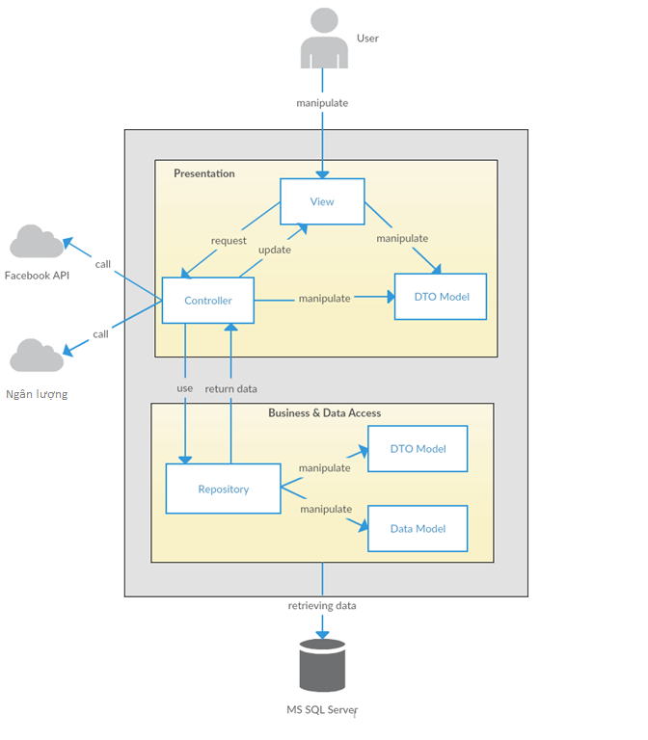

Figure 3‑1: System Overview

We follow MVC architecture to implement the WS Project. MVC offers architectural benefits over standard Jquery and AngularJS — it helps us write better-organized and therefore more maintainable code.

* **DTO Model (data transfer object model)** is an object that defines how the data will be sent over the network to remove circular references from data model, Hide particular properties that clients are not supposed to view, omit some properties in order to reduce payload size, flatten object graphs that contain nested objects, to make them more convenient for clients, avoid “over-posting” vulnerabilities and decouple your service layer from your database layer.
* **View** is what is presented to the users and how users interact with the system. The view is expected to render the model in a meaningful way to the user. In WS, the view is made with .cshtml file including css, AngularJS and jQuery, it sends user gestures to controller and allows controller to select view.
* **Controller** is the decision maker and the glue between the model and view; it handles user actions and gestures, and responds to user events. For example, in CMS, when a user clicks the “Create” button to create a new contract, the controller for that action is invoked. The controller will then make changes to the contract model. The view will then render the modified contract model to the display so that user can view the new contract he added in the contract list.
* **Data Model** is where the application’s data objects are stored. A model object is in charge of encapsulating application state and one object could be related to other objects establishing a one-to-one or one-to-many relationship.
* **Repository** is intermediate layer which used to separate the controller and the data access layer (database context). It queries the data source for data, maps it to DTO models, processes data and returns data to controller.

### ARCHITECTURAL GOALS AND CONSTRAINTS

* **Availability:**
* The application must be available 95% of time. Users can access to it everywhere from there .Web browser with internet connection.
* **Maintainability:**
  + Coding standards and naming conventions:
    - Output of the project must include coding standards and naming conventions documentations. Implementation code must be easy to maintain.
    - All code must be clearly commented, including class, method documentations.
    - If some components are reused, the documentations of those components must also be included.
* Design:
  + - The design of the system must be loosely coupled that chances on some module will not affect others.
* Logging:
  + - All the errors should be logged, supporting for bug fixing and maintenance.
    - All strange or sensitive situations should also be logged.
* **Usability:**
  + Intuitiveness: all help/error messages are simple to understand; user can know exactly how to do each feature after one time using it.
* **Capacity and scalability:**
  + Throughput, storage and growth requirements.

### Use-case View

* **This application includes two parts:**
* The first part is User module. User module includes registered and guest.
* Next part is Administrator module.

#### User Group Function

##### Guest/ Registered Group Function

###### Common Module



Figure 5‑1: Common Module

|  |  |  |  |
| --- | --- | --- | --- |
| No | Use-case name | Actor | Description |
| 1 | Searching | Guest & Registered user | Search existing information about User/Account/Event/Thread/  Organization |
| 2 | View Event | Guest & Registered user | Show all existing events stored on WS |
| 3 | View comment in event | Guest & Registered user | This function allows user to view all comments in event |
| 4 | View Thread | Guest & Registered user | Show all existing threads stored on WS |
| 5 | View comment in thread | Guest & Registered user | This function allows user to view all comments in thread |

Table 5‑1: Common Module UC

##### Guest Group Function

###### Common ModuleGuestOnly

Figure 5‑2: Guest’s Common Module

|  |  |  |  |
| --- | --- | --- | --- |
| No | Use-case name | Actor | Description |
| 1 | Register | Guest | Create new account to use more function as a register user |

Table 5‑2: Guest’s Common Module UC

##### Registered Group Function

###### Common Module

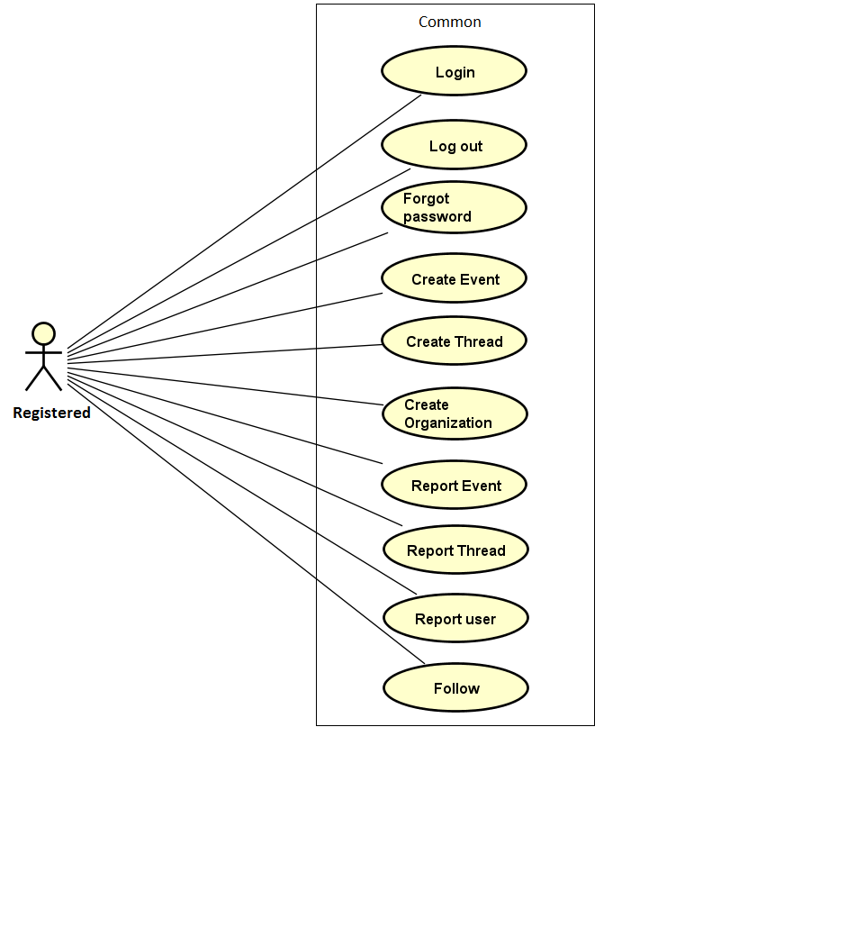

Figure 5‑3: Registered Common Module

|  |  |  |  |
| --- | --- | --- | --- |
| No | Use-case name | Actor | Description |
| 1 | Login | Registered User | User login by Facebook/ Register account to use more functions in website |
| 2 | Logout | Registered User | User want to logout their account |
| 3 | Forgot password | Registered User | When User forgot their password to login the system, this function will receiving their password to email |
| 4 | Create event | Registered User | This function allows user to create an event |
| 5 | Create thread | Registered User | This function allows user to create a thread |
| 6 | Create organization | Registered User | This function allows user to create a organization |
| 7 | Report event | Registered User | This function allows user to report an event |
| 8 | Report thread | Registered User | This function allows user to report a thread |
| 9 | Report user | Registered User | This function allows user to report an user |
| 10 | Follow |  | This function allows user to follow an event and receive notification about this event |

Table 5‑3: Registered Common Module UC

###### View Personal page



Figure 5‑4: View Personal Page

|  |  |  |  |
| --- | --- | --- | --- |
| No | Use-case name | Actor | Description |
| 1 | View profile | Registered User | Display all user profile |
| 2 | Display created threads | Registered User | WS records all thread which user created |
| 3 | Display number donated events | Registered User | WS records all events which user donated |
| 4 | View activities point | Registered User | WS records all user’s activities and display point base on it. |
| 5 | Edit Profile | Registered User | This function allows user to edit profile |
| 6 | Change Password | Registered User |  |

Table 5‑4: View Personal Page UC

###### Message Module

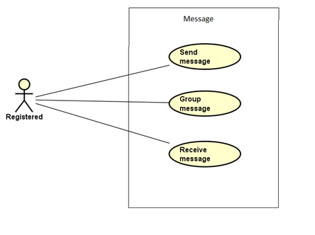

Figure 5‑5: Message Module Page

|  |  |  |  |
| --- | --- | --- | --- |
| No | Use-case name | Actor | Description |
| 1 | Send message | Registered User | This function allows user to send a message |
| 2 | Group message | Registered User | This function allows user to group kinds of message to view (All, unread, read) |
| 3 | Receive message | Registered User | This function allows user to receive a message |

Table 5‑5: Message UC

###### Chat room Module



Figure 5‑6: Chat room

|  |  |  |  |
| --- | --- | --- | --- |
| No | Use-case name | Actor | Description |
| 1 | Go to room chat | Registered User | This function allows user to connect to room chat |
| 2 | View all message | Registered User | This function allows user to view all message in room chat |
| 3 | Receive message | Registered User | This function allows user to receive message of all user who connect to this room chat |
| 4 | Send message | Registered User | This function allows user to send a message |

Table 5‑6: Chat room Module

###### Like Module



Figure 5‑7: Like Module

|  |  |  |  |
| --- | --- | --- | --- |
| No | Use-case name | Actor | Description |
| 1 | Like | Registered User | This function allows user to express their feeling by click like an event or thread |
| 2 | Unlike | Registered User | This function allows user to undo their like action before. |

Table 5‑7: Like Module

###### Comment Module



Figure 5‑8: Comment Module

|  |  |  |  |
| --- | --- | --- | --- |
| No | Use-case name | Actor | Description |
| 1 | View list comment | Registered User | WS show all comment of a project |
| 2 | Post comment | Registered User | User post a comment |
| 3 | Reply comment | Registered User | User reply a comment |
| 4 | Delete comment | Registered User | User edit comment |

Table 5‑8: Comment Module

#### Administrator Group Function

##### Manage user's account



Figure 5‑9: Manage user's account

|  |  |  |  |
| --- | --- | --- | --- |
| No | Use-case name | Actor | Description |
| 1 | View user list | Administrator | This function allows Administrator to view User list of the project |
| 2 | View user profile | Administrator | This function allows Administrator to view profile of an user |
| 3 | Activate user's account | Administrator | This function allows Administrator to activate an user’s account |
| 4 | Deactivate user's account | Administrator | This function allows Administrator to deactivate an user’s account |
| 5 | Search user | Administrator | This function allows Administrator to search user on the user list |
| 6 | View user’s dashboard | Administrator | This function allows Administrator to view dashboard about user of the event |

Table 5‑9: Manage user's account UC

##### Common Module



Figure 5‑10: Common module

|  |  |  |  |
| --- | --- | --- | --- |
| No | Use-case name | Actor | Description |
| 1 | Admin login | Administrator | This function allows Admin logins into website |
| 2 | Admin logout | Administrator | This function allows Admin logouts of WS website |
| 3 | Admin forgot password | Administrator | This function allows Admin receiving her/ his password to email |

Table 5‑10: Common module UC

##### Manage Event

###### Manage Event



Figure 5‑11: Manage event

|  |  |  |  |
| --- | --- | --- | --- |
| No | Use-case name | Actor | Description |
| 1 | View event list | Administrator | This function allows Administrator to view project list of the event |
| 2 | Search event | Administrator | This function allows Administrator to search an event |
| 3 | Ban an event | Administrator | This function allows Administrator ban an event |
| 4 | Unban an event | Administrator | This function allows Administrator to Unban an event |
| 5 | View event detail | Administrator | This function allows Administrator to view information of an event |
| 6 | View event’s dashboard | Administrator | This function allows Administrator to view dashboard event |

Table 5‑11: Manage events UC

###### Manage Event Categories



Figure 5‑12: Manage Categories

|  |  |  |  |
| --- | --- | --- | --- |
| No | Use-case name | Actor | Description |
| 1 | View category list | Administrator | This function allows Administrator to view Category list of the event |
| 2 | Activate category | Administrator | This function allows Administrator to activate a category |
| 3 | Deactivate category | Administrator | This function allows Administrator to deactivate a category |
| 4 | Add new category | Administrator | This function allows Administrator to add new a category |
| 5 | Edit category | Administrator | This function allows Administrator to edit a category |

Table 5‑12: Manage Categories

##### Manage Thread

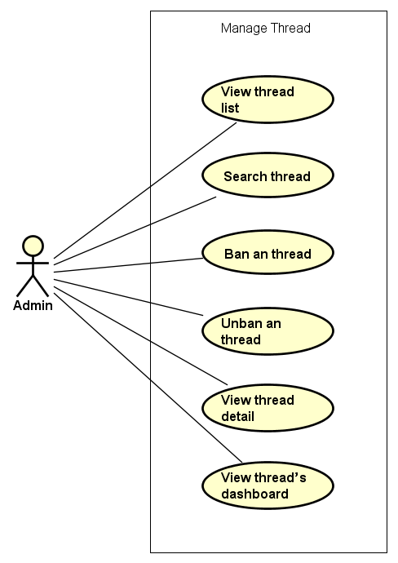

Figure 5‑13: Manage thread

|  |  |  |  |
| --- | --- | --- | --- |
| No | Use-case name | Actor | Description |
| 1 | View thread list | Administrator | This function allows Administrator to view project list of the event |
| 2 | Search thread | Administrator | This function allows Administrator to search an event |
| 3 | Ban an thread | Administrator | This function allows Administrator ban an event |
| 4 | Unban an thread | Administrator | This function allows Administrator to Unban an event |
| 5 | View thread detail | Administrator | This function allows Administrator to view information of an event |
| 6 | View thread’s dashboard | Administrator | This function allows Administrator to view dashboard about thread |

Table 5‑13: Manage thread

##### Manage Organization



Figure 5‑13: Manage organization

|  |  |  |  |
| --- | --- | --- | --- |
| No | Use-case name | Actor | Description |
| 1 | View organization list | Administrator | This function allows Administrator to view project list of the event |
| 2 | Search thread | Administrator | This function allows Administrator to search an event |
| 3 | Ban an thread | Administrator | This function allows Administrator ban an event |
| 4 | Unban an thread | Administrator | This function allows Administrator to Unban an event |
| 5 | View thread detail | Administrator | This function allows Administrator to view information of an event |
| 6 | View thread’s dashboard | Administrator | This function allows Administrator to view dashboard about thread |
| 7 | Change organization register request | Administrator | This function allows Administrator to manage register organization request |

Table 5‑13: Manage thread

##### Manage Report



Figure 5‑15: Manage Report

|  |  |  |  |
| --- | --- | --- | --- |
| No | Use-case name | Actor | Description |
| 1 | View report list | Administrator | This function allows Administrator to view Report list of the event, thread, user or organization |
| 2 | View report detail | Administrator | This function allows Administrator to view information of a report |
| 3 | Change report's status | Administrator | This function allows Administrator to change status of a report if it has been solved |

Table 5‑15: Manage Report

### Logical View

#### Overview

Logical View includes Package diagram and Class diagram. Package diagram describes the organization of packages and elements. Class Diagram provides an overview of the target system by describing the objects and classes inside the system and the relationships between them. It provides a wide variety of usages; from modeling the domain-specific data structure to detailed design of the target system

* + Controller contain the interface between:
    - Associated models
    - Associated views
    - The input devices (e.g., keyboard, pointing device, time).
    - Send commands to the model to update the model's state.
  + Model is:
    - the domain-specific software simulation
    - Or implementation of the application's central structure.
  + View: deal with everything graphical:
    - Requests data from their model
    - Display the data.
  + Repository:
    - Create queries to DB.
    - Process data.
    - Return to controller.

#### Architecturally Significant Design Packages

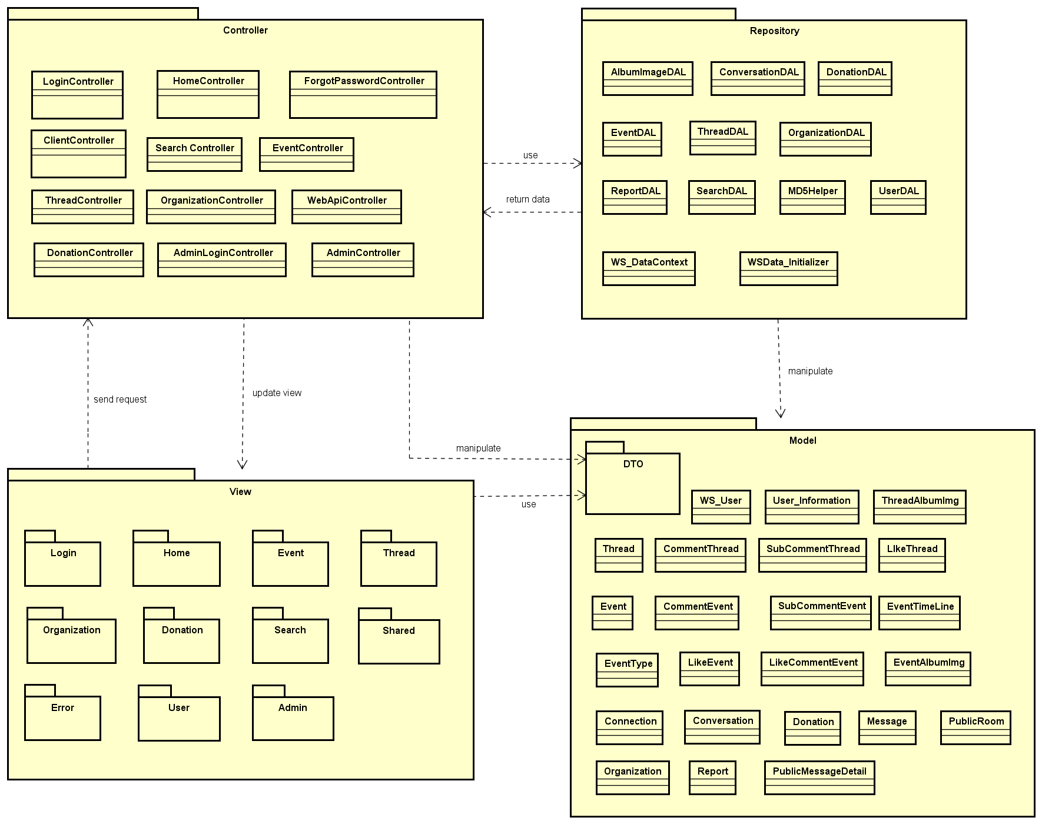

Figure 6‑1: Package Diagram

* **Model:**

|  |  |  |
| --- | --- | --- |
| No | Model class | Role |
|  | WS_User | Description entity of User account information in database |
|  | User_Information | Description entity of User information in database |
|  | Thread | Description entity of Thread in database |
|  | ThreadAlbumImg | Description entity of Album image of event in database |
|  | CommentThread | Description entity of Comment in thread in database |
|  | SubCommentThread | Description entity of SubComment in thread in database |
|  | LikeThread | Description entity of Like in thread in database |
|  | Event | Description entity of Event in database |
|  | EventTimeLine | Description entity of the schedule of event in database |
|  | CommentEvent | Description entity of Comment in event in database |
|  | SubCommentEvent | Description entity of SubComment in event in database |
|  | EventType | Description entity of Event’s category in database |
|  | LikeEvent | Description entity of Like in event in database |
|  | EventAlbumImg | Description entity of Album image of event in database |
|  | Connection | Description entity of Connection of user when connect to system in database |
|  | Conversation | Description entity of Conversation of event chatroom in database |
|  | Donation | Description entity of donate information in database |
|  | Message | Description entity of Message of user in database |
|  | PublicRoom | Description entity of Public room chat in database |
|  | Organization | Description entity of Organization in database |
|  | Report | Description entity of Report in database |
|  | PublicMessageDetail | Description entity of Public Message Detail of chatroom in database |

Table 6‑1: Model list

* **Controller:**

|  |  |  |
| --- | --- | --- |
| No | Controller class | Role |
|  | LoginController | * Receive request login, logout from client. * Call method login, logout. * Respond login view and login, logout status. |
|  | HomeController | * Receive request to home page from client. * Handle request from client and call methods to get all data of home page. * Respond data back to Home View. |
|  | ClientController | * Receive request get client partial views of from client. * Generate partial views and respond to client. |
|  | ForgotPassword Controller | * Receive request get new password from client. * Call methods to get. * Respond data back. |
|  | Search Controller | * Receive request search from client. * Handle request from client and call methods to get all data which match with searching key * Respond data back to Search View |
|  | EventController | * Receive request to event page from client. * Handle request from client and call methods to get all data of event page. * Respond data back to Event view |
|  | ThreadController | * Receive request to thread page from client. * Handle request from client and call methods to get all data of thread page. * Respond data back to Thread View. |
|  | OrganizationController | * Receive request to organization page from client. * Handle request from client and call methods to get all data of organization page. * Respond data back to organization View. |
|  | WebApiController | * Receive requests (get, post, push, delete) about information from client. * Respond status, message and json data to client. |
|  | DonationController | * Receive request to Donation page from client. * Handle request from client and call methods to get all data of Donation page. * Respond data back to Donation View. |
|  | AdminLoginController | * Receive request login, logout from admin. * Call method login, logout. * Respond login view and login, logout status. |
|  | AdminController | * Receive request get admin partial views of admin user. * Generate partial views and respond to admin. |

Table 6‑2: Controller list

* **Repository:**

|  |  |  |
| --- | --- | --- |
| No | Repository class | Role |
|  | WS_DataContext | * Connect to DB, create queries to select, update, deletes data. |
|  | WSData_Initializer | * Initialize data. |
|  | AlbumImageDAL | * Process album image and return to controller. |
|  | ConversationDAL | * Process conversation data and return to controller. |
|  | DonationDAL | * Process donation data and return to controller. |
|  | EventDAL | * Process event data and return to controller. |
|  | ThreadDAL | * Process thread data and return to controller. |
|  | OrganizationDAL | * Process organization data and return to controller. |
|  | ReportDAL | * Process report data and return to controller. |
|  | SearchDAL | * Process search data and return to controller. |
|  | MD5DAL | * Process password initialize data and return to controller. |

Table 6‑3: Repository list

* **DTOs:**

Include many data transfer object classes.

* **View:**

Include many .cshtml file

### Process view

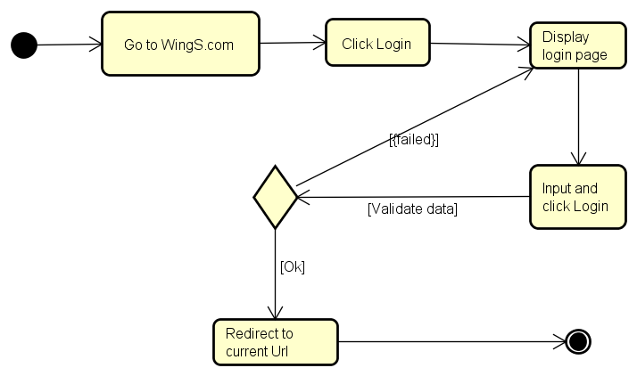

Figure 7‑1: Login activity diagram

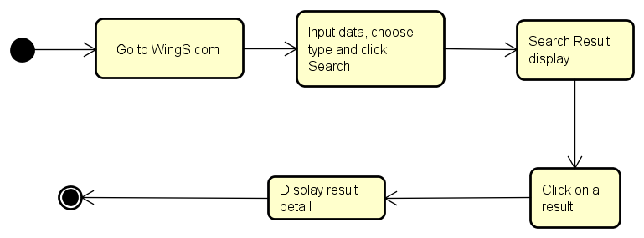

Figure 7‑2: Searching activity diagram

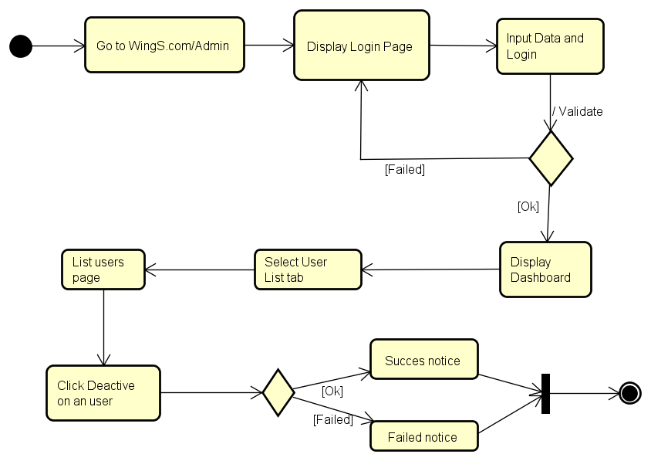

Figure 7‑3: De-active user activity diagram

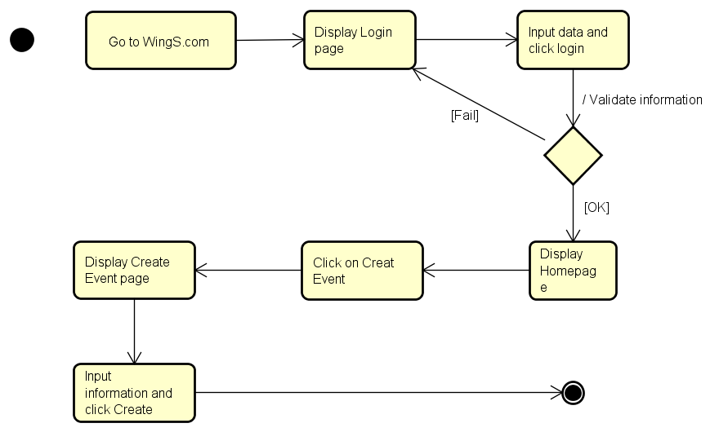 Figure 7‑4: Create Event activity diagram

### Deployment View

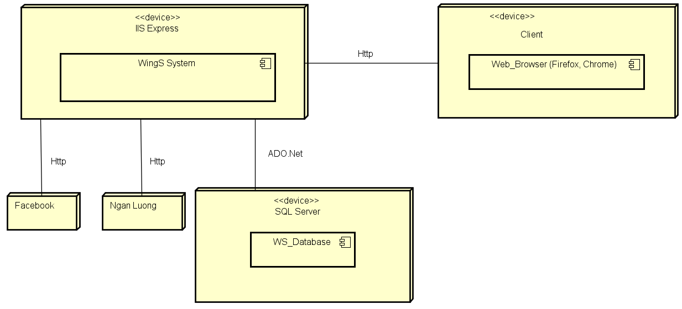

Figure 8‑1: Deployment Diagram

|  |  |  |
| --- | --- | --- |
| **No** | **Name** | **Description** |
| 1 | SQL Server | SQL Server use to store system’s data.  Using SQL Server 2013 or higher. |
| 2 | Facebook | Facebook Api server |
| 3 | Ngan luong | Ngan luong Api server |
| 4 | Client | Client is web browser to use system. Firefox 50, Chrome 53 or higher. |

**Table 8‑1:** Deployment Diagram Description

## Detail Design

### Package

#### Package Diagram

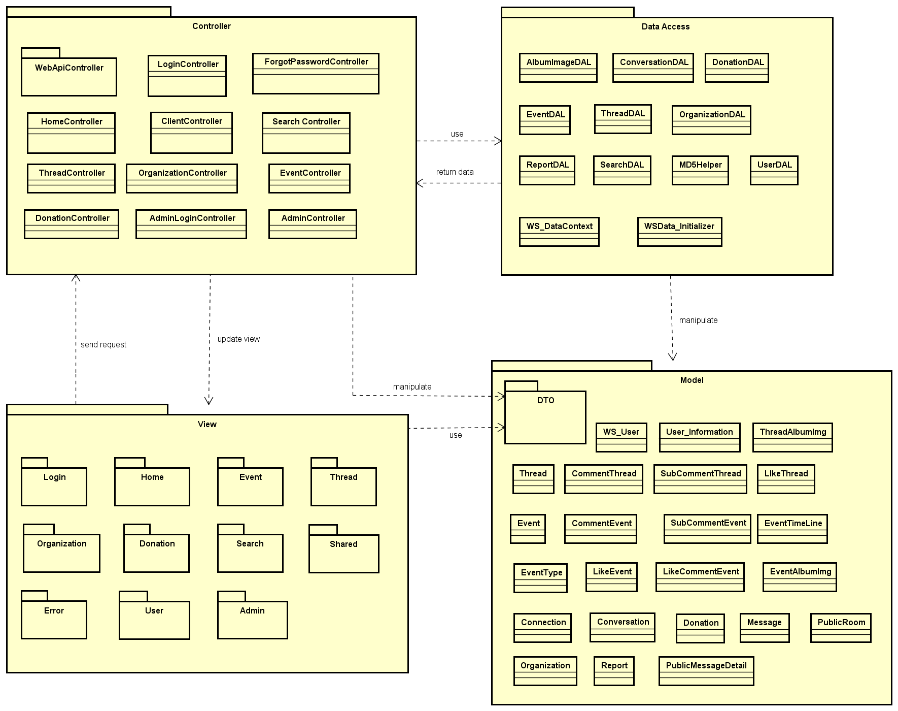

Package Diagram

#### Package Description

##### Model

###### WS_User

|  |  |  |  |  |  |
| --- | --- | --- | --- | --- | --- |
| No | Field Name | Type | Default | Note | Description |
|  | UserID | int |  | public | User’s ID |
|  | UserName | String |  | public | User’s name |
|  | UserPassword | String |  | public | User’s password |
|  | AccountType | bool |  | public | User’s account type (user, admin) |
|  | IsActive | bool |  | public | User’s status (active or inactive) |
|  | IsVerify | bool |  | public | User’s account verify status (yes or not) |
|  | CreatedDate | Datetime |  | public | User’s created date |
|  | LastLogin | Datetime? |  | public | User’s last login time |
|  | Email | string |  | public | User’ email verify status |
|  | VerifyCode | string |  | public | User’s verify account code |

1. WS_User model

###### User_Information

|  |  |  |  |  |  |
| --- | --- | --- | --- | --- | --- |
| No | Field Name | Type | Default | Note | Description |
|  | UserID | int |  | public | User’s ID |
|  | FullName | String |  | public | User’s full name |
|  | EFullName | String |  | public | User’s full name |
|  | ProfileImage | String |  | public | User’s profile image |
|  | UserAddress | String |  | public | User’s address |
|  | EUserAddress | String |  | public | User’s eaddress |
|  | PhoneNumber | String |  | public | User’s phone number |
|  | DoB | Datetime |  | public | User’s date of birth |
|  | Phone | String |  | public | User’s website |
|  | Gender | String |  | public | User’s gender |
|  | Country | String |  | public | User’s country |
|  | FacebookUrl | String |  | public | User’s facebook link |
|  | OrgnazationIDFollow | String |  | public | User’s OrgnazationIDFollow |
|  | UserSignature | String |  | public | User’s Signature |
|  | Point | Int |  | public | User’s point |

1. User_Information model

###### Event

|  |  |  |  |  |  |
| --- | --- | --- | --- | --- | --- |
| No | Field Name | Type | Default | Note | Description |
|  | EventID | int |  | public | Event’s ID |
|  | CreatorID | int |  | public | Event’s creator (userID) |
|  | EventType | int |  | public | Event’s type |
|  | EventName | String |  | public | Event’s name |
|  | Created_Date | Datetime |  | public | Event’s date created |
|  | Finish_Date | Datetime |  | public | Event’s finish date |
|  | Updated_Date | Datetime |  | public | Event’s update timeline |
|  | ShortDescription | String |  | public | Event’s shortDescription |
|  | Description | String |  | public | Event’s description |
|  | Location | String |  | public | Event’s location |
|  | VideoUrl | String |  | public | Event’s video URL |
|  | TotalPoint | int |  | public | Event’s TotalPoint |
|  | Status | bit |  | public | Event’s status |
|  | Views | int |  | public | Event’s total views |
|  | Likes | int |  | public | Event’s total likes |
|  | ExpectedMoney | decimal |  | public | Event’s expected money |
|  | IsOpen | bool |  | public | Event’s activity status |

1. Event model

###### Organization Model

|  |  |  |  |  |  |
| --- | --- | --- | --- | --- | --- |
| No | Field Name | Type | Default | Note | Description |
|  | OrganazationID | Int |  | public | Organization’s ID |
|  | OrganazationName | String |  | public | Organization’s Name |
|  | Introduction | String |  | public | Introduce about Organization |
|  | LogoUrl | String |  | public | Organization’s logo |
|  | Phone | String |  | public | Organization’s phone |
|  | Email | String |  | public | Organization’s email for contact |
|  | Address | String |  | public | Organization’s Address |
|  | Status | String |  | public | Organization’s Status |
|  | Point | int |  | public | Organization’s point |
|  | IsActive | bool |  | public | Organization’s activity status |
|  | IsVerify | bool |  | public | Organization’s creating request status |
|  | CreatedDate | DateTime |  | public | Organization’s created date |

1. Organization Model

###### Event Type model

|  |  |  |  |  |  |
| --- | --- | --- | --- | --- | --- |
| No | Field Name | Type | Default | Note | Description |
|  | EventTypeID | int |  | private | EventType’s ID |
|  | EventTypeName | String |  | private | EventType’s name |
|  | IsActive | bool |  | private | EventType’s active status |
|  | Content | String |  | private | EventType’s description |

1. Event Type Model

###### ReportEvent Model

|  |  |  |  |  |  |
| --- | --- | --- | --- | --- | --- |
| No | Field Name | Type | Default | Note | Description |
|  | ReportID | int |  | public | Report ’s ID |
|  | UserID | int |  | public | Report ’s user id, who report project |
|  | Reason | String |  | public | Report ’s Reason |
|  | ReportTime | datetime |  | public | Report ’s report date |
|  | Type | String |  | public | Report ’s type |
|  | ReportTo | int |  | public | Report ’s to whom |
|  | Status | String |  | public | Report’s status (new, viewed, done) |
|  | UpdatedTime | DateTime |  | public | Report ’s update time |

1. Report Model

###### Donation Model

|  |  |  |  |  |  |
| --- | --- | --- | --- | --- | --- |
| No | Field Name | Type | Default | Note | Description |
|  | DonationId | int |  | public | Donation’s ID |
|  | UserID | int |  | public | Back’s user id |
|  | EventId | int |  | public | Event’s project id |
|  | DonatedDate | Datetime |  | public | Donated’s date |
|  | IsPublic | bool |  | public | Is Back public |
|  | DonatedMoney | decimal |  | public | Amount money donate |
|  | TradeCode | string |  | public | Trade code |
|  | Content | string |  | public | Content of donate |

1. Donation Model

###### EventTimeLine Model

|  |  |  |  |  |  |
| --- | --- | --- | --- | --- | --- |
| No | Field Name | Type | Default | Note | Description |
|  | TimeLineId | int |  | public | Event’s schedule |
|  | EventId | int |  | public | EventID |
|  | Content | string |  | public | Event’s timeline content |
|  | FromDate | DateTime |  |  | Starting date |
|  | ToDate | DateTime |  |  | End date |
|  | Status | bool |  |  | Sub event’s status |

1. EventTimeLine Model

###### CommentEvent Model

|  |  |  |  |  |  |
| --- | --- | --- | --- | --- | --- |
| No | Field Name | Type | Default | Note | Description |
|  | CommentEventId | int |  | public | Comment’s ID |
|  | UserID | int |  | public | Comment’s user id |
|  | EventID | int |  | public | Comment’s Event id |
|  | CmtContent | String |  | public | Comment’s content |
|  | CmtDate | Datetime |  | public | Comment’s date |
|  | Status | bool | true | public | Comment’s status |

1. CommentEvent Model

###### SubcommentEvent Model

|  |  |  |  |  |  |
| --- | --- | --- | --- | --- | --- |
| No | Field Name | Type | Default | Note | Description |
|  | SubCommentEventId | int |  | public | SubCommentEvent’s ID |
|  | CommentEventId | int |  | public | CommentEvent’s ID |
|  | UserId | int |  | public | UserID who comment |
|  | Content | string | 0 | public | SubCommentEvent’s content |
|  | CommentDate | Datetime | 1 | public | SubCommentEvent’s date |
|  | Status | bool |  | public | SubCommentEvent’s status |

1. SubcommentEvent Model

###### LikeEvent Model

|  |  |  |  |  |  |
| --- | --- | --- | --- | --- | --- |
| No | Field Name | Type | Default | Note | Description |
|  | LikeId | int |  | public | Like’s ID |
|  | UserId | int |  | public | Like’s user id |
|  | EventId | int |  | public | Like’s event id |
|  | Status | bool |  | public | Like’s status |

1. LikeEvent Model

###### LikeCommentEvent Model

|  |  |  |  |  |  |
| --- | --- | --- | --- | --- | --- |
| No | Field Name | Type | Default | Note | Description |
|  | LikeCommentId | int |  | public | LikeComment’s ID |
|  | CommentId | int |  | public | LikeComment’s comment id |
|  | UserId | int |  | public | LikeComment’s user id |
|  | Status | bool |  | public | LikeComment’s status |

1. LikeCommentEvent Model

###### EventAlbumImage Model

|  |  |  |  |  |  |
| --- | --- | --- | --- | --- | --- |
| No | Field Name | Type | Default | Note | Description |
|  | ImageId | int |  | public | Image’s Id |
|  | EventId | int |  | public | Event’s ID |
|  | ImageUrl | String |  | public | Image URL link |
|  | Status | bool |  | public | Image’s status |

1. EventAlbumImage Model

###### Thread Model

|  |  |  |  |  |  |
| --- | --- | --- | --- | --- | --- |
| No | Field Name | Type | Default | Note | Description |
|  | ThreadId | int |  | public | Thread’s ID |
|  | UserId | Int |  | public | user id of user who create slide |
|  | Title | String |  | public | Thread’s title |
|  | [Content] | String |  | public | Thread’s content |
|  | ShortDescription | String |  | public | Thread’s short description |
|  | VideoUrl | String |  | public | Thread’s url link |
|  | CreatedDate | datetime | true | public | The date which thread has been created |
|  | UpdatedDate | datetime |  | public | Last update of thread |
|  | Status | bool |  | public | Thread’s status |

1. Thread table

###### CommentThread Model

|  |  |  |  |  |  |
| --- | --- | --- | --- | --- | --- |
| No | Field Name | Type | Default | Note | Description |
|  | CommentThreadId | int |  | public | CommentThread’s ID |
|  | UserID | int |  | public | Comment’s user id |
|  | ThreadID | int |  | public | Comment’s Thread id |
|  | CmtContent | String |  | public | Comment’s content |
|  | CmtDate | Datetime |  | public | Comment’s date |
|  | Status | bool | true | public | Comment’s status |

1. Comment Thread table

###### SubCommentThread Model

|  |  |  |  |  |  |
| --- | --- | --- | --- | --- | --- |
| No | Field Name | Type | Default | Note | Description |
|  | CommentThreadId | int |  | public | CommentThread’s ID |
|  | UserID | int |  | public | Comment’s user id |
|  | ThreadID | int |  | public | Comment’s Thread id |
|  | CmtContent | String |  | public | Comment’s content |
|  | CmtDate | Datetime |  | public | Comment’s date |
|  | Status | bool | true | public | Comment’s status |

1. Comment Thread table

###### LikeThread Model

|  |  |  |  |  |  |
| --- | --- | --- | --- | --- | --- |
| No | Field Name | Type | Default | Note | Description |
|  | LikeId | int |  | private | Like’s ID |
|  | UserId | int |  | private | Like’s user id |
|  | ThreadId | int |  | private | Like’s thread id |
|  | Status | String |  | private | Like’s status |

1. Like Thread Model

###### ThreadAlbumImage Model

|  |  |  |  |  |  |
| --- | --- | --- | --- | --- | --- |
| No | Field Name | Type | Default | Note | Description |
|  | ImageId | int |  | public | Image’s Id |
|  | ThreadId | int |  | public | Thread’s ID |
|  | ImageUrl | String |  | public | Image URL link |
|  | Status | bool |  | public | Image’s status |

1. ThreadAlbumImage Model

###### Connection Model

|  |  |  |  |  |  |
| --- | --- | --- | --- | --- | --- |
| No | Field Name | Type | Default | Note | Description |
|  | ConnectionId | int |  | public | Connection’s Id |
|  | UserId | int |  | public | User’s ID |
|  | ConnectionString | String |  | public | Connection string of each user when connect to WS system |

1. Connection Model

###### Conversation Model

|  |  |  |  |  |  |
| --- | --- | --- | --- | --- | --- |
| No | Field Name | Type | Default | Note | Description |
|  | ConversationID | int |  | public | Conversation’s ID |
|  | CreatorID | int |  | public | Conversation’s creator id |
|  | ReceiverID | int |  | public | Conversation’s receiver |
|  | Title | String |  | public | Conversation’s title |
|  | CreatedDate | Datetime |  | public | Conversation’s created date |
|  | UpdatedDate | Datetime |  | public | Conversation’s update date |
|  | isHidden | bool |  | public | Conversation’s showing status |
|  | isRead | bool |  | public | Conversation’s reading status |
|  | Status | bool |  | public | Conversation’s status |

1. Conversation Model

###### Message Model

|  |  |  |  |  |  |
| --- | --- | --- | --- | --- | --- |
| No | Field Name | Type | Default | Note | Description |
|  | MessageID | int |  | public | Message’s ID |
|  | ConversationID | int |  | public | Message’s conversation id |
|  | UserID | int |  | public | Message’s user id |
|  | CreatedDate | Datetime |  | public | Message’s sent time |
|  | Content | String |  | public | Message’s content |
|  | Status | bool |  | public | Message’s status |

1. Message Model
2. Conversation Model

###### PublicMessageDetail Model

|  |  |  |  |  |  |
| --- | --- | --- | --- | --- | --- |
| No | Field Name | Type | Default | Note | Description |
|  | Id | int |  | public | PublicMessage’s ID |
|  | UserId | int |  | public | UserID who send message |
|  | EventId | int |  | public | Event id which contain message |
|  | Message | String |  | public | Message’s content |
|  | CreatedDate | Datetime |  | public | Message’s sent time |
|  | Status | bool |  | public | Message’s status |

1. Public Message Detail Model

###### PublicRoom Model

|  |  |  |  |  |  |
| --- | --- | --- | --- | --- | --- |
| No | Field Name | Type | Default | Note | Description |
|  | PublicRoomId | int |  | public | PublicMessage’s ID |
|  | ConnectionId | int |  | public | Connection ID of room chat |
|  | EventId | int |  | public | Event’s id which contain room chat |

1. Public Room Model

##### DTOs

Contain many data transfer object classes.

##### View

Contain many .cshtml files to display user interface.

##### DataAccess

###### UserDAL

|  |  |  |  |  |
| --- | --- | --- | --- | --- |
| No | Method | Parameter | Return | Description |
|  | AddNewUser | WS_User | GetUserByUserNameOrEmail | Add new user to database |
|  | CountTotalUser |  | string | Count number of user |
|  | CountTotalEvent |  | string | Count number of event |
|  | CountTotalThread |  | string | Count number of thread |
|  | GetAllUser |  | listUser | Get all user by list |
|  | GetFullInforOfUserAsBasicUser | int | currentUser | Get all basic information of user account by user ID |
|  | GetByUserNameOrEmail | string, string | WS_User | Get user by username, email and password |
|  | GetByUserNameOrEmail | string | WS_User | Get user by username or email |
| 9 | GetNewUser |  | List<Ws_User> | get the new user who recently registered |
| 10 | GetTopNumberRankingUser | int | List<UserBasicInfoDTO> | Get list top users who have highest point |
| 11 | GetTopNumberThreadCreator | int | List<UserBasicInfoDTO> | Get list top threads which have highest point |
| 12 | GetUserInformation | int | User_Information() | Get the user information |
| 13 | RegisterFacebook | dynamic | WS_User | Register new user from facebook information |
| 14 | UpdateUser | WS_User | WS_User | Update information of a user |

1. UserDAL

###### AlbumImageDAL

|  |  |  |  |  |
| --- | --- | --- | --- | --- |
| No | Method | Parameter | Return | Description |
|  | AddEventAlbum | EventAlbumImageDTO | string | Add new event album |
|  | AddNewAlbum | ThreadAlbumImageDTO | string | Add new thread album |
|  | CreateEmptyEventAlbum |  | string | Create empty event album |
|  | CreateEmptyThreadAlbum |  | string | Create empty thread album |

1. AlbumImageDAL

###### EventDAL

|  |  |  |  |  |
| --- | --- | --- | --- | --- |
| No | Method | Parameter | Return | Description |
|  | AddNewEvent | string, string, string |  | Create a project report function |
|  | AddNewEventTimeLine | string, string, string |  | Create a user report function |
|  | AddNewComment |  | List<ReportProjectDTO> | Get list project report |
|  | AddNewSubComment | int, string |  | Change status of a project report |
|  | ChangelikeState | int, string | Bool | Change status of a user report |
|  | ChangelikeStateForComment | Int, string | Bool | Check like status of comment |
|  | CheckUserIsLikedOrNot | Int, string | Bool | Check user liked or not |
|  | CountCommentInEvent | int | int | Count total comments in event |
|  | CountDonatedUserOfEvent | int | int | Count number user donated in event |
|  | UpdateEvent | String | GetEventTypeById | Update event |
|  | CountLikeInCommentEvent | int | int | Count number like in a comment |
|  | CountNumberEventRelateAnEventType | int | int | Count number event relate an event type to group by |
|  | CreateEmptyEvent |  | eventInfo | Crate an empty event |
|  | CreateEventType |  | string | Create an event type |
|  | CreateEmptyEventTimeLine |  | eventInfo | Create an empty event timeline |
|  | DeleteComment | Int, string | bool | Delete a comment |
|  | DeleteSubComment | Int, string | Bool | Delete a sub comment |
|  | GetAllCommentIdAndSubCommentId |  | List | Get all comment and sub comment |
|  | GetAllCommentInEvent | Int, string | List | Get all comment in event |
|  | GetAllEvents |  | List | Get all events |
|  | GetAllEventType |  | List | Get all event type |
|  | GetAllImageEventById | int | List | Get all image event by id of event |
|  | GetAllPublicMessage | int | List | Get all public message in chat room |
|  | GetAllSubCommentInEvent |  | List | Get all sub comment in event |
|  | GetDonatorInEvent | Int | List | Get donors list |
|  | GetEventBasicInfoById | Int | EventBasicInfo | Get event basic information |
|  | GetEventById | int | string | Get an event |
|  | GetEventNameById | int | string | Get event name by event id |
|  | GetEventsBelongToCreator | int | List | Get event’s creator |
|  | GetEventsBelongToCreatorByPoint | Int | List | Get event belong to creator by point |
|  | GetEventsBelongToCreatorByStatus | Int,  bool | List | Get event belong to creator by status |
|  | GetEventSortByPoint |  | List<Event> | Get event list and Sort event by point |
|  | GetEventSortByNumberOfDonator |  | List<Event> | Get event list and Sort event by donors |
|  | GetEventTimeLineByEventId | int | String | Get event time line |
|  | GetEventType |  | EventTypeDropList | Get event types |
|  | GetEventTypeById | int | EventType | Get event types |
|  | GetEventTypeInfomation |  | EventBasicInfo | Get event type’s information |
|  | GetFullEventBasicInformation | int |  | Get full event basic information |
|  | GetMainImageEventById | int | EventAlbumImage | Get Main Image Event By Id |
|  | GetNewestEventByCreatedDate |  | List<Event> | Get Newest Event By Created Date |
|  | GetOrganizationById | Int | String | Get Organization By Id |
|  | GetSubCommentInEventById | Int,  String | List<BasicCommentThread> | Get Sub Comment In Event By Id |
|  | GetTopEventSortByMoneyDonateIn | int | List<EventBasicInfo> | Get Top Event Sort By Money Donate In |
|  | GetTopFourEventByPoint | int | List<EventBasicInfo> | Get Top Four Event By Point |
|  | GetTopNewEvent |  | List<EventBasicInfo> | Get Top New Event |
|  | GetTopOneEventOfOrganization | int | List<Event> | Get Top One Event Of Organization |
|  | GetTotalRaisedMoneyOfEvent | int | decimal | Get Total Raised Money Of Event |

1. EventDAL

###### ThreadDAL

|  |  |  |  |  |
| --- | --- | --- | --- | --- |
| No | Method | Parameter | Return | Description |
|  | AddNewComment | CommentThread |  | Add new comment in thread |
|  | SubCommentThread | string string |  | Get sub comment thread |
|  | AddNewThread | CreateThreadInfo, string | GetThreadById | Add new thread |
|  | ChangelikeState | int, string |  | Change like status |
|  | CheckUserIsLikedOrNot | int, string |  | Check user liked or not |
|  | CountCommentInThread | int, | int | Count number comment in thread |
|  | CountLikeInThread | int | int | Count like in thread |
|  | CountNewThread |  | int | Count new thread |
|  | CountThreadIsBan |  | int | Count thread banned |
|  | CountTotalThread |  | int | Count all thread |
|  | CreateEmptyThread |  |  | Create an empty thread |
|  | GetAllCommentIdAndSubCommentId |  | list | Get all comment and sub comment in thread |
|  | GetAllCommentInThread | int | list | Get all comment in thread |
|  | GetAllImageThreadById | Int | list | Get all image thread |
|  | GetAllSubCommentInThread |  | list | Get all sub comment |
|  | GetAllThread |  | list | Get all thread |
|  | GetFullThreadBasicInformation | Int | ThreadBasicInfo | Get full thread information |
|  | GetMainImageThreadById | Int | ThreadAlbumImage | Get main image thread |
|  | GetNewestNumberThread | Int | list | Get newest number thread |
|  | GetNewestThreadByCreatedDate |  | List | Get newest thread by created date |
|  | GetNewThread |  | List | Get new thread by created date |
|  | GetNumberOfPostPerUser | Int | Int | Get number thread of user |
|  | GetSubCommentInThreadById | Int | List | Get sub comment of thread |
|  | GetThreadById | Int |  | Get thread information |
|  | GetThreadsOfUser | Int | List | Get thread by user owned |
|  | GetTopLikeNumberThread | Int | List | Get top like thread |
|  | GetTopThreadByCreatedDate | Int | List | Get top thread by created date |
|  | UpdateThread | thread | thread | Update thread |

1. ThreadDAL

###### OrganizationDAL

|  |  |  |  |  |
| --- | --- | --- | --- | --- |
| No | Method | Parameter | Return | Description |
|  | AddNewOrganization | CreateOrganization,  string | GetOrganizationById | Add new organization |
|  | CountOrganizationActiveOrNot | bool | int | Count Organization by active or inactive |
|  | CountOrganizationVerifyOrNot | Bool | int | Count number of organization by verify |
|  | CountTotalOrganization |  | int | Count total number of organization |
|  | CreatEmptyOrganization |  | Organizations | Create an empty organization |
|  | EditOrganization | organizationBasic, string | bool | Edit organization |
|  | GetAllOrganization |  | List | Get all organization |
|  | GetFullOrganizationBasicInformation | Int | OrganizationBasic | Get all organization information |
|  | GetNewestCreatedOrgzation |  | List | New list new created organization |
|  | GetOrganizationById | Int |  | Get organization by ID |
|  | GetOrganizationOrderByDecendingPoint |  | List | List organization order by descending point |
|  | GetStatisticAboutOrgaization |  | StatisticManageBasicInforDTO | Get statistic about organization |
|  | GetTopOrganization | Int | List | Get the top organizations |
|  | GetTopThreeOrganizations | int | List | Get the 3 top organizations |
|  | UpdateOrganization | Organization | Organization | Update organization |

1. OrganizationDAL

###### DonationDAL

|  |  |  |  |  |
| --- | --- | --- | --- | --- |
| No | Method | Parameter | Return | Description |
|  | AddNewDonation | DonationDTO | bool | Add new donation |
|  | GetFullInformationOfDonation | Int | DonationDTO | Get full information of donations |
|  | GetLastDonateInformation | Int | Donation | Get the information of last donation |
|  | GetNumberEventDonatedInByUsingUserId | int | Int | Get the number event donated by an user |
|  | GetTopNumberDonator | int | List | The list top donors |
|  | GetTopRecentlyDonator | int, | List<DonationDTO> | Get top recently donors |
|  | GetTotalMoneyDonatedInByUsingUserId | int | decimal | List total money donated by an user |

1. DonationDAL

###### SearchDAL

|  |  |  |  |  |
| --- | --- | --- | --- | --- |
| No | Method | Parameter | Return | Description |
|  | GetAllImageThreadById | Int | List<ThreadAlbumImage> | List all image of a thread |
|  | GetMainImageEventById | int | EventAlbumImage | Get avatar of thread |
|  | GetUserInfoById | Int,  string |  | Get user information |
|  | GetUserNameById | int | string | Get user name by user ID |
|  | SearchEvent | string | List<Event> | Search event |
|  | SearchOrganizations | string | List<Organization> | Search Organization |
|  | SearchThreads | string | List<Thread> | Search Thread |
|  | SearchUserInfo | string | List<User_Information> | Search User information |
|  | SearchUsers | string | List<Ws_User> | Search User account |

1. SearchDAL

###### ConversationDAL

|  |  |  |  |  |
| --- | --- | --- | --- | --- |
| No | Method | Parameter | Return | Description |
|  | AddNewConversation | Conversation | Conversation | Add a new conversation |
|  | AddNewMessage | Message | Message | Add new message in conversation |
|  | GetAllConservationByUserId | string | List<ConservationBasicInfoDTO> | List all conversation of an user |
|  | GetAllMessageByConservationId | int | List<MessageBasicInfoDTO> | List all message of conversation |
|  | GetConservationById | int | Conversation | Get conversation |
|  | UpdateTime | Conversation |  | Update time |

1. ConversationDAL

###### ReportDAl

|  |  |  |  |  |
| --- | --- | --- | --- | --- |
| No | Method | Parameter | Return | Description |
|  | AddNewReport | Report | Report | Add new report |
|  | CheckCurrentUserReportedOrNot | String, int, string | bool | Check current user has been reported or not |

1. ReportDAL

###### MD5Helper

|  |  |  |  |  |
| --- | --- | --- | --- | --- |
| No | Method | Parameter | Return | Description |
|  | MD5Encrypt | string | string | Encrypt password string to md5 string |

1. MD5Helper

##### Controller

###### LoginController

|  |  |  |  |  |
| --- | --- | --- | --- | --- |
| No | Method | Parameter | Return | Description |
|  | AuthenFacebook |  | ActionResult | Use to request login to Facebook |
|  | FacebookCallback | string | ActionResult | Function callback, get data from Facebook |
|  | ChangePass | String, string | ActionResult | Encrypt user password to MD5 string and save to database |
|  | Login | LoginInfoDTO | ActionResult | Login user to WS system |
|  | ValidateUser | String, String, bool | ActionResult | Receive request login with form data included user name, password and account type. |
|  | Logout |  | ActionResult | Logout current user from WS. |
|  | CheckExistedUserNameOrEmail | String, string | ActionResult | Receive user account information and check if existence. |
|  | CheckVerifyCode | Object, string | ActionResult | Receive user account information and check if verify. |
|  | Register | UserRegisterDTO | ActionResult | Receive user information register request. |
|  | Active | string, string | ActionResult | Verify email account, active new account with code. |

1. Login Controller

###### HomeController

|  |  |  |  |  |
| --- | --- | --- | --- | --- |
| No | Method | Parameter | Return | Description |
|  | Index |  | ActionResult | Display main page of WS client. |
|  | AdminIndex |  | ActionResult | Display main page of WS admin. |
|  | Error |  | ActionResult | Display error page |

1. Home Controller

###### ClientController

|  |  |  |  |  |
| --- | --- | --- | --- | --- |
| No | Method | Parameter | Return | Description |
|  | Home |  | ActionResult | Display home page |
|  | Register |  | ActionResult | Display Register page |
|  | RegisterSuccess |  | ActionResult | Display register successful page |
|  | ForgotPassword |  | ActionResult | Display ForgotPassword page |
|  | Message |  | ActionResult | Display message list page |
|  | Profile |  | ActionResult | Display Profile page |
|  | Search |  | ActionResult | Display Search page |
|  | Login |  | ActionResult | Display login page |
|  | Discussion |  | ActionResult | Display Discussion page |
|  | ThreadDetail |  | ActionResult | Display Thread Detail page |
|  | CreateDiscussion |  | ActionResult | Display Create Discussion page |
|  | Event |  | ActionResult | Display Event page |
|  | CreateEvent |  | ActionResult | Display Create Event page |
|  | EventDetail |  | ActionResult | Display Event Detail page |
|  | Organization |  | ActionResult | Display Organization page |
|  | OrganizationDetail |  | ActionResult | Display Organization Detail page |
|  | CreateOrganization |  | ActionResult | Display Create Organization page |
|  | EditOrganization |  | ActionResult | Display Edit Organization page |
|  | Donate |  | ActionResult | Display Donation page |
|  | DonationComplete |  | ActionResult | Display donation successful page |
|  | Error |  | ActionResult | Display error page |
|  | VerifyAccount |  | ActionResult | Display verify account page when user finish sign-up their account. |

1. ClientController

###### AdminController

|  |  |  |  |  |
| --- | --- | --- | --- | --- |
| No | Method | Parameter | Return | Description |
|  | Dashboard |  | ActionResult | Display dashboard page. |
|  | AdminLogin |  | ActionResult | Display Project Dashboard page |
|  | UserDashBoard |  | ActionResult | Display Project List page |
|  | UserList |  | ActionResult | Display project detail page |
|  | UserProfile |  | ActionResult | Display slide page. |
|  | ThreadDashBoard |  | ActionRes | Display message list for admin. |
|  | ThreadList |  |  | Display message detail for admin. |
|  | ThreadDetail |  | ActionResult | Display User Dashboard project page |
|  | EventDashBoard |  | ActionResult | Display User List page |
|  | EventList |  | ActionResult | Display profile of a user page |
|  | EventType |  |  | Display backing list page. |
|  | EventDetail |  |  | Display category page. |
|  | OrganizationDashBoard |  |  | Display report user page. |
|  | OrganizationList |  |  | Display report project page |
|  | RegisterOrganization |  | ActionResult | Display Error page. |
|  | OrganizationDetail |  | ActionResult | Display 404 not found page. |
|  | DonationInfo |  |  |  |
|  | ReportUser |  |  |  |
|  | ReportUserDetail |  |  |  |
|  | ReportOrganization |  |  |  |
|  | ReportEvent |  |  |  |
|  | ReportThread |  |  |  |
|  | Index |  |  |  |

1. AdminPartialController

###### ForgotPasswordController

|  |  |  |  |  |
| --- | --- | --- | --- | --- |
| No | Method | Parameter | Return | Description |
|  | ValidateUser | string | ActionResult | Receive user data and validate. |
|  | Index | string | ActionResult | Reset password to random string for a user and send to user’s email. |

Table 2-21: User ForgotPassword Controller

###### DonationController

|  |  |  |  |  |
| --- | --- | --- | --- | --- |
| No | Method | Parameter | Return | Description |
|  | CheckOutNganLuong | Object | ActionResult | Get data from form and set to nganluongAPI |

Table 2-22: Donation Controller

###### EventPageController

|  |  |  |  |  |
| --- | --- | --- | --- | --- |
| No | Method | Parameter | Return | Description |
|  | CreateEvent | Object,  Object | ActionResult | Receive creating information of event |

Table 2-22: EventController

###### ThreadController

|  |  |  |  |  |
| --- | --- | --- | --- | --- |
| No | Method | Parameter | Return | Description |
|  | CreateDiscussion | Object, Object | ActionResult | Receive creating data of thread |

Table 2-22: Thread Controller

###### OrganizationController

|  |  |  |  |  |
| --- | --- | --- | --- | --- |
| No | Method | Parameter | Return | Description |
|  | CreateOrganization | Object, Object | ActionResult | Receive creating data of organization |
|  | EditOrganization | Object, Object | ActionResult | Receive update data of organization |

Table 2-22: Organization Controller

###### SearchController

|  |  |  |  |  |
| --- | --- | --- | --- | --- |
| No | Method | Parameter | Return | Description |
|  | Index |  | ActionResult | Display searching page |
|  | SearchResult | String,  string | ActionResult | Display search result below searching page |

Table 2-22: Search Controller

###### WebApiController

* + - * 1. UserController

|  |  |  |  |  |
| --- | --- | --- | --- | --- |
| No | Method | Parameter | Return | Description |
|  | CheckLoginStatus |  | IHttpActionResult | Check status login of user |
|  | GetCreatedThreadOfUser | string | IHttpActionResult | Get list thread created of current user |
|  | GetCurrentUser | string | IHttpActionResult | Get current user. |
|  | GetCurrentUserId |  | IHttpActionResult | Get current user id. |
|  | GeUsertDonationInformation | string | IHttpActionResult | Get information of user who donate |
|  | UpdateUserInfo | Object | IHttpActionResult | Update user information |

Table 2-23: UserController Controller

* + - * 1. ThreadController

|  |  |  |  |  |
| --- | --- | --- | --- | --- |
| No | Method | Parameter | Return | Description |
|  | AddComment | Object | IHttpActionResult | Add a comment to thread |
|  | AddSubComment |  | IHttpActionResult | Add a sub comment to thread |
|  | ChangeLikeState | int | IHttpActionResult | Change like status of thread |
|  | ChangeLikeStateForComment | int | IHttpActionResult | Change like status of comment |
|  | CheckCurrentUserIsLikedOrNot | int | IHttpActionResult | Check current like status of user |
|  | CheckExistedSubCommentOrNot | int | IHttpActionResult | Check current like status of sub comment |
|  | CountLikeInCommentThread | int | IHttpActionResult | Count number like of a comment |
|  | CountLikeInThread |  | IHttpActionResult | Count number like of a thread |
|  | DeleteComment |  | IHttpActionResult | Delete comment |
|  | DeleteSubComment |  | IHttpActionResult | Delete sub comment |
|  | GetAllComment |  | IHttpActionResult | List all comment in thread |
|  | GetAllSubComment |  | IHttpActionResult | List all sub comment in thread |
|  | GetNewestThread |  | IHttpActionResult | List all newest thread |
|  | GetSubCommentByCommentId |  | IHttpActionResult | List all sub comment by ID |
|  | GetThreadById |  | IHttpActionResult | List all thread by same creator |
|  | GetTopThreadByCreatedDate |  | IHttpActionResult | List top thread order by created date |

Table 2-23: Thread Controller

* + - * 1. EventController

|  |  |  |  |  |
| --- | --- | --- | --- | --- |
| No | Method | Parameter | Return | Description |
|  | AddComment | Object | IHttpActionResult | Add a comment to thread |
|  | AddSubComment |  | IHttpActionResult | Add a sub comment to thread |
|  | ChangeLikeState | int | IHttpActionResult | Change like status of thread |
|  | ChangeLikeStateForComment | int | IHttpActionResult | Change like status of comment |
|  | CheckCurrentUserIsLikedOrNot | int | IHttpActionResult | Check current like status of user |
|  | CheckExistedSubCommentOrNot | int | IHttpActionResult | Check current like status of sub comment |
|  | CountLikeInCommentEvent | int | IHttpActionResult | Count number like of a comment |
|  | CountLikeInEvent |  | IHttpActionResult | Count number like of a event |
|  | DeleteComment |  | IHttpActionResult | Delete comment |
|  | DeleteSubComment |  | IHttpActionResult | Delete sub comment |
|  | GetAllComment |  | IHttpActionResult | List all comment in event |
|  | GetAllSubComment |  | IHttpActionResult | List all sub comment in event |
|  | GetNewestEvent |  | IHttpActionResult | List all newest thread |
|  | GetSubCommentByCommentId |  | IHttpActionResult | List all sub comment by ID |
|  | GetEventById |  | IHttpActionResult | List all thread by same creator |
|  | GetTopEventByCreatedDate |  | IHttpActionResult | List top thread order by created date |
|  | GetpublicMessage | Int | IHttpActionResult | Get message in chat room |
|  | GetDonatorInEvent | int | IHttpActionResult | Get donor of event |
|  | OrderEventListOfOrganizationByPoint | int | IHttpActionResult | List event order by organization’s point |
|  | OrderEventListOfOrganizationByStatus | Int, bool | IHttpActionResult | List event order by organization status |

Table 2-25: Event Controller

* + - * 1. OrganizationController

|  |  |  |  |  |
| --- | --- | --- | --- | --- |
| No | Method | Parameter | Return | Description |
|  | GetAllOrganization |  | IHttpActionResult | List all organization |
|  | GetAllOrganizationWaitForAccept |  | IHttpActionResult | List all organizations waiting for accept |
|  | GetOrganizationSortByPoint |  | IHttpActionResult | List all organization order by activity point |
|  | GetOrganizationUsingId |  | IHttpActionResult | List organization by ID |
|  | GetRankOfOrganization |  | IHttpActionResult | List rank of organization |
|  | GetTopThreeOrganization |  |  | List top 3 organizations |

Table 2-24: Organization Controller

* + - * 1. ReportApiController

|  |  |  |  |  |
| --- | --- | --- | --- | --- |
| No | Method | Parameter | Return | Description |
|  | CheckCurrentUserReportedOrNot | String, string | IHttpActionResult | Check current user reported or not |
|  | GetReportContentForOrg |  | IHttpActionResult | Get report content for organization |
|  | GetReportContentForUser |  | IHttpActionResult | Get report content for User |
|  | ReportOrg | String, int | IHttpActionResult | Report organization |
|  | ReportUser | String, string | IHttpActionResult | Report user |

Table 2-24: Report Controller

### Function

#### Common

##### Class Diagram

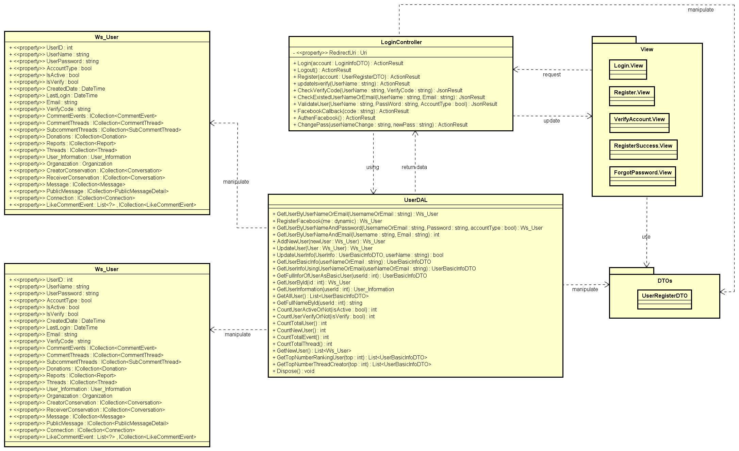

Common functions class diagram

##### Sequence diagram

###### Login

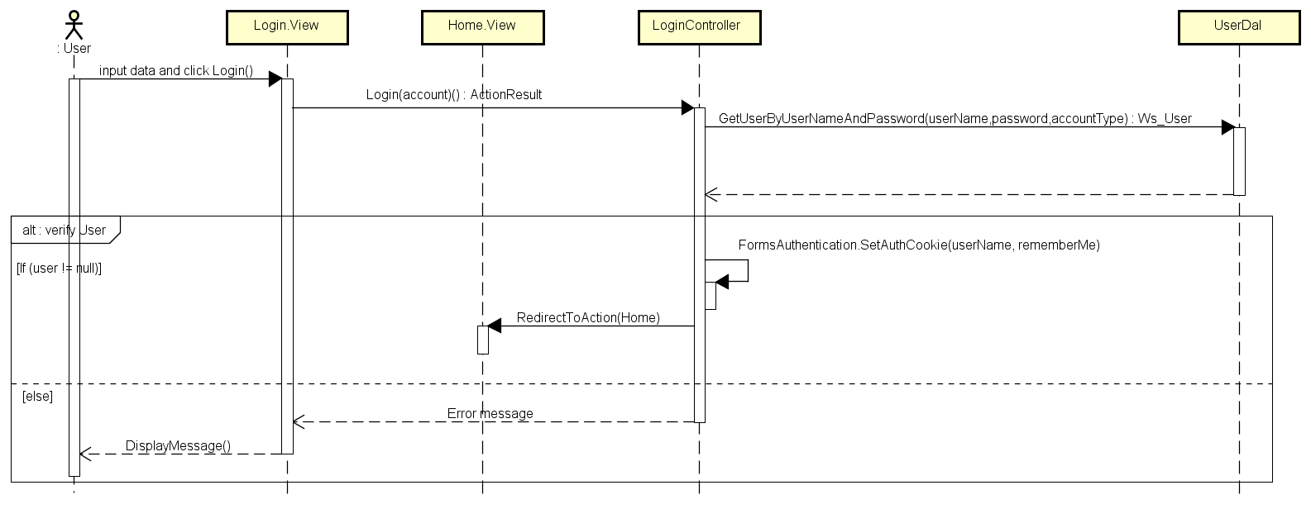

Login sequence diagram

###### Logout

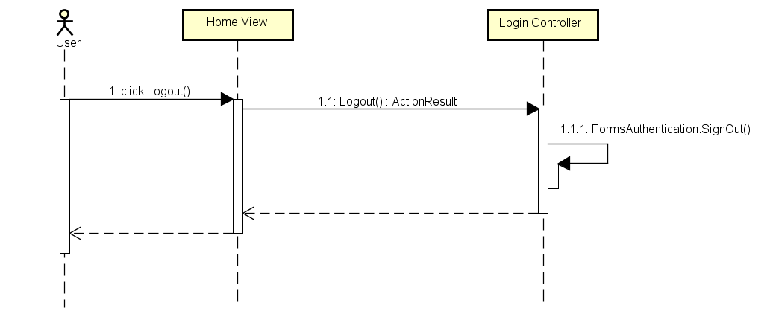

Logout sequence diagram

###### Register

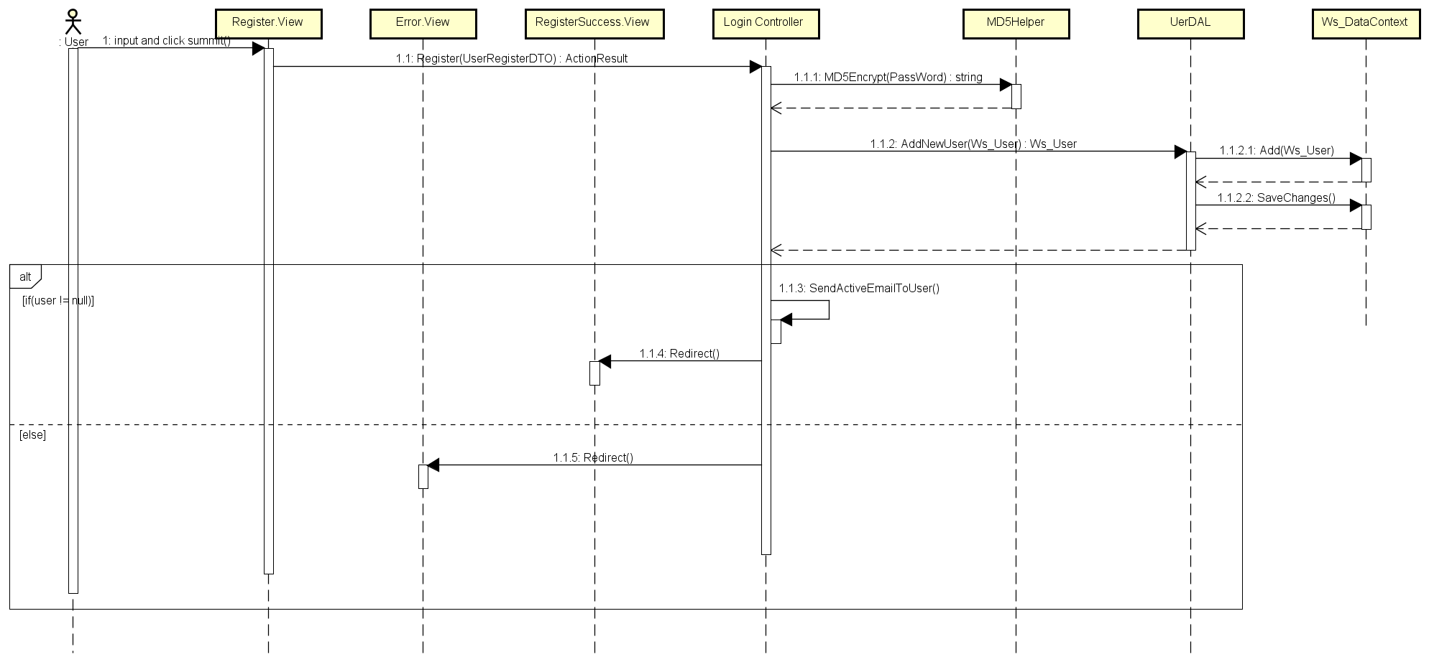

Register sequence diagram

###### Forgot Password

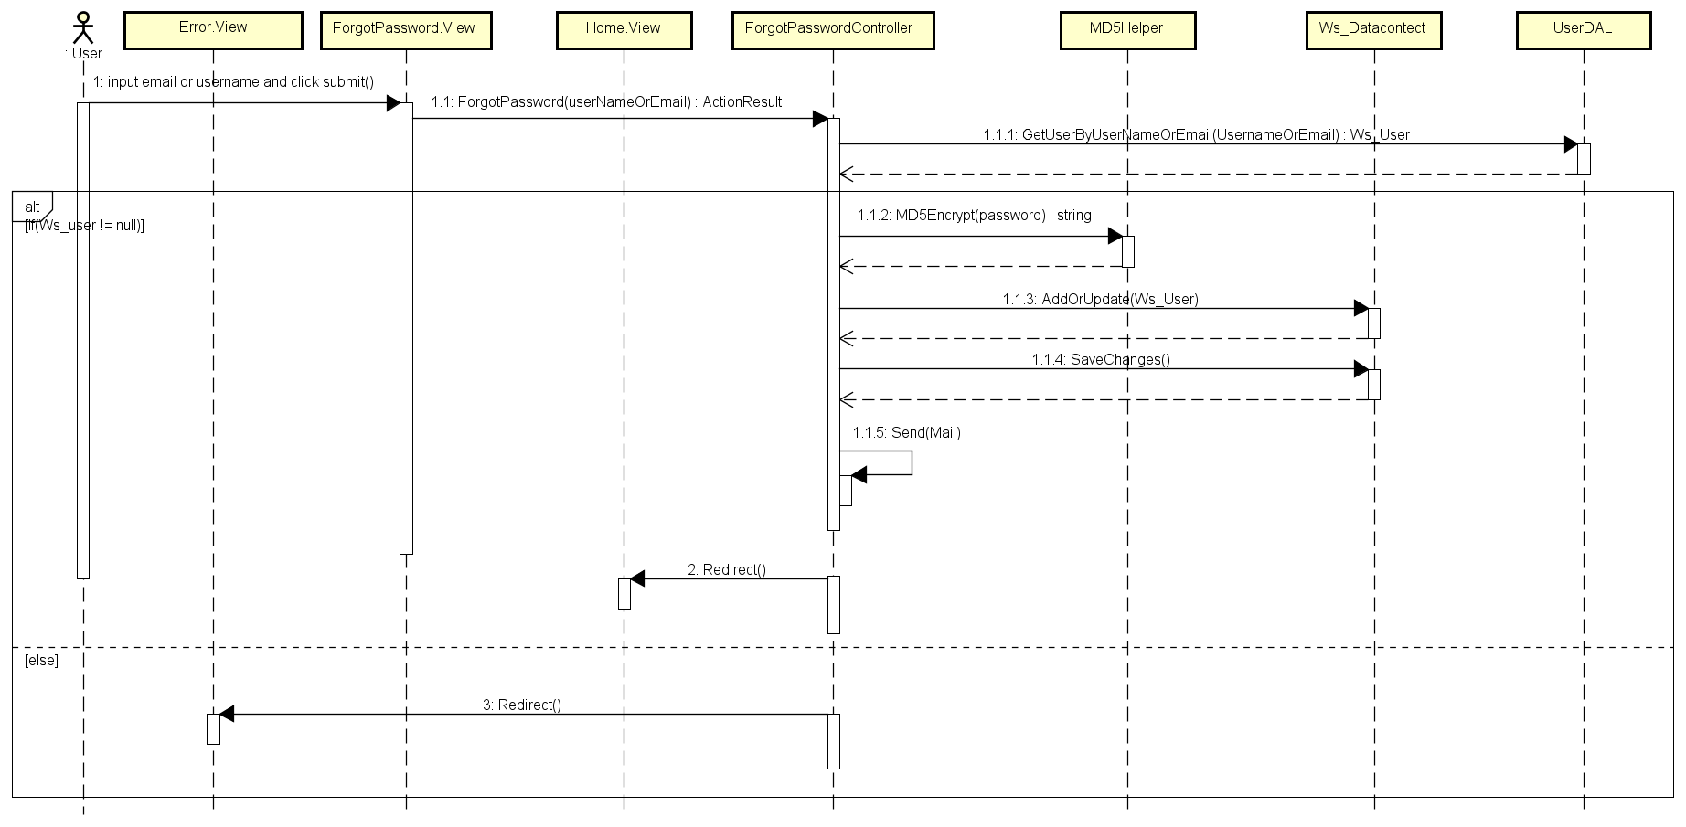

Forgot password sequence diagram

#### Event management

##### Class diagram

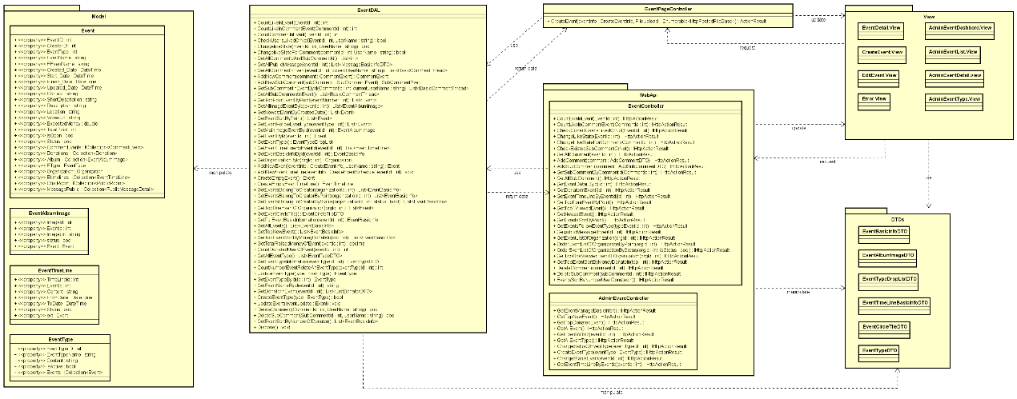

Event Management Class Diagram

##### Sequence diagram

###### Create event

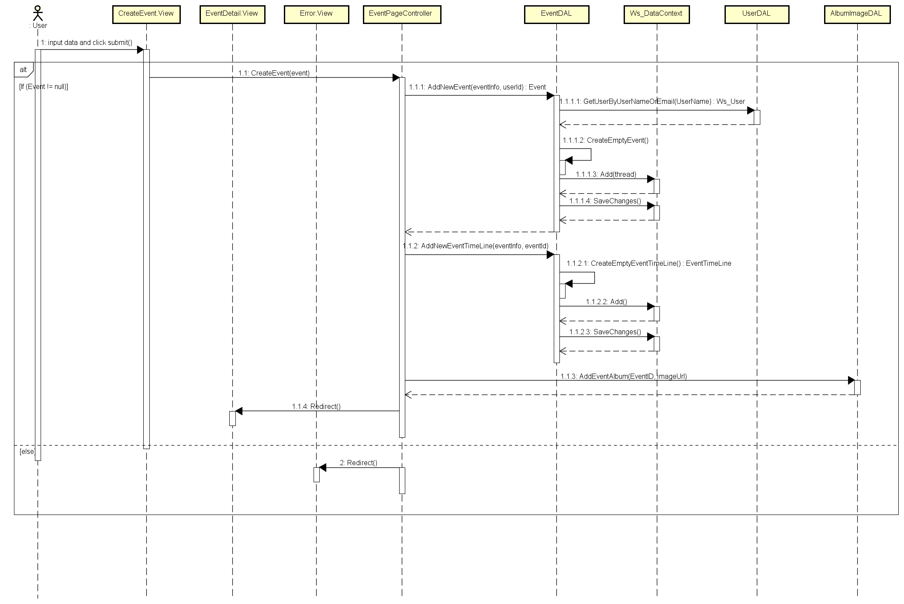

Create Event Sequence Diagram

#### Thread management

##### Class diagram

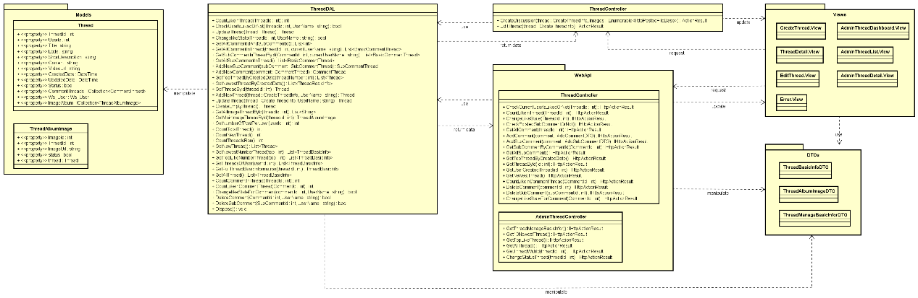

Thread Management Sequence Diagram

##### Sequence diagram

###### Create thread

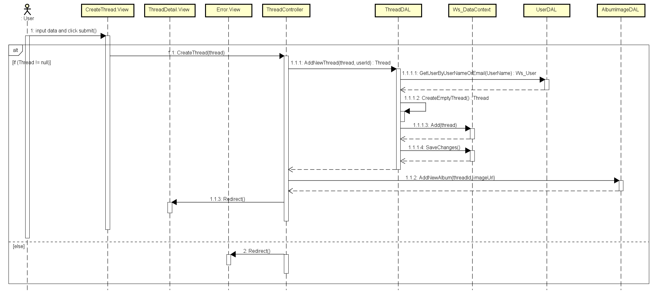

Create Thread Sequence Diagram

###### Edit Thread

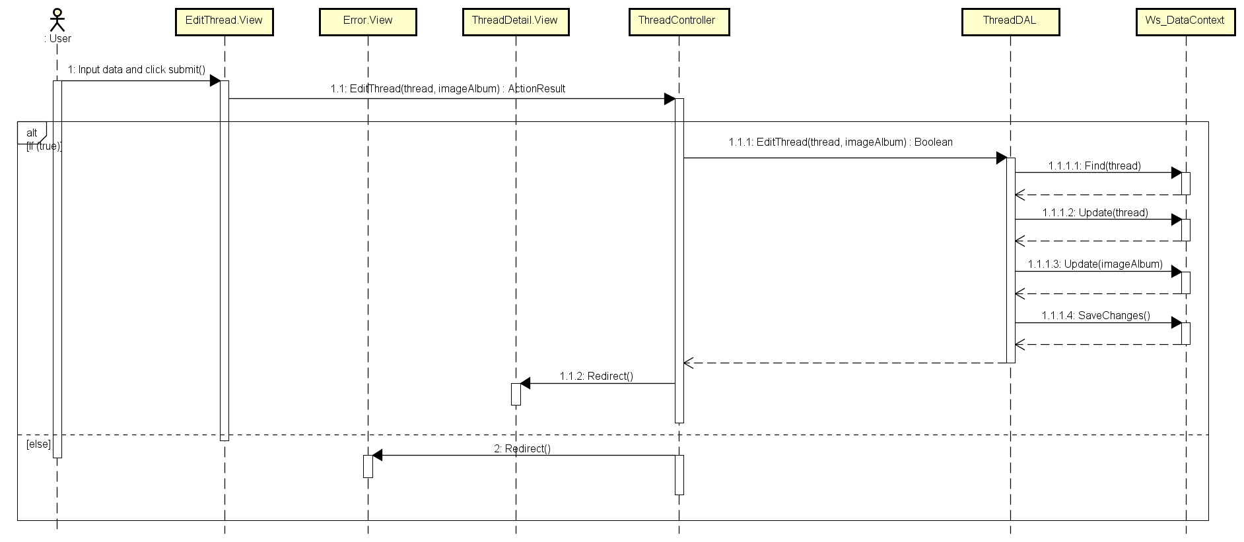

Edit Thread Sequence Diagram

#### Organization management

##### Class diagram

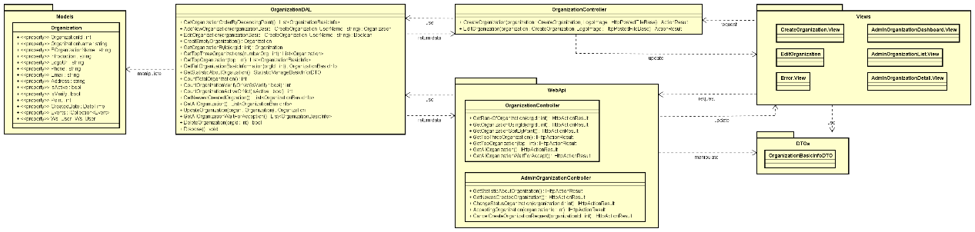

Organization Management Class Diagram

##### Sequence diagram

###### Create organization

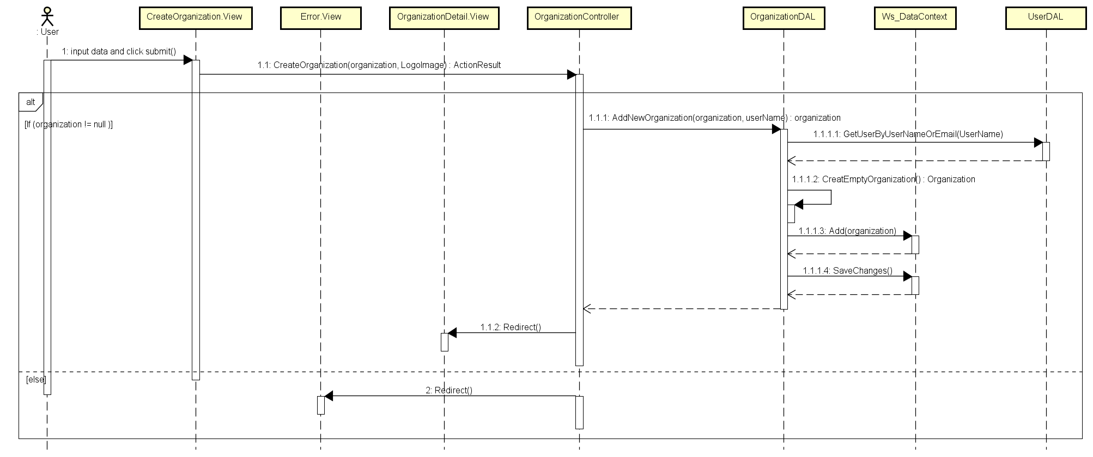

Create Organization Sequence Diagram

###### Edit organization

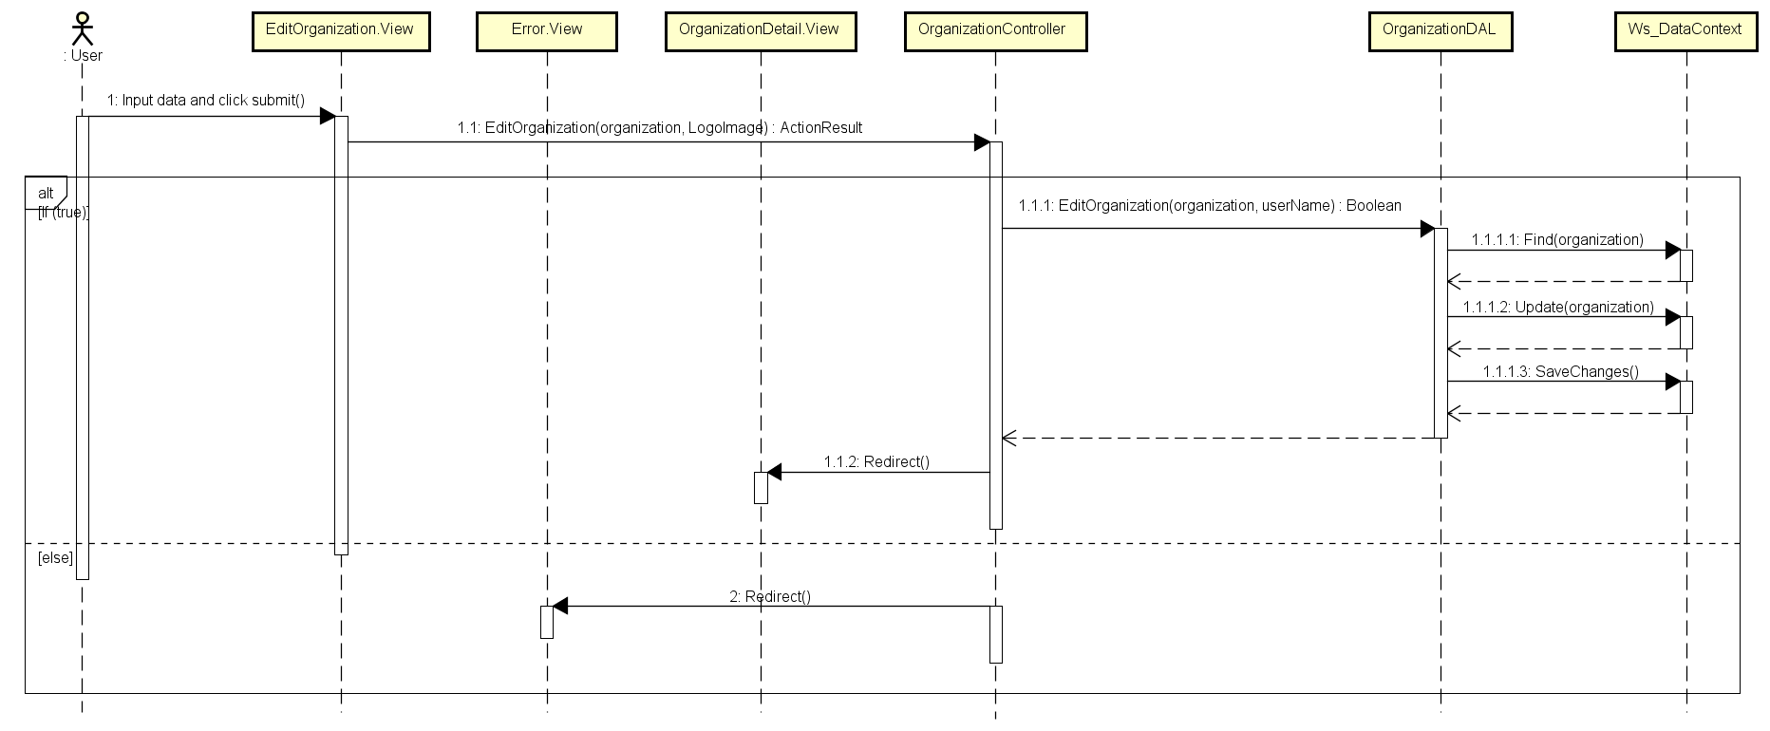

Edit Organization Sequence Diagram

#### User information management

##### Class diagram

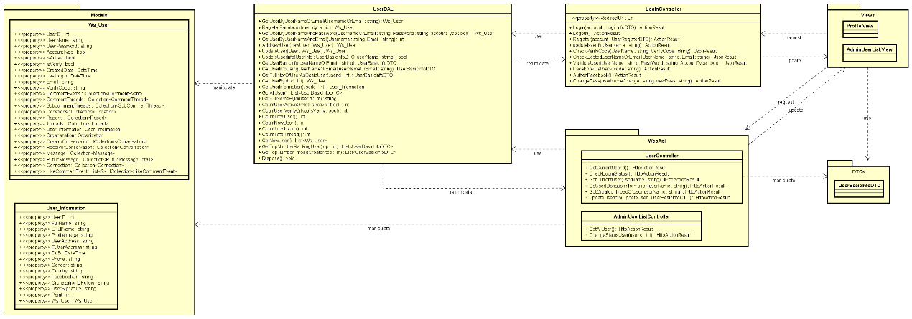

User information Management Class Diagram

##### Sequence diagram

###### Edit profile

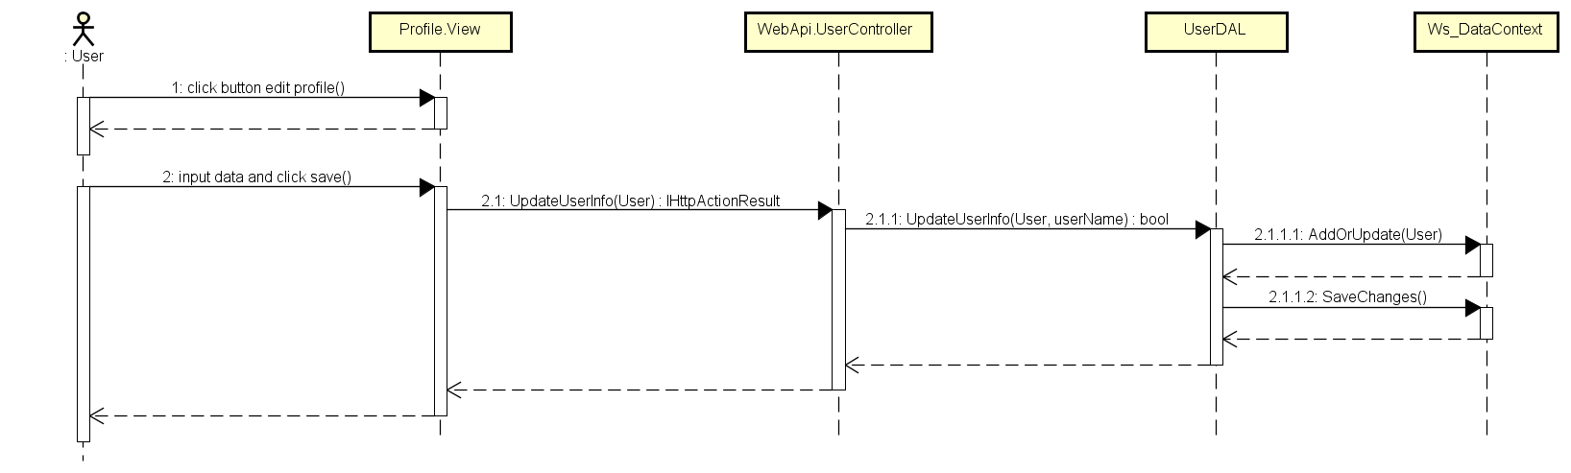

Edit Profile Sequence Diagram

###### Change password

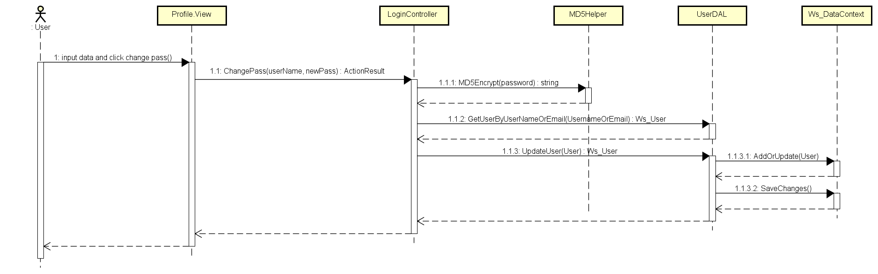

Change Password Sequence Diagram

###### Active/ De-active user account

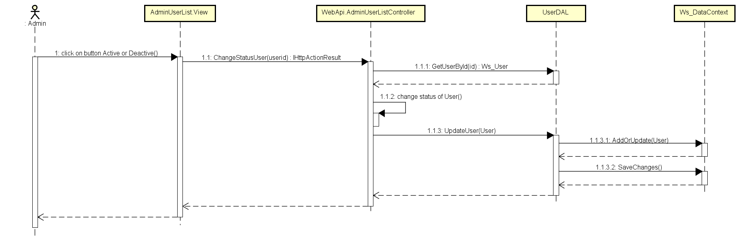

Active/ De-active user account Sequence Diagram

#### Report management

##### Class diagram

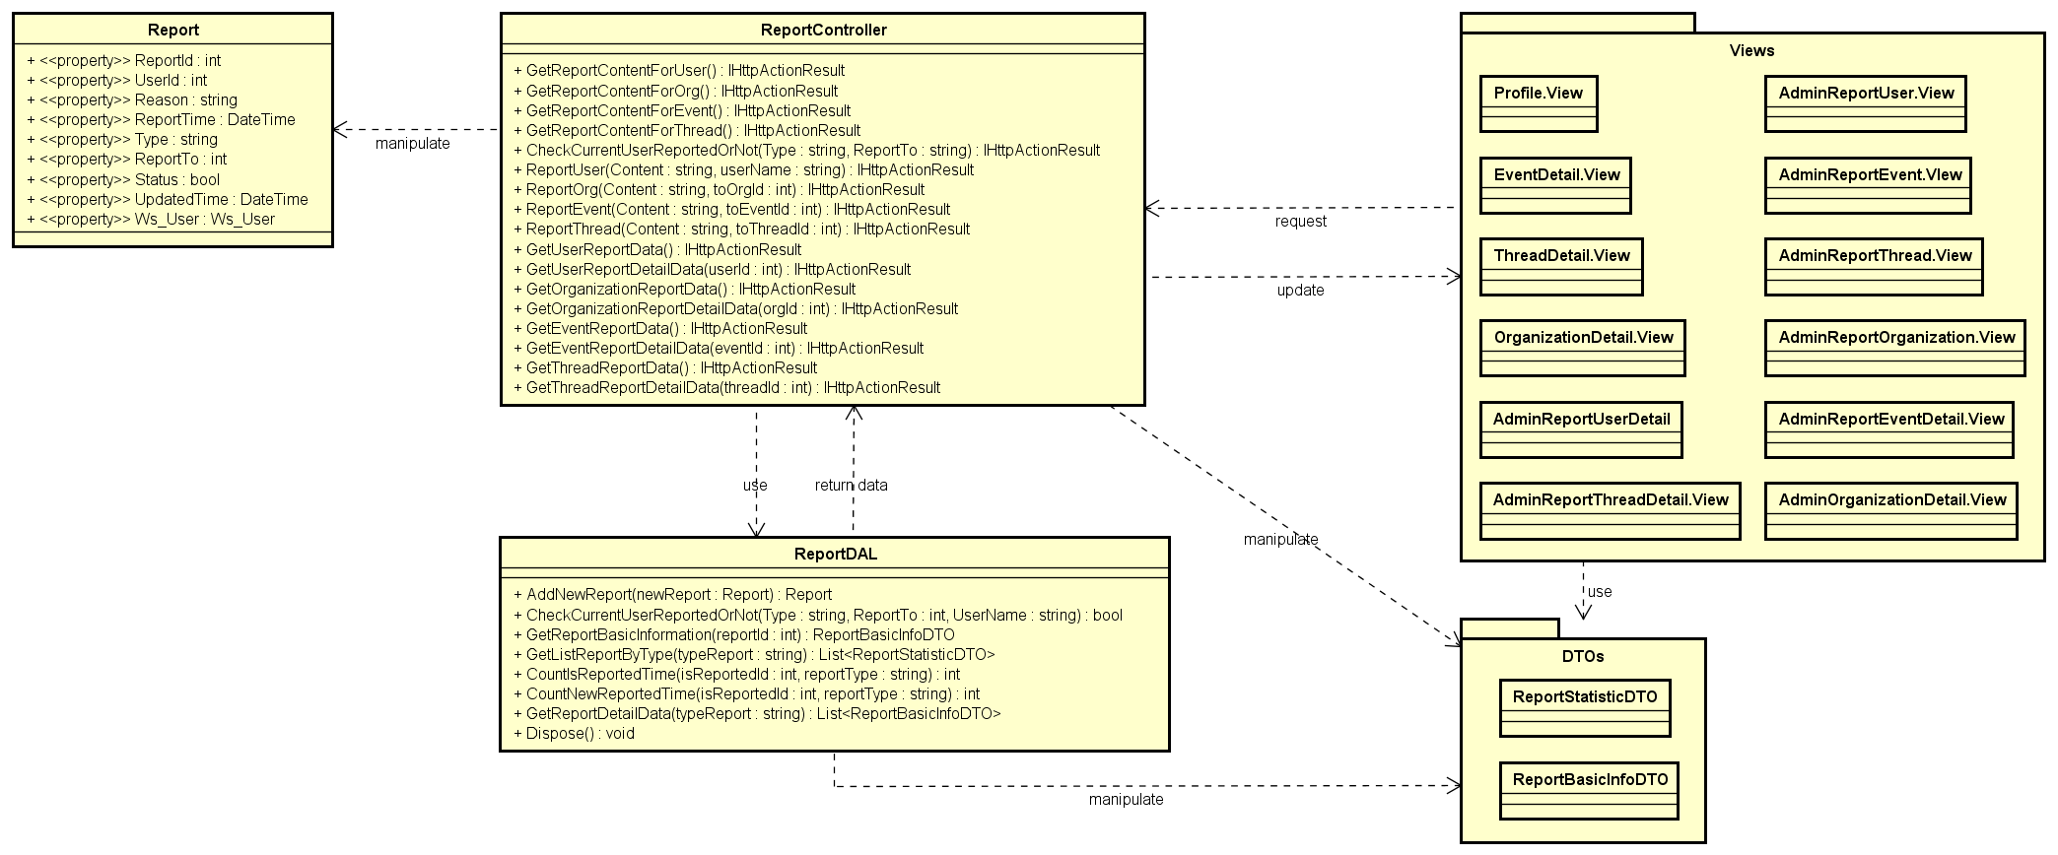

Report Management Class Diagram

##### Sequence diagram

###### Report event

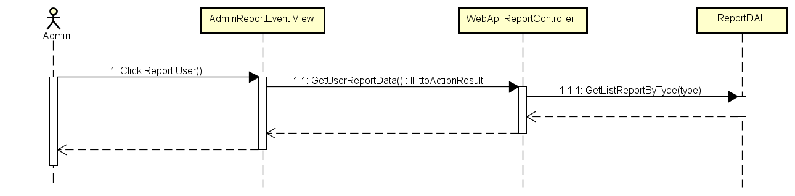

Load Event’s Report Sequence Diagram

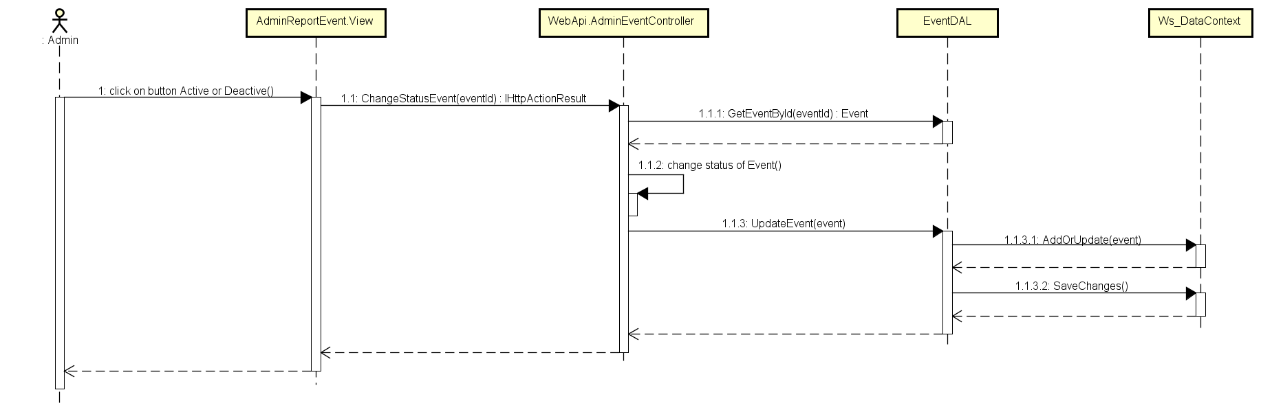

Change Status of Event Sequence Diagram

###### Report user

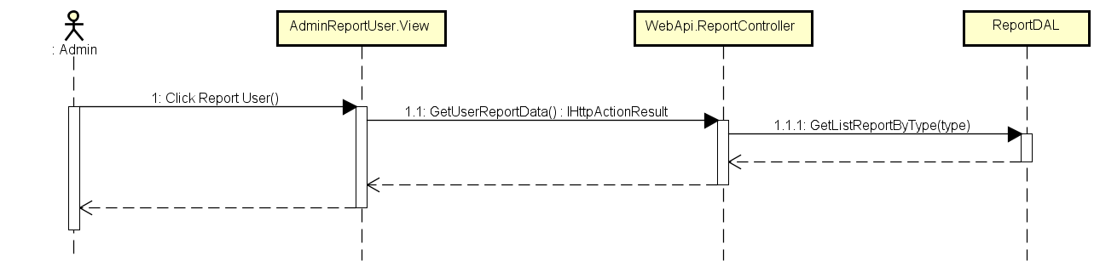

Load User’s Report Sequence Diagram

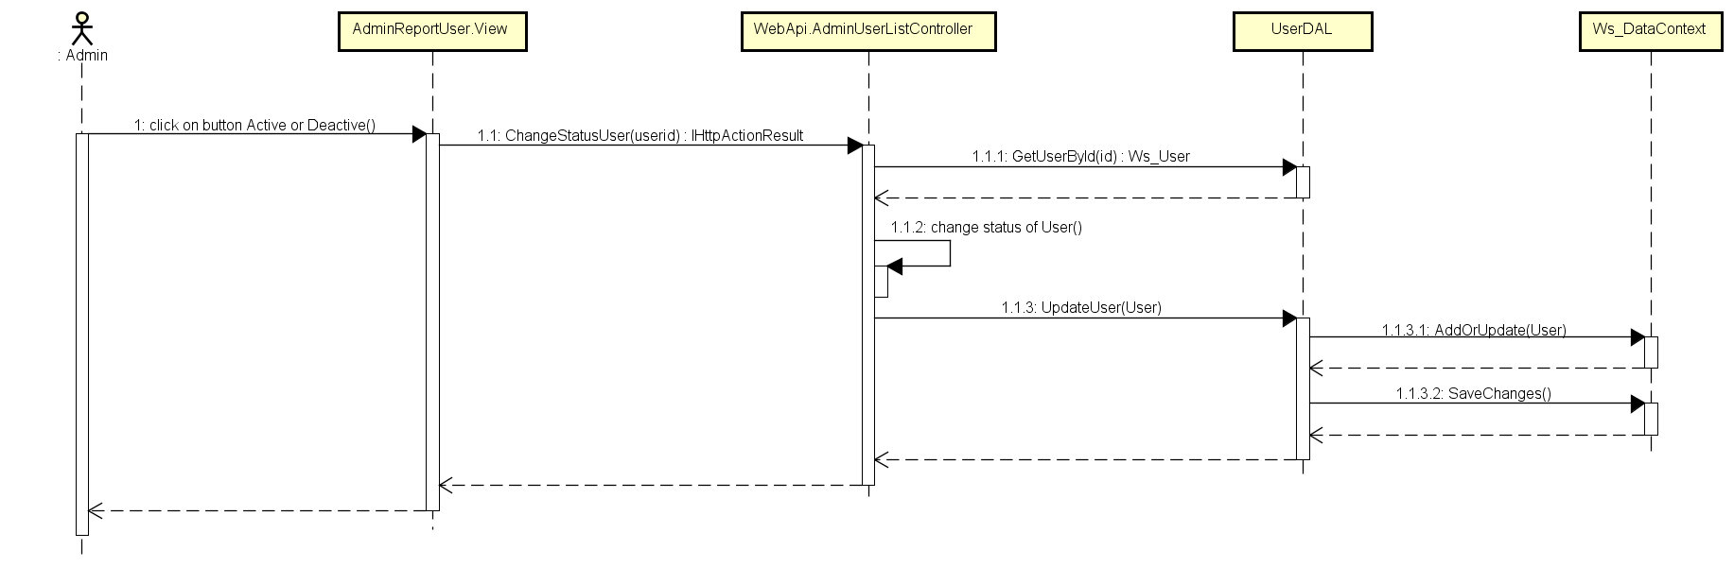

Change Status User Sequence Diagram

###### Report thread

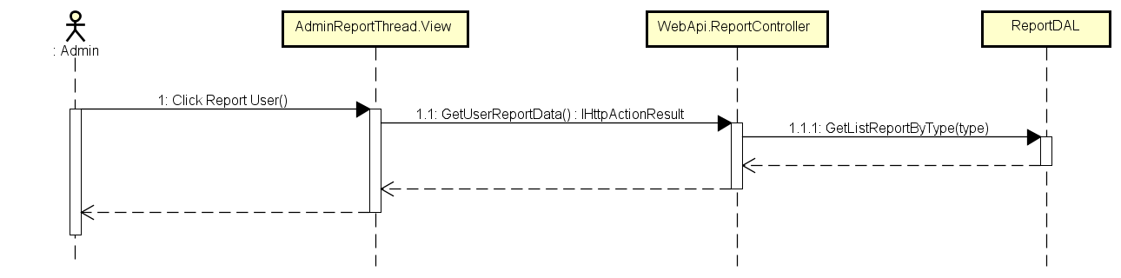

Load Thread’s Report Sequence Diagram

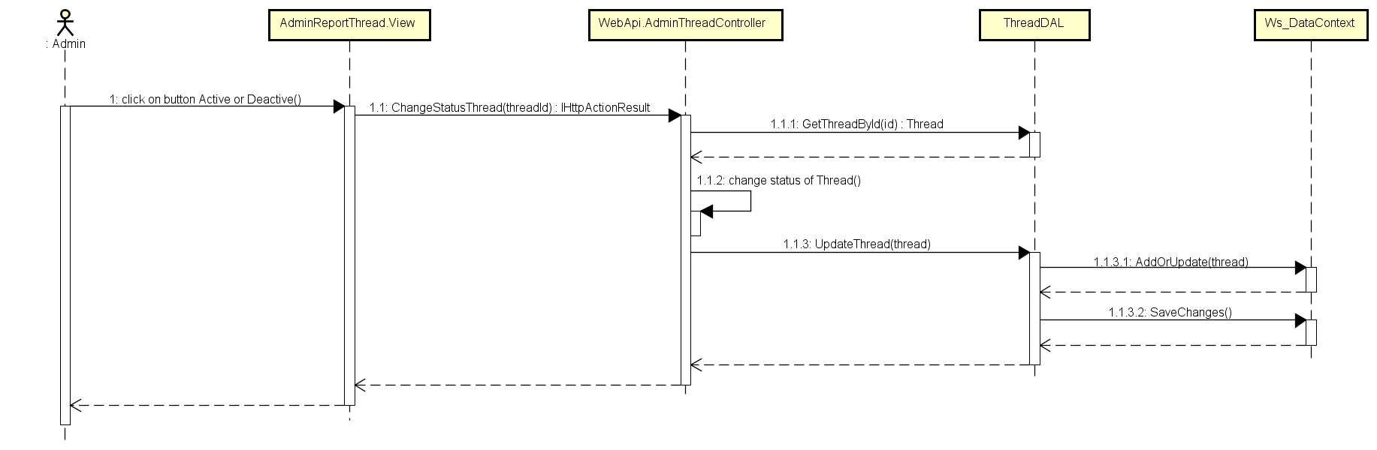

Change Status Thread Sequence Diagram

###### Report organization

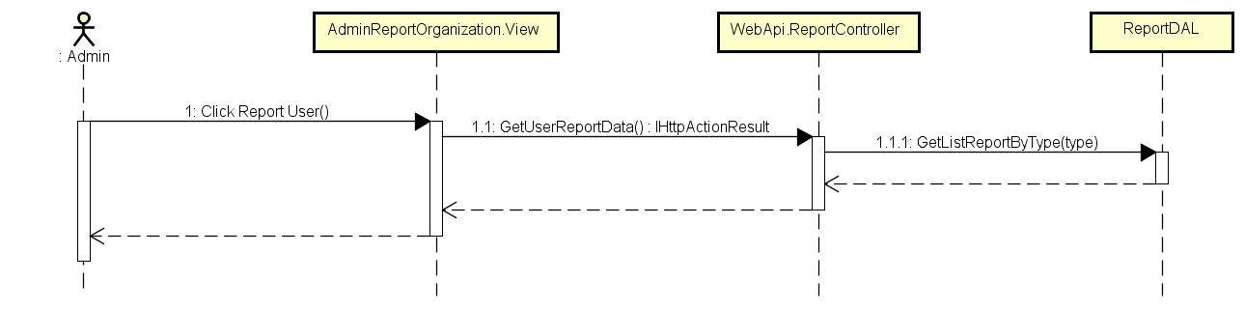

Load Organization’s Report Sequence Diagram

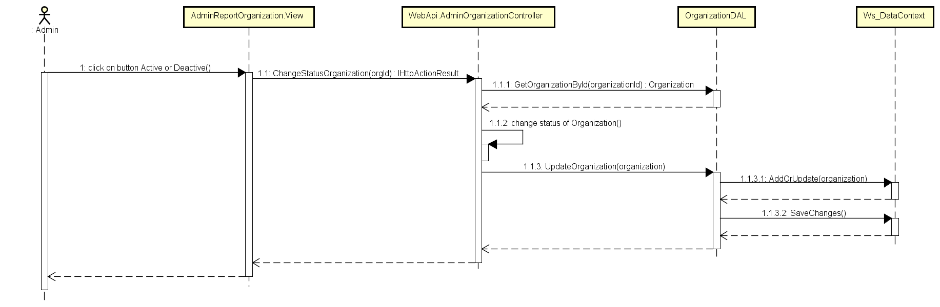

Change Status Organization Sequence Diagram

#### Comment management

##### Class diagram

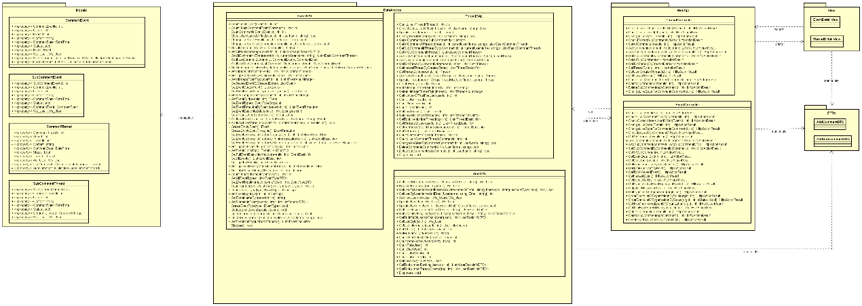

Comment Management Class Diagram

##### Sequence diagram

###### Event Post Comment

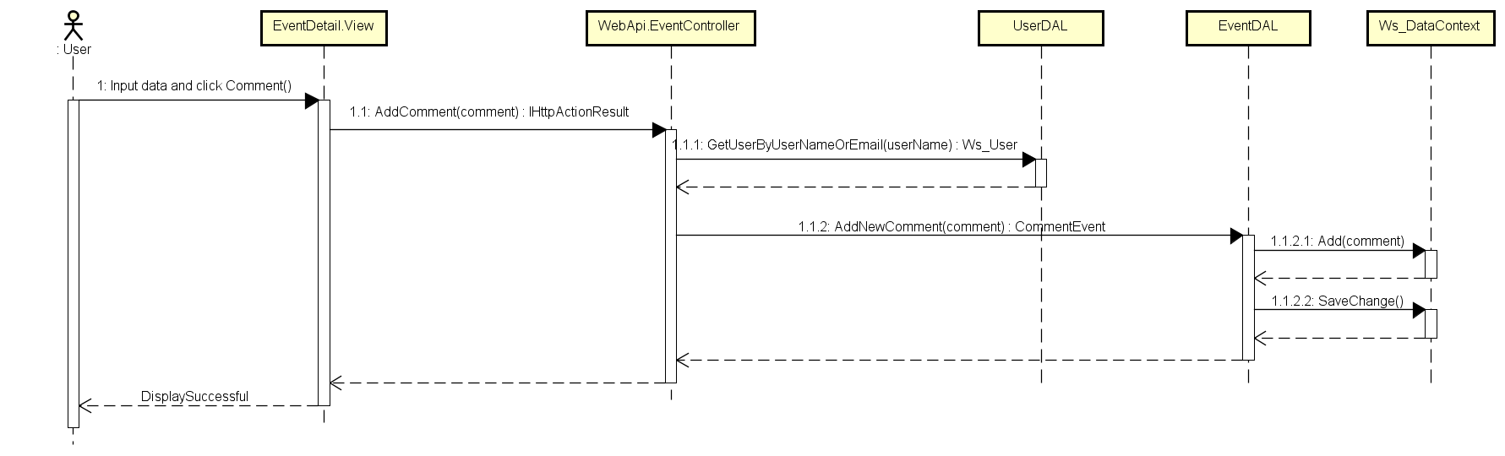

Event Post Comment Sequence Diagram

###### Event Reply Comment

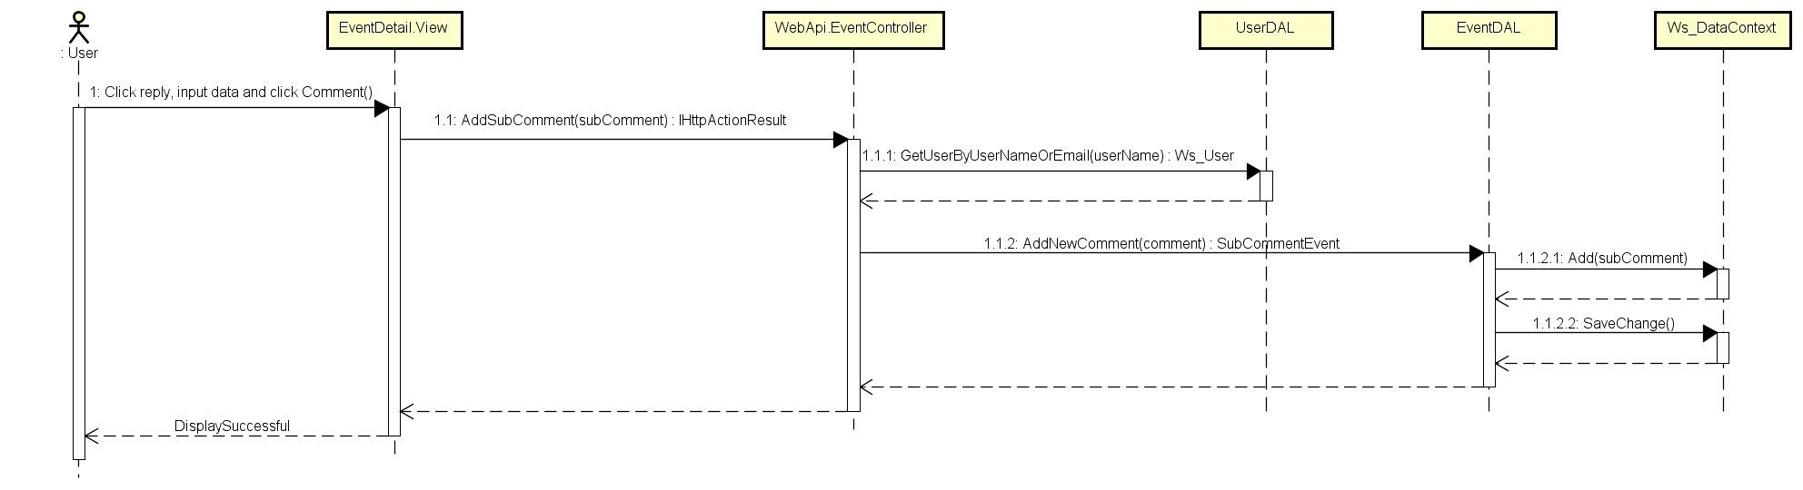

Event Reply Comment

###### Event Delete Comment

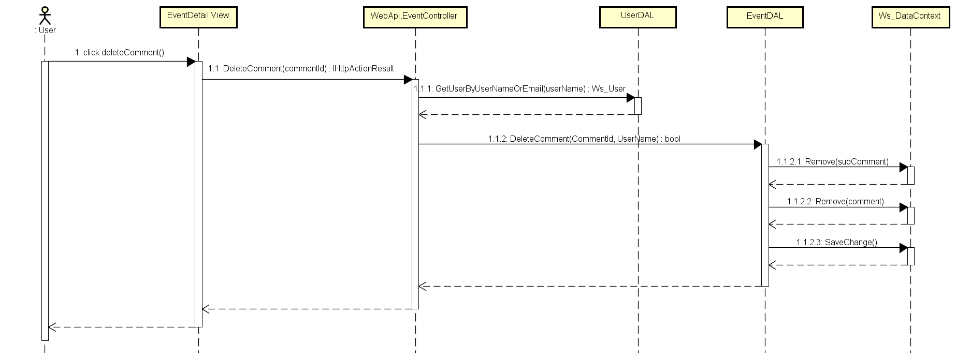

Event Delete Comment Sequence Diagram

###### Event Delete Reply Comment

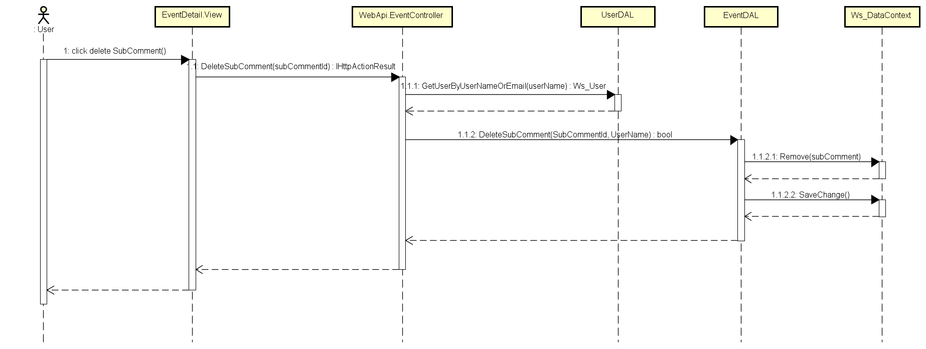

Event Delete Reply Comment

###### Thread Post Comment

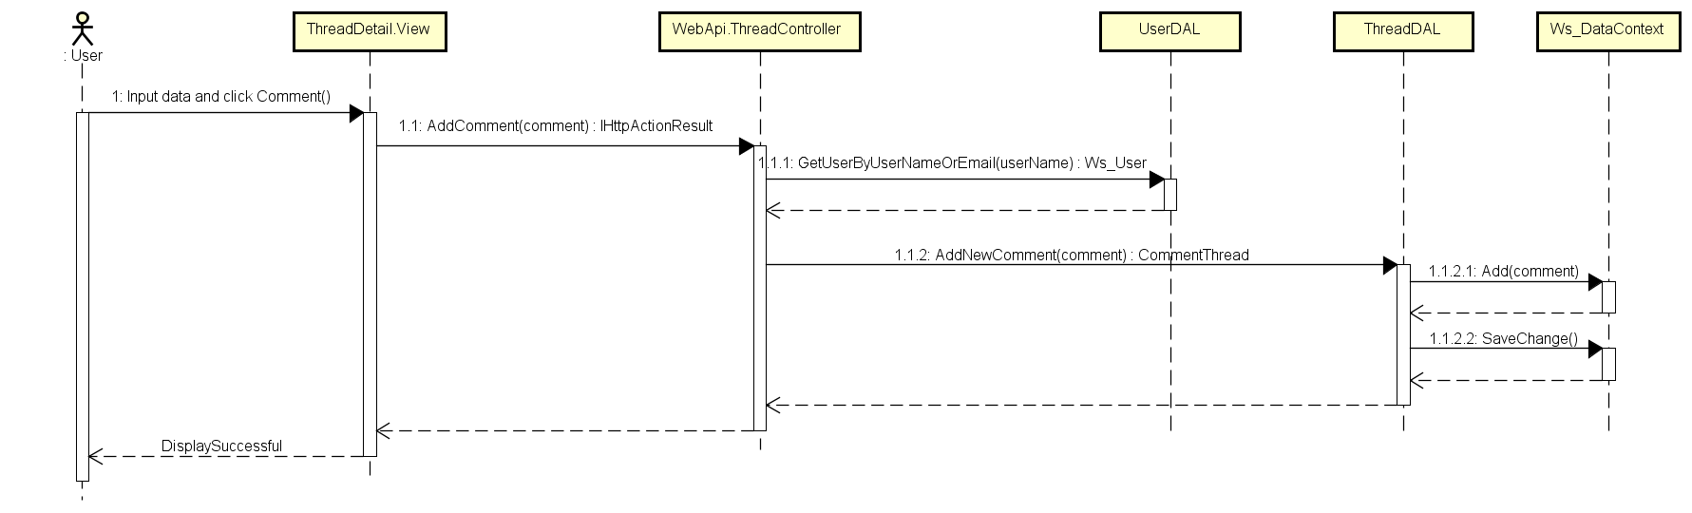

Thread Post Comment Sequence Diagram

###### Thread Reply Comment

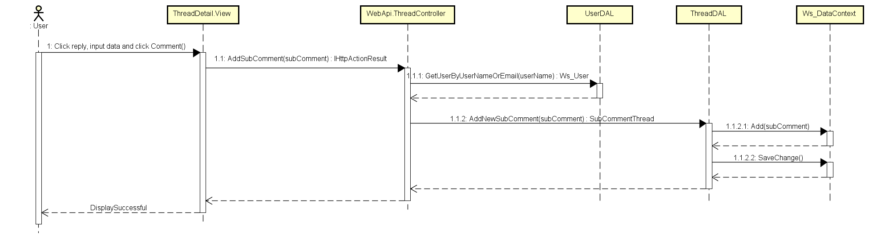

Thread Reply Comment Sequence Diagram

###### Thread Delete Comment

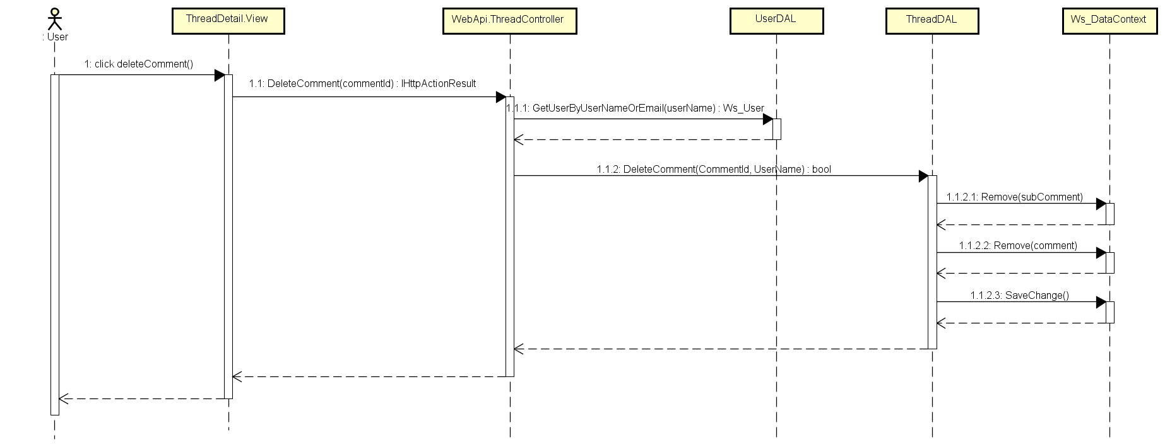

Thread Delete Comment Sequence Diagram

###### Thread Delete Reply Comment

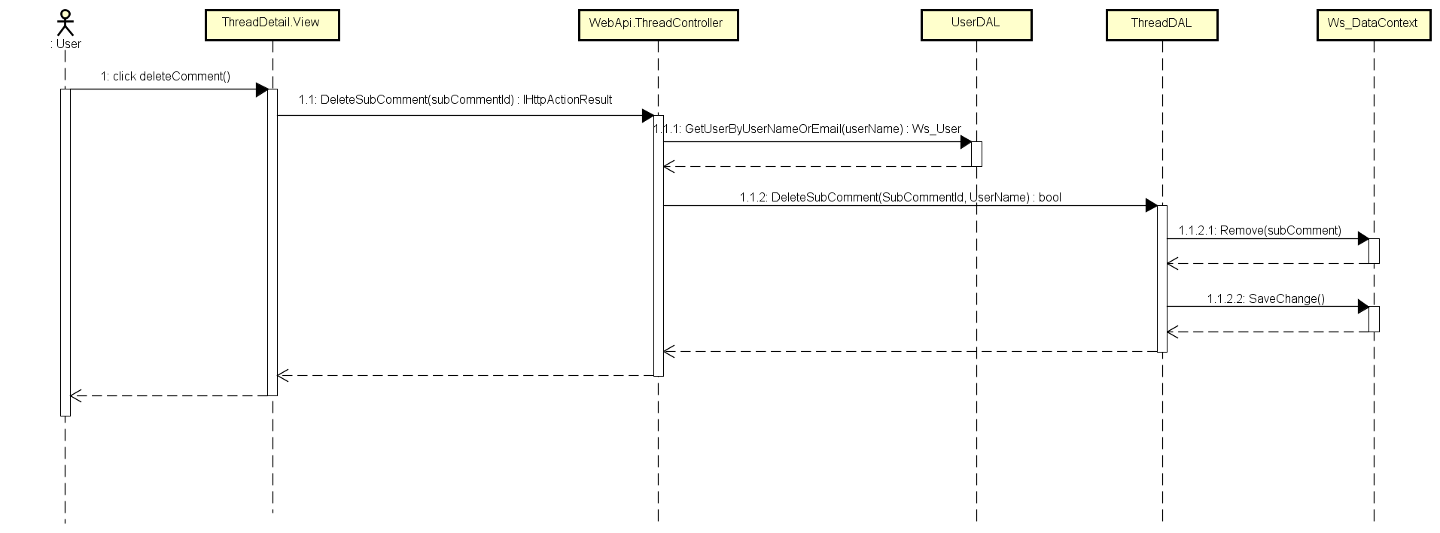

Thread Delete Reply Comment Sequence Diagram

## Data design

### Entity Relationship Diagram

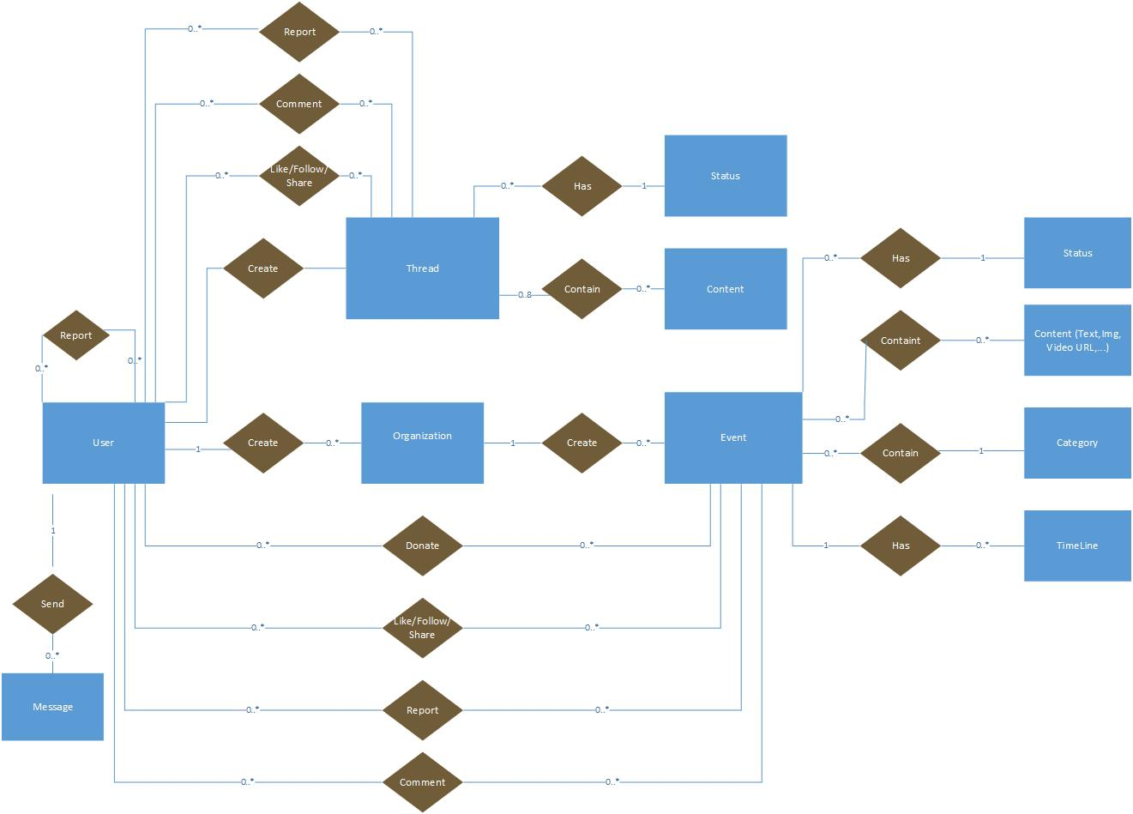

**Figure 2‑1:** Entity Relationship Diagram

#### Entity description

|  |  |  |
| --- | --- | --- |
| **No** | **Entity** | **Description** |
|  | WS_User | User is all people who using WS feature |
|  | Event | An event which user created, includes content, schedule, photo, video to descripting. |
|  | Time Line | Timeline detail of an event. |
|  | Category | A category which user use to filter event |
|  | Organization | An organization can be created by an user (If user or group qualify). Only group can create event |
|  | Thread | Post of user created. Where all user can discussion. |
|  | Status | A status of Event or Thread. Active or be banned. |
|  | Conversation | A Conversation which user created and joined to send and receive message together |
|  | Message | A Message which user send or receive to talk together |

**Table 2-3:** Entity description

#### Relationship

|  |  |  |  |  |  |
| --- | --- | --- | --- | --- | --- |
| **No** | **Relation** | **Properties** | **From** | **To** | **Description** |
|  | CONTAINS | None | Category | Event | A category contains many Event |
|  | HAS | None | Status | Event | A status contains many Event |
|  | HAS | None | Project | TimeLine | A event has one or more timelines, describe the detail of event |
|  | CONTAINS | None | Event | Content | An event contains many content (picture, text, video url…) |
|  | CREATE | None | User | Organization | An user can create organization if they want create event or group other users who have same idea. |
|  | CREATE | None | Organization | Event | An organization can create one or more event |
|  | COMMENT | UserID  EventID | User | Event | A Comment which user give to event |
|  | DONATE | UserID  EventID | User | Event | A event which user donate |
|  | FOLLOW | UserID  EventID | User | Event | A Remind which user bookmark an Event. |
|  | REPORT | UserID  EventID | User | Event | A Report which user report an Event |
|  | CONTAINS | None | Thread | Content | A thread contains many content (picture, text, video url…) |
|  | HAS | None | Status | Thread | A status contains many thread |
|  | CREATE | None | User | Thread | An user can create one or more thread |
|  | COMMENT | UserID  ThreadID | User | Thread | A Comment which user give to thread |
|  | FOLLOW | UserID  ThreadID | User | Thread | A Remind which user bookmark a thread. |
|  | REPORT | UserID  ThreadID | User | Thread | A Report which user report an thread |
|  | REPORT | ReportUseID  ReportedUseID | User |  | A Report which User report another user |
|  | HAS | None | Conversation | Message | A Has which conversation has message(s) |
|  | SEND | None | User | Message | A Send which User create and send message |

Table 2‑1: Relationship description

### Table Diagram



**Figure 2‑2:** Table Diagram

#### User table

|  |  |  |  |  |
| --- | --- | --- | --- | --- |
| **No** | **Field Name** | **Type** | **Allow Null** | **Description** |
|  | UserID | int | No | User’s ID |
|  | UserName | String | No | User’s name |
|  | UserPassword | String | No | User’s password |
|  | IsActive | bool |  | User’s active status (inactive, active) |
|  | CreatedDate | Datetime |  | User’s created date |
|  | LoginType | String |  | User’s created type includes: normal, Facebook or both |
|  | LastLogin | Datetime |  | User’s last login |
|  | AccountType | Bit |  | User’s type (admin or nomal user) |
|  | IsVerify | bool |  | User’ email verify status |
|  | VerifyCode | String |  | User’s verify code |
|  | Email | String | No | User’s email |

Table 2‑2: User table

#### UserInformation table

|  |  |  |  |  |
| --- | --- | --- | --- | --- |
| **No** | **Field Name** | **Type** | **Allow Null** | **Description** |
|  | UserID | int | No | Person’s ID |
|  | FullName | String |  | Person’s full name |
|  | ProfileImage | String |  | Person’s profile image |
|  | OrgnazationIDFollow | String |  | Person’s OrgnazationIDFollow |
|  | UserAddress | String |  | Person’s address |
|  | Gender | String |  | Person’s gender |
|  | PhoneNumber | String |  | Person’s phone number |
|  | DateOfBirth | Datetime |  | Person’s date of birth |
|  | Country | String |  | Person’s country |
|  | Phone | String |  | Person’s Phone |
|  | FacebookURL | String |  | Person’s facebook link |
|  | UserSignature | String |  | Person’s UserSignature |
|  | Point | Int | No | Person’s Point |

Table 2‑2: UserInformation table

#### Event table

|  |  |  |  |  |
| --- | --- | --- | --- | --- |
| **No** | **Field Name** | **Type** | **Allow Null** | **Description** |
|  | EventID | int | No | Event’s ID |
|  | CreatorID | int | No | Event’s creator (userID) |
|  | EventType | int | No | Event’s type |
|  | EventName | String |  | Event’s name |
|  | Created_Date | Datetime | No | Event’s date created |
|  | Finish_Date | Datetime |  | Event’s finish date |
|  | Updated_Date | Datetime | No | Event’s update timeline |
|  | ShortDescription | String | No | Event’s shortDescription |
|  | Description | String | No | Event’s description |
|  | Location | String | No | Event’s location |
|  | VideoUrl | String | No | Event’s video URL |
|  | TotalPoint | int | No | Event’s TotalPoint |
|  | Status | bit |  | Event’s status |
|  | IsOpen | bool |  | Event’s activity status |
|  | Views | int |  | Event’s total views |
|  | Likes | int |  | Event’s total likes |
|  | ExpectedMoney | decimal |  | Event’s expected money |

Table 2‑3: Event table

#### Organization table

|  |  |  |  |  |
| --- | --- | --- | --- | --- |
| **No** | **Field Name** | **Type** | **Allow Null** | **Description** |
|  | OrganazationID | Int | No | Organization’s ID |
|  | OrganazationName | String |  | Organization’s Name |
|  | Introduction | String |  | Introduce about Organization |
|  | LogoUrl | String |  | Organization’s logo |
|  | Phone | String |  | Organization’s phone |
|  | Email | String |  | Organization’s email for contact |
|  | Address | String |  | Organization’s Address |
|  | Status | String | No | Organization’s Status |
|  | Point | int | No | Organization’s point |
|  | IsActive | bool |  | Organization’s activity status |
|  | IsVerify | bool |  | Organization’s creating request status |
|  | CreatedDate | DateTime |  | Organization’s created date |

Table 2‑4: Organization table

#### EventType table

|  |  |  |  |  |
| --- | --- | --- | --- | --- |
| **No** | **Field Name** | **Type** | **Allow Null** | **Description** |
|  | EventTypeID | int | No | EventType’s ID |
|  | Name | String |  | EventType’s name |
|  | IsActive | bool |  | EventType’s active status |
|  | [Content] | String |  | EventType’s description |

Table 2‑5: Category table

#### Report table

|  |  |  |  |  |
| --- | --- | --- | --- | --- |
| **No** | **Field Name** | **Type** | **Allow Null** | **Description** |
|  | ReportID | int | No | Report ’s ID |
|  | UserID | int | No | Report ’s user id, who report project |
|  | Reason | String |  | Report ’s Reason |
|  | ReportTime | Datetime | No | Report ’s report date |
|  | Type | String | No | Report ’s type |
|  | ReportTo | int |  | Report ’s to whom |
|  | Status | String |  | Report’s status (new, viewed, done) |
|  | UpdatedTime | DateTime |  | Report ’s update time |

Table 2‑6 Report table

#### EventTimeLine table

|  |  |  |  |  |
| --- | --- | --- | --- | --- |
| **No** | **Field Name** | **Type** | **Allow Null** | **Description** |
|  | TimeLineId | int | No | Event’s schedule |
|  | EventId | int | No | EventID |
|  | Content | string | No | Event’s timeline content |
|  | FromDate | DateTime |  | Starting date |
|  | ToDate | DateTime |  | End date |
|  | Status | bool |  | Sub event’s status |

Table 2‑7: EventTimeLine table

#### Donate table

|  |  |  |  |  |
| --- | --- | --- | --- | --- |
| **No** | **Field Name** | **Type** | **Allow Null** | **Description** |
|  | DonationId | int | No | Donation’s ID |
|  | UserID | int | No | Donor id |
|  | EventId | int | No | Event’s id |
|  | DonatedDate | Datetime |  | Donated’s date |
|  | IsPublic | bool | No | Is public |
|  | DonatedMoney | decimal |  | Amount money donate |
|  | TradeCode | string |  | Trade code |
|  | Content | string |  | Content of donate |

Table 2‑8: Donate table

#### CommentEvent table

|  |  |  |  |  |
| --- | --- | --- | --- | --- |
| **No** | **Field Name** | **Type** | **Allow Null** | **Description** |
|  | CommentEventId | int | No | Comment’s ID |
|  | UserID | int | No | Comment’s user id |
|  | EventID | int | No | Comment’s Event id |
|  | CmtContent | String |  | Comment’s content |
|  | CmtDate | Datetime | No | Comment’s date |

Table 2‑9: CommentEvent table

#### SubcommentEvent table

|  |  |  |  |  |
| --- | --- | --- | --- | --- |
| **No** | **Field Name** | **Type** | **Allow Null** | **Description** |
|  | SubCommentEventId | int |  | SubCommentEvent’s ID |
|  | CommentEventId | int |  | CommentEvent’s ID |
|  | UserId | int |  | UserID who comment |
|  | Content | string |  | SubCommentEvent’s content |
|  | CommentDate | Datetime |  | SubCommentEvent’s date |
|  | Status | bool |  | SubCommentEvent’s status |

Table 2‑10: Subcomment table

#### LikeEvent table

|  |  |  |  |  |
| --- | --- | --- | --- | --- |
| **No** | **Field Name** | **Type** | **Allow Null** | **Description** |
| 1 | LikeId | int |  | Like’s ID |
| 2 | UserId | int |  | Like’s user id |
| 3 | EventId | int |  | Like’s event id |
| 4 | Status | bool |  | Likes’s status |

Table 2‑13: LikeEvent table

#### LikeCommentEvent table

|  |  |  |  |  |
| --- | --- | --- | --- | --- |
| **No** | **Field Name** | **Type** | **Allow Null** | **Description** |
| 1 | LikeCommentId | int |  | LikeComment’s ID |
| 2 | CommentId | int |  | LikeComment’s comment id |
| 3 | UserId | int |  | LikeComment’s user id |
| 4 | Status | String |  | LikeComment’s status |

Table 2‑13: LikeCommentEvent table

#### EventAlbumImage table

|  |  |  |  |  |
| --- | --- | --- | --- | --- |
| **No** | **Field Name** | **Type** | **Allow Null** | **Description** |
|  | ImageId | int | No | Image’s Id |
|  | EventId | int | No | Event’s ID |
|  | ImageUrl | String |  | Image URL link |
|  | Status | bool |  | Image’s status |

Table 2‑11: EventAlbumImage table

#### Thread table

|  |  |  |  |  |
| --- | --- | --- | --- | --- |
| **No** | **Field Name** | **Type** | **Allow Null** | **Description** |
|  | ThreadId | int | No | Thread’s ID |
|  | UserId | Int | No | user id of user who create slide |
|  | Title | String |  | Thread’s title |
|  | [Content] | String |  | Thread’s content |
|  | ShortDescription | String |  | Thread’s short description |
|  | VideoUrl | String |  | Thread’s url link |
|  | CreatedDate | datetime | No | The date which thread has been created |
|  | UpdatedDate | datetime | No | Last update of thread |
|  | Status | bool | No | Thread’s status |

Table 2‑11: Thread table

#### CommentThread table

|  |  |  |  |  |
| --- | --- | --- | --- | --- |
| **No** | **Field Name** | **Type** | **Allow Null** | **Description** |
|  | CommentThreadId | int | No | CommentThread’s ID |
|  | UserID | int | No | Comment’s user id |
|  | ThreadID | int | No | Comment’s Thread id |
|  | CmtContent | String |  | Comment’s content |
|  | CmtDate | Datetime | No | Comment’s date |
|  | Status | bool | No | Comment’s status |

Table 2‑12: Comment thread table

#### SubCommentThread table

|  |  |  |  |  |
| --- | --- | --- | --- | --- |
| **No** | **Field Name** | **Type** | **Allow Null** | **Description** |
|  | CommentThreadId | int | No | CommentThread’s ID |
|  | UserID | int | No | Comment’s user id |
|  | ThreadID | int | No | Comment’s Thread id |
|  | CmtContent | String |  | Comment’s content |
|  | CmtDate | Datetime |  | Comment’s date |
|  | Status | bool |  | Comment’s status |

Table 2‑14: SubComment Thread table

#### LikeThread table

|  |  |  |  |  |
| --- | --- | --- | --- | --- |
| **No** | **Field Name** | **Type** | **Allow Null** | **Description** |
|  | LikeId | int | No | Like’s ID |
|  | UserId | int | No | Like’s user id |
|  | ThreadId | int | No | Like’s thread id |
|  | Status | String |  | Like’s status |

Table 2‑14: Like Thread table

#### ThreadAlbumImage table

|  |  |  |  |  |
| --- | --- | --- | --- | --- |
| **No** | **Field Name** | **Type** | **Allow Null** | **Description** |
|  | ImageId | int | No | Image’s Id |
|  | ThreadId | int | No | Thread’s ID |
|  | ImageUrl | String |  | Image URL link |
|  | Status | bool |  | Image’s status |

Table 2‑11: ThreadAlbumImage table

#### Connection table

|  |  |  |  |  |
| --- | --- | --- | --- | --- |
| **No** | **Field Name** | **Type** | **Allow Null** | **Description** |
|  | ConnectionId | int | No | Connection’s Id |
|  | UserId | int | No | User’s ID |
|  | ConnectionString | String |  | Connection string of each user when connect to WS system |

Table 2‑11: Connection table

#### Conversation table

|  |  |  |  |  |
| --- | --- | --- | --- | --- |
| **No** | **Field Name** | **Type** | **Allow Null** | **Description** |
|  | ConversationID | int |  | Conversation’s ID |
|  | CreatorID | int |  | Conversation’s creator id |
|  | ReceiverID | int |  | Conversation’s receiver |
|  | Title | String |  | Conversation’s title |
|  | CreatedDate | Datetime |  | Conversation’s created date |
|  | UpdatedDate | Datetime |  | Conversation’s update date |
|  | isHidden | bool |  | Conversation’s showing status |
|  | isRead | bool |  | Conversation’s reading status |
|  | Status | bool |  | Conversation’s status |

Table 2‑11: Conversation table

#### Message table

|  |  |  |  |  |
| --- | --- | --- | --- | --- |
| **No** | **Field Name** | **Type** | **Allow Null** | **Description** |
|  | MessageID | int |  | Message’s ID |
|  | ConversationID | int |  | Message’s conversation id |
|  | UserID | int |  | Message’s user id |
|  | CreatedDate | Datetime |  | Message’s sent time |
|  | Content | String |  | Message’s content |
|  | Status | bool |  | Message’s status |

Table 2‑11: Message table

#### PublicMessageDetail table

|  |  |  |  |  |
| --- | --- | --- | --- | --- |
| **No** | **Field Name** | **Type** | **Allow Null** | **Description** |
|  | Id | int |  | PublicMessage’s ID |
|  | UserId | int |  | UserID who send message |
|  | EventId | int |  | Event id which contain message |
|  | Message | String |  | Message’s content |
|  | CreatedDate | Datetime |  | Message’s sent time |
|  | Status | bool |  | Message’s status |

Table 2‑11: PublicMessageDetail table

#### PublicRoom table

|  |  |  |  |  |
| --- | --- | --- | --- | --- |
| **No** | **Field Name** | **Type** | **Allow Null** | **Description** |
|  | PublicRoomId | int |  | PublicMessage’s ID |
|  | ConnectionId | int |  | Connection ID of room chat |
|  | EventId | int |  | Event’s id which contain room chat |

Table 2‑11: PublicRoom table

## Screen Design

### User

#### Screen flow

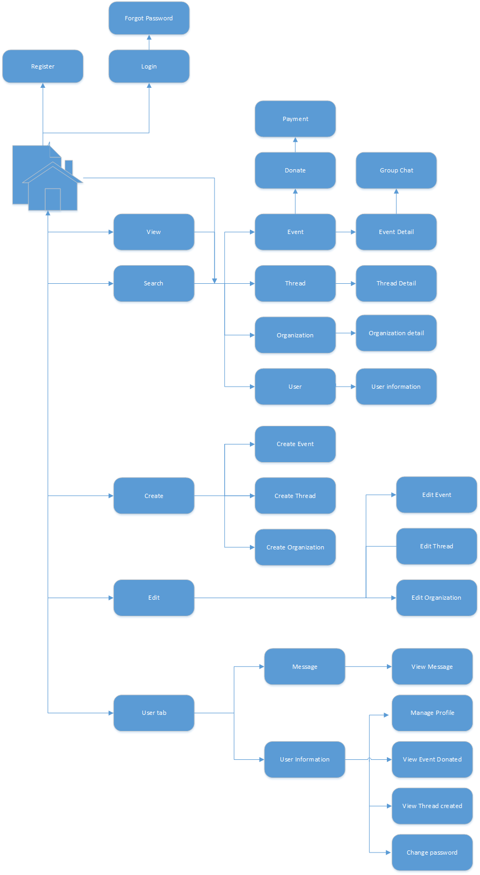

1. Client screen flow

#### Register

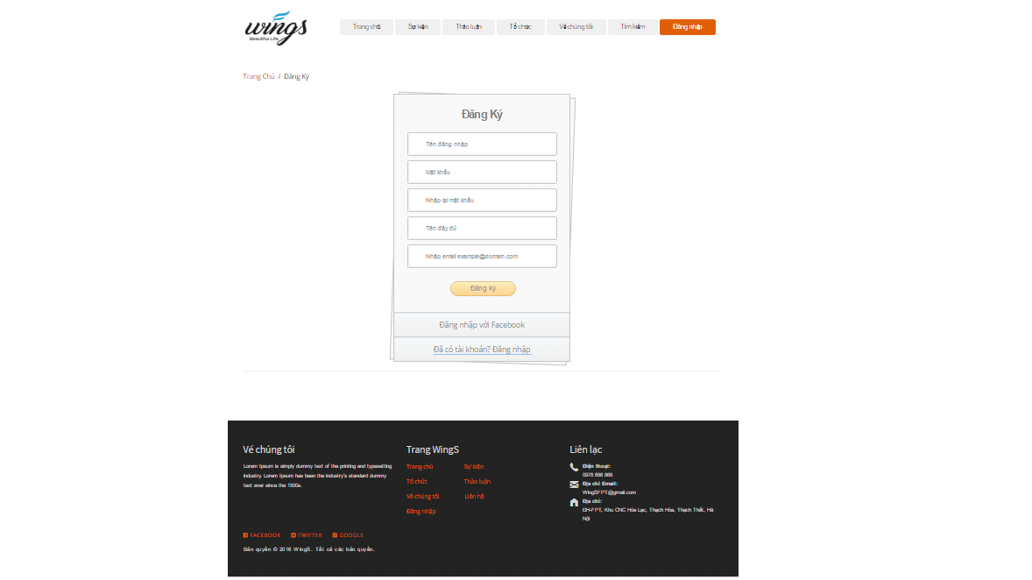

1. Register screen

|  |  |  |  |  |  |  |  |
| --- | --- | --- | --- | --- | --- | --- | --- |
| No | Field name | Field name in Vietnamese | Type | Require | Mandatory | Max-Length | Description |
|  | Register | Đăng ký | Label |  | Y |  | Display register form |
|  | AccountName | Tên hiển thị | Text box | Type | Y | 8-20 | Name of user |
|  | Username | Tên tài khoản | Text box | Type | Y | 8-20 | Username of user |
|  | Password | Mật khẩu | Text box | Type | Y | 8-50 | Password of user |
|  | Confirm Password | Nhập lại mật khẩu | Text box | Type | Y |  | User retype password |
|  | Email | Email | Textbox | Type | Y |  | Email of user |
|  | Sign up | Đăng ký | Button | Click | Y |  | User register a new account |
|  | Login now | Đăng nhập ngay | Hyperlink | Click | Y |  | Login when user have an account |

1. Register screen

#### Login

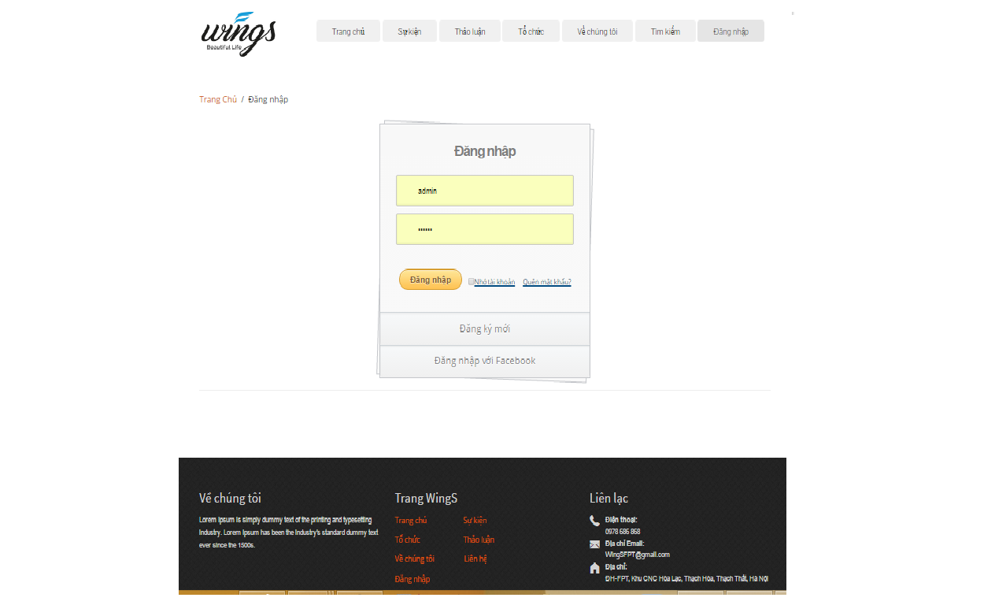

Login screen

|  |  |  |  |  |  |  |  |
| --- | --- | --- | --- | --- | --- | --- | --- |
| No | Field name | Field name in Vietnamese | Type | Require | Mandatory | Max-Length | Description |
|  | Username | Tên đăng nhập | Text box | Type | Y |  | Username of registered user |
|  | Password | Mật khẩu | Text box | Type | Y |  | Password of registered user |
|  | Remember Me | Lưu đăng nhập | Check box | Click | Y |  | Save login information |
|  | Login | Đăng nhập | Button | Click | Y |  | Login |
|  | Forgot Password | Quên mật khẩu | Hyperlink | Click | Y |  | Resend password to user |
|  | Register now | Đăng ký | Hyperlink | Click | Y |  | Register when user have not an account |
|  | Login with Facebook | Đăng nhập qua Facebook | Button | Click | Y |  | Login with Facebook |

1. Login screen

#### Searching

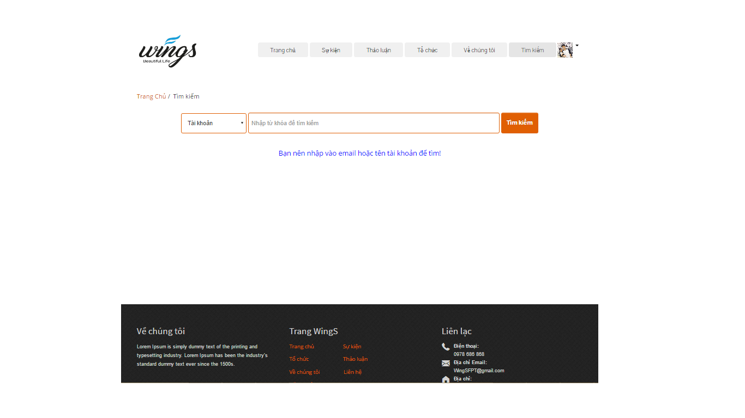

Searching screen design

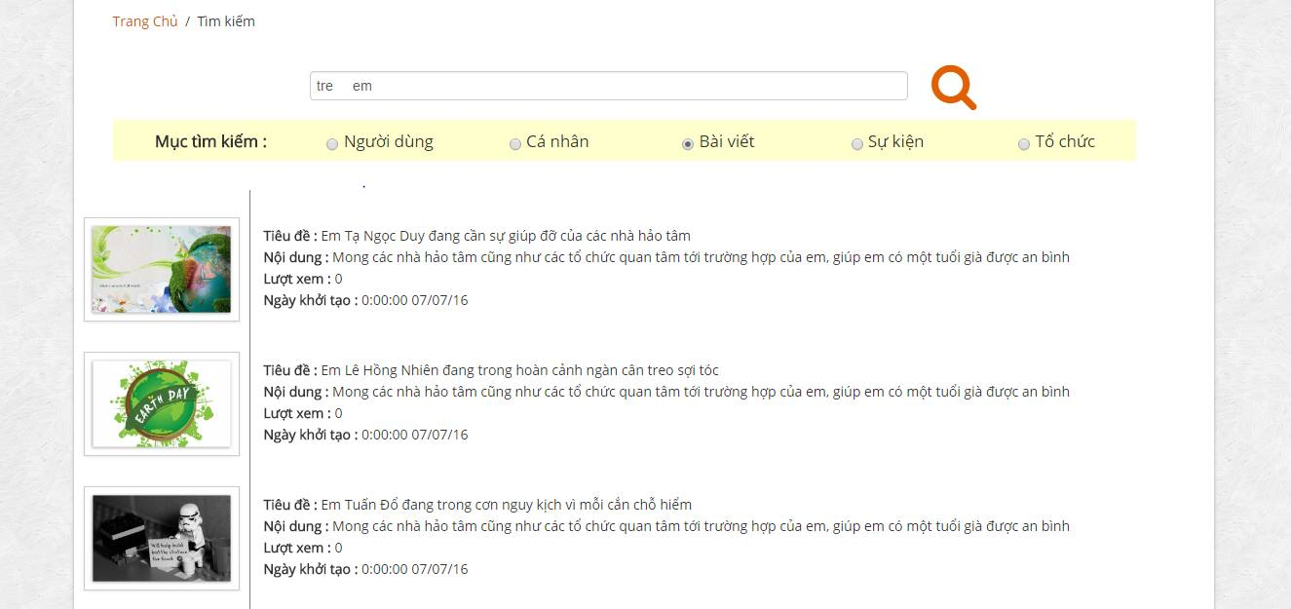

Search Event result screen design

|  |  |  |  |  |  |  |  |
| --- | --- | --- | --- | --- | --- | --- | --- |
| No | Field name | Field name in Vietnamese | Type | Require | Mandatory | Max-Length | Description |
| 1 | Search box | Ô tìm kiếm | Text |  | Y |  | Display text |
| 2 | Search icon |  | Button | Click | Y |  | Search Event |
| 2 | Search type | Mục tìm kiếm | Label |  | Y |  | Display search type |
| 3 | Event | Sự kiện | Drop down list | Click | Y |  | Filter by category of Events |
| 4 | User | Cá nhân | Drop down list | Click | Y |  | Filter by status of Events |
| 5 | User | Cá nhân | Drop down list | Click | Y |  | Filter by status of Events |
| 6 | Thread | Bài viết | Drop down list | Click | Y |  | Filter by status of Events |
| 7 | Organization | Tổ chức | Drop down list | Click | Y |  | Filter by status of Events |
| 8 | List result | Kết quả | List |  |  |  | Display list result |

1. Search screen

#### View

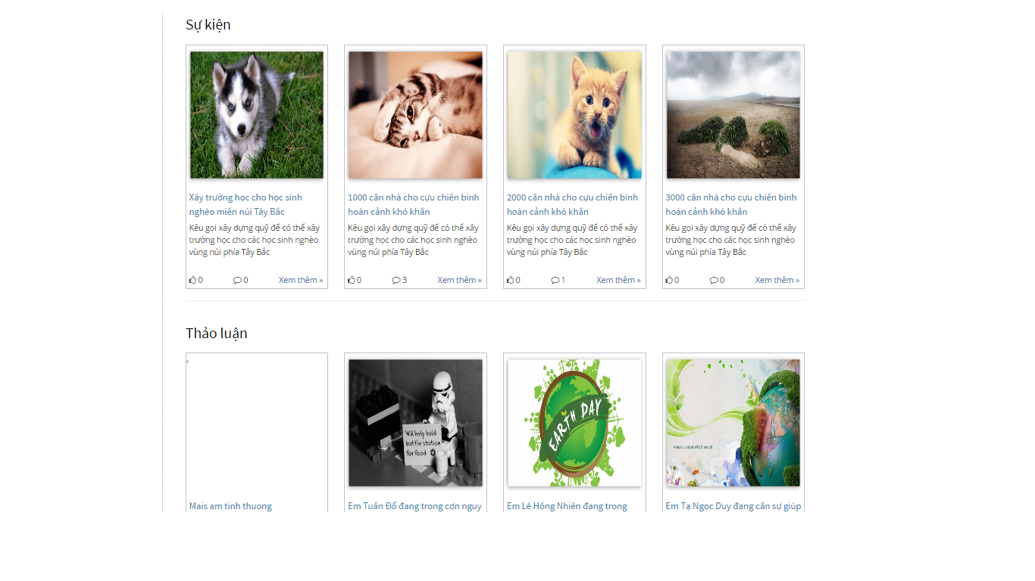

Home view screen

|  |  |  |  |  |  |  |  |
| --- | --- | --- | --- | --- | --- | --- | --- |
| No | Field name | Field name in Vietnamese | Type | Require | Mandatory | Max-Length | Description |
| 1 | Event | Event | Label |  | Y |  | Label display “Event” |
| 2 | List event | Danh sách các Event | List |  | Y |  | Display list of event |
| 3 | Thread | Thảo luận | Label |  | Y |  | Label display “Thảo luận” |
| 5 | List thread | Danh sách các bài thảo luận | List |  | Y |  | Display list of thread |
| 6 | Organization ranking | Xếp hạng các tổ chức | Label |  | Y |  | Label display “Xếp hạng các tổ chức” |
| 7 | List highest ranking | Các tổ chức xếp hạng cao nhất | List |  | Y |  | Display 3 of highest rank organization |
| 8 | View ranking | Xem xếp hạng | Button |  | Y |  | Button display “Xem xếp hạng” |

1. Home view screen

#### Create event

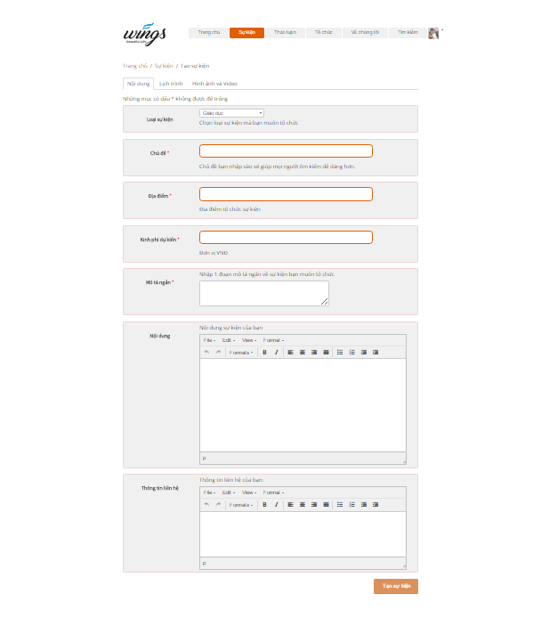

Create event screen (Content)

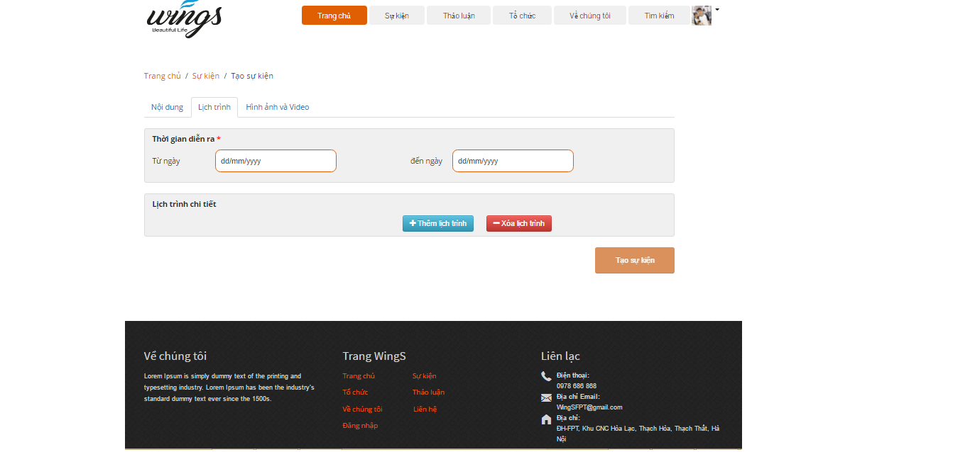

Create event screen (Schedule)

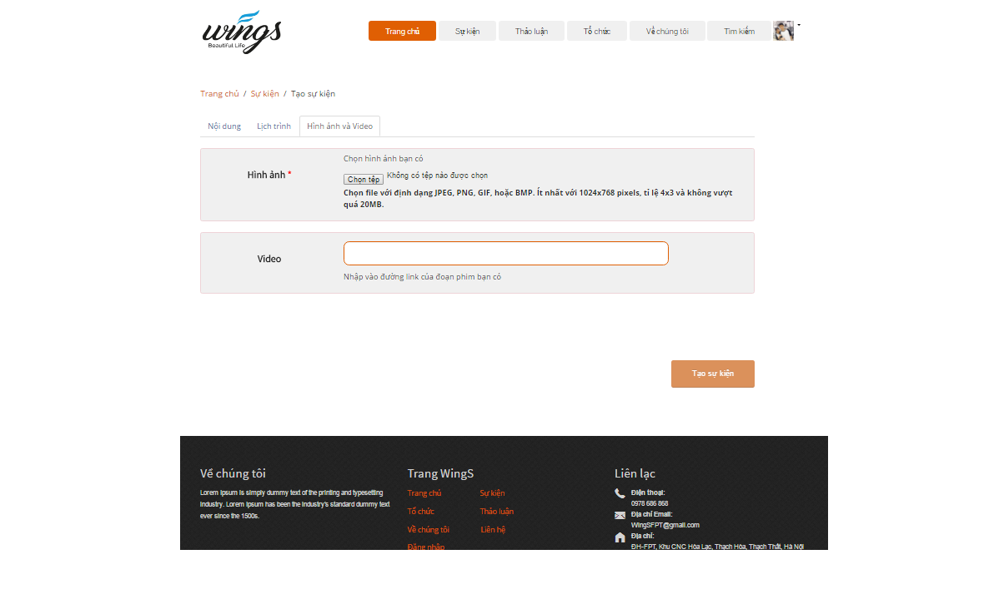

Create event screen (Pictures and videos)

|  |  |  |  |  |  |  |  |
| --- | --- | --- | --- | --- | --- | --- | --- |
| No | Field name | Field name in Vietnamese | Type | Require | Mandatory | Max-Length | Description |
| 1 | Content | Nội dung | Tab | Click | Y |  | Content of event |
| 2 | Warning | Những mục có dấu * không được để trống |  |  |  |  | The warning about the necessary field |
| 3 | Event category | Loại Event | DropdownList | Click | Y |  | Choose a category of event |
| 4 | Event name | Chủ đề | Text |  | Y | 100 | Name of event |
| 5 | Location | Địa điểm | Text |  | Y |  | Location of event |
| 6 | Short description | Mô tả ngắn | Text |  | Y |  | Description of event |
| 7 | Content | Nội dung | Text |  | Y |  | Event’s content |
| 8 | Contact | Thông tin liên hệ | Button | Button | Y |  | Contact to creater |
| 9 | Schedule | Lịch trình |  | Click |  |  |  |
| 10 | Time of event | Thời gian diễn ra | Label |  |  |  | Time of event |
| 11 | Start date | Từ ngày | Date/Time | Click | Y |  | Starting date of event |
| 12 | End date | Đến ngày | Date/Time | Click | Y |  | End date of event |
| 13 | Description | Mô tả | Text |  |  |  | Desctiption of schedule |
| 14 | Pictures and videos | Hình ảnh và video | Label |  |  |  | Pictures and videos tab |
| 15 | Pictures | Hình ảnh | Button |  | Y |  | Pictures of event |
| 16 | Videos | Videos | URL/text |  |  |  | Videos of event |

1. Create Event screen

#### Event detail

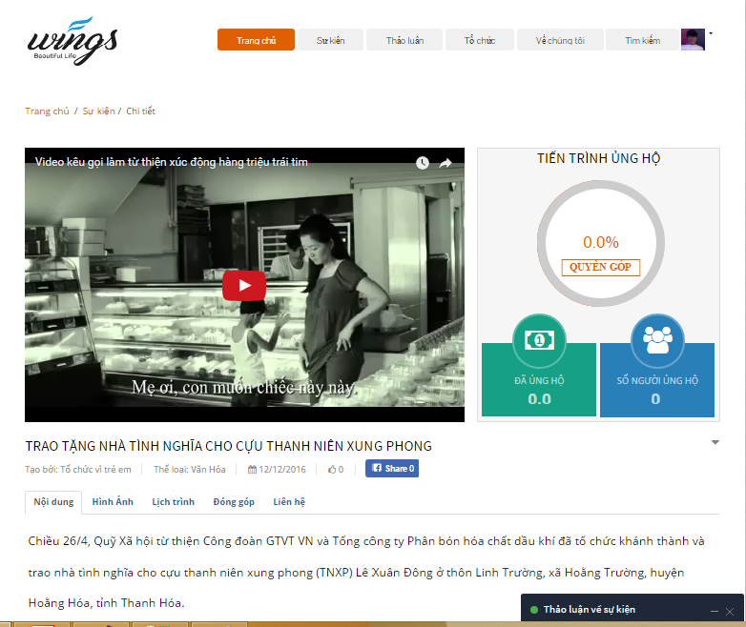

Event detail

|  |  |  |  |  |  |  |  |
| --- | --- | --- | --- | --- | --- | --- | --- |
| No | Field name | Field name in Vietnamese | Type | Require | Mandatory | Max-Length | Description |
| 1 | Name of Event | Tên Event | Label |  | Y |  | Name of event |
| 2 | Name of creator | Tên người gây quỹ | Label |  | Y |  | Name of creator |
| 3 | Category | Thể loại | Label |  | Y |  | Category of Event |
| 4 | Created date | Ngày tạo | Label |  | Y |  | Created date |
| 5 | Send massage | Gửi tin nhắn | Icon |  | Y |  | Send massage to organization |
| 6 | Content | Nội dung | Tab | Click | Y |  | Content of Event |
| 7 | Pictures | Hình ảnh | Tab | Click | Y |  | Pictures of Event |
| 8 | Schedule | Lịch trình | Tab | Click | Y |  | Schedule of Event |
| 9 | List of donor | Danh sách đóng góp | Tab | Click | Y |  | List of donor to event |
| 10 | Tab contact | Liên hệ | Tab | Click | Y |  | Display contact information of event |
| 12 | Donate | Đóng góp | Button | Click | Y |  | Display comment of event |
| 13 | Join in | Tham gia | Button |  |  |  | Join in event |
| 14 | Like | Thích | Button |  |  |  | Like event |
| 15 | Share | Chia sẻ | Button |  |  |  | Share event |
|  |  |  |  |  |  |  |  |

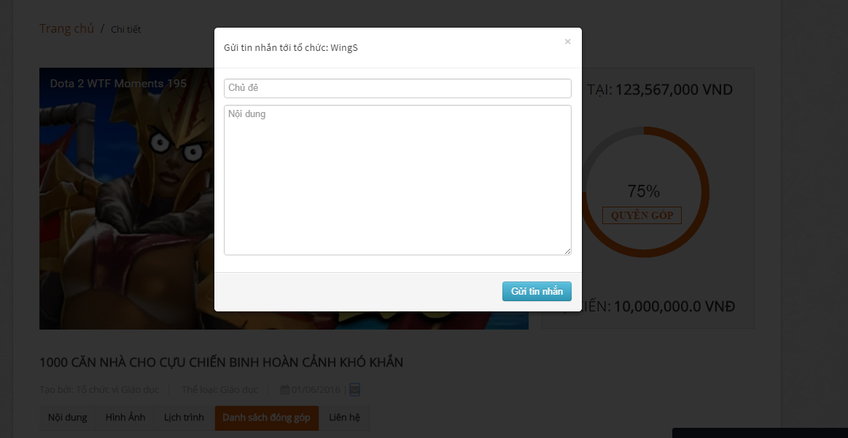

Sent report, question screen

|  |  |  |  |  |  |  |  |
| --- | --- | --- | --- | --- | --- | --- | --- |
| No | Field name | Field name in Vietnamese | Type | Require | Mandatory | Max-Length | Description |
| 2 | Sent a question | Gửi tin nhắn | Icon | Click | Y |  | Sent a question to creator’Event |
| 3 | Popup Sent message | Popup tin nhắn | Popup |  |  |  | Display popup sent message when click “Message” icon |
| 4 | Report this event | Báo cáo sai phạm | Button | Click | Y |  | Report Event |
| 5 | Popup Report this event | Popup Báo cáo Event | Popup |  |  |  | Display popup report event when click “Report” icon |

1. Sent report, question

##### Comment

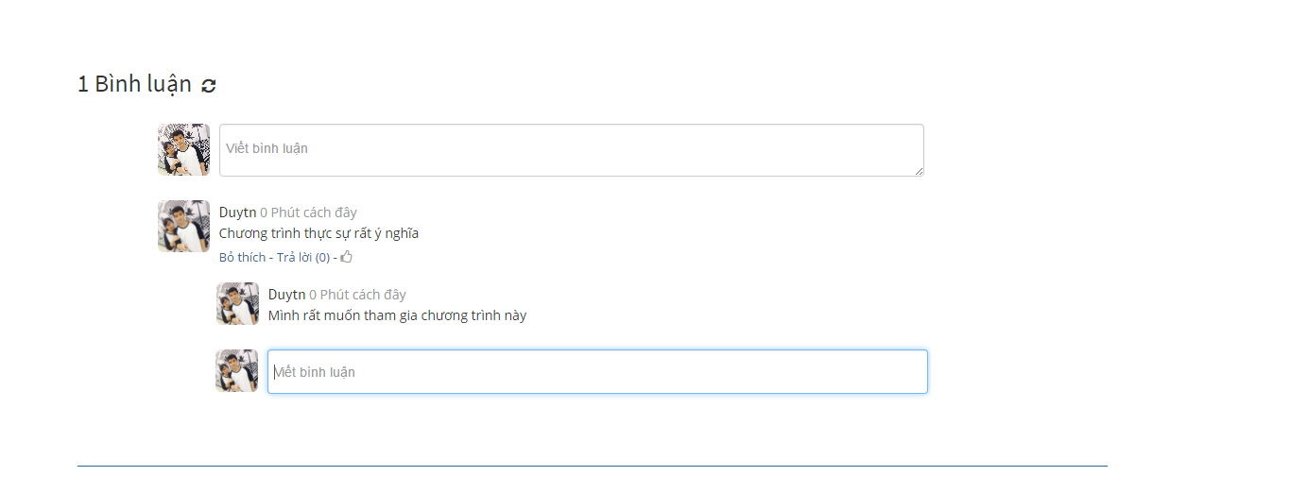

Comment area

|  |  |  |  |  |  |  |  |  |
| --- | --- | --- | --- | --- | --- | --- | --- | --- |
| No | | Field name | Field name in Vietnamese | Type | Require | Mandatory | Max-Length | Description |
| 1 | List comments | | Bình luận | List |  | Y |  | Display list comment |
| 2 | Input comment | | Nhập bình luận… | Textarea |  | Y | 100 | Display content of comment. |
| 3 | Reply | | Trả lời | Button | Click | Y | 100 | Sent a reply to comment. |
| 5 | Refresh | | Tải lại bình luận | Button | Click |  |  | Refresh all comments. |

1. Comment area

#### Create Thread

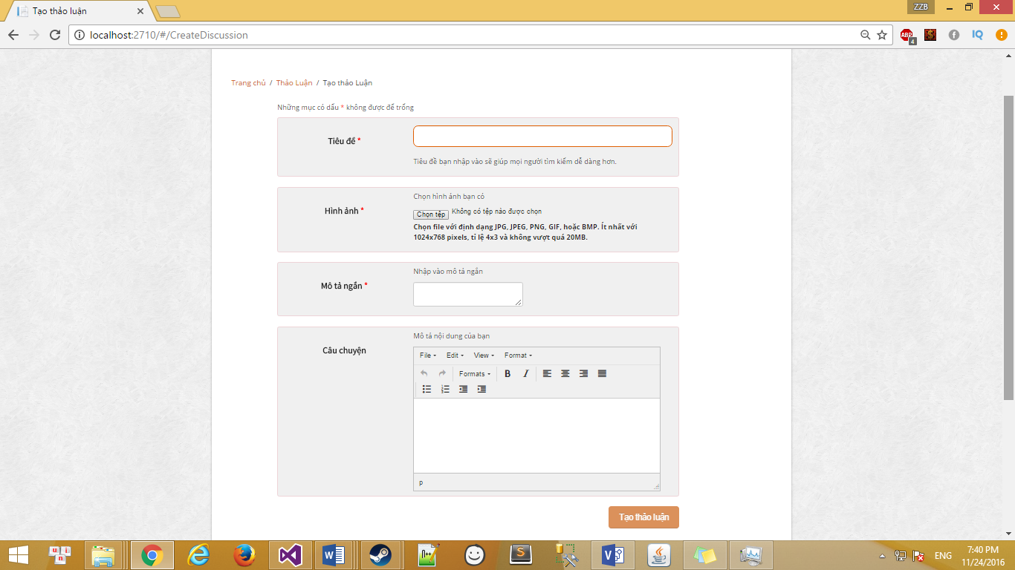

1. Create thread screen

|  |  |  |  |  |  |  |  |
| --- | --- | --- | --- | --- | --- | --- | --- |
| No | Field name | Field name in Vietnamese | Type | Require | Mandatory | Max-Length | Description |
| 1 | Warning | Những mục có dấu * không được để trống | Text |  | Y |  | The warning about the necessary field |
| 2 | Thread Title | Chủ đề | Text |  | Y | 100 | Title of thread |
| 3 | Pictures | Hình ảnh | Button |  | Y |  | Pictures of thread |
| 4 | Short description | Mô tả ngắn | Text |  | Y |  | Description of thread |
| 5 | Content | Nội dung | Text |  | Y |  | Thread’s content |

1. Comment area

#### Thread detail

##### Thread detail

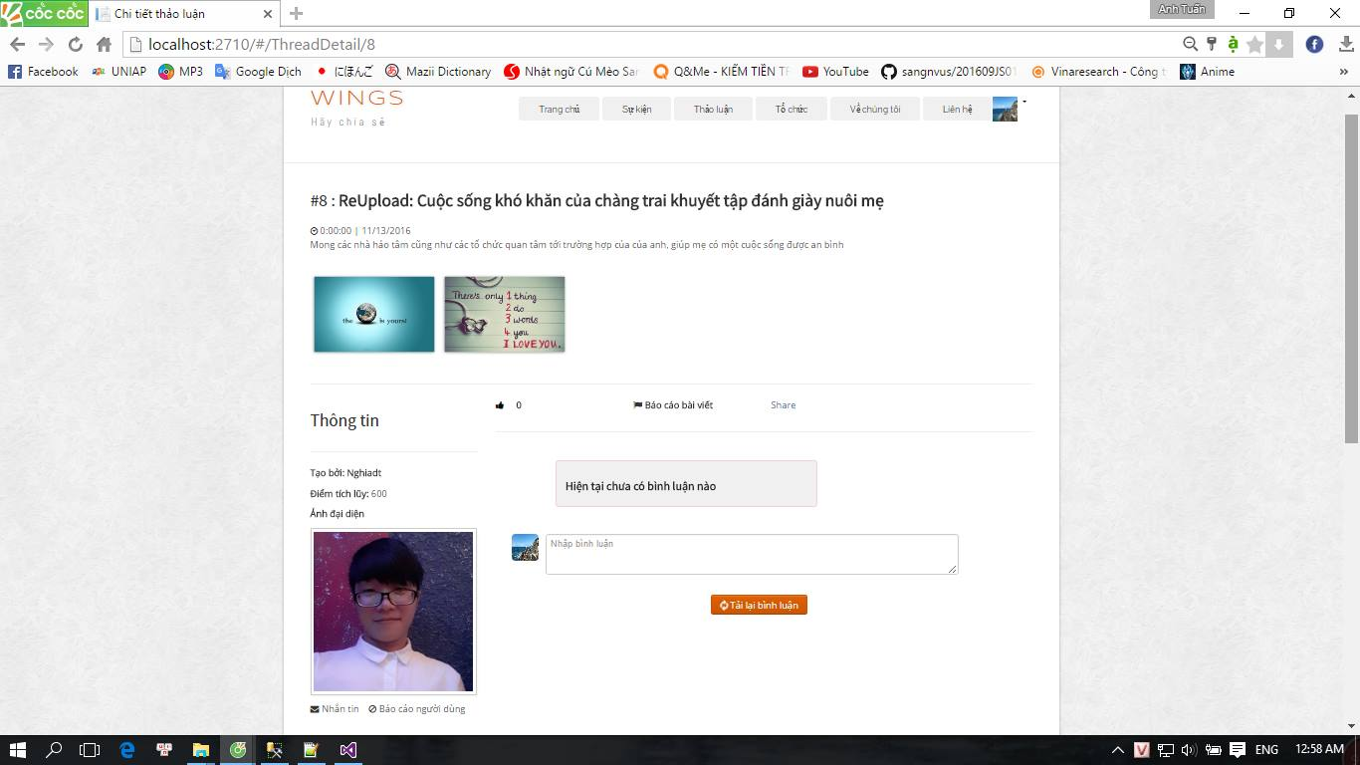

Thread detail

|  |  |  |  |  |  |  |  |
| --- | --- | --- | --- | --- | --- | --- | --- |
| No | Field name | Field name in Vietnamese | Type | Require | Mandatory | Max-Length | Description |
| 1 | Title of Thread | Tiêu đề | Label |  | Y |  | Title of thread |
| 2 | Date/time created | Thời gian tạo | Label |  | Y |  | Date/time created of thread |
| 3 | Content | Nội dung | Label |  | Y |  | Content of Thread |
| 4 | Creator information | Thông tin người tạo | Label |  | Y |  | Creator information |
| 5 | Creator name | Tên người tạo | Label |  | Y |  | Creator name |
| 6 | Point | Điểm tích lũy | Label |  | Y |  | Activities point of creator |
| 7 | Avatar | Ảnh người tạo | URL link |  | Y |  | Avatar of creator |
| 8 | Like | Thích | Icon | Click | Y |  | Like thread button |
| 9 | Report | Báo cáo bài thảo luận | Icon | Click | Y |  | Report thread button |
| 10 | Comment list | Bình luận | Label |  | Y |  | Display all comment of thread |
| 12 | Comment | Viết bình luận | Text |  | Y |  | Write comment |
| 13 | Reload comment | Tải bình luận | Button |  |  |  | Reload comment |

1. Thread detail table

##### Edit thread

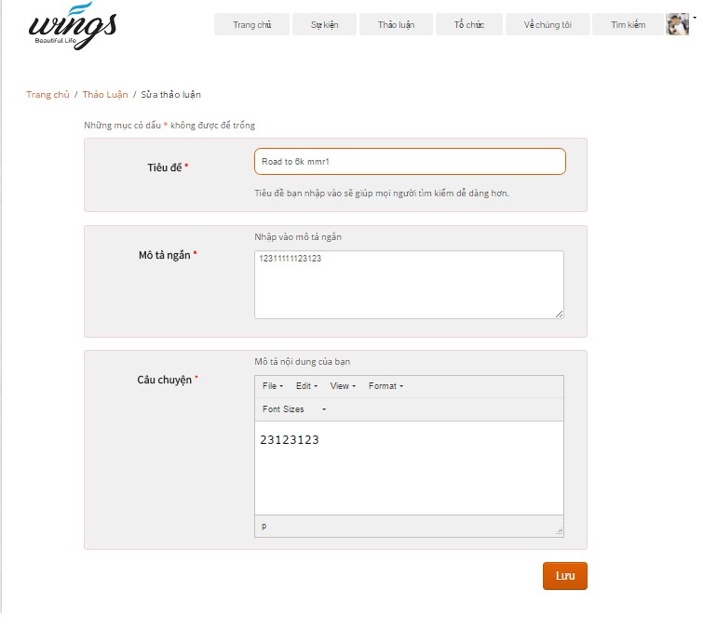

Edit thread screen

|  |  |  |  |  |  |  |  |
| --- | --- | --- | --- | --- | --- | --- | --- |
| No | Field name | Field name in Vietnamese | Type | Require | Mandatory | Max-Length | Description |
| 2 | Warning | Những mục có dấu * không được để trống | Text |  | Y |  | The warning about the necessary field |
|  | Title | Tiêu đề | Text |  | Y |  | The title of thread |
|  | Short description | Mô tả ngắn | Text |  | Y |  | Short description of thread |
|  | Content | Câu chuyện | Text |  | Y |  | Content of thread |
|  | Save | Lưu | Button | Click | Y |  | Save thread |

1. Edit thread table

#### Create Organization

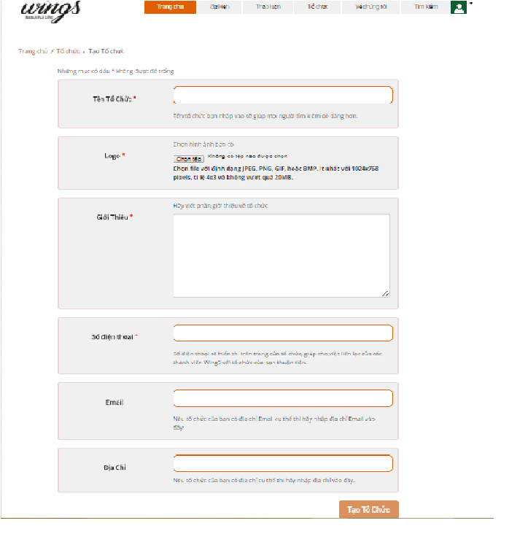

1. Create thread screen

|  |  |  |  |  |  |  |  |
| --- | --- | --- | --- | --- | --- | --- | --- |
| No | Field name | Field name in Vietnamese | Type | Require | Mandatory | Max-Length | Description |
| 1 | Warning | Những mục có dấu * không được để trống | Text |  | Y |  | The warning about the necessary field |
| 2 | Logo | Logo | Button |  | Y |  | Logo of organization |
| 3 | Introduction | Giới Thiệu | Text |  | Y |  | Introduction about organization |
| 4 | Phone Number | Mô tả ngắn | Text |  | Y |  | Phone number |
| 5 | Email | Email | Text |  | Y |  | Email contact |
| 6 | Address | Địa chỉ | Text |  | Y |  | Address |
| 7 | Create Organization | Tạo sự kiện | Button | Click | Y |  | Create an organization |

1. Create organization

#### Organization detail

##### Organization detail

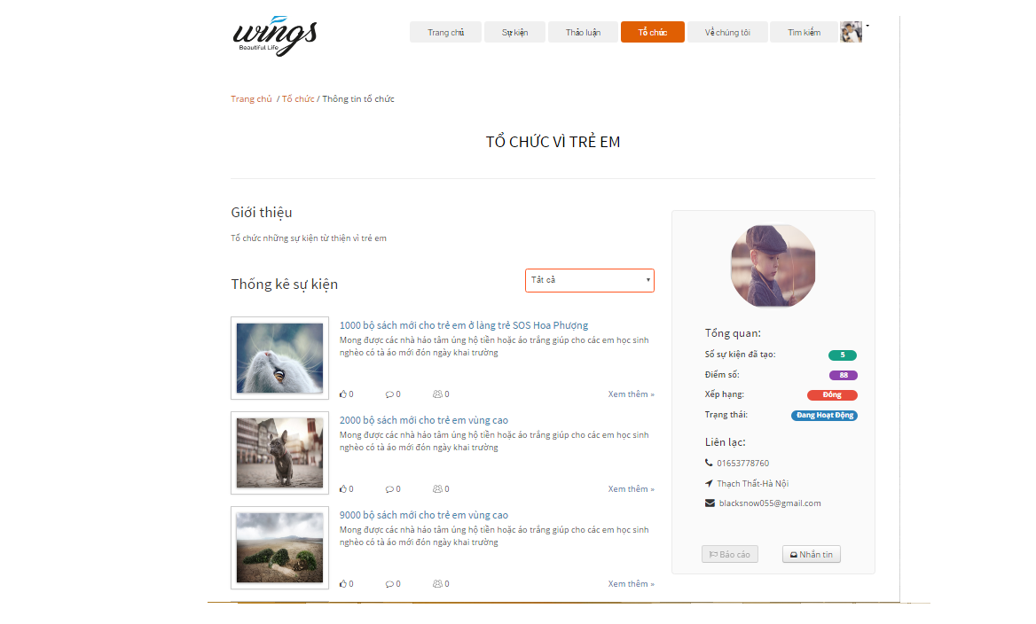

Organization detail

|  |  |  |  |  |  |  |  |
| --- | --- | --- | --- | --- | --- | --- | --- |
| No | Field name | Field name in Vietnamese | Type | Require | Mandatory | Max-Length | Description |
| 1 | Name of Organization | Tiêu đề | Label |  | Y |  | Name of organization |
| 2 | Description | G | Label |  | Y |  | Description about organization |
| 3 | Statistic | Nội dung | Label |  | Y |  | Statistic |
|  | Order by | Sắp xếp | Dropdownlist |  | Y |  | Click to group event by status: Ongoing, closed, all. |
| 4 | Event list | Thông tin người tạo | Label |  | Y |  | Event list which organization created |
|  | View more | Xem them | Button | Click | Y |  | Click to view event detail |
|  | Load more | Xem thêm | Button | Click |  |  | Click to view more events which organization created |
| 5 | Organization logo | Tên người tạo | Picture |  | Y |  | Creator name |
| 6 | Organization information tab | Tổng quan | Table |  | Y |  | Information of organization |
| 7 | Report | Báo cáo | Button | Click | Y |  | Report the organization |
| 8 | Message | Nhắn tin | Button | Click | Y |  | Message to organization |

1. Organization detail table

##### Edit Organization

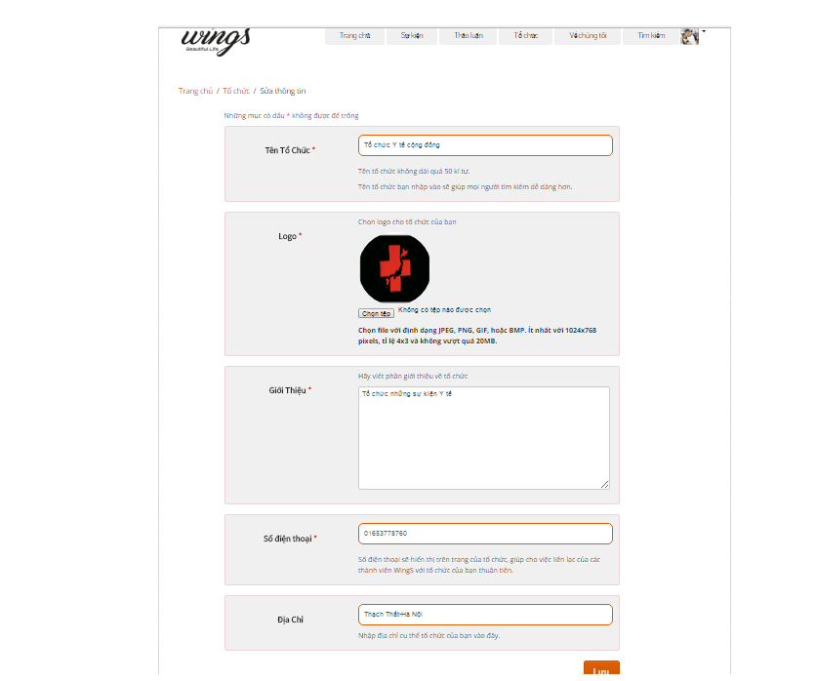

Edit organization screen

|  |  |  |  |  |  |  |  |
| --- | --- | --- | --- | --- | --- | --- | --- |
| No | Field name | Field name in Vietnamese | Type | Require | Mandatory | Max-Length | Description |
| 1 | Warning | Những mục có dấu * không được để trống | Text |  | Y |  | The warning about the necessary field |
| 2 | Logo | Logo | Button |  | Y |  | Logo of organization |
| 3 | Introduction | Giới Thiệu | Text |  | Y |  | Introduction about organization |
| 4 | Phone Number | Mô tả ngắn | Text |  | Y |  | Phone number |
| 5 | Email | Email | Text |  | Y |  | Email contact |
| 6 | Address | Địa chỉ | Text |  | Y |  | Address |
| 7 | Create Organization | Tạo sự kiện | Button | Click | Y |  | Edit organization |

1. Edit organization table

#### User Information

##### Manage profile

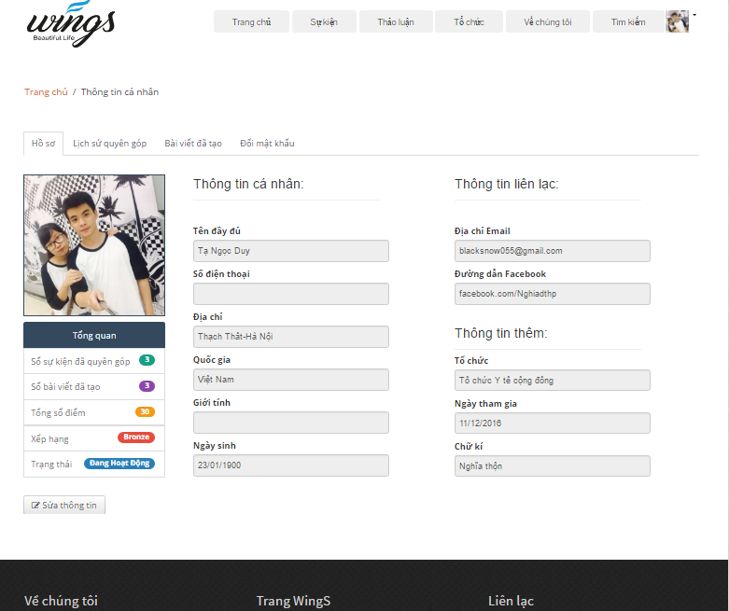

User profile screen

|  |  |  |  |  |  |  |  |
| --- | --- | --- | --- | --- | --- | --- | --- |
| No | Field name | Field name in Vietnamese | Type | Require | Mandatory | Max-Length | Description |
| 1 | Profile | Hồ sơ | Tab |  | Y |  | Profile tab |
| 2 | User avatar | Ảnh đại diện | URL image |  | Y |  | User avatar |
| 3 | Overview | Tổng quan | Label |  | Y |  | Overview information of user |
| 4 | Number donated event | Số sự kiện đã quyên gop | Label |  | Y |  | Display number donated event |
| 5 | Number created thread | Số bài viết đã tạo | Label |  | Y |  | Display number donated thread |
| 6 | Total point | Tổng số điểm | Label |  | Y |  | Total point |
| 7 | Rank | Xếp hạng | Label |  | Y |  | Rank of user |
| 8 | Status | Trạng thái | Label |  |  |  | Account status |
| 9 | Edit profile | Sửa thông tin | Button | Click |  |  | Click to edit profile |
| 10 | User Information | Thông tin cá nhân | Label |  |  |  | User Information |
| 11 | FullName | Tên đầy đủ | Label |  | Y |  | FullName of user |
| 12 | Phone | Số điện thoại | Label |  |  |  | Phone of user |
| 13 | Address | Địa chỉ | Label |  |  |  | Address of user |
| 14 | Country | Quốc gia | Label |  |  |  | Country of user |
| 15 | Gender | Giới tính | Label |  |  |  | Gender |
| 16 | DOB | Ngày sinh | Label |  |  |  | Date of birth |
| 17 | Contact information | Thông tin liên lạc | Label |  |  |  | Contact information |
| 18 | Email | Địa chỉ email | Label |  | Y |  | Email link |
| 19 | Facebook | Địa chỉ facebook | Label |  | Y |  | Facebook link |
| 20 | Organization | Tổ chức | Label |  |  |  | Organization of user |
| 21 | Created date | Ngày tham gia | Label |  | Y |  | Created date |
| 22 | Sign | Chữ ký | Label |  |  |  | Sign of user |

1. User profile table

##### Edit profile

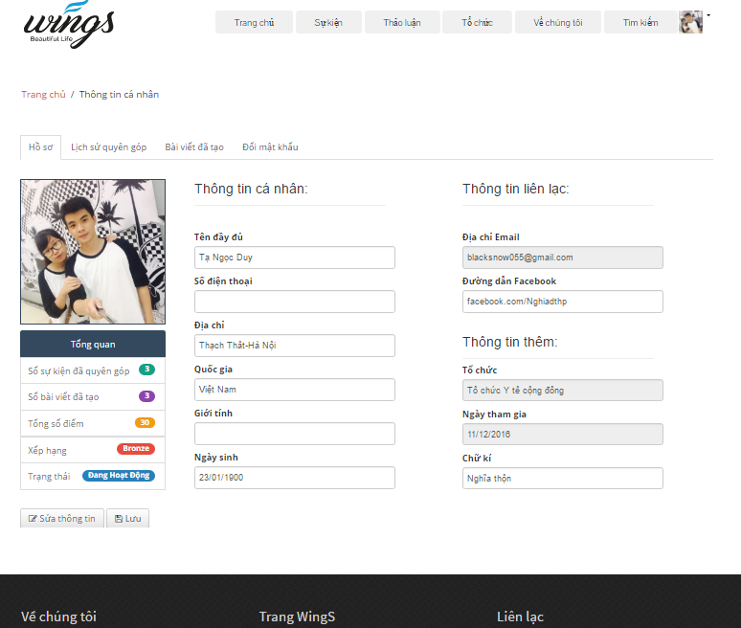

Edit profile screen

|  |  |  |  |  |  |  |  |
| --- | --- | --- | --- | --- | --- | --- | --- |
| No | Field name | Field name in Vietnamese | Type | Require | Mandatory | Max-Length | Description |
| 1 | Profile | Hồ sơ | Tab |  | Y |  | Profile tab |
| 2 | User avatar | Ảnh đại diện | URL image |  | Y |  | User avatar |
| 3 | Overview | Tổng quan | Label |  | Y |  | Overview information of user |
| 4 | Number donated event | Số sự kiện đã quyên gop | Label |  | Y |  | Display number donated event |
| 5 | Number created thread | Số bài viết đã tạo | Label |  | Y |  | Display number donated thread |
| 6 | Total point | Tổng số điểm | Label |  | Y |  | Total point |
| 7 | Rank | Xếp hạng | Label |  | Y |  | Rank of user |
| 8 | Status | Trạng thái | Label |  |  |  | Account status |
| 9 | Edit profile | Sửa thông tin | Button | Click |  |  | Click to edit profile |
| 10 | Save | Lưu thông tin | Button | Click |  |  | Click to save the changing |
| 11 | User Information | Thông tin cá nhân | Label |  |  |  | User Information |
| 12 | FullName | Tên đầy đủ | Text |  | Y |  | FullName of user |
| 13 | Phone | Số điện thoại | Text |  |  |  | Phone of user |
| 14 | Address | Địa chỉ | Text |  |  |  | Address of user |
| 15 | Country | Quốc gia | Text |  |  |  | Country of user |
| 16 | Gender | Giới tính | Text |  |  |  | Gender |
| 17 | DOB | Ngày sinh | Text |  |  |  | Date of birth |
| 18 | Contact information | Thông tin liên lạc | Label |  |  |  | Contact information |
| 19 | Email | Địa chỉ email | Label |  | Y |  | Email link |
| 20 | Facebook | Địa chỉ facebook | Label |  | Y |  | Facebook link |
| 21 | Organization | Tổ chức | Label |  |  |  | Organization of user |
| 22 | Created date | Ngày tham gia | Label |  | Y |  | Created date |
| 23 | Sign | Chữ ký | Text |  |  |  | Sign of user |

1. Edit profile table

##### Manage donation

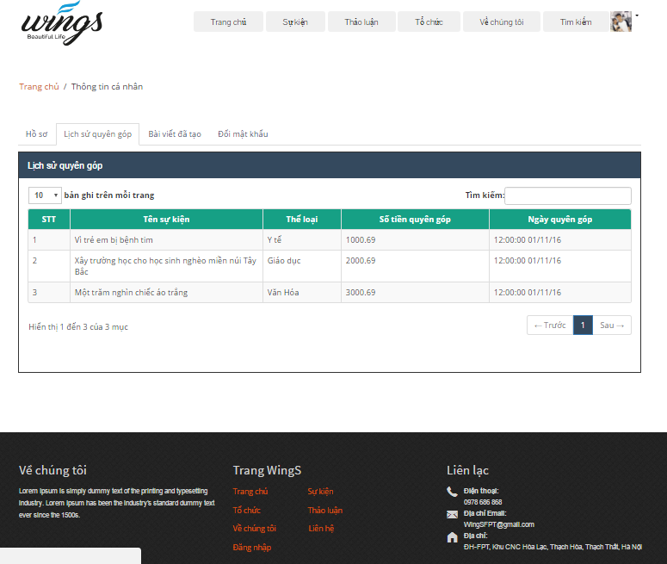

Donation screen

|  |  |  |  |  |  |  |  |
| --- | --- | --- | --- | --- | --- | --- | --- |
| No | Field name | Field name in Vietnamese | Type | Require | Mandatory | Max-Length | Description |
| 1 | Donation record | Lịch sử quyên góp | Tab |  | Y |  | Donation record tab |
| 2 | Record number | Số bản ghi mỗi trang | Label |  | Y |  | Number of record (event) |
| 3 | Search | Tìm kiếm | Text |  | Y |  | Search event by keyword |
| 4 | Number | Số thứ tự | Label |  | Y |  | Event number |
| 5 | Event name | Tên sự kiện | Label |  | Y |  | Event name |
| 6 | Event type | Loại sự kiện | Label |  | Y |  | Event type |
| 7 | Money donated | Số tiền đã quyên góp | Label |  | Y |  | Amount of money which user donated |
| 8 | Donated date | Ngày quyên góp | Label |  | Y |  | Date when user donated |
| 9 | Paging | Trang | Button | Click | Y |  | Paging |

1. Donation table

##### Manage created thread

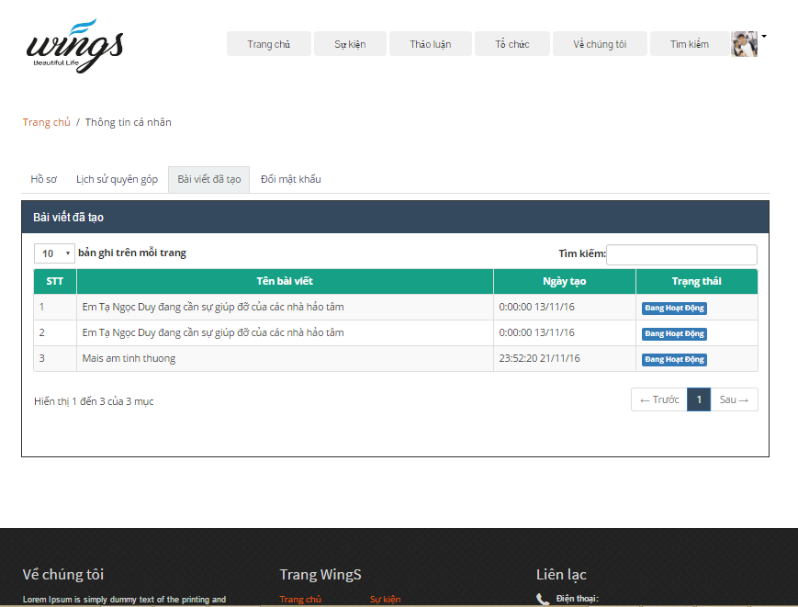

Created thread screen

|  |  |  |  |  |  |  |  |
| --- | --- | --- | --- | --- | --- | --- | --- |
| No | Field name | Field name in Vietnamese | Type | Require | Mandatory | Max-Length | Description |
| 1 | Created thread | Bài viết đã tạo | Tab |  | Y |  | Created thread tab |
| 2 | Record number | Số bản ghi mỗi trang | Label |  | Y |  | Number of record (thread) |
| 3 | Search | Tìm kiếm | Text |  | Y | 100 | Search thread by keyword |
| 4 | Number | Số thứ tự | Label |  | Y |  | Thread number |
| 5 | Thread title | Tên bài thảo luận | Label |  | Y |  | Thread title |
| 7 | Created date | Ngày tạo | Label |  | Y |  | Date when user created thread |
| 8 | Status | Tình trạng | Label |  | Y |  | Status of thread |
| 9 | Paging | Trang | Button | Click | Y |  | Paging |

1. Created thread table

##### Change password

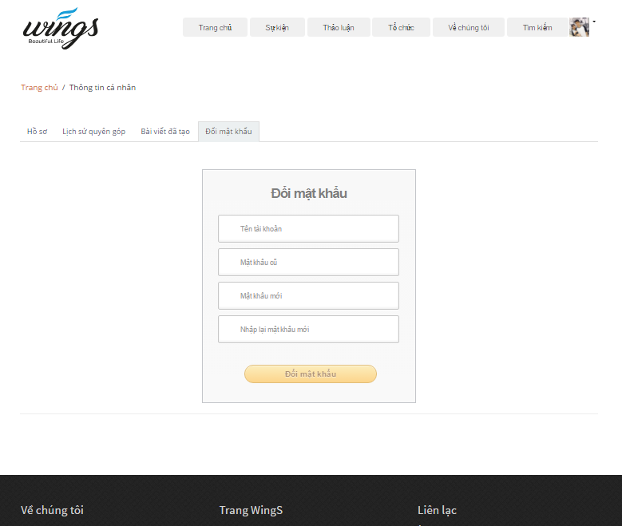

Change password screen

|  |  |  |  |  |  |  |  |
| --- | --- | --- | --- | --- | --- | --- | --- |
| No | Field name | Field name in Vietnamese | Type | Require | Mandatory | Max-Length | Description |
| 1 | Change password | Đổi mật khẩu | Tab |  | Y |  | Change password tab |
| 2 | Change password | Đổi mật khẩu | Label |  | Y |  | Number of record (thread) |
| 3 | UserName | Tìm kiếm | Text |  | Y | 100 | Search thread by keyword |
| 4 | Old Password | Mật khẩu cũ | Label |  | Y |  | Current password |
| 5 | New Password | Mật khẩu mới | Label |  | Y |  | New password which user want to change |
| 7 | Confirm new password | Xác nhận mật khẩu | Label |  | Y |  | Confirm new password |
| 8 | Change password | Đổi mật khẩu | Button | Click | Y |  | Change password button |

1. Change password table

#### Message

##### Message view

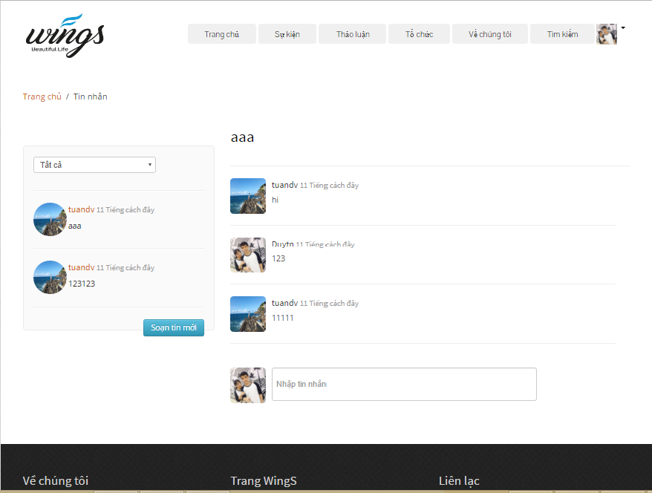

View message screen

|  |  |  |  |  |  |  |  |
| --- | --- | --- | --- | --- | --- | --- | --- |
| No | Field name | Field name in Vietnamese | Type | Require | Mandatory | Max-Length | Description |
| 1 | Group Message | Loại tin nhắn | Drop downlist |  | Y |  | Group type of message |
| 2 | List message | Danh sách tin nhắn | List |  | Y |  | All list message of user |
| 3 | New Message | Viết tin nhắn mới | Button |  | Y | 100 | Create new message |
| 4 | Message title | Tiêu đề tin nhắn | Label |  | Y |  | Message title |
| 5 | Message content | Nội dung tin nhắn | Label |  | Y |  | Message content |
| 7 | Message | Viết tin nhắn | Text |  | Y |  | Write new message |

1. View message table

##### Send message

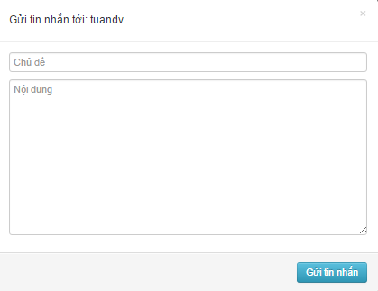

View message screen

|  |  |  |  |  |  |  |  |
| --- | --- | --- | --- | --- | --- | --- | --- |
| No | Field name | Field name in Vietnamese | Type | Require | Mandatory | Max-Length | Description |
| 1 | Receiver | Người nhận | Label |  | Y |  | People who receive the message |
| 2 | Message title | Tiêu đề tin nhắn | Label |  | Y |  | Message title |
| 3 | Message content | Nội dung tin nhắn | Label |  | Y |  | Message content |
| 4 | Send Message | Gửi tin nhắn | Button |  | Y |  | Send new message |

1. Send message table

#### Donate

##### Donate

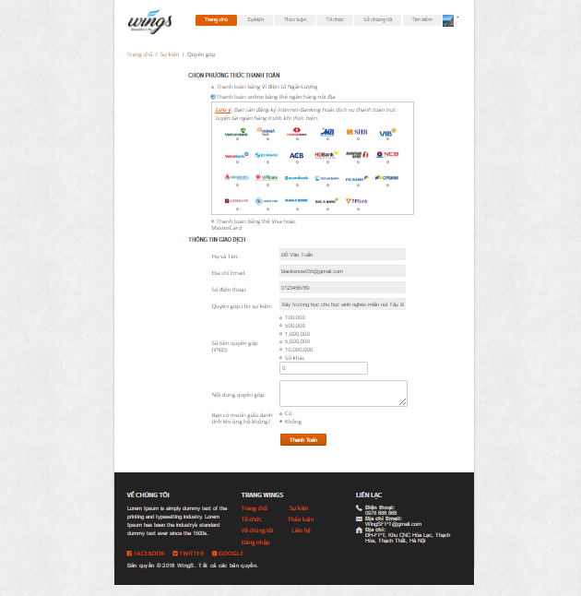

Donate Event screen

|  |  |  |  |  |  |  |  |  |
| --- | --- | --- | --- | --- | --- | --- | --- | --- |
| No | Field name | | Field name in Vietnamese | Type | Require | Mandatory | Max-Length | Description |
| 1 | Name of Event | Tên sự kiện | | Hyperlink | Click | Y |  | Name of Event |
| 2 | Name of organization | Tên người tổ chức | | Hyperlink | Click | Y |  | Display information of organization |
| 3 | Money | Số tiền ủng hộ | | Number |  | Y |  | Money to donate |
| 4 | Donate | Ủng hộ | | Button | Click | Y |  | Click to link to payment page |

1. Donate Event

### Admin

#### Login

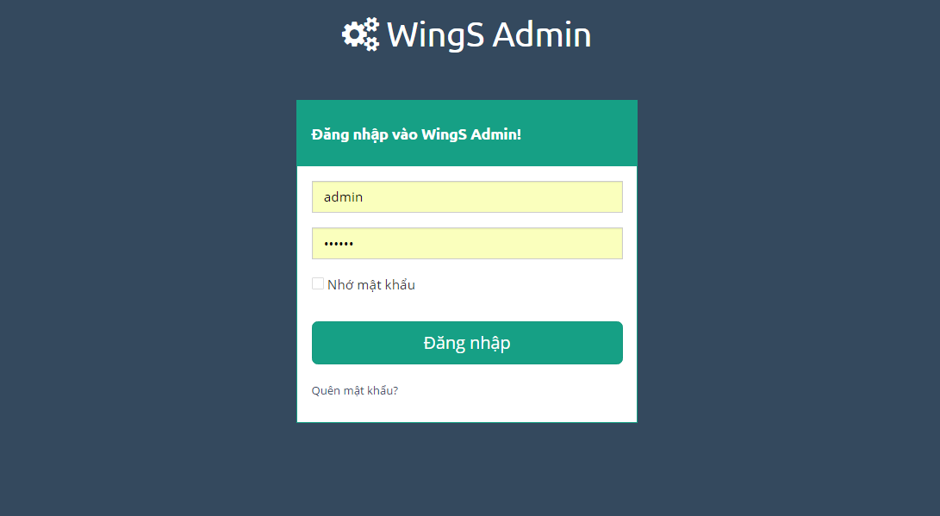

Login screen

|  |  |  |  |  |  |  |  |
| --- | --- | --- | --- | --- | --- | --- | --- |
| No | Field name | Field name in Vietnamese | Type | Require | Mandatory | Max-Length | Description |
| 1 | Username or email | Tên tài khoản hoặc email | Text box | Type | Y |  | Username or Email of Admin |
| 2 | Password | Mật khẩu | Text box | Type | Y |  | Password of registered Admin |
| 3 | Remember Me | Lưu đăng nhập | Check box | Click | Y |  | Save login information |
| 4 | Login | Đăng nhập | Button | Click | Y |  | Login |

1. Login

#### Dashboard

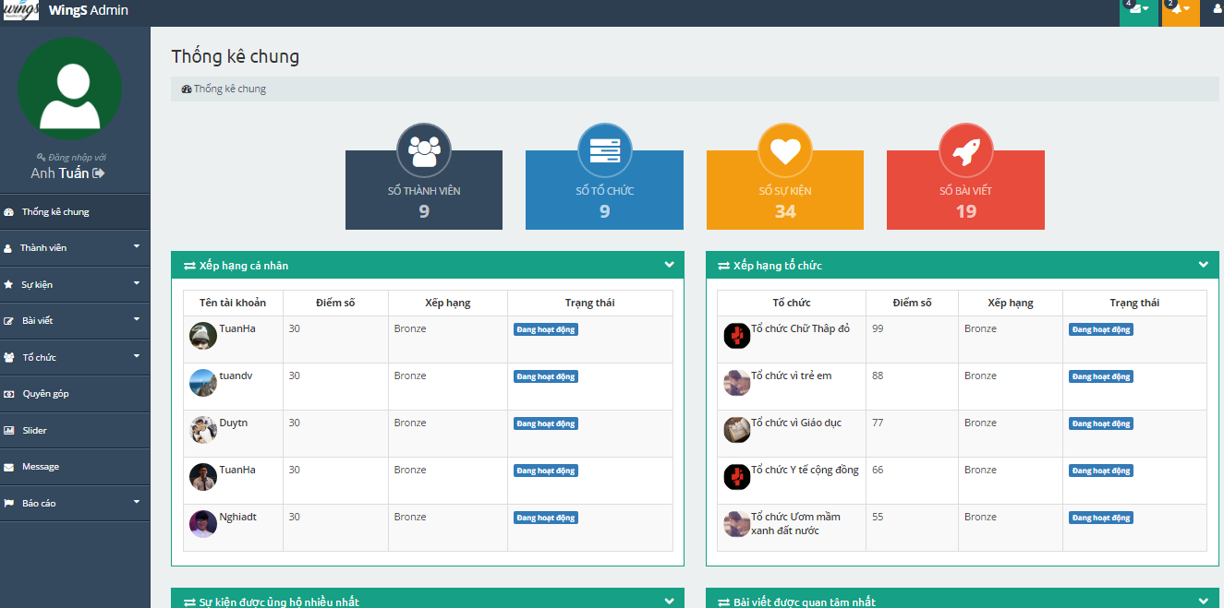

1. Dash board

|  |  |  |  |  |  |  |  |
| --- | --- | --- | --- | --- | --- | --- | --- |
| No | Field name | Field name in Vietnamese | Type | Require | Mandatory | Max-Length | Description |
| 1 | Total users | Số thành viên | Label |  | Y |  | Total users registed |
| 2 | Total Organization | Số tổ chức | Label |  | Y |  | Total Organization created |
| 3 | Total Event | Số sự kiện | Label |  | Y |  | Total Event created |
| 4 | Total Thread | Số bài viết | Label |  | Y |  | Total Thread created |
| 5 | Top User | Thành viên có số điểm cao nhất | Table |  | Y |  | Table top 5 users has highest point |
| 6 | Top Organization | Tổ chức có số điểm cao nhất | Table |  | Y |  | Table top 5 organizations has highest point |
| 7 | Top Thread | Bài viết được quan tâm nhiều nhất | Table |  | Y |  | Table top 5 threads have most like |
| 8 | Top donor | Người dùng ủng hộ nhiều nhất | Table |  | Y |  | Table top 5 donors |
| 9 | Recently Event | Sự kiện vừa được quyên góp | Table |  | Y |  | Event which has been donated recently |

1. Dashboard

#### Users

##### Users dashboard

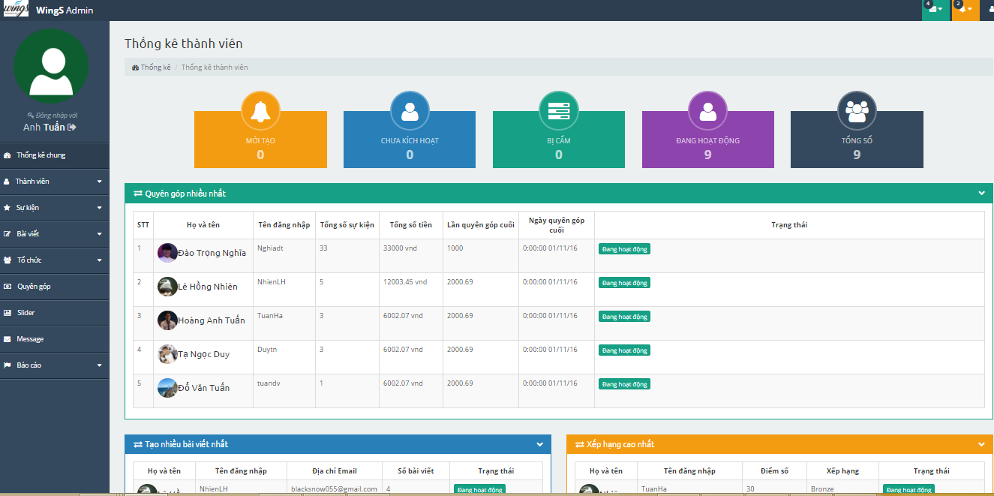

Users dashboard screen

|  |  |  |  |  |  |  |  |
| --- | --- | --- | --- | --- | --- | --- | --- |
| No | Field name | Field name in Vietnamese | Type | Require | Mandatory | Max-Length | Description |
| 1 | Total new users | Người dùng mới | Label |  | Y |  | Total new users |
| 3 | Total users deactive | Người dùng chưa kích hoạt | Label |  | Y |  | Total user NOT Active |
| 3 | Total users be banned | Người dùng bị cấm | Label |  | Y |  | Total user be banned |
| 4 | Total users active | Người dùng đang hoạt động | Label |  | Y |  | Total user Active |
| 5 | Total users | Tổng số người dùng | Label |  | Y |  | Total users registed |
| 6 | Top donation | Quyên góp nhiều nhất | Table |  | Y |  | Top 5 donors with highest donation |
| 7 | Most user backed | Tạo nhiều bài viết nhất | Table |  | Y |  | Top 5 users with most created thread |
| 8 | New users | Xếp hạng cao nhất | Table |  | Y |  | Top 5 user with highest point |

Users dashboard

##### Users list

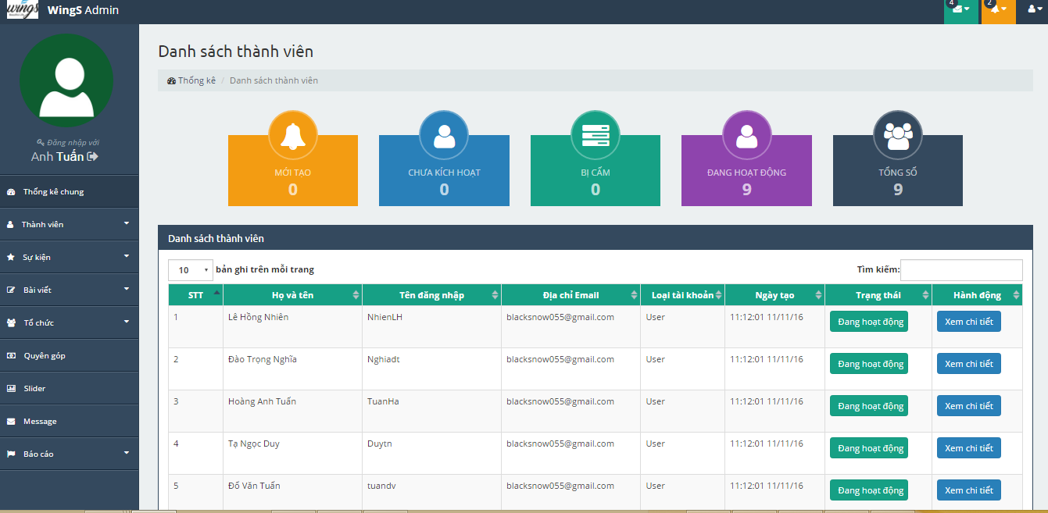

Users list screen

|  |  |  |  |  |  |  |  |
| --- | --- | --- | --- | --- | --- | --- | --- |
| No | Field name | Field name in Vietnamese | Type | Require | Mandatory | Max-Length | Description |
| 1 | Total new users | Người dùng mới | Label |  | Y |  | Total new users |
| 3 | Total users deactive | Người dùng chưa kích hoạt | Label |  | Y |  | Total user NOT Active |
| 3 | Total users be banned | Người dùng bị cấm | Label |  | Y |  | Total user be banned |
| 4 | Total users active | Người dùng đang hoạt động | Label |  | Y |  | Total user Active |
| 5 | Total users | Tổng số người dùng | Label |  | Y |  | Total users registed |
| 6 | View (icon) | Xem (biểu tượng) | Button | Click | Y |  | Link to profile of user |
| 7 | Active (icon) | Mở khóa (biểu tượng) | Button | Click | Y |  | Unlock/Active user |
| 8 | Deactive (icon) | Khóa (biểu tượng) | Button | Click | Y |  | Lock/Deactive user |

1. Users list

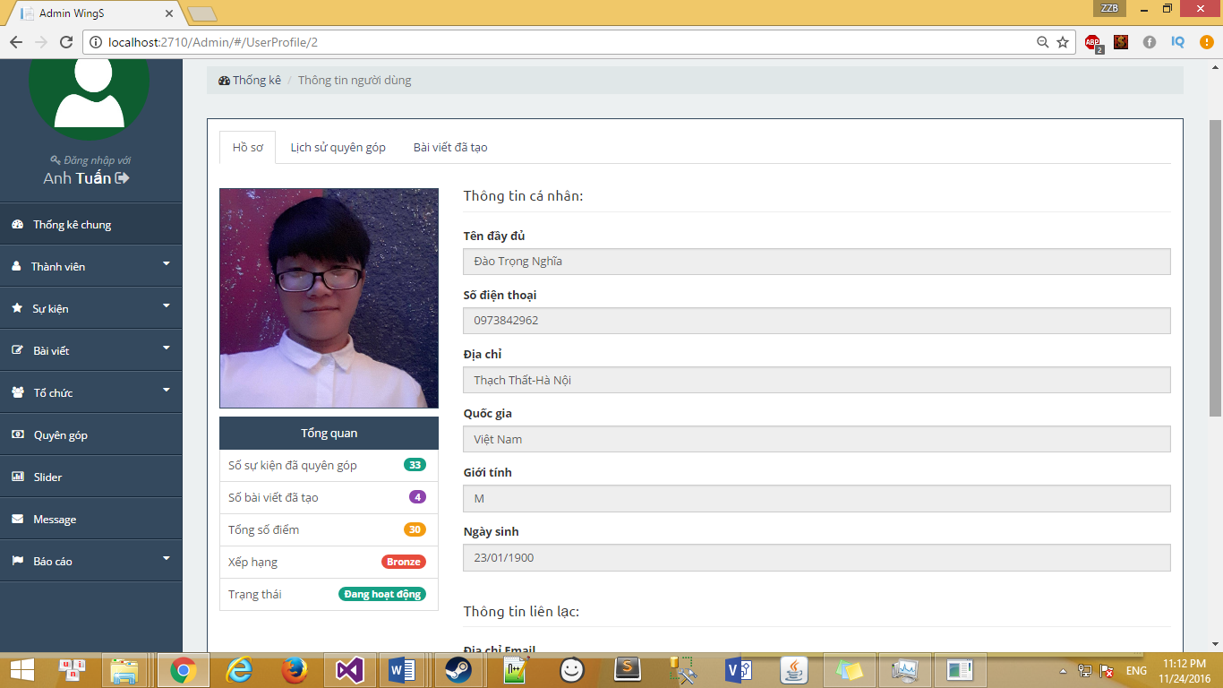

User’profile screen

#### Event

##### Event dashboard

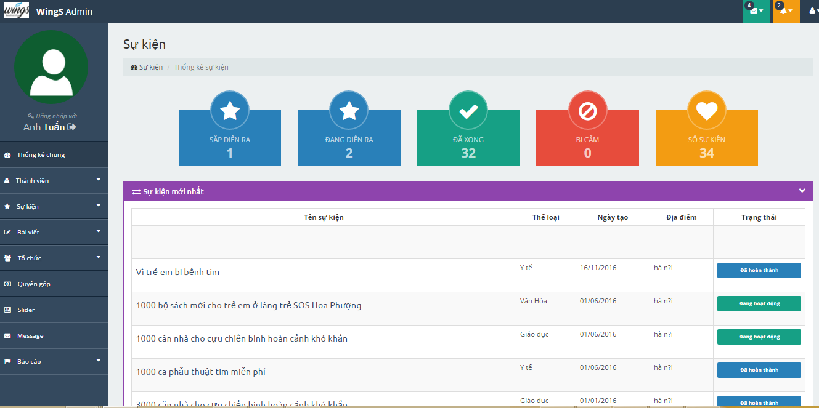

Event dashboard screen

|  |  |  |  |  |  |  |  |
| --- | --- | --- | --- | --- | --- | --- | --- |
| No | Field name | Field name in Vietnamese | Type | Require | Mandatory | Max-Length | Description |
| 1 | Total Event upcoming | Số sự kiện sắp diễn ra | Label |  | Y |  | Total Event upcoming |
| 2 | Total Event running | Số sự kiện đang diễn ra | Label |  | Y |  | Total Event running |
| 3 | Total Event Closed | Số sự kiện đã xong | Label |  | Y |  | Total Event Closed |
| 4 | Total Event be banned | Số sự kiện bị cấm | Label |  | Y |  | Total Event be banned |
| 5 | Total Event | Tống số sự kiện | Label |  | Y |  | Total Event |
| 6 | Top New Events | Danh sách các sự kiện mới | Table |  | Y |  | List Events |
| 7 | Top Donation Events | Danh sách sự kiện ủng hộ nhiều nhất | Table |  | Y |  | List Events |

1. Event dashboard

##### Events list

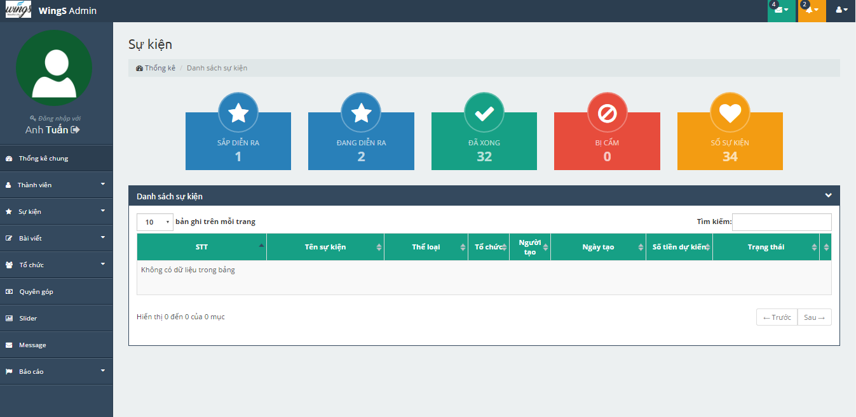

Events list screen

|  |  |  |  |  |  |  |  |
| --- | --- | --- | --- | --- | --- | --- | --- |
| No | Field name | Field name in Vietnamese | Type | Require | Mandatory | Max-Length | Description |
| 1 | Order number | Số thứ tự | Label |  | Y |  | Order number |
| 2 | Event name | Tên sư kiện | Label |  | Y |  | Event name |
| 3 | Event type | Thể loại sự kiện | Label |  | Y |  | Event type |
| 4 | Organization name | Tên tổ chức | Label |  | Y |  | Organization name |
| 5 | Creator | Người tạo | Label |  | Y |  | Creator |
| 6 | Created date | Ngày tạo | Label |  | Y |  | Created date |
| 7 | Expected money | Số tiền dự kiến | Label |  | Y |  | Expected money |
| 8 | Status | Trạng thái | Button | Click | Y |  | Status |

1. Event list

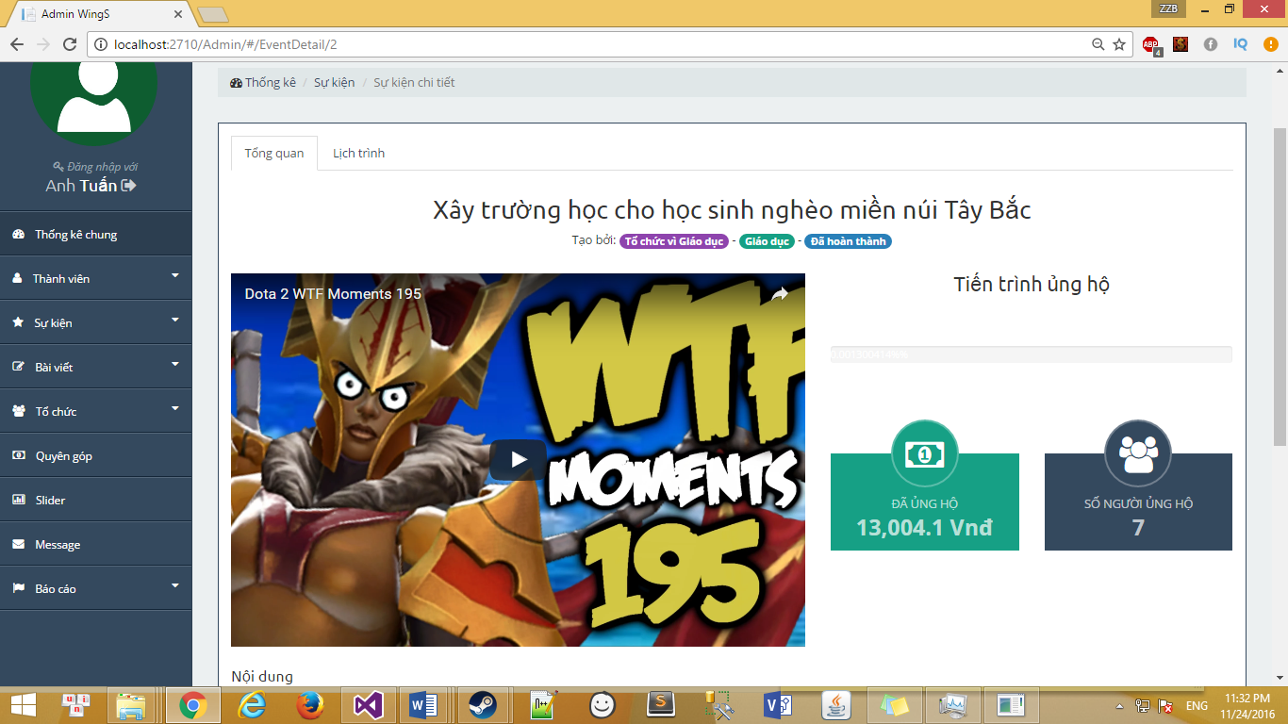

Event detail screen

|  |  |  |  |  |  |  |  |
| --- | --- | --- | --- | --- | --- | --- | --- |
| No | Field name | Field name in Vietnamese | Type | Require | Mandatory | Max-Length | Description |
| 1 | Infomation | Tổng quan | Tab |  | Y |  | Profile |
| 2 | Schedule | Lịch trình | Tab |  | Y |  | Backed Event |
| 3 | Created Event | Cập nhật | Tab |  | Y |  | Created Event |

1. Event detail

##### Event category

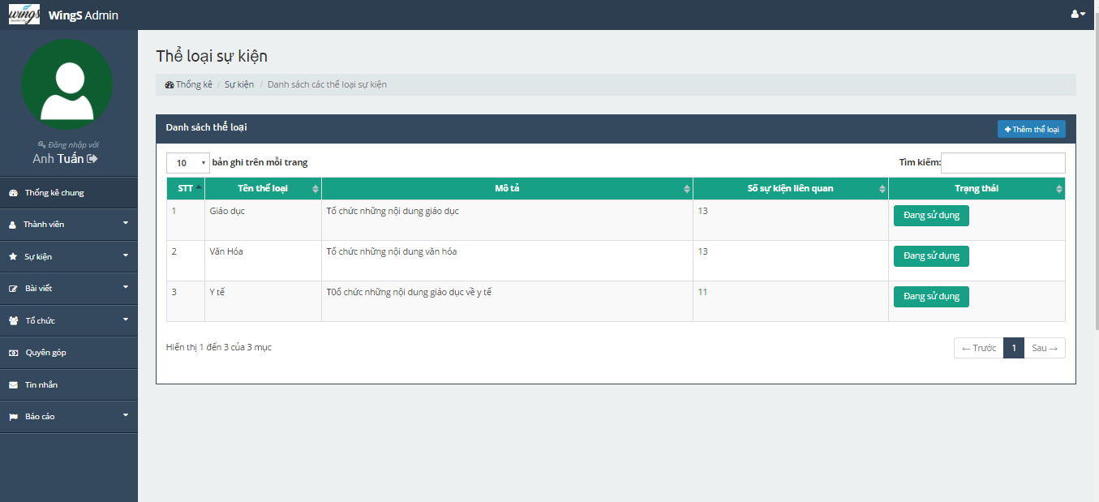

Event type screen

|  |  |  |  |  |  |  |  |
| --- | --- | --- | --- | --- | --- | --- | --- |
| No | Field name | Field name in Vietnamese | Type | Require | Mandatory | Max-Length | Description |
| 1 | Order number | Số thứ tự | Label |  | Y |  | Order number |
| 2 | Event type name | Tên thể loại | Label |  | Y |  | Event type names |
| 3 | Description | Thể loại sự kiện | Label |  | Y |  | Description |
| 4 | Numbers of event relate | Số sự kiện liên quan | Label |  | Y |  | Numbers of event relate |
| 5 | Status | Trạng thái | Button | Click | Y |  | Status |
| 6 | Add event type | Thêm thể loại | Button | Click | Y |  | Add event type |

1. Event type

#### Thread

##### Thread dashboard

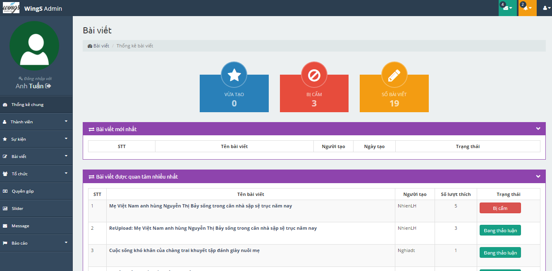

Thread dashboard screen

|  |  |  |  |  |  |  |  |
| --- | --- | --- | --- | --- | --- | --- | --- |
| No | Field name | Field name in Vietnamese | Type | Require | Mandatory | Max-Length | Description |
| 1 | Total Thread recently | Số sự bài viết vừa tạo | Label |  | Y |  | Total Thread upcoming |
| 2 | Total Thread running | Số bài viết bị cấm | Label |  | Y |  | Total Thread running |
| 3 | Total Thread | Tống số bài viết | Label |  | Y |  | Total Thread |
| 4 | Top New Thread | Danh sách các bài viết mới | Table |  | Y |  | Top New Thread |
| 5 | Top interested thread | Danh sách bài viết được quan tâm | Table |  | Y |  | Top interested thread |

1. Thread dashboard

##### Thread list

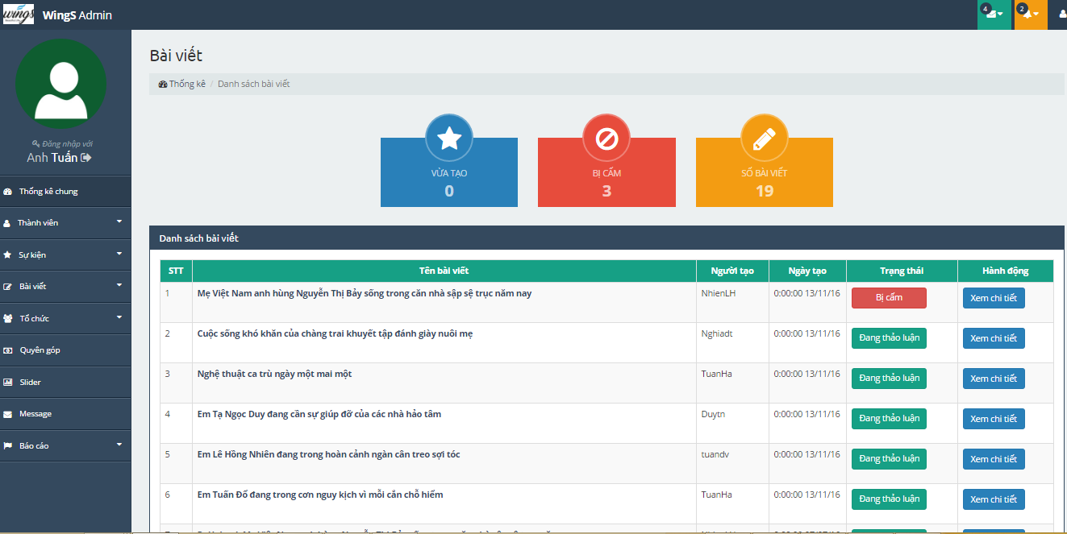

Thread list screen

|  |  |  |  |  |  |  |  |
| --- | --- | --- | --- | --- | --- | --- | --- |
| No | Field name | Field name in Vietnamese | Type | Require | Mandatory | Max-Length | Description |
| 1 | Order number | Số thứ tự | Label |  | Y |  | Order number |
| 2 | Name of thread | Tên bài viết | Label |  | Y |  | Name of thread |
| 3 | Creator | Người tạo |  |  | Y |  | Creator |
| 4 | Created date | Ngày tạo | Table |  | Y |  | Created date |
| 5 | Status | Trạng thái | Button | Click | Y |  | Status |
| 6 | Action | Hành động | Button | Click | Y |  | Action |

1. Thread list

#### Organization

##### Organization dashboard

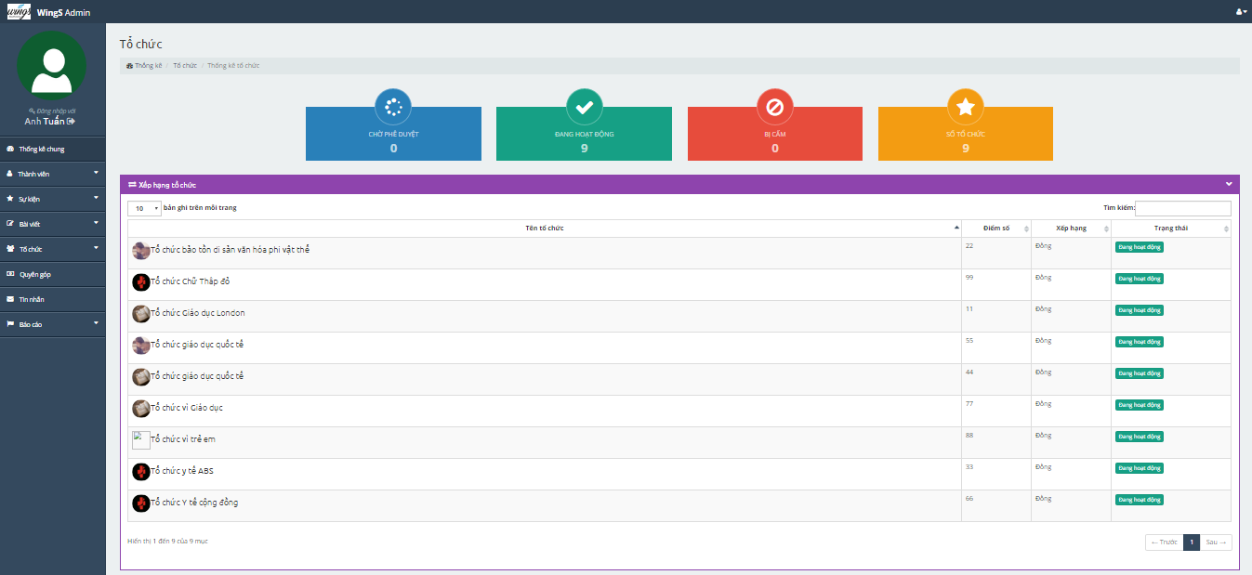

Organization dashboard screen

|  |  |  |  |  |  |  |  |
| --- | --- | --- | --- | --- | --- | --- | --- |
| No | Field name | Field name in Vietnamese | Type | Require | Mandatory | Max-Length | Description |
| 1 | Total pending approval | Số tổ chức chờ xử lý | Label |  | Y |  | Total pending approval |
| 2 | Total running | Số tổ chức đang hoạt động | Label |  | Y |  | Total running |
| 3 | Total be banned | Số tổ chức bị cấm | Label |  | Y |  | Total be banned |
| 5 | Total | Số tổ chức | Label |  | Y |  | Total |
| 6 | Rank of organization | Xếp hạng tổ chức | Table |  | Y |  | Rank of organization |
| 7 | New organization | Tổ chức mới nhất | Table |  | Y |  | New organization |

1. Organization dashboard

##### Organization list

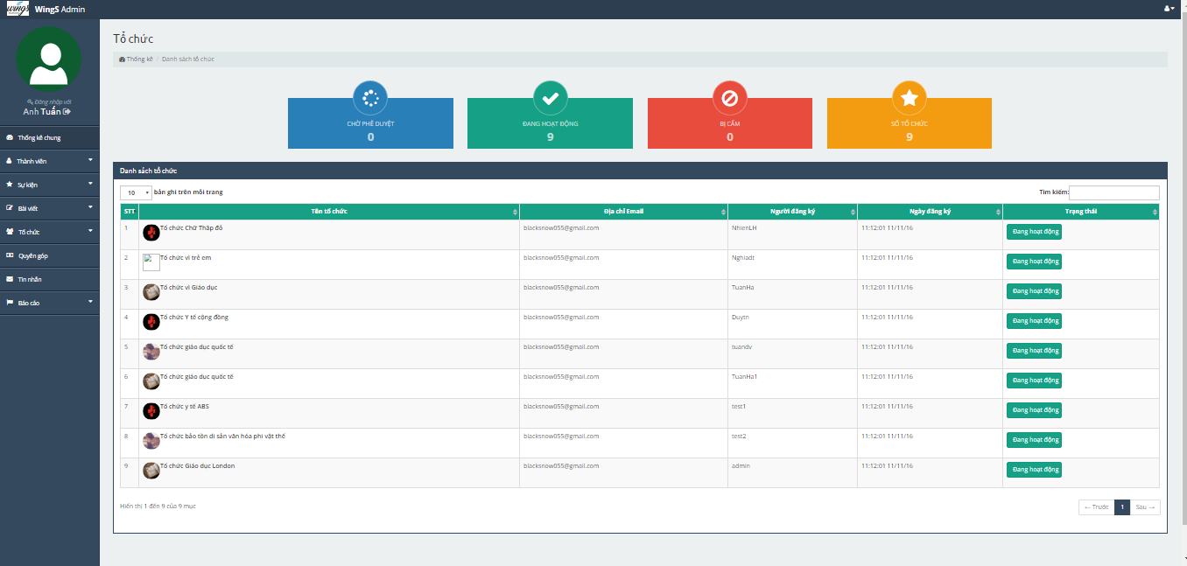

Organization list screen

|  |  |  |  |  |  |  |  |
| --- | --- | --- | --- | --- | --- | --- | --- |
| No | Field name | Field name in Vietnamese | Type | Require | Mandatory | Max-Length | Description |
| 1 | Order number | Số thứ tự | Label |  | Y |  | Order number |
| 2 | Name of organization | Tên tổ chức | Label |  | Y |  | Name of organization |
| 3 | Email | Địa chỉ email | Label |  | Y |  | Email |
| 4 | Register | Người đăng ký | Label |  | Y |  | Register |
| 5 | Registed date | Ngày đăng ký | Label |  | Y |  | Registed date |
| 6 | Status | Trạng thái | Button | Click | Y |  | Status |

1. Organization list

#### Donate

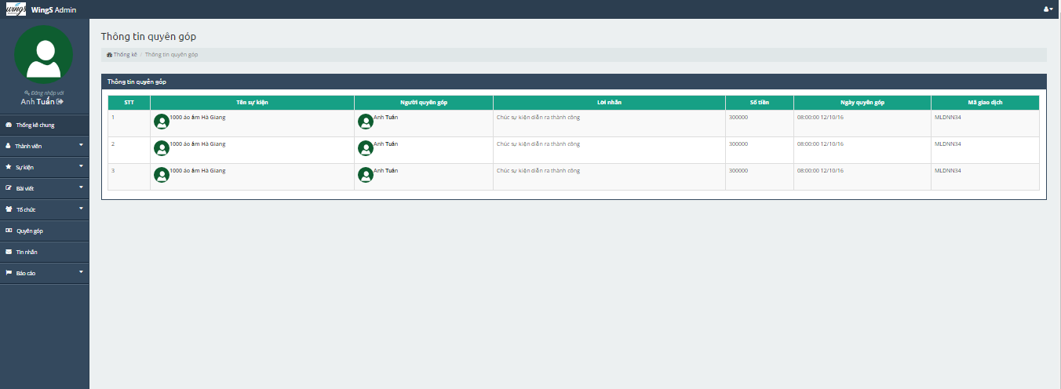

Donate list screen

|  |  |  |  |  |  |  |  |
| --- | --- | --- | --- | --- | --- | --- | --- |
| No | Field name | Field name in Vietnamese | Type | Require | Mandatory | Max-Length | Description |
| 1 | Order number | Số thứ tự | Label |  | Y |  | Order number |
| 2 | Name of event | Tên sự kiện | Label |  | Y |  | Name of event |
| 3 | Donater | Người quyên góp | Label |  | Y |  | Donater |
| 4 | Content | Lời nhắn | Label |  | Y |  | Content |
| 5 | Number of money | Số tiềns | Label |  | Y |  | Number of money |
| 6 | Donated date | Ngày quyên góp | Label |  |  |  | Donated date |
| 7 | Trading code | Mã giao dịch | Label |  | Y |  | Trading code |

1. Donate list

#### Message

N/A

#### Report

##### Report user

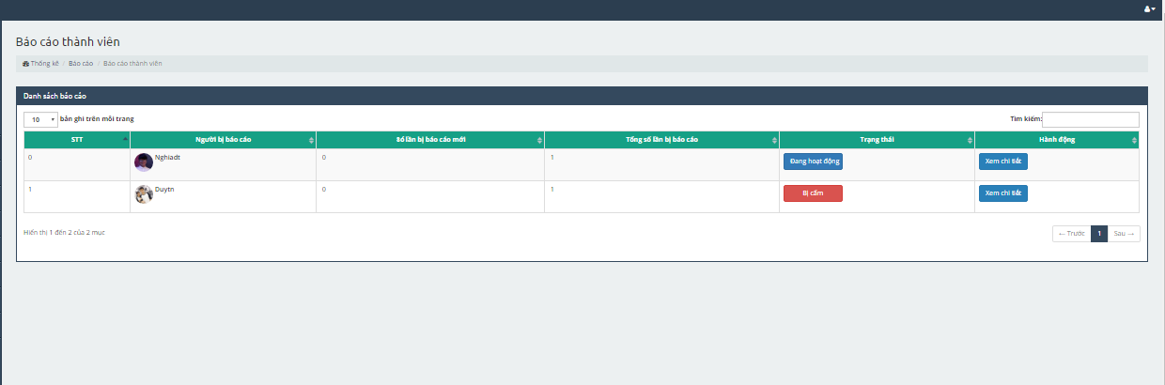

Report user management screen

|  |  |  |  |  |  |  |  |
| --- | --- | --- | --- | --- | --- | --- | --- |
| No | Field name | Field name in Vietnamese | Type | Require | Mandatory | Max-Length | Description |
| 1 | Order number | Số thứ tự | Lable |  | Y |  | Order number |
| 2 | User has been reported | Người bị báo cáo | Lable |  | Y |  | User has been reported |
| 3 | Numbers of reported | Số lần bị báo cáo | Lable |  | Y |  | Numbers of reported |
| 4 | Status | Trạng thái | Lable |  | Y |  | Status |
| 5 | Action | Hành động | Button | Click | Y |  | Action |

1. Report user management

##### Report organization

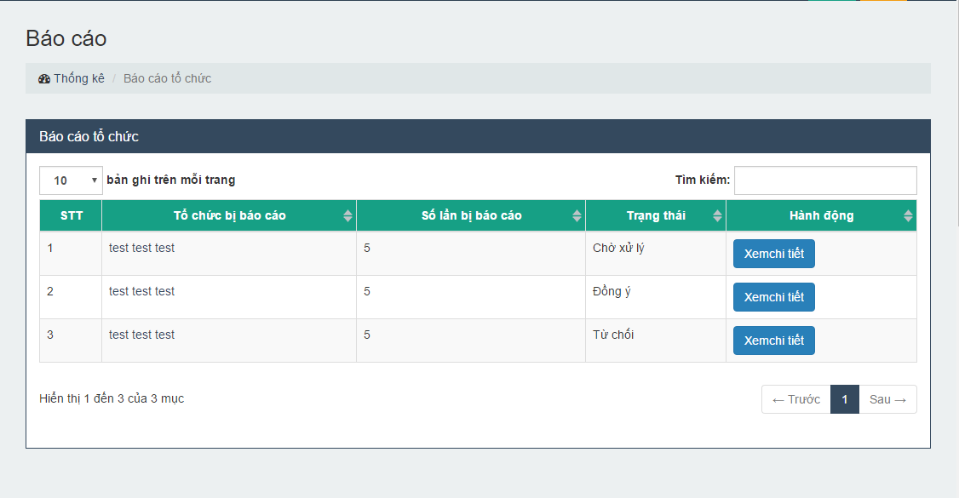

Report Organization management screen

|  |  |  |  |  |  |  |  |
| --- | --- | --- | --- | --- | --- | --- | --- |
| No | Field name | Field name in Vietnamese | Type | Require | Mandatory | Max-Length | Description |
| 1 | Order number | Số thứ tự | Lable |  | Y |  | Order number |
| 2 | Organization has been reported | Tổ chức bị báo cáo | Lable |  | Y |  | Organization has been reported |
| 3 | Numbers of reported | Số lần bị báo cáo | Lable |  | Y |  | Numbers of reported |
| 4 | Status | Trạng thái | Lable |  | Y |  | Status |
| 5 | Action | Hành động | Button | Click | Y |  | Action |

1. Report Event management

##### Report thread

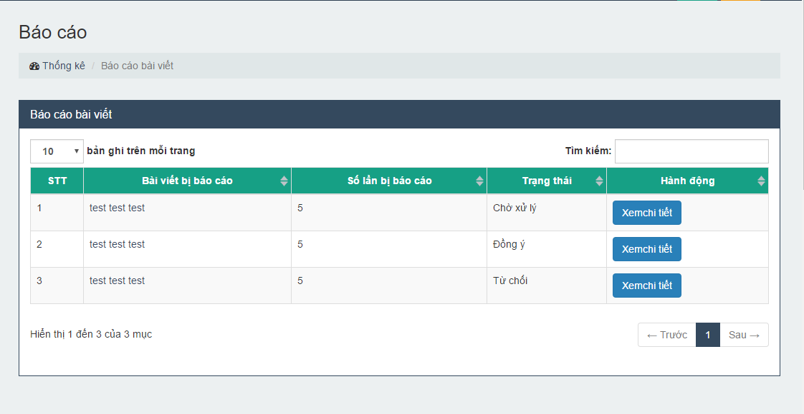

Report thread management scren

|  |  |  |  |  |  |  |  |
| --- | --- | --- | --- | --- | --- | --- | --- |
| No | Field name | Field name in Vietnamese | Type | Require | Mandatory | Max-Length | Description |
| 1 | Order number | Số thứ tự | Lable |  | Y |  | Order number |
| 2 | Thread has been reported | Bài viết bị báo cáo | Lable |  | Y |  | Thread has been reported |
| 3 | Numbers of reported | Số lần bị báo cáo | Lable |  | Y |  | Numbers of reported |
| 4 | Status | Trạng thái | Lable |  | Y |  | Status |
| 5 | Action | Hành động | Button | Click | Y |  | Action |

1. Report thread management

##### Report event

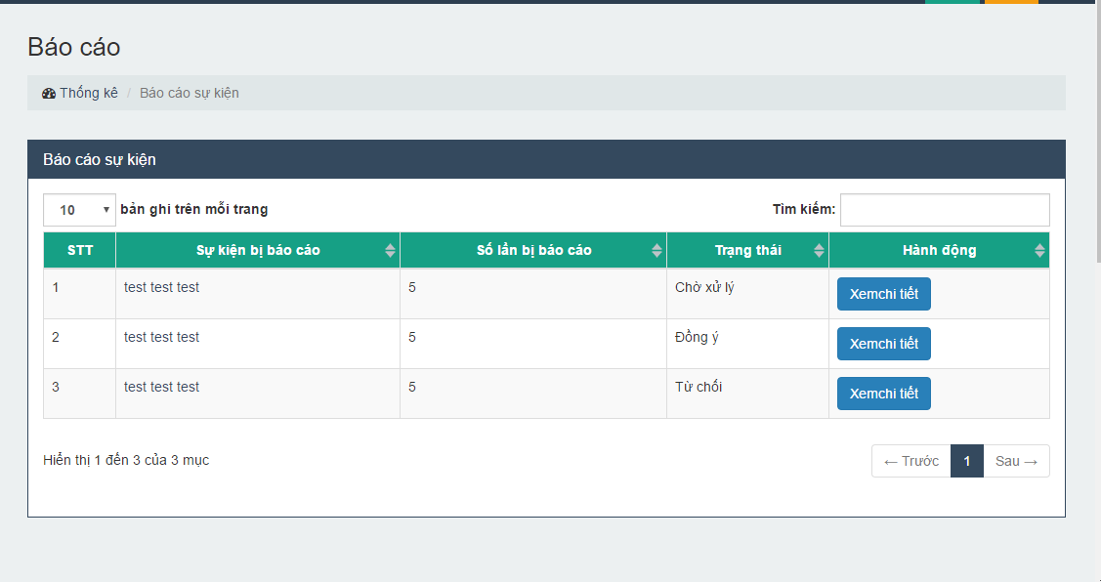

Report event management screen

|  |  |  |  |  |  |  |  |
| --- | --- | --- | --- | --- | --- | --- | --- |
| No | Field name | Field name in Vietnamese | Type | Require | Mandatory | Max-Length | Description |
| 1 | Order number | Số thứ tự | Lable |  | Y |  | Order number |
| 2 | Event has been reported | Sự kiện bị báo cáo | Lable |  | Y |  | Event has been reported |
| 3 | Numbers of reported | Số lần bị báo cáo | Lable |  | Y |  | Numbers of reported |
| 4 | Status | Trạng thái | Lable |  | Y |  | Status |
| 5 | Action | Hành động | Button | Click | Y |  | Action |

1. Report event management

# SOFTWARE TESTING

## Introduction

### Purpose

This is the comprehensive test plan of the WS project. The purpose of this chapter describes scopes of test and activities which need to be taken during test process of project. It addresses the following items: Scopes of Testing, Requirements for Testing, Test Strategy, Test Resources, Test Environment, Test Milestones and Deliverables.

### Definitions and Acronyms

This section describes the definitions, terms, and acronyms that are used in software requirements specification.

|  |  |  |
| --- | --- | --- |
| **Acronym** | **Definition** | **Note** |
| WS | WingS |  |
| GUI | Graphic User Interface |  |
| IT | Integration Test |  |
| KLOC | 1000 line of code |  |
| PM | Project Manager |  |
| QA | Quality Assurance |  |
| SRS | Software Requirement Specification |  |
| ST | System Test |  |
| TC | Test Case |  |
| TL | Test Leader |  |
| TP | Test Plan |  |
| TR | Test Report |  |
| UT | Unit Test |  |

1. Definitions and Acronyms

### Scope of testing

WS will be tested by 3 phases:

**Phase 1: Unit testing**

* Unit testing will be done by developers.
* Developers use White Box Testing and Black Box Testing (for some function) technique to do.
* When executing unit testing, if any bugs are found, developers have to log bug on “Defect Log Management” file and fix it until it is correct.

*Rule for filling test result:*

|  |  |
| --- | --- |
| Test result pass | Pass |
| Test result fail | Fail |
| Do not test | Untested |
| Cannot test | N/A (Not available) |

**Phase 2: Integration testing**

* After finishing component testing, integration testing will be performed by testers.
* Material are integration test cases, high- level design and test tools.
* Integration test focuses on specific areas of use cases when all requirements are completed.
* Integration test should be performed to ensure all components incorporate well.
* When executing integration testing, if any bugs are found, testers have to log on “Defect Log Management” file and assign to developer fix it and redo this process until it is correct.

*Rule for filling test result:*

|  |  |
| --- | --- |
| Test result pass | Pass |
| Test result fail | Fail |
| Do not test | Untested |
| Cannot test | N/A (Not available) |

**Phase 3: System testing**

* After finishing integration testing and developers collect all functions and items, testers will be performed system testing, it means doing test whole system.
* Material area system test case, SRS
* If any bugs are found, developers have to fix and testers will verify them. System test is ended only when test cases are passed and no bug is found.

*Rule for filling test result:*

|  |  |
| --- | --- |
| Test result pass | Pass |
| Test result fail | Fail |
| Do not test | Untested |
| Cannot test | N/A (Not available) |

### Constraints

* Deadline for testing only can be met if development progress is on time.
* Test execution can be performed when system passes Unit Test Inspection.
* At least one round of testing must be performed for requirements.
* Have more environments should be tested: Window XP, Window 8… and more browsers: Firefox and Google Chrome…

## Test plan

### Test type

#### Function Testing

* Functional Testing is a testing technique that is used to test the features/functionality of the system or Software, should cover all the scenarios including failure paths and boundary cases.
* Functions are tested by feeding them input and examining the output. Functional testing ensure that the requirements are properly satisfied by the website. This type of testing is not concerned with how processing occurs, but rather, with the results of processing.
* During functional testing, there are two major Functional Testing techniques Black Box Test and White Box Test. [Black Box Testing](http://softwaretestingfundamentals.com/black-box-testing/) technique is used in which the internal logic of the system being tested is not known to the tester.

|  |  |
| --- | --- |
| **Test Objective:** | The type of this test is to ensure proper target-of-test functionality, including user interaction, all function defined in specification document implemented correctly. |
| **Technique:** | Executing each use case, use-case flow, or function, using valid and invalid data, to verify the following:  - The expected results occur when valid data is used.  - The appropriate error or warning messages are displayed when invalid data is used.  - Each business rule is properly applied. |
| **Completion Criteria:** | - All planned tests have been executed.  - All identified defects have been addressed and closed. |
| **Special Considerations:** | Testing may be stopped when  Time runs out  A certain number of defects found  Test coverage > 98%  Stop when testing becomes unproductive |

**Table 3-1:** Function Testing

#### User Interface Testing

GUI testing is the process of ensuring proper functionality of the GUI for a given web and making sure it conforms to its written specifications.

GUI testing evaluates design elements such as layout, colors, [fonts](http://whatis.techtarget.com/definition/font), font sizes, labels, text boxes, text formatting, captions, buttons, lists, icons, links, content and more.

|  |  |
| --- | --- |
| **Test Objective:** | Verify the following:  - Navigation through the target-of-test properly reflects business functions and requirements, including window-to-window, field-to-field, and use of access methods (tab keys, mouse movements, accelerator keys)  - Window objects and characteristics, such as menus, size, position, state, and focus conform to standards. |
| **Technique:** | Create or modify tests for each window to verify proper navigation and object states for each application window and objects. |
| **Completion Criteria:** | Each window successfully verified to remain consistent with benchmark version or within acceptable standard |
| **Special Considerations:** | Not all properties for custom and third party objects can be accessed. |

**Table 3-2:** GUI Testing

### Test stages

Clearly state the stage in which the test will be executed. Identified below are the stages in which common test are executed

| **Type of Tests** | **Stage of Test** | | | |
| --- | --- | --- | --- | --- |
| **Unit** | **Integration** | **System** | **Acceptance** |
| Function Testing | X | X | X | X |
| User Interface Testing |  |  | X | X |

### Guarantee the quality model

WS follows V-Model process:

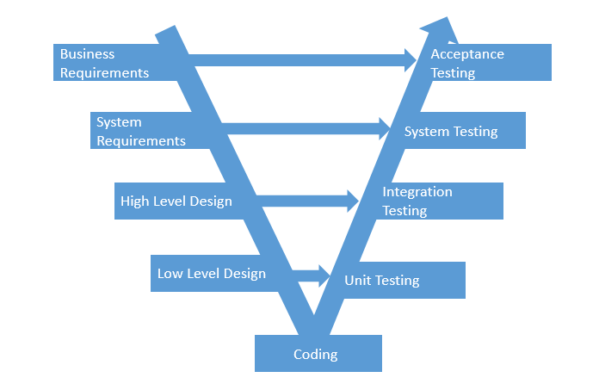

**Figure 2-1**: V-Model

Testing progress is divided to 5 phases include: Unit test, Component test, Integration test and System test (But in WS project, we not cover Component test).

* Unit test:
  + Unit testing is used to verify a single minimal unit of source code. The purpose of unit testing is to isolate the smallest testable parts of WS and verify that they function properly in isolation.
  + Unit testing is the first level of testing and is perform prior to component testing
  + Unit testing will be done by developer.
* Integration test:
  + Integration testing is a level of the software testing process where individual units or component are combined and tested as a group.
  + The purpose is to expose faults in the interaction between integrated units.
  + Integration testing is performed after component testing
  + Integration testing will be done by tester
  + There are two methods of doing integration testing: Bottom-up Integration testing and Top Down Integration testing:

|  |  |
| --- | --- |
| No | Integration Testing Method |
| 1 | Bottom-up integration  This testing begins with unit testing, followed by tests of progressively higher-level combinations of units called modules. |
| 2 | Top- Down integration  This testing, the highest-level modules are tested first and progressively lower-level modules are tested after that |

**Table 1-3:** Integration test

* System test:
  + System Testing is a level of the software testing process where a complete, integrated system is tested.
  + The purpose is to evaluate the system’s compliance with the specified requirements.
  + System testing is performed after integration testing.
  + System testing will be done by tester.
* Acceptance test:
  + Acceptance testing is performed after system testing.
  + Acceptance testing will be performed by the test leader and team leader.
  + The acceptance test will be done for a period of 1 weeks after completion of the system test process.

### Acceptance Test Criteria

* Criteria for Unit test of Development team, for Test team accepts to start testing:
  + Number of TC/KLOC: 30TC/KLOC
  + Number defects/KLOC: 3-4 defects/KLOC
  + Statement coverage: 97%
  + Branch coverage: 100%
  + Path coverage: 100%
* Criteria for Integration test:
  + Number of TC/KLOC: 30 TC/KLOC
  + Number defects/KLOC: 2-3 defects/KLOC
* Criteria for System test:
  + Number of TC/KLOC: 50 TC/KLOC
  + Number defects/KLOC: 4-6 defects/KLOC

### Futures to be tested

Refer 3.3.1.2 Product features for more detail.

### Feature not to be tested

* Large amount of donation.
* The stable of website when do not connect internet.
* Too much users connect to system at the same time.

### Human resource

|  |  |  |
| --- | --- | --- |
| **Worker/Doer** | **Role** | **Specific Responsibilities/Comments** |
| DuyTN | Test Leader | Manage Test Resource and assign test tasks.  Create and review Test Plan.  Create and review Test Case.  Execute test.  Create and review Test Report |
| NghiaDT | Tester | Create and review Test Case.  Execute test.  Create Test view points  Create and review Test Report |

**Table 3-5:** Human resource

### TEST ENVIRONMENT

#### Hardware

|  |  |  |
| --- | --- | --- |
| **Name** | **Purpose** | **Detail** |
| Laptop Asus | Device for create and execute test | Window 8.1 Pro Core i5 |

**Table 5-1:** Hardware

#### Software

|  |  |  |
| --- | --- | --- |
| Name | Purpose | Detail |
| Test Plan | Managing test | Microsoft Word 2010, 2013 |
| Test case | Executing test | Microsoft Excel 2010, 2013 |
| Test report, Test checklist | Tracking test | Microsoft Excel 2010, 2013 |
| Chrome | Executing test | Chrome 53 |
| Firefox | Executing test | Firefox 50 |

**Table 5-2:** Software

#### Infrastructure

|  |  |  |  |  |
| --- | --- | --- | --- | --- |
| **Name** | **Purpose** | **Detail** | **Vendor/In-house** | **Version** |
| WS_Defect Log Management_v1.0_EN | Tracking bug during testing time | Microsoft Excel 2013, 2010 | FPT-University | v1.0 |
| Test Effort | Effort execute test | Microsoft Excel 2013, 2010 | FPT-University | v1.0 |

**Table 5-3:** Infrastructure

### TEST MILESTONES

|  |  |  |  |
| --- | --- | --- | --- |
| **Milestone Task** | **Effort (pd)** | **Start Date** | **End Date** |
| Create Test Plan | 6 |  |  |
| Review & Update Test Plan | 2 |  |  |
| Create Component Test case | 12 |  |  |
| Review & Update Component Test Case | 2 |  |  |
| Create Integration Test case | 4 |  |  |
| Review & Update Integration Test Case | 2 |  |  |
| Create System Test case | 8 |  |  |
| Review & Update System Test Case | 2 |  |  |
| Execute Component test phase 1 | 2 |  |  |
| Execute Component test phase 2 | 2 |  |  |
| Execute Integration test phase 1 | 3 |  |  |
| Execute Integration test phase 2 | 4 |  |  |
| Execute System test phase 1 | 4 |  |  |
| Execute System test phase 2 | 4 |  |  |

**Table 6.1:** Test milestones

### DELIVERABLES

| **No** | **Deliverables** | **Responsibilities** | **Delivered Date** |
| --- | --- | --- | --- |
| 1 | Test Plan | Tester |  |
| 2 | Component Test case | Tester |  |
| 3 | Integration Test case | Tester |  |
| 4 | System Test case | Tester |  |
| 5 | Defect Log Management | All members |  |
| 6 | Test report | PM |  |

**Table 7-1:** Deliverables

## Test case

Refer to:

* + WS_Integration Test Case_v1.0_EN.xlsx
  + WS_System Test Case_v1.0_EN.xlsx
  + WS_Common Test Case_v1.0_EN.xlsx
  + WS_Unit Test Case_Conservation_v1.0.xlsx
  + WS_Unit Test Case_Donation_v1.0.xlsx
  + WS_Unit Test Case_Event_v1.0.xlsx
  + WS_Unit Test Case_Organization_v1.0.xlsx
  + WS_Unit Test Case_Report_v1.0.xls
  + WS_Unit Test Case_Search_v1.1.xlsx
  + WS_Unit Test Case_Thread_v1.1 .xlsx
  + WS_Unit Test Case_User_v1.1.xlsx

## Test Report

### System test report

|  |  |  |  |  |  |
| --- | --- | --- | --- | --- | --- |
| **No** | **Module Code** | **Pass** | **Fail** | **N/A** | **Number of Test Case** |
| 1 | Common | 88 | 0 | 0 | 88 |
| 2 | Managa Event | 110 | 2 | 0 | 110 |
| 3 | Manage Thread | 68 | 0 | 0 | 68 |
| 4 | Organization | 40 | 0 | 0 | 40 |
| 5 | User Profile | 36 | 0 | 0 | 36 |
| 6 | Donate | 30 | 0 | 0 | 30 |
| 7 | Message | 36 | 0 | 0 | 36 |
| 8 | Admin module | 134 | 0 | 0 | 134 |
|  | **Total** | 542 | 0 | 0 | 542 |

1. System test report

### Integration test report

|  |  |  |  |  |  |
| --- | --- | --- | --- | --- | --- |
| **No** | **Module Code** | **Pass** | **Fail** | **N/A** | **Number of Test Case** |
| 1 | Registered_User_function | 298 | 0 | 0 | 298 |
| 2 | Admin_Function | 128 | 2 | 0 | 128 |
|  | **Total** | 426 | 2 | 0 | 426 |

1. Integration test report

### Test report

|  |  |  |  |  |  |  |  |  |  |  |
| --- | --- | --- | --- | --- | --- | --- | --- | --- | --- | --- |
| **No** | **Module Code** | **Round 1** | | | | **Round 2** | | | | **Final** |
| Pass | Fail | Untest | N/A | Pass | Fail | Untest | N/A |
| 1 | Unit Test | 337 | 3 | 0 | 0 | 340 | 0 | 0 | 0 | 340 |
| 2 | Integration Test | 414 | 13 | 0 | 0 | 426 | 0 | 0 | 0 | 426 |
| 3 | System Test | 510 | 42 | 6 | 4 | 536 | 0 | 0 | 0 | 536 |
|  | **Total** | 1261 | 58 | 6 | 4 | 1302 | 0 |  |  | 1302 |

1. Test Report

### Defect report

|  |  |  |  |  |
| --- | --- | --- | --- | --- |
| **Defects** | **Logged** | **%Closed** | **%Invalid** | **%Open** |
| **Critical** | 0 | 0% | 0% | 0% |
| **High** | 3 | 0% | 0% | 0% |
| **Medium** | 13 | 100% | 0% | 0% |
| **Low** | 42 | 100% | 0% | 0% |
| **Total** | 58 | 100% | 0% | 0% |

1. Test Report

# USER MANUAL

## Introduction

### Purpose

This document contains guide-lines step by step to deploy WS Web App to local IIS Web Server.

### Environment

Following are the software required to start the WS system:

* Operating System: Windows 7, Windows 8, Window 10
* Browsers: Firefox 50, Chrome 53 or higher.
* Database: SQL 2008 or higher
* .NET Framework 4.5

## Installation Guideline

### Installing IIS on Windows

**Step 1:** Open Control Panel and click on “Programs” as shown in the figure below:

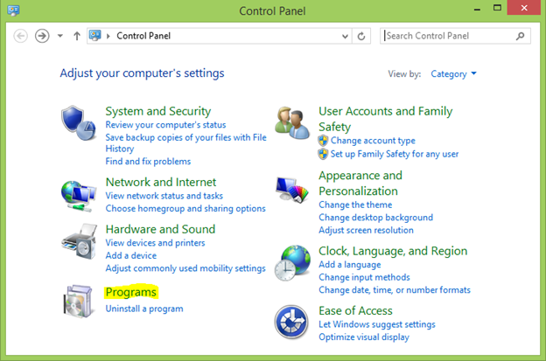

**Windows Control Panel**

**Step 2:** Then click on “Turn Windows features on or off” from the Programs and Features dialog and select “Internet Information Services” from the list as shown in the figure below:

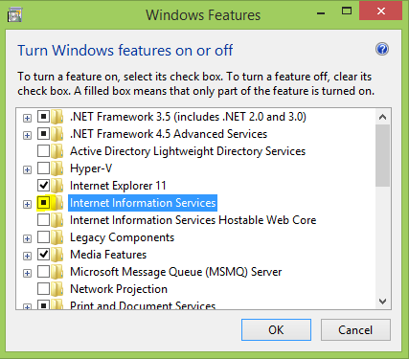

**Windows Features dialog**

**Step 3:** Expand IIS and check/enable all components under “World Wide Web Services” > “Application Development Features” as shown in the figure below:

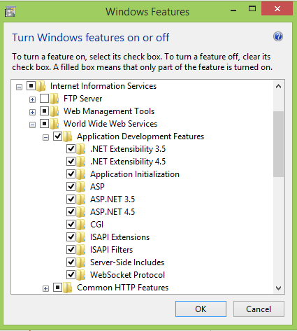

**Windows Features dialog**

**Step 4:** Click “OK” to let Windows install the required files. Once installed you may now close the dialog.

#### Creating Application Pool.

Open the Internet Information Services (IIS) Manager and follow the procedure given below:  
**Step 1:** Select Application Pools -> add new 2 Application Pools is : ASP.NET v4.0 (select Integrated) and ASP.NET v4.0 Classic (select Classic) all .NET Framework select v4.0.30319.

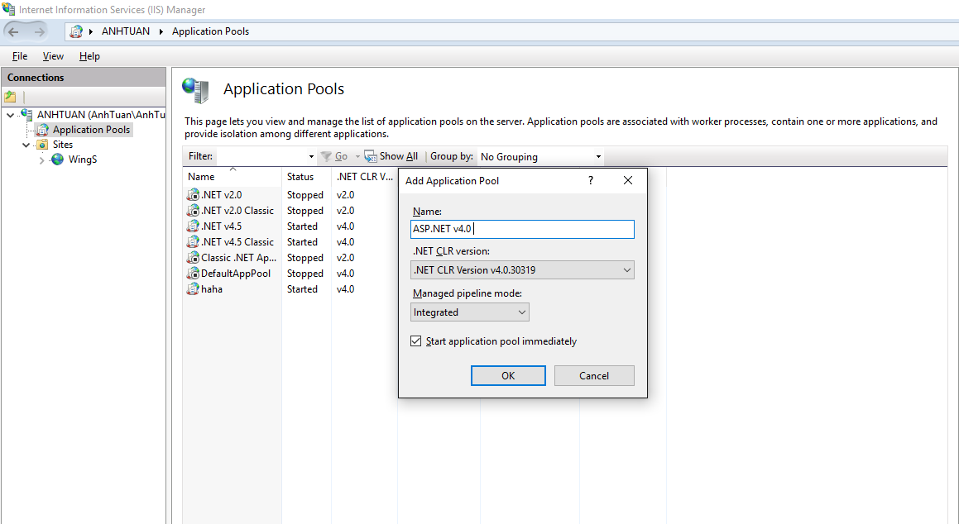

**Step 2:** Close IIS. After, go to Run enter:

%windir%\Microsoft.NET\Framework\v4.0.30319\aspnet _regiis.exe -i

Open IIS select ISAPI and CGI Restrictions as figure below:

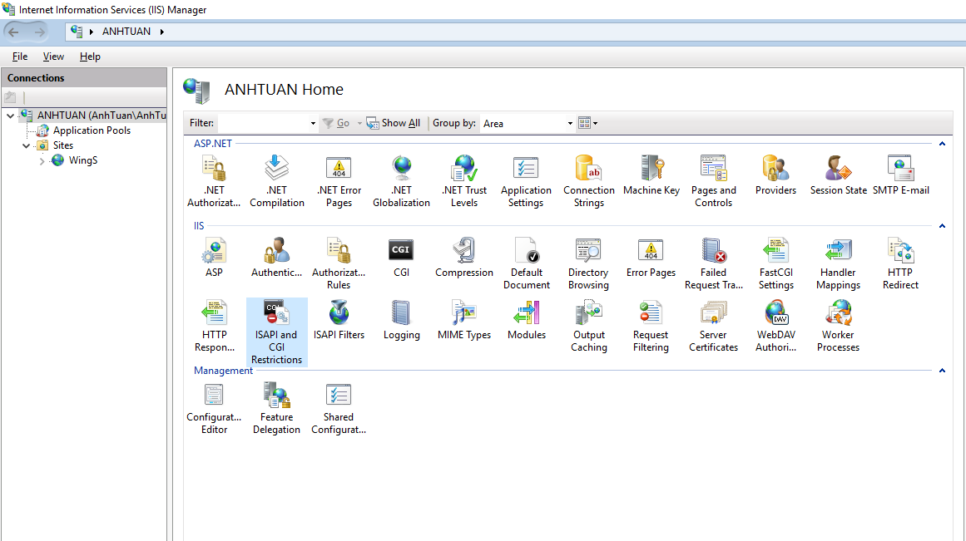

**Step 3:** Allowed 2 items ASP.NET v4.0.

**Step 4:** Select “Application Pools” and select “ASP.NET v4.0” from the list since our app uses this default application pool. If you are using a different application pool for your app then select that instead. On the left panel, select the link “Advance Settings” as shown in the figure below:

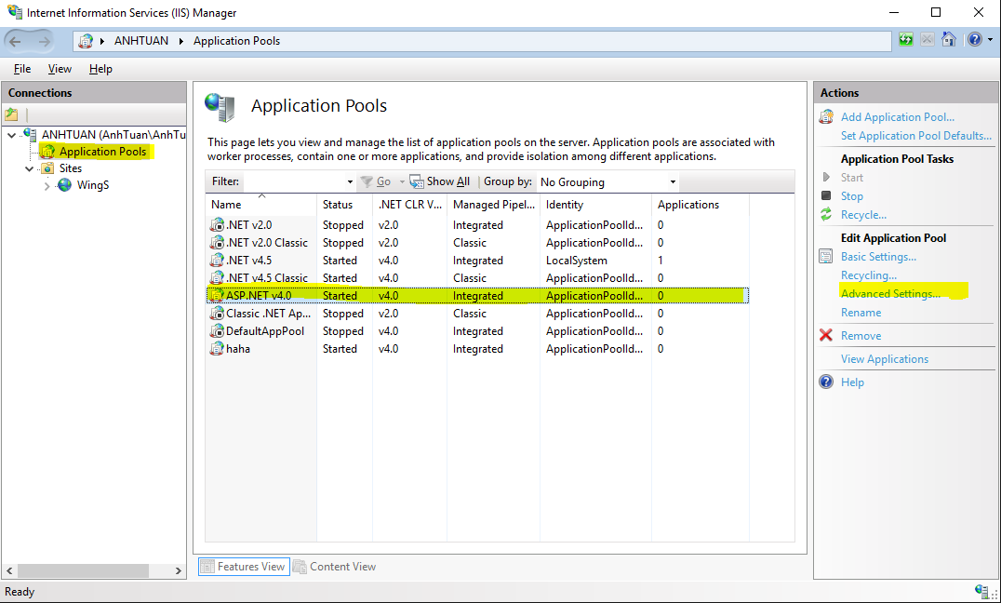

**Step 5:** Make sure that you select “Local System” as the Identity from the Advance Settings dialog as shown in the figure below:

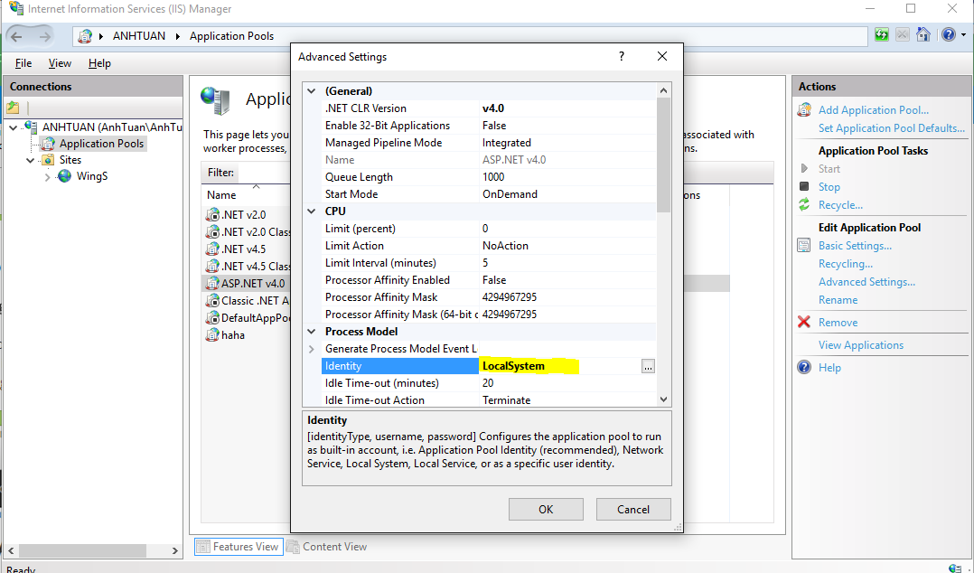

### Add WingS web app into IIS.

**Step 1:** Right click on “Sites -> select Add website…”

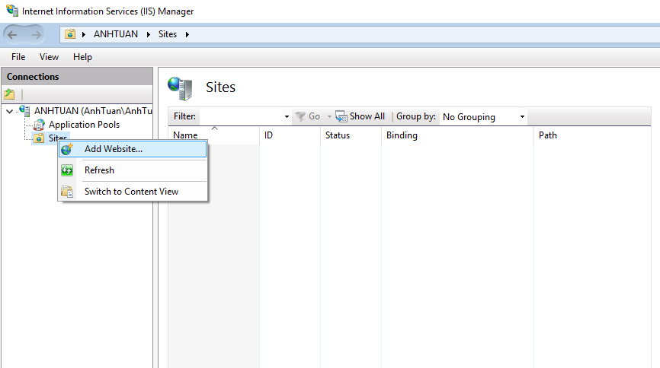

**Step 2:** Enter Site name and Select pool is ASP.NET v4.0.

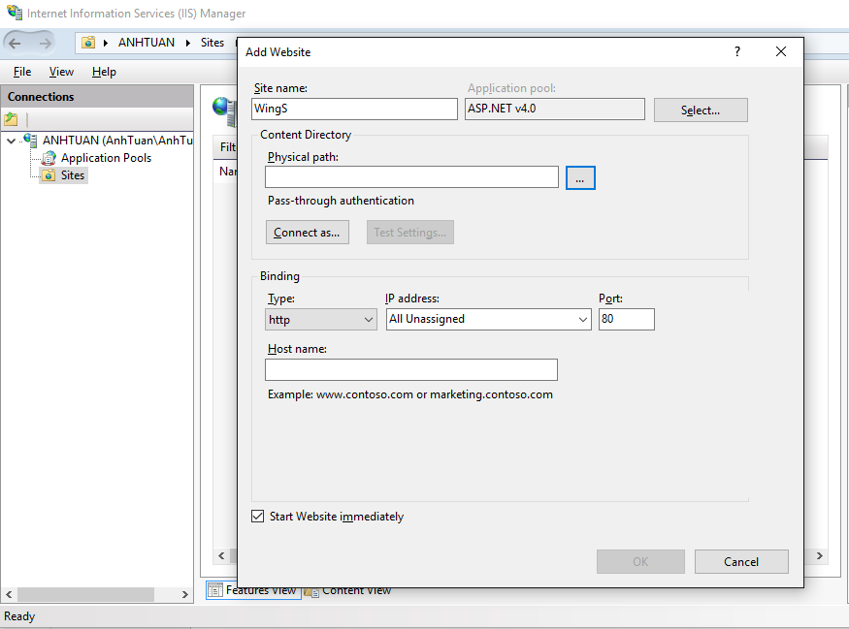

**Step 3:** Select Physical path (location store wings web app ) ,change default Port to 2710 and click “OK”.

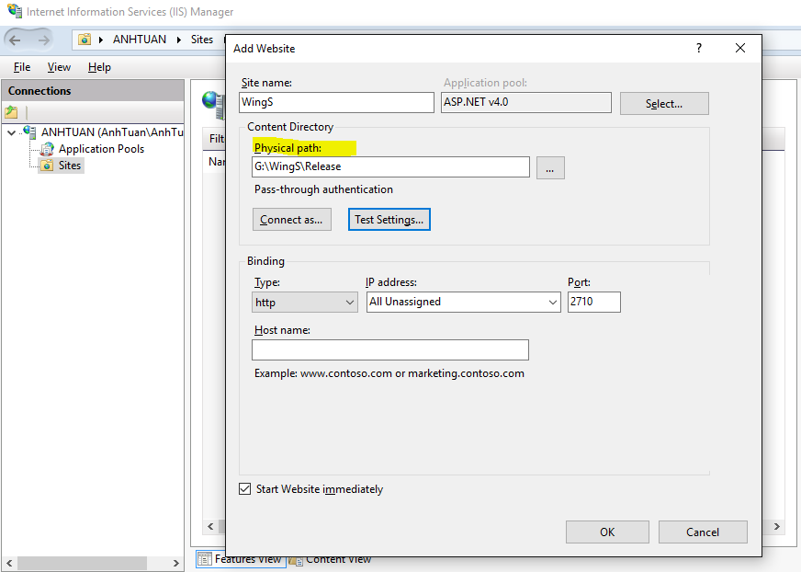

**Step 4:** Right click WingS (Site name is created), select “Manage Website -> Browse”.

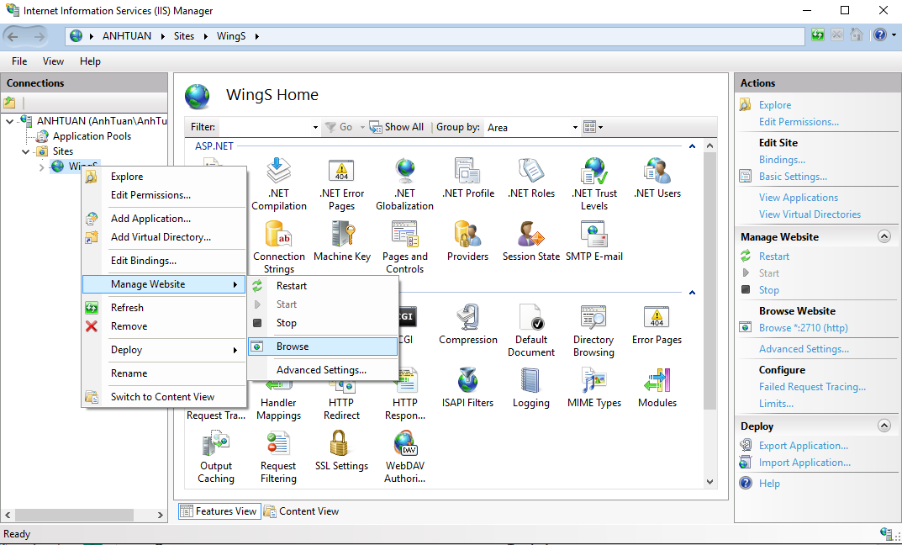

## User Guideline

### User

#### Register

This is the first page which user will see. From this page the user can go to every page they want.

To register account on website, the users do the steps below:

Step 1: Open browser and enter to the address bar: <http://wings.com/>. Homepage is displayed.

Step 2: Click on “ăng nhập -> Đăng ký” button in header. Users will go to Register page.

Step 3: Enter information and click on Đăng ký button or User can register by choose Login with Facebook.

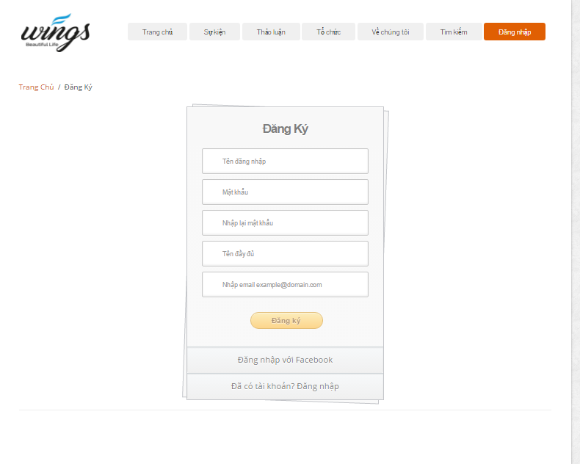

1. Register screen

#### Login

To login account on website, the users do the steps below:

Step 1: Open browser and enter to the address bar: <http://wings.com/>. Homepage is displayed.

Step 2: Click on “Đăng nhập” button in header. User will go to Login page.

Step 3: User can choose Login with Facebook.

Step 3: User can choose Login with WS’account:

Step 3.1: User enter username and password

Step 3.2: Click on Login button

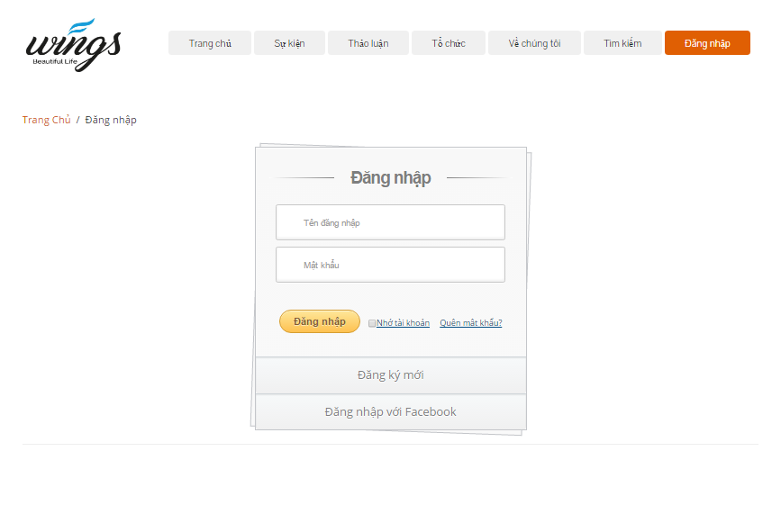

1. Login page

#### Search

To use search function on website, the users do the steps below:

Step 1: In Home page, click “Tìm kiếm” button in header. User will go to Search page.

Step 2: Choose type search follow: Tài khoản, Cá nhân, Bài viết, Sự kiện, Tổ chức. Enter key word into text filed and click “Tìm kiếm” button or press enter.

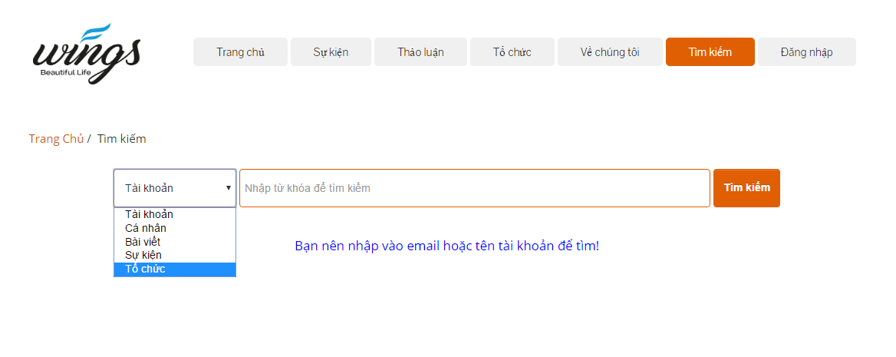

1. Search page

Step3: Search result page is displayed.

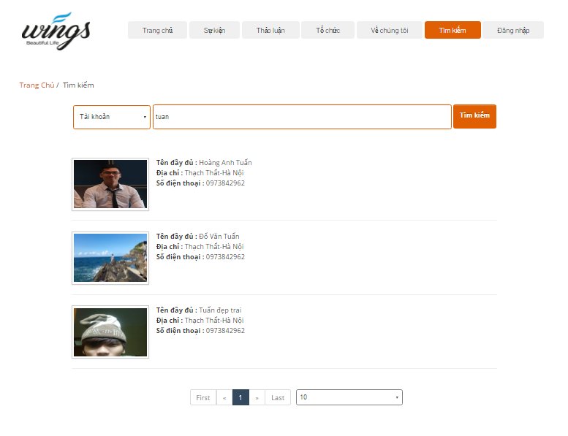

1. Search “Tài khoản” result

#### Create thread

In this page, user can create a new thread to discussion…

Go to Create thread page, the user do the steps below:

Step 1: Go to Homepage.

Step 2: Click on “Tạo thảo luận” button. System will go to Create thread page.

Step 3: User enter information

Step 4: Click on “Tạo thảo luận” button.

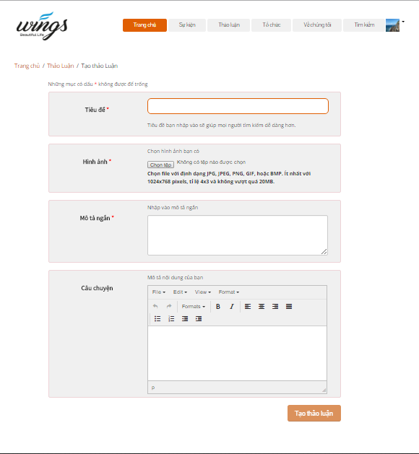

1. Create thread screen

#### Thread

In this page, user can view thread list, view number likes, number comments…  
Go to Thread page, the user do the steps below:

Step 1: Go to Homepage.

Step 2: Click on “Thảo luận” button in header

Step 3: Thread page is displayed and allow user can view. Thread list ordered by create date.

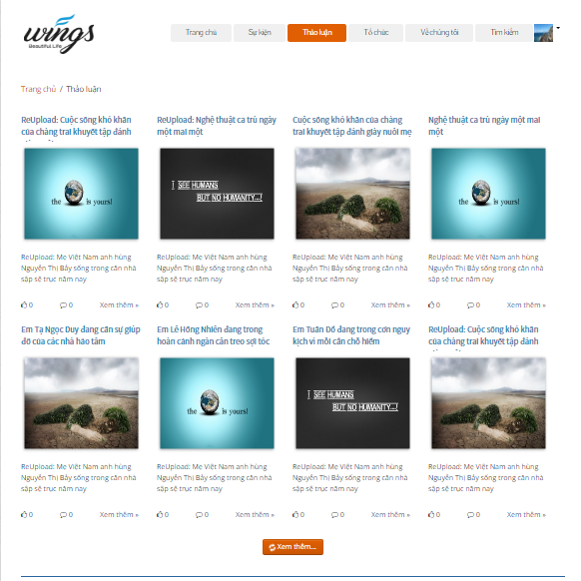

1. Thread page

#### Thread detail

In this page user can view details project. And user also can like, share, comment, report.

Go to the Thread detail page, user can click any into image of thread or “Xem thêm” link in thread list.

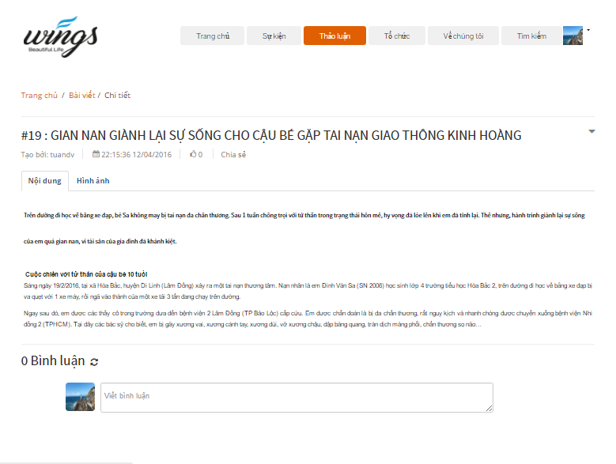

1. Thread detail screen

##### Report thread

To sent report about thread user do the step below:

Step 1: Go to thread detail of a thread.

Step 2: Click  in thread detail page. System will display:

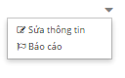

Step 3: Click on “Báo cáo”. Dialog Report will display :

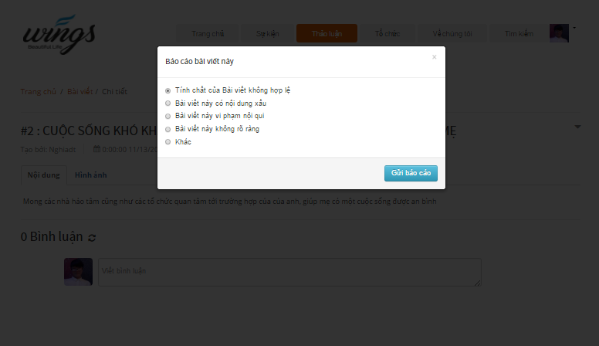

1. Dialog report

Step 4: Choose a reason which you want see and click on “Gửi báo cáo” button.

##### Comment thread

User can comment all of things relate about thread

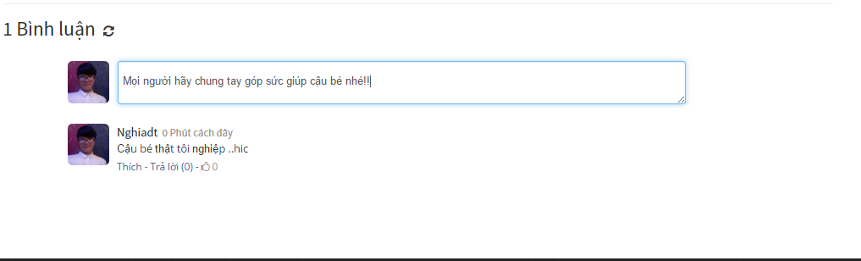

1. Comment screen

#### Edit thread

To edit thread user do the step below:

Step 1: Go to thread detail page .

Step 2: Click  in thread detail page. System will display:



Step 3: Click on “Sửa thông tin”. User go to edit thread page.

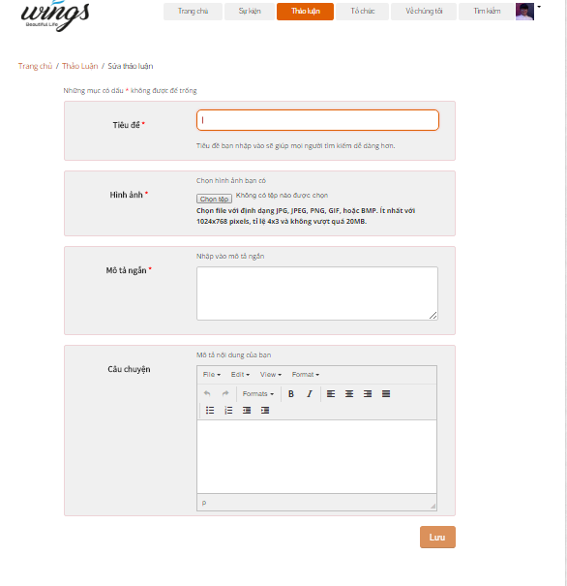

1. Edit thread screen

Step 4: Edit information and click “Lưu” button.

#### Create Event

In this page, user can create a new event to raise Donate.

Go to Create event page, the user do the steps below:

Step 1: Go to Homepage.

Step 2: Click on “Tạo sự kiện” button. User will go to Create event page.

Step 3: User enter information

Step 4: Click on “Tạo sự kiện” button.

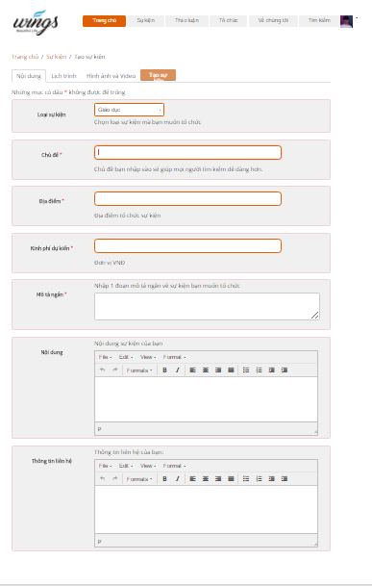

1. Create Event screen

#### Event

In this page, user can view event list and filter event by create date, point, type…   
Go to Event page, the user do the steps below:

Step 1: Go to Homepage.

Step 2: Click on “Sự kiện” button in header

Step 3: Event page is displayed and allow user can view.

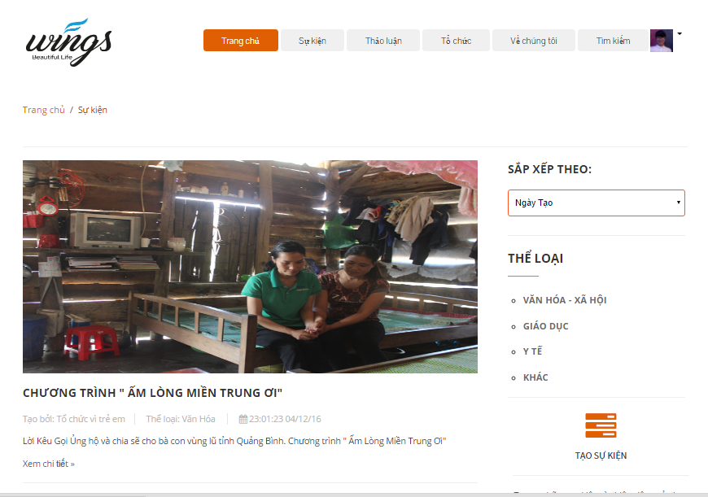

1. Event page screen

#### Event Detail

In this page user can view details event. And user also can like, share, comment, report, Donate, Chat room, see video, process of Donate.

Go to the Event detail page, user can click any into image of event or “Xem chi tiết” link in event list.

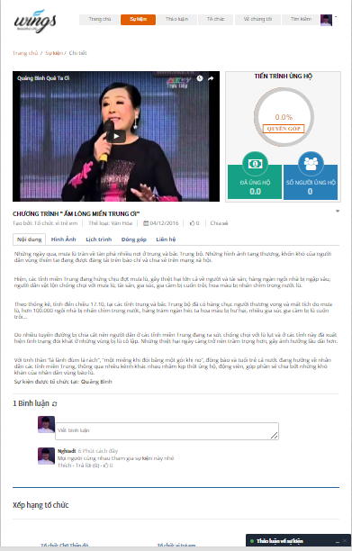

1. Event Detail Screen

##### Report event

To send report about event, user do the step below:

Step 1: Go to event detail of a event.

Step 2: Click  in event detail page. System will display:



Step 3: Click on “Báo cáo”. Dialog Report will display :

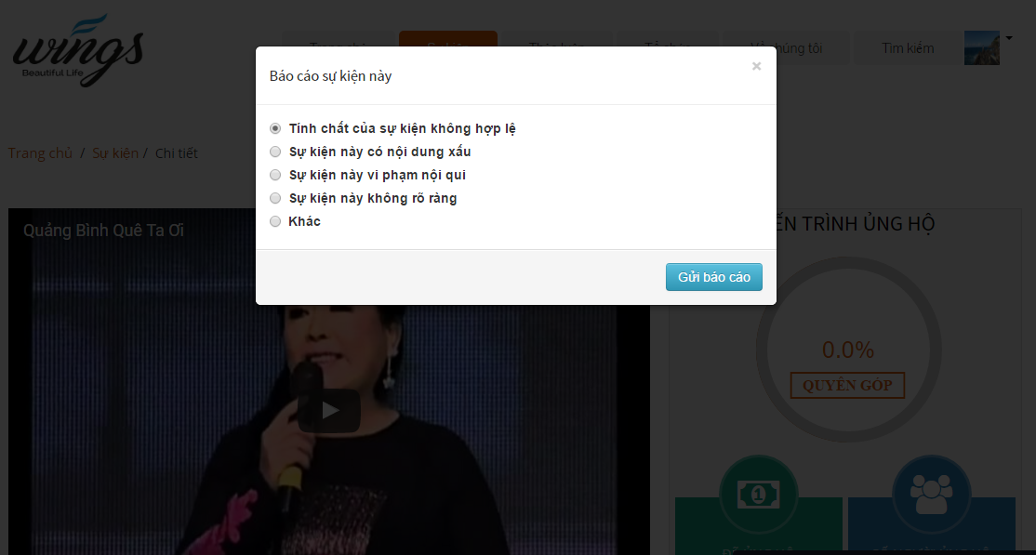

1. Dialog report event

Step 4: Choose a reason which you want see and click on “Gửi báo cáo” button.

##### Comment event

User can comment all of things relate about event.



1. Comment event screen

##### Chat room

User can chat any thing about event.  
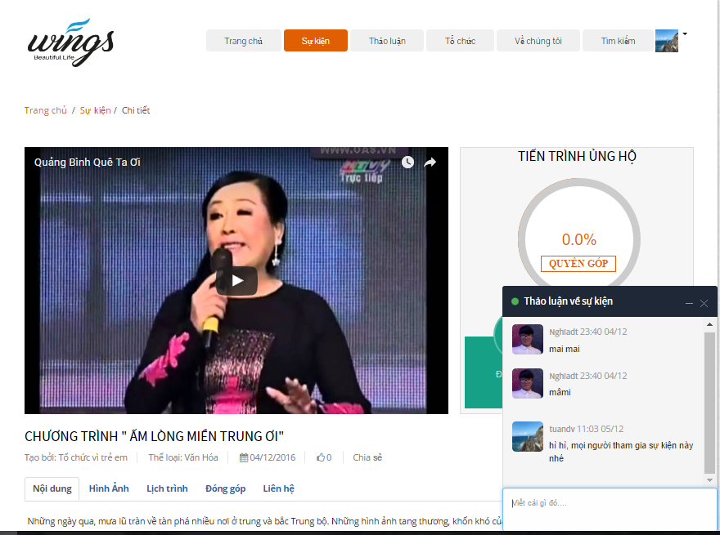

1. Chat room screen

#### Edit Event

To edit event user do the step below:

Step 1: Go to event detail page .

Step 2: Click  in event detail page. System will display:



Step 3: Click on “Sửa thông tin”. User go to edit event page.

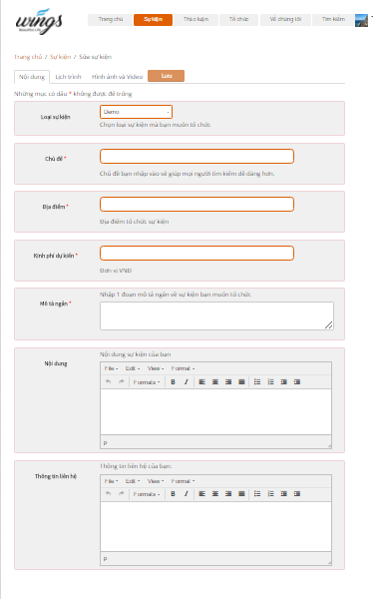

1. Edit Event screen

Step 4: Edit information and click “Lưu” button.

#### Create organization

In this page, user can create a new organization to create events.

Go to Create organization page, the user do the steps below:

Step 1: Go to Homepage.

Step 2: Click on “Tạo tổ chức” button. User will go to create organization page.

Step 3: User enter information

Step 4: Click on “Tạo tổ chức” button.

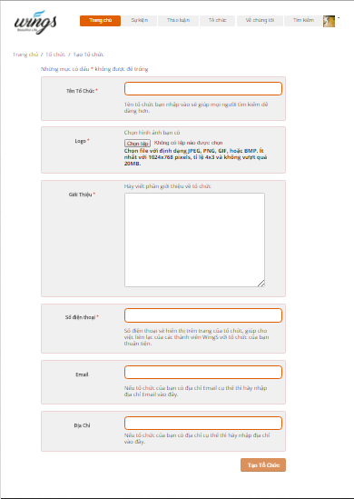

1. Create organization screen

#### Organization

In this page, user can view organization list.  
Go to Organization page, the user do the steps below:

Step 1: Go to Homepage.

Step 2: Click on “Tổ chức” button in header

Step 3: Organization page is displayed and allow user can view.

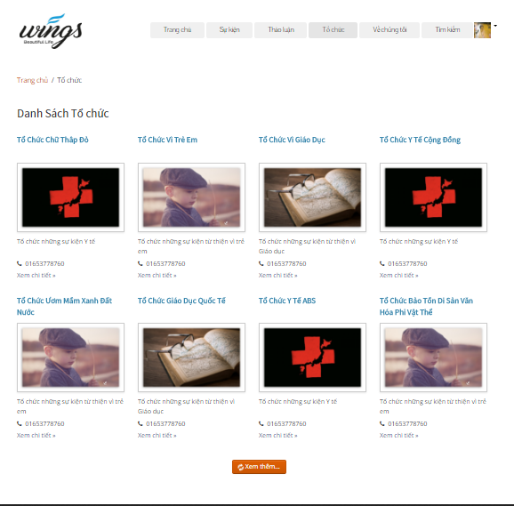

1. Organization screen

#### Organization detail

In this page user can view details organization. And user also can inbox, report.

Go to the Organization detail page, user can click any into image of organization or “Xem chi tiết” link in organization list.

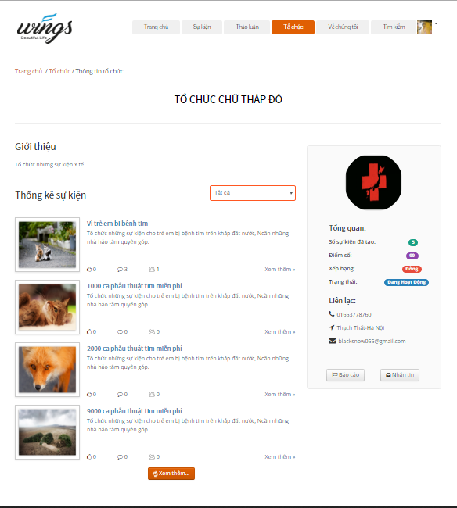

1. Organization detail screen

##### Report organization

To send report about organization, user do the step below:

Step 1: Go to organization detail of organization.

Step 2: Click “Báo cáo” button in organization detail page. Dialog Report will display:

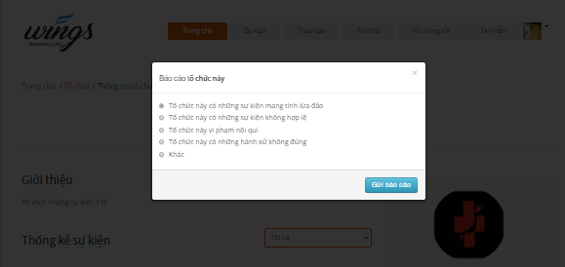

1. Dialog report organization

Step 3: Choose a reason which you want see and click on “Gửi báo cáo” button.

##### Send message to Organization

To send message to organization, user do the step below:

Step 1: Go to organization detail of organization.

Step 2: Click “Nhắn tin” button in organization detail page. Dialog Message will display:

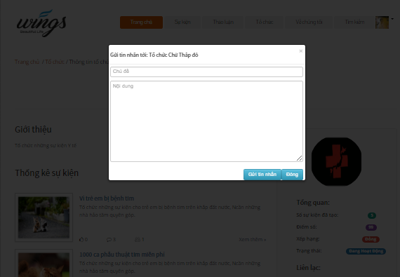

1. Dialog message screen

Step 3: Enter content what you want message to organization, and click “Gửi tin nhắn” button.

#### Edit Organization

To edit organization user do the step below:

Step 1: Click  in header. System will display:

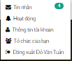

Step 2: Click on “Tổ chức của bạn”. User go to organization detail page, and click on “Sửa thông tin” button. User will go to Edit Organization page:  
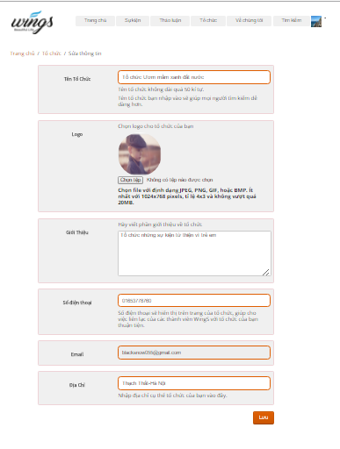

1. Edit Organization screen

Step 3: Enter information and click on “Lưu” button.

#### Donate Event

This is the most importance feature. To use this fearture user do the steps below:

Step 1: From event details page, click on “Quyên góp” link. System go to donate project page.

Step 2: Choose payment methods, numbers of money , enter content and click on “Thanh toán” button. System go to the Ngân lượng and backer complete some of step in Ngân lượng to donate success event.

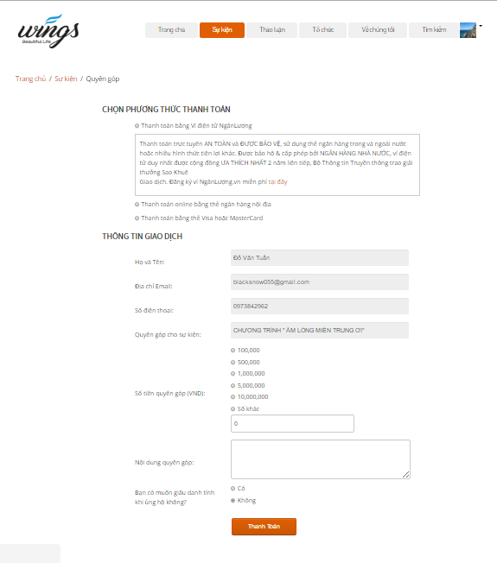

1. Donate event screen

#### Message

In this page user can view messages to create new message, view message.

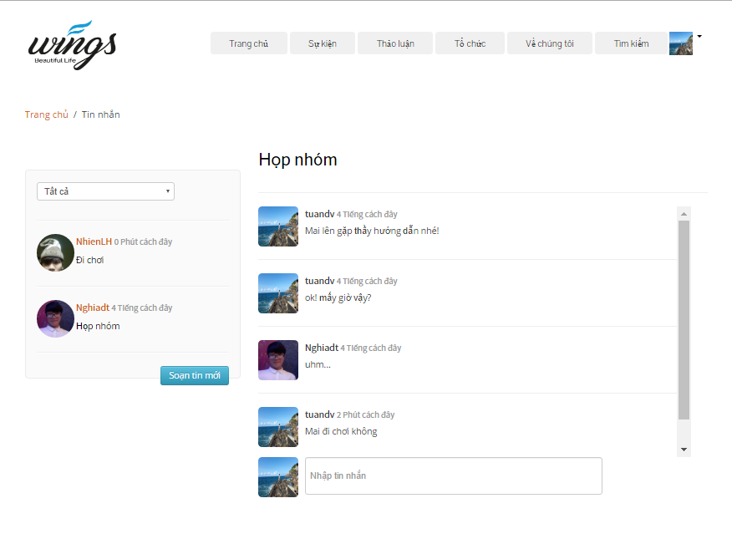

1. Message screen

##### Sent message

To sent message user do the steps below:

Step 1: Click on avatar in header, then click on “Tin nhắn” link. System go to message page.

Step 2: Click on “Soạn tin nhắn” button.

Step 3: Enter information and click sent button.

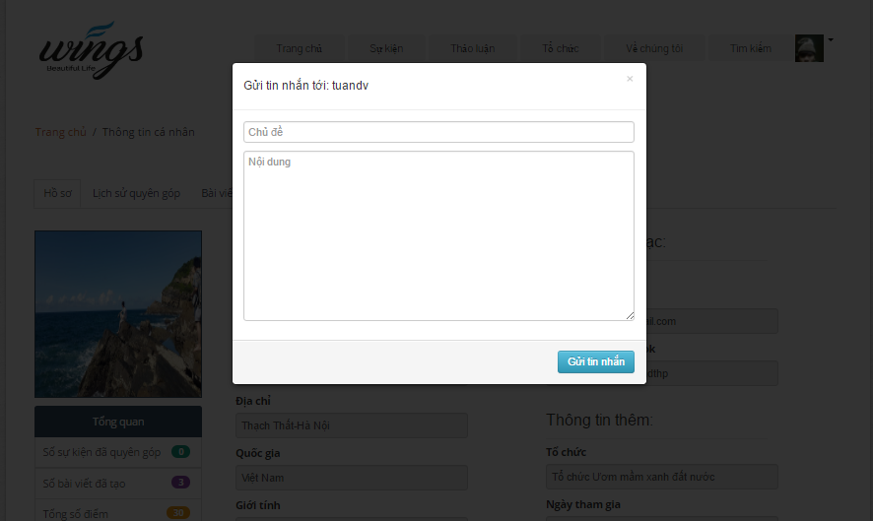

1. Sent message

##### Message view

In this page, user can sent and receive message create a conversation. To view conversation user do the steps below:

Step 1: Click on avatar in header, then click on “Tin nhắn” link. System go to message page.

Step 2: Click on a message to view conversation.

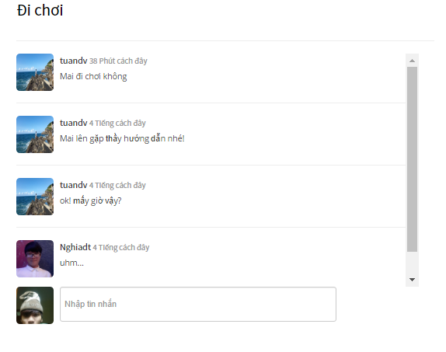

1. Message view screen

#### Account management

##### Change password

To change password user do the steps below:

Step 1: Click on avatar in header, then click on “Thông tin tài khoản” button. System will go to account detail page.

Step 2: Click on “Đổi mật khẩu” tab

Step 3: Enter username, old pass, new pass, confirm new pass.

Step 4: Click “Đổi mật khẩu” button.

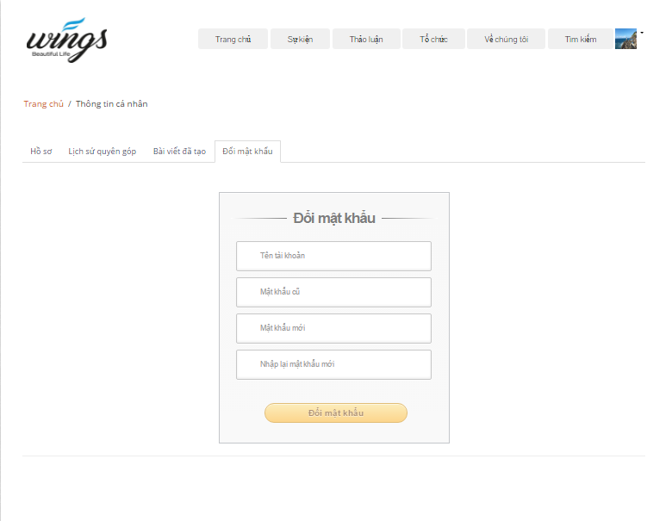

1. Change pass screen

##### Public profile

User can view public profile.

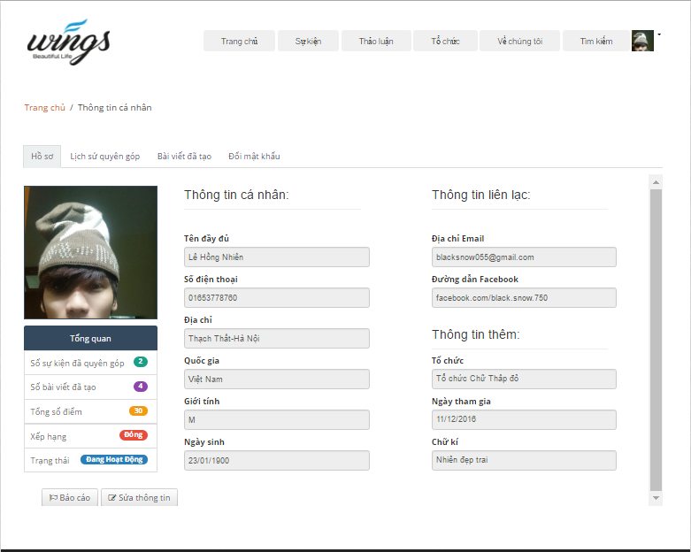

1. Public profile screen

##### Donated history

User can view donate history.

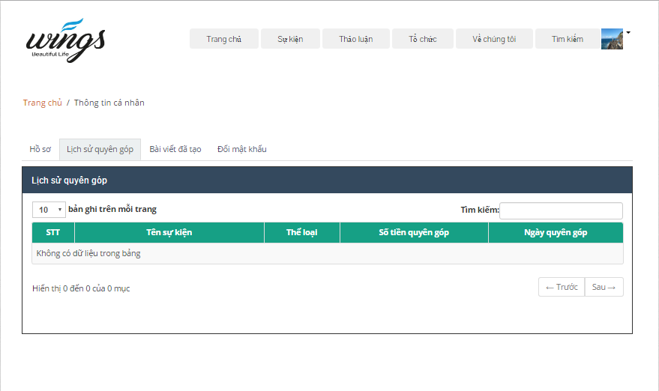

1. Donated history

##### Created thread

User can view created thread.

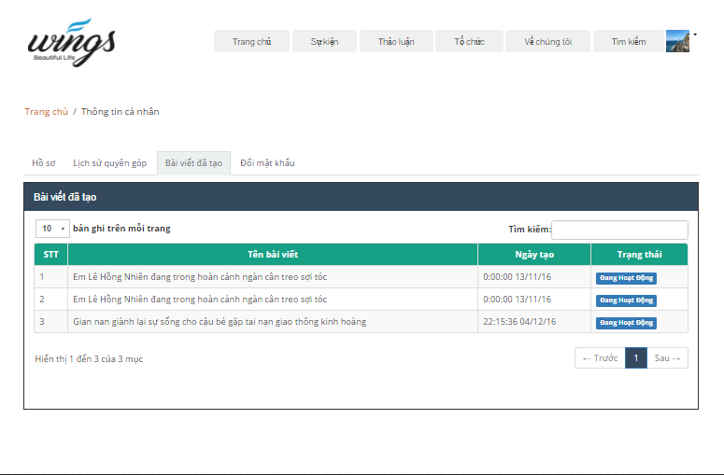

1. Created thread

##### Edit profile

To change info of user do the steps below:

Step 1: Click on avatar in header, then click on “Thông tin tài khoản” link. System will go to account detail page.

Step 2: Click on “Sửa thông tin” button

Step 3: Enter information.

Step 4: Click “Lưu” button.

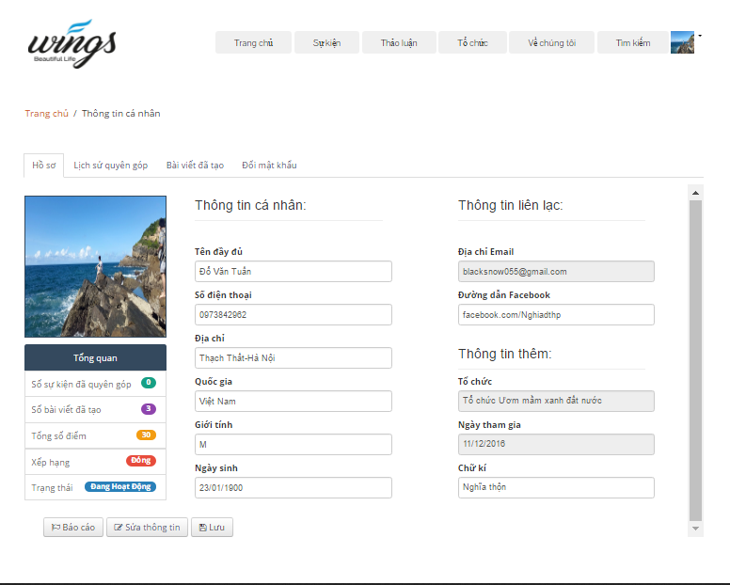

1. Edit profile screen

### ADMIN

#### Login

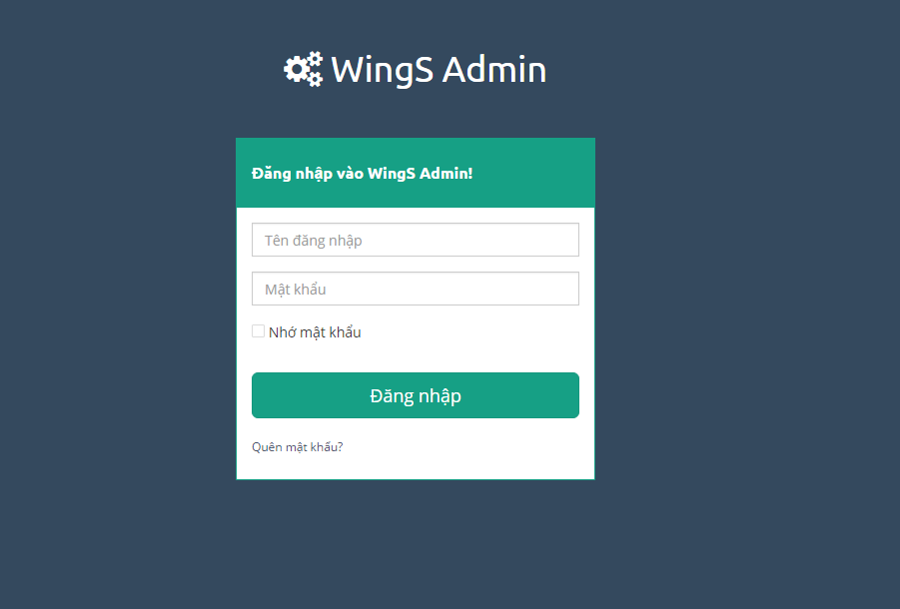

1. Login screen

To login admin account, the users do the steps below:

Step 1: Open browser and enter to the address bar: <http://wings.com/admin/>.

Step 2: User enter username and password

Step 3: Click on “Đăng nhập” button

#### Dashboard

At this page, Admin can view overview about user, organization, thread, event.

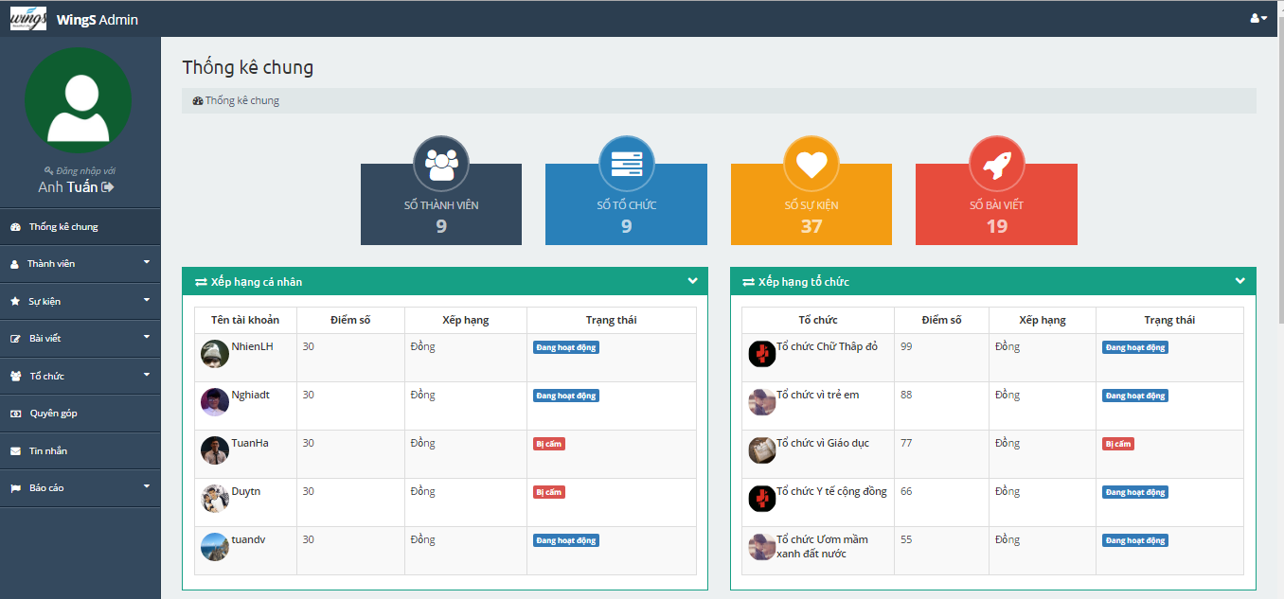

1. Dashboard 1

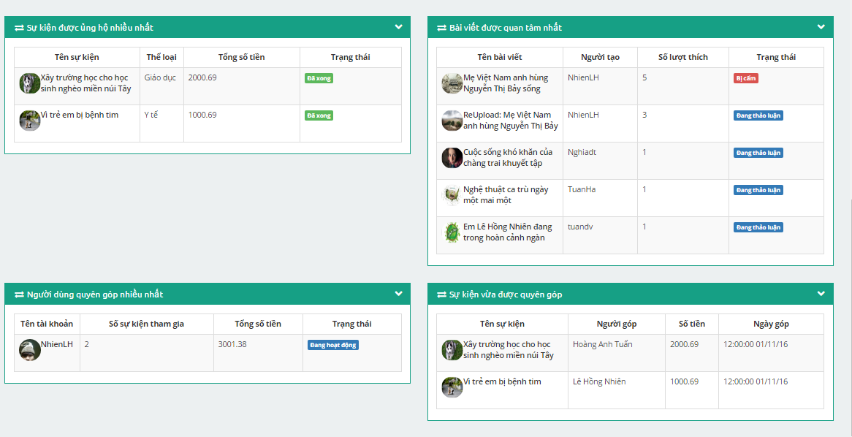

1. Dash board 2

#### Users

To lock/unlock a account. Admin do the step below:

Step 1: Go to Admin page, Click on “Thành viên -> Danh sách thành viên” link. System return list account.

Step 2: Choose account and click on “Trạng thái” column to lock/unlock account.

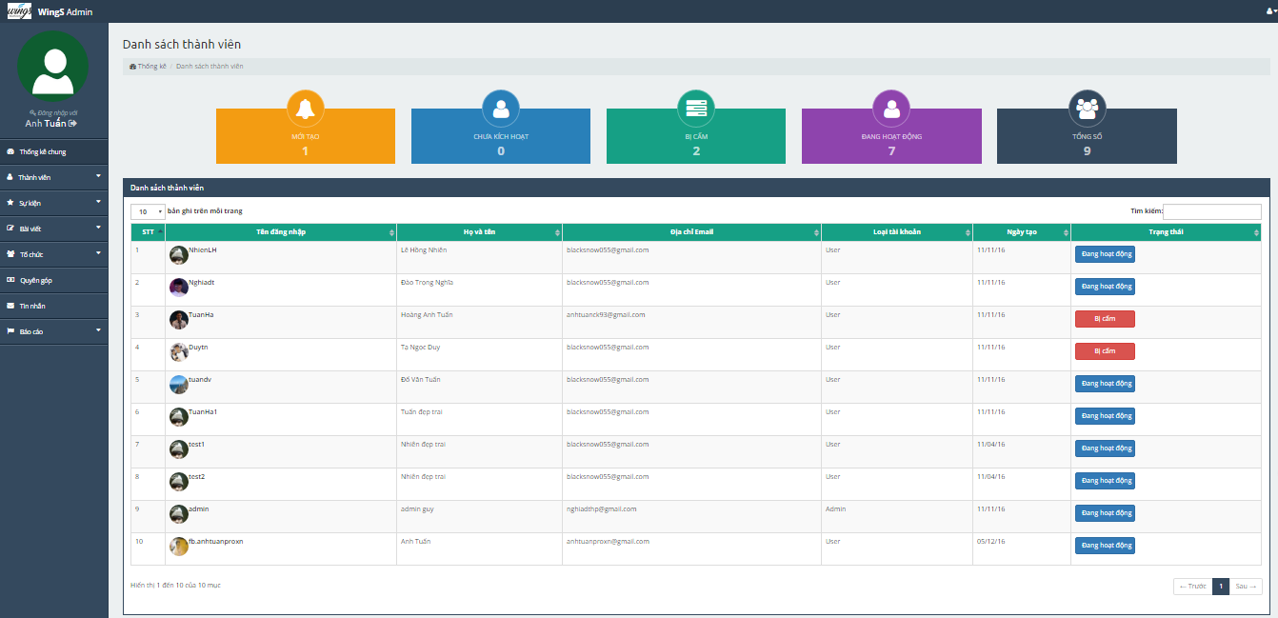

1. Users list screen

#### Event

To lock/unlock event. Admin do the step below:

Step 1: Go to Admin page, Click on “Sự kiện -> Danh sách sự kiện”. System returns list event.

Step 2: Choose event and click on “Trạng thái” column to lock/unlock event when status of event is : “Đang diễn ra” or “Bị cấm”. System go to project detail page.

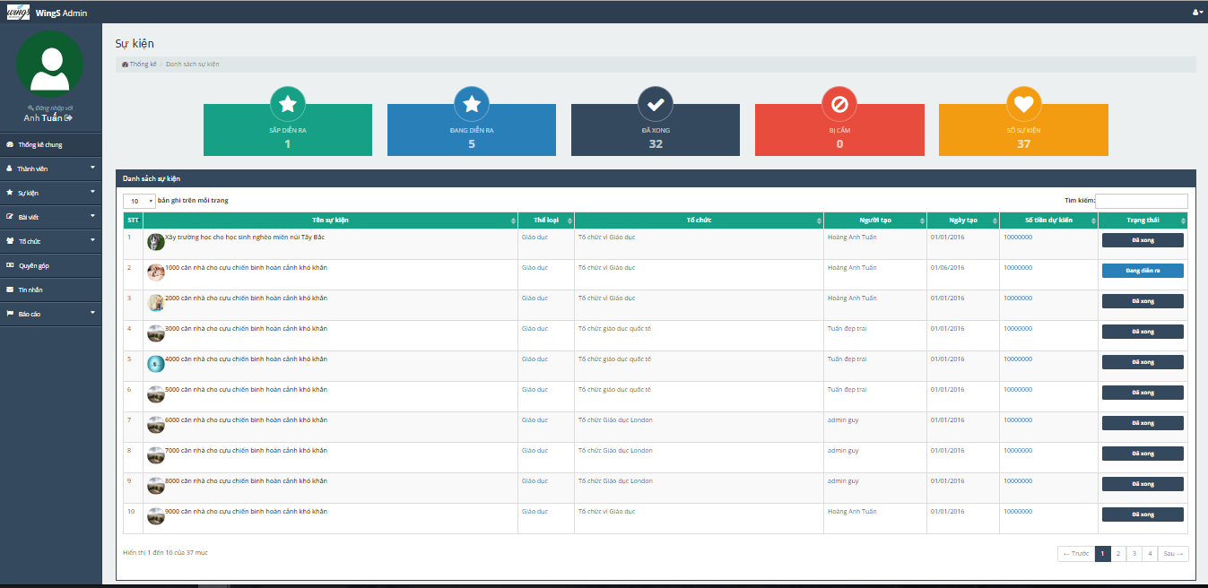

1. Projects list screen

##### Add event type

Admin can add new event type or lock/unlock event type.

Adding new event type, admin do the step below:

Step 1: Go to Admin page, Click on “Sự kiện -> Thể loại sự kiện”. System returns event type page.

Step 2: Click on “Thêm thể loại” button in header. Dialog event type will display:  
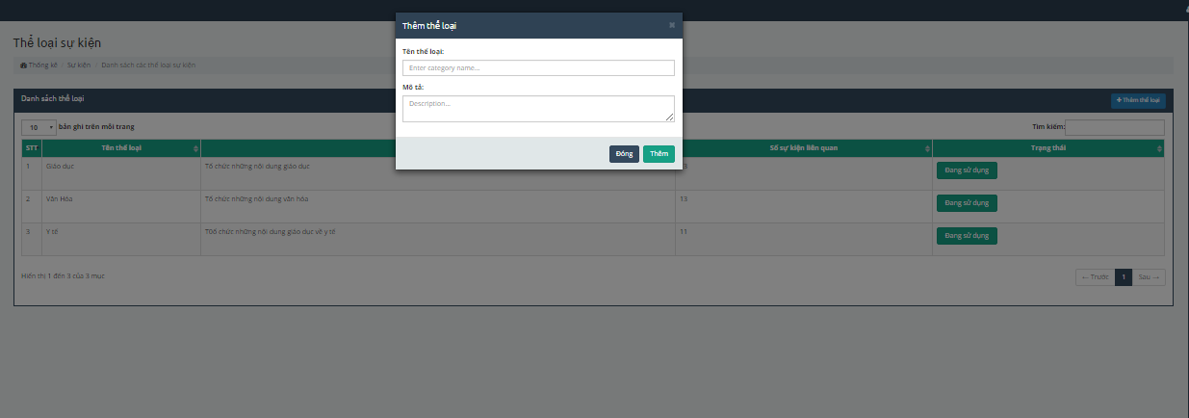

**Fi**

Step 3: Enter information, and click “Thêm” button to add.

Lock/unlock event type, admin do the step below:

Step 1: Go to Admin page, Click on “Sự kiện -> Thể loại sự kiện”. System returns event type page.

Step 2: Choose event type and click on “Trạng thái” column to lock/unlock event type.

#### Thread

To lock/unlock a thread. Admin do the step below:

Step 1: Go to Admin page, Click on “Bài viết -> Danh sách bài viết” link. System return list thread.

Step 2: Choose thread and click on “Trạng thái” column to lock/unlock account.

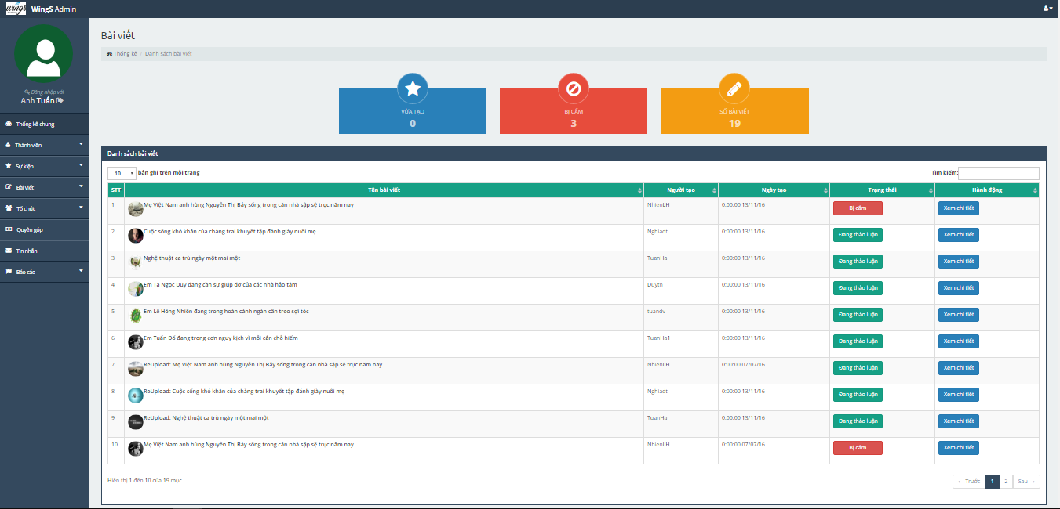

1. Thread list screen

#### Organization

##### Organization register list

To accept/refuse a request create an organization from user. Admin do the step below:

Step 1: Go to Admin page, Click on “Tổ chức -> Danh sách đăng ký” link. System return organization register list.

Step 2: Choose organizarion and click on “Đồng ý” or “Từ chối” button to accept/refuse organizarion.

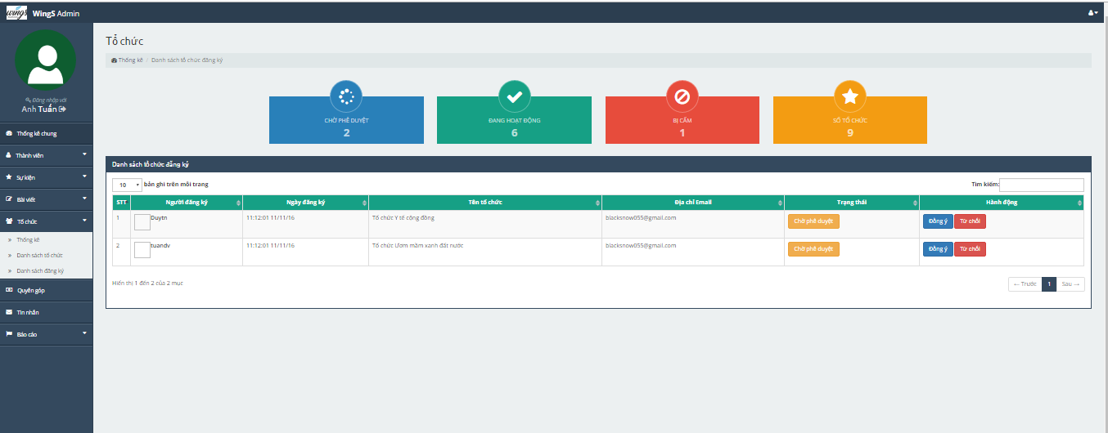

1. Organization register list

##### Organization list

To lock/unlock a organization. Admin do the step below:

Step 1: Go to Admin page, Click on “Tổ chức -> Danh sách tổ chức” link. System return list organization.

Step 2: Choose organization and click on “Trạng thái” column to lock/unlock organization.

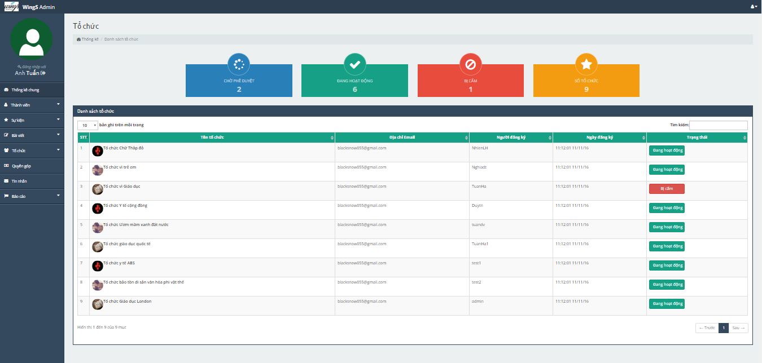

1. Organization list screen

#### Donation

Admin can manage list banker.

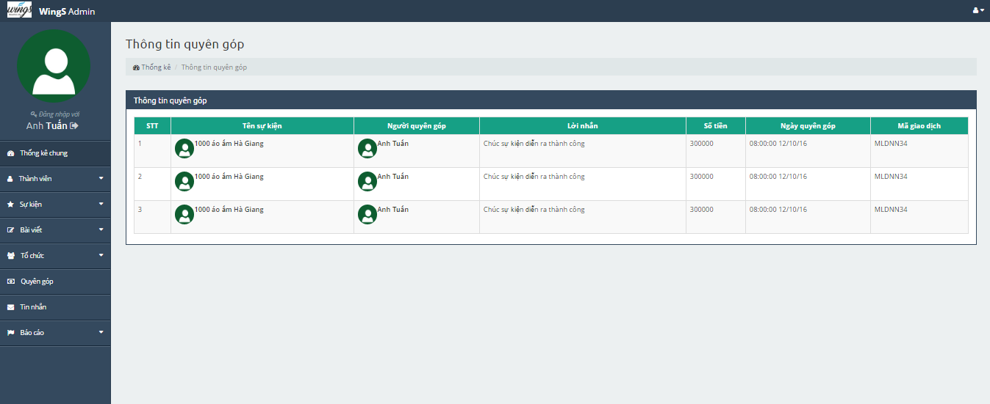

1. Backing list screen

#### Message

Admin can manage message (send, receive message).



1. Message screen

#### Report

##### Report user

Step 1: Go to Admin page , click on ”Báo cáo -> Thành viên” link. System will display user list has been report.

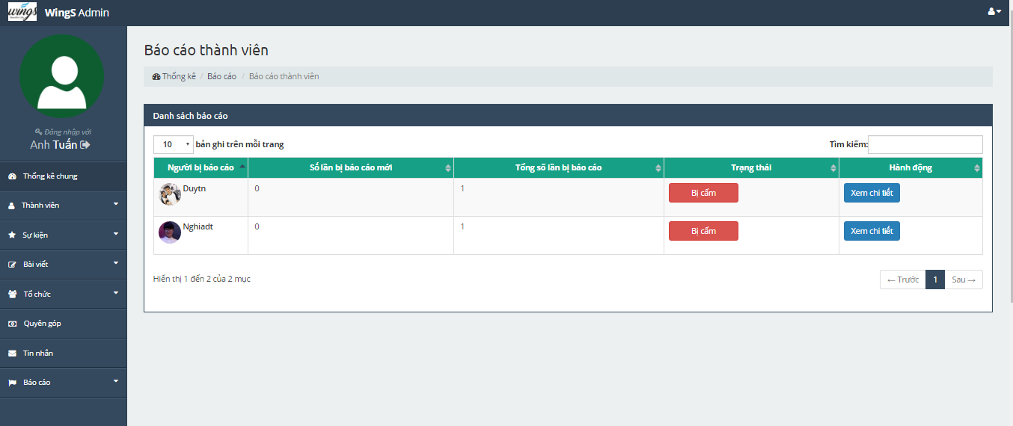

1. User list has been report screen

Step 2: Click on ”Xem chi tiết” button, system will redirect report detail page.

Step 3: Click on “Khóa tài khoản này” to lock account of user.

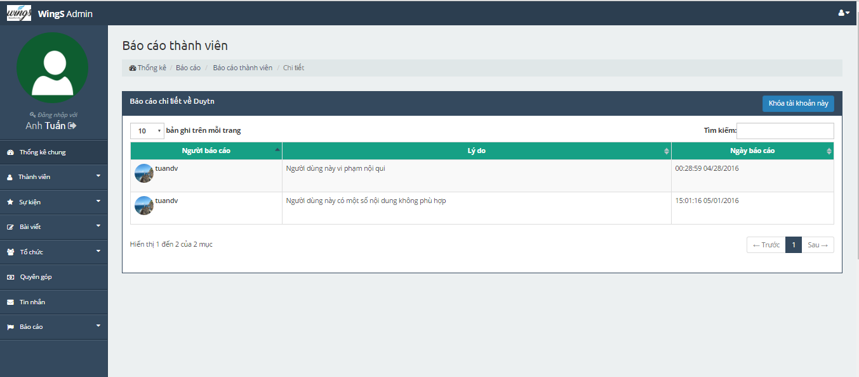

1. Report Detail page screen

##### Report organization

Perform the same steps at Report user.

##### Report thread

Perform the same steps at Report user.

##### Report event

Perform the same steps at Report user.

# PROJECT RESULT REPORT

## Product Judging

### Advantage of Dandelion system

WS makes connections that enable people to help themselves and each other. Website allows users (who created organization) create charity topics or event as long as it follows our rules to help other people. Donors can also take part in a event by donating money through a single donation or supporting event as a regular donor publicly or privately, not to profit financially. Instead, charity topic creators offer rewards to thank backers for their support. We hope our event can help as much people as we can in our country.

As the goals that we have set before started project, the WingS system has been developed in right direction. And what it provides to users is listed below:

Guest: guest can search, view event which is created on WingS with friendly interface.

Member: Have account on system, they can use all functions of website. For example: Searching, create post, event, donate etc.

* Admin: They can use all functions of normal member and have an Administrator control panel to manage all configuration of system.

### Current Limitations

* Website not support for English language.
* Not support payment methods for people in other countries.
* Now only can donate by banking method.

### Expectation in Future

* Support multi-language and other payment method such as visa and master card or PayPal to donate.
* App for Android and IOS which supports members manage their account
* Expand server to inscrease number of users.

## Project Summary

|  |  |  |  |  |
| --- | --- | --- | --- | --- |
| **Project Title** | | **WingS** | | |
| **Project Supervisor** | | Nguyễn Văn Sang | | |
| **Committers (6)** | | | | |
| **1** | **Project Manager** | Đào Trọng Nghĩa | Nghiadtse03220@fpt.edu.vn | |
| **2** | **Team member** | Tạ Ngọc Duy | [Duytnse03267@fpt.edu.vn](mailto:Duytnse03267@fpt.edu.vn) | |
| **3** | **Team member** | Lê Hồng Nhiên | [Nhienlhse03377@fpt.edu.vn](mailto:Nhienlhse03377@fpt.edu.vn) | |
| **4** | **Team member** | Đỗ Văn Tuấn | [Tuandvse03297@fpt.edu.vn](mailto:Tuandvse03297@fpt.edu.vn) | |
| **5** | **Team member** | Hoàng Anh Tuấn | [tuanhase03108@fpt.edu.vn](mailto:tuanhase03108@fpt.edu.vn) | |
| **Main objective** | | The main of WS is to get people involved with the charity or attend event, usally resulting in the user donating. | | |
| **Purpose** | | Provide a WingS online on website. | | |
| **Source Repository** | | <https://github.com/sangnvus/201609JS01.git> | | |
|  | | **Plan** | | **Actual** |
| **Start Date** | | 05/09/2016 | | 05/09/2016 |
| **End Date** | | 16/12/2016 | | 14/12/2015 |
| **Releases version** | | 1.0 | | 1.0 |
| **Duration** | | 75 days | | 73 days |
| **Effort (person-day)** | | 375 | | 365 |
| **Test cases** | | 1302 | | 1302 |
| **Defects** | | 100-150 | | 58 |
| **Document pages** | | ~ 800 pages | | ~ 3500 pages |
| **Lines of code (C#)** | | ~ 7000 | | ~ 8000 |
| **Lines of code (HTML)** | | ~ 8000 | | ~ 10000 |
| **Lines of code (AngularJS)** | | ~ 3000 | | ~ 4000 |
| **LOC (Total)** | | ~ 18000 | | ~ 22000 |

1. Project summary

Knowledge:

* Work process of FPT Software to develop a project.
* Putting the learned knowledge into practice.
* Improve skils: teamwork, leader-ship, research and self-study, plan and manage time.
* Technical: AngularJS (Single Page Appliction), WebApi 2.0, ASP.Net MVC5.
* Tools: Visual Studio, TortoiseGit, Astah, Visio, Office tools.

## Lesson Learnt

* Be work hard and feel free to ask other when you got stuck.
* Ability to look from business perspective apart from (typical) code-level perspective
* Together with leadership skills, the project manager needs to be aware of the strengths and weaknesses of his/her staff, so that the talents are harnessed and the shortfalls downplayed for the benefit of the project.
* Will and ability to self-develop, learn (quickly) new things and adapt to new environments.
* Procrastination does not work. After assimilating the relevant information, decisions need to be made. Wrong decisions can be salvaged, if discovered early; but right decisions cannot be postponed.
* Good communication is that which will stop mistakes from becoming failures.

# REFERENCES

1. Lovingkindnessvietnam

<https://www.Lovingkindnessvietnam.org/>

1. Childrenofvietnam

<https://www.Childrenofvietnam.com/>

1. Boostrap Overview

<http://www.w3schools.com/bootstrap/>

1. SignalR Overview

<http://signalr.net/>

<https://www.asp.net/signalr>

1. AngularJS Overview

<http://www.tutorialspoint.com/angularjs/angularjs_overview.html>

1. Capstone Project Report Teamplate – FPT University, Ha Noi, Viet Nam.
2. Report document guidelines (2013) – FPT University, Ha Noi, Viet Nam.
3. Template_Project_Plan, (2010), FPT University, Hanoi, Vietnam
4. Template Software_Requirements_Specification, (2010), FPT Software, Hanoi, Vietnam
5. Template Software_Design_Template, (2010), FPT Software, Hanoi, Vietnam
6. Templates for Test case & Defect log, FPT Software, Hanoi, Vietnam
7. The Unified Modeling Language diagram

<http://www.uml-diagrams.org/>